Encryption Worksheet
Name: |  |  | Date:

Encrypting messages
Encryption involves scrambling messages to keep information private to only the people who should see it. There are lots of different ways that encryption is used when transmitting data. The example below shows how encryption could keep patient data (like names) private from hackers who should not have access to that data.

Without encryption
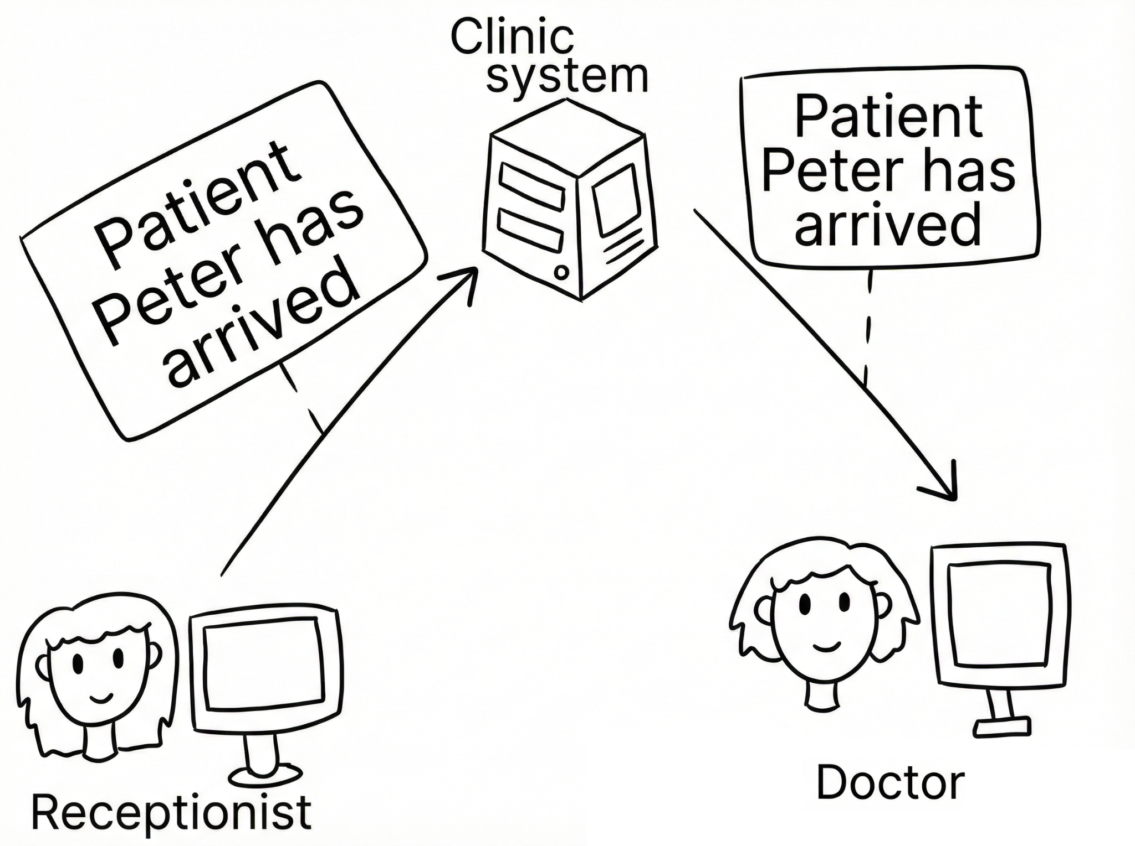

Imagine that a student named Peter has a doctor’s appointment. They arrive at the clinic and let the receptionist know they have arrived. The receptionist uses a digital system to record that Peter has arrived and that message gets sent through to the doctor, who’s working in their office and will call out Peter’s name when they’re ready for the appointment.

Intercepting messages
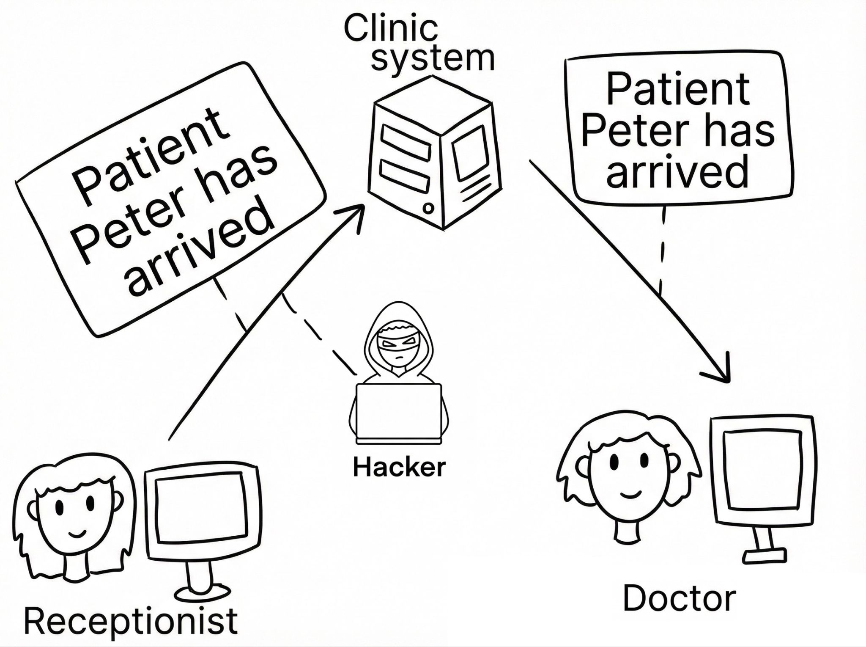

Now imagine that someone (such as a hacker) can see the messages that are sent between the receptionist and the clinic system. If the messages are not scrambled (not encrypted), then a hacker could read that data, and any other data that gets sent through the system. This could include data that is more private, like addresses, health data or bank details.

With encryption
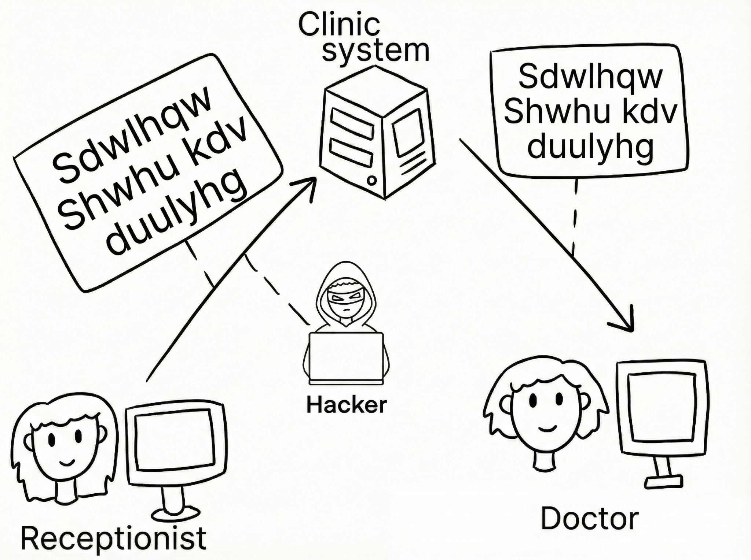
However, if the messages are encrypted (scrambled) and the messages are intercepted by someone who does not know how to decrypt them, the data will be kept safe. In the image above, the messages that were “Patient Peter has arrived” have now been scrambled so that they’re nonsense and won’t make sense to a hacker.

Question 1
Your friend left an encrypted message and a clue on your laptop for you. A picture of your laptop is shown below. Can you use a cipher wheel and the clue in this picture to decrypt and reveal the message?

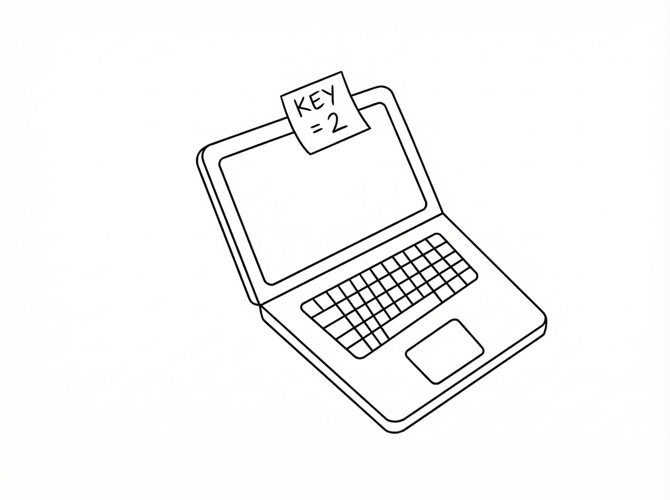

Encrypted message:

K | S | S | H |  | Q | S | V | R | M | R | K

What is the key?

Decrypted message:

Question 2
Your friend left another encrypted message for you but, this time, has also left part of the decrypted message. Can you work out what the encryption key was and decrypt the rest?

Encrypted message:
N | Y | L | H | A |  | D | V | Y | R

What is the key?

Decrypted message:
A

More encryption
If you complete these questions quickly, you can encrypt some secret messages for your classmates, using your cipher wheel. First, make sure the As on the inner and outer wheel are lined up, like the image below.
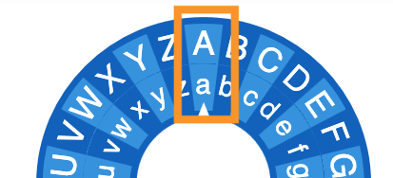
Next, choose a key (a number between 1 and 25) and shift the inner wheel that many times clockwise. The wheel rotated for a key of 2, is shown below. Your classmate will need this key for decryption.
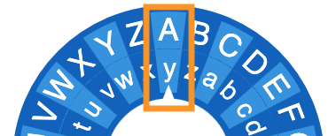
To encrypt, go through each letter in the message, look at that letter on the inner wheel and write down the letter on the outer wheel. If the letter is ‘a’ then you would write down ‘C’ in the image above.

To decrypt a message, you go through each letter in the message, look at it on the outer wheel and write down the letter that lines up with it. For example, if the letter is ‘A’ then you would write down ‘y in the image above.

