Design Examples
Name: |  |  | Date:

Over the next four pages, there are four example solution designs and each design could be improved to have a better User Interface. Choose one of the solution designs and respond to the questions below. Then sketch your own design that has a better User Interface.

Solution #1: Fruit Tracker App - an app that students can use to set a goal number of fruits to eat each day and to record each piece of fruit they eat.

Solution #2: Monster Trainer App - an app where students train a monster by walking. Each step that a student takes will make the monster stronger and the app keeps track of how many steps a student has made.

Solution #3: Doctor’s Appointment App - an app that people can use to book an appointment with a doctor.

Design #4: TV Remote for Grandparent - a remote that has been designed for a grandparent who would like a simple remote with only the buttons they use each day when watching TV.

What do you like about the design?

How can the design be improved?

Solution #1: Fruit Tracker App

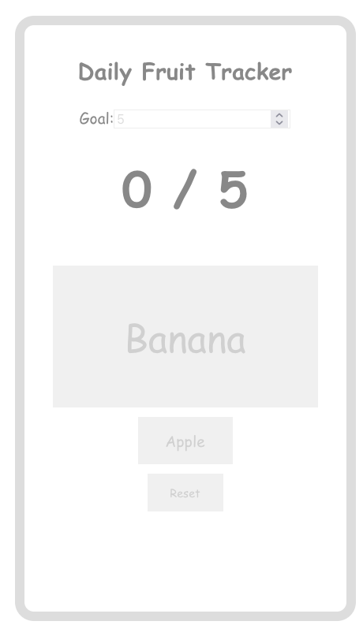

Solution #2: Monster Trainer app
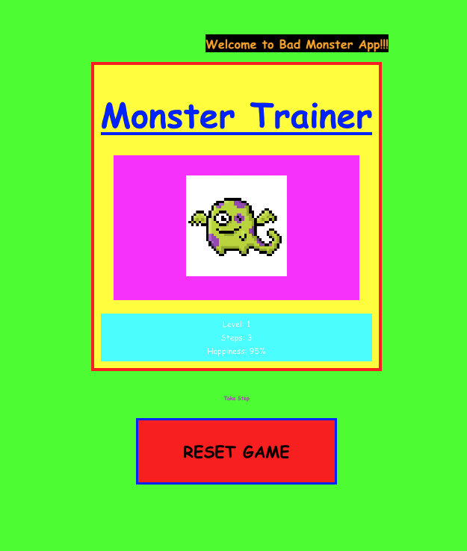

Solution #3: Doctor’s Appointment App

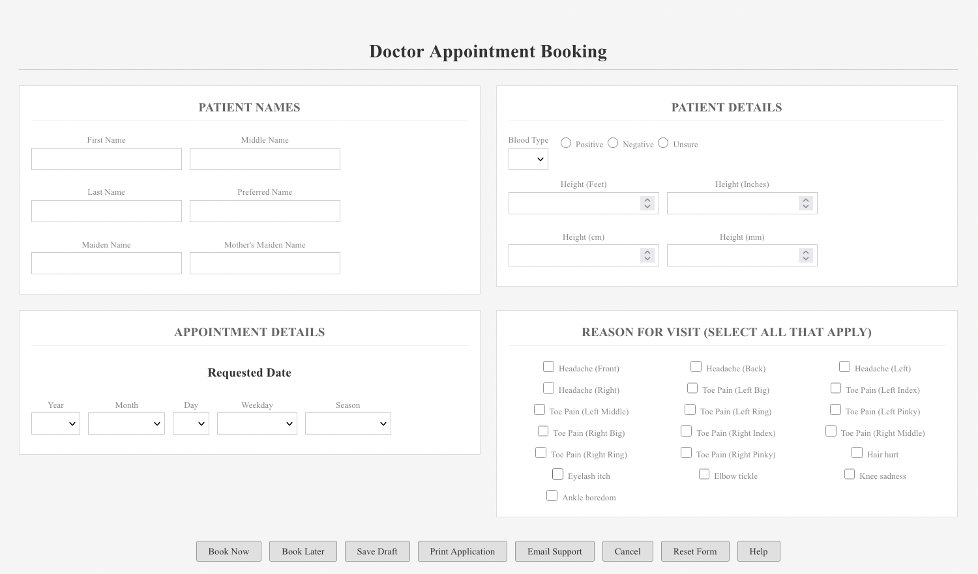

Solution #4: TV Remote for Grandparent
