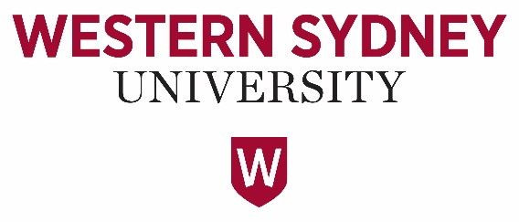

Western Sydney University Student Elections Guide
Student Representative Council (SRC)
2021

POSITIONS CONTESTED
PRESIDENT
VICE PRESIDENT UNDERGRADUATE
VICE PRESIDENT POSTGRADUATE
VICE PRESIDENT ACITVITIES
GENERAL SECRETARY
INTERNATIONAL REPRESENTATIVE
WOMENS REPRESENTATIVE
DISABILITIES REPRESENTATIVE
ETHNOCULTURAL REPRESENTATIVE
ENVIRONMENT REPRESENTATIVE
CAMPBELLTOWN REPRESENTATIVE
HAWKESBURY REPRESENTATIVE
PARRAMATTA SOUTH REPRESENTATIVE
PARRAMATTA CITY REPRESENTATIVE
PENRITH REPRESENTATIVE

BALLOT: PRESIDENT
ELIGIBLE CANDIDATES LISTED ON THIS PAGE HAVE NOT SUPPLIED A CANDIDATE IMAGE OR CANDIDATE STATEMENT

Zohra ADBEL-FATTAH,
Mary HINCHCLIFFE and
Ashley FLOCKHART
BALLOT: PRESIDENT
ABBAS, Muhammad
[ NO IMAGE AVAILABLE ]
19968663
Muhammad ABBAS
My name is Muhammad Nouman. I am an International student who started the university with Master’s degree in Electrical Engineering in Feb 2020.
The question is always raised about the trust and the capability of new students becoming the member of Student Council and today I want to prove them wrong with my beliefs, my power, and my faith in achieving the highest mark.
I believe the role of president require a different set of minds and the responsibilities to maintain a balance is very essential. I also believe that my prior experience working in the university and the SRC in various different roles would be a positive point to work for the betterment of the council and to make it the most successful era of the time.
BALLOT: PRESIDENT
ARMSTRONG-MENSAH, Rosina
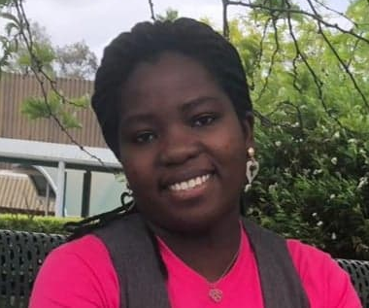
18581498
Rosina Armstrong- Mensah
My name is Rosina Armstrong-Mensah doing my master’s in international criminology. I have built up my engagement and connection with the Western Sydney University in different ways such being part of the student leadership and other university community engagement. Believing in my capability I am willing to represent students for their voice to be heard and action taken within the university as well as external duties. Therefore, I have nominated myself to take on the President position to support students throughout their studies and networking.
BALLOT: PRESIDENT
BEKKER, Frederick
[NO IMAGE AVAILBALE]
19367402
Hi there! My name is Frederick W. Bekker and I am keen to be your next elected representative. We all know that although WSU is a great Uni, there are a lot of things that we can improve upon. We are coming together in 2021 to bring you a new and revamped platform which we are hoping will benefit every student. Having a student advisory group on academic school boards, free university supplies such as notebooks and pens for all students because finances should be no barrier to education, and large social events with other universities for increased social collaboration, are just some of the ideas that we want to bring to you this year. This 2021, make sure you vote dream team - not for us – but for your university experience.

BALLOT: PRESIDENT
CHESTERS, Cameron

19836052
Cameron Chesters
My name is Cameron Chesters and I’m seeking to join the Student Representative Council!
I’m currently the founder and president of The WSU Fun Club and an executive for the WSU Law Society.
I’m very committed to making uni fun for every single student.
With me elected you can be sure any university social event you could dream of will be fought for by me.
If there is anything that has ever annoyed you about uni, I will also be very excited to fight for a solution.
Thank you for trusting me to be a part of the SRC!

BALLOT: PRESIDENT
CUPITT, Sarah

19760041
Sarah Cupitt
Hi! I'm Sarah Cupitt, an ambitious 3rd-year student studying a Bachelor of Communication (Journalism & PR), playing a vital role in student advocacy relating to university-wide issues, working on programs and services that offer a range of student opportunities. I want to continue representing student's rights and interests at WSU alongside my team, Strength & Integrity. I'm a creative young leader and have held various student positions such as; Director of Student Publications, SRC Vice-President, Multimedia Editor, SRC Online Rep, and NUS delegate since 2019. I founded WSU's first writing community Modern Ink, and am an exec of 7 other clubs and a recipient of various leadership awards from WSU and the local community. This year, my goal is to connect students in shaping the systems that affect their learning experiences. To ensure equity for students, transparency for SSAF, ongoing policy change, and more club funding!
BALLOT: PRESIDENT
FERRER, Natasha

19795371
Natasha Ferrer
As the founder and current president of the Nursing and Midwifery Student’s Society (NaMSS), I have cultivated a passion for student advocation and creation of student platforms. As the President of SRC, I plan to focus on social, academic and advocation domains for students. Students deserve to have a platform where our voice can be listened to. Creation of student advisory groups for all academic schools will be promoted and advocated for. I also plan to create relationships between student bodies and academic staff. Mental health advocation will also be focused on. Encouragement of student-based course specific societies will be done as well as educational social media platforms that encourage collaboration, information distribution and community. As a student in her final months of university, I strive to make a positive change that future student generations will benefit from. Vote for me and the dream team!

BALLOT: PRESIDENT

HADER, Alannah
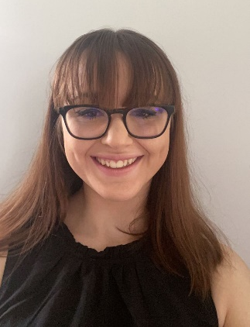
20379865
Alannah Hader
I, Alannah Hader am nominating myself to run for the President position in WSU Young Labor club I am a dedicated and passionate young woman who believes strongly in equality and equity, seeking to make a difference in the community around me. Currently, I am studying a Bachelor of Psychology (honours), where I envision myself one day to be able to enable a higher quality of life for those who seek my assistance, while being a voice for those who are in need of help that they may not be able to reach due to limitations causing an increase in need for mental health aid. Vote jumpstart.

BALLOT: PRESIDENT

KAPOOR, Anushka

19925527
Anushka Kapoor
I am very diligent and highly motivated student. I have always been inquisitive and involved in student body affairs. This unique opportunity at Student Representative Council (SRC) will give me a platform to officially make a different for everyone in the University. This role brings many perspectives with it; like helping students voice out their opinions and making sure they are heard by the right crowd, bridging the gap between faculties and students to help each other understand the worth of knowledge and experience. I have been closely looking at our association level work and there is need for a change for a better student experience and voice out the issues as well.
I am a Media and Communications Officer at Council of Australian Postgraduate Association (CAPA) since 2019 and experienced in managing the situations of international students.

BALLOT: PRESIDENT

MANOS, Maria

Maria Manos
20176974
I would be honoured to be responsible for representing and promoting the interests of students to the University and the wider community. My diligence, motivation and passion for leadership has been reflected in my active involvement during my school years until the present day (including, SRC, Social Justice Leader, Director/Founder of Justice in Action (newly founded non-profit), speaker at many conferences, consistent volunteering, church youth leader, Student of the Year (consecutively) and many more. I currently hold positions of Liverpool Student Representative & President of Strong Sisters Assemble (SSA) at WSU.
I am eager to implement change in the world in which we are immersed in at the present, but also to leave a significant impact and contribution for the future generations through carefully planned SRC meetings. I would like to encourage all students within the SRC and beyond, to work collaboratively in unity and to respect each other.

BALLOT: PRESIDENT

MATIC, Nikodin
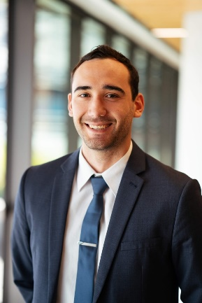
17236007
Nikodin MATIC
After playing sports at a national level, I returned to University to continue my Bachelor of Business/ Bachelor of Laws and have been heavily involved in all aspects of University including academically, sport and student clubs.

Last year, I ran on the promise to help our Student Clubs and increase the quality and variety of activities available. As the SRC Vice President – Activities, I have made SSAF bids for an eSports Lounge and an upgrade to the multi-purpose courts at Kingswood. I have made $10,000 of funding available to our Student Clubs to help them host better events. I organised the $1000 Kahoot with over 13 clubs and oversaw the purchase of several items to boost student engagement and make events and their University life more enjoyable.

BALLOT: PRESIDENT

PARKAR, Rameez
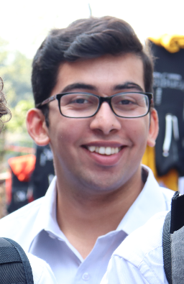
19290573
Rameez Parkar
Hi I’m Rameez. I never thought I would ever run for the Western SRC but I don’t think I could sit by quietly any longer. That’s why I put my hand up to be a representative. For too long now the students of Western Sydney University have had their interests ignored. Like many students, my “uni life” consists of coming to class and going home because there is not enough to do on campus. That is why I started a student club and that’s why I’ve run for the SRC. I think that so much can be done to serve the interests of students and that is what I have been doing over the last year as a representative. There has never been a more important time for strong progressive, principled and pragmatic students representatives fighting for us! Let’s make WSU even better! Vote [1] Rameez Parkar and JUMPSTART!

BALLOT: PRESIDENT

PREUSS-KEARNEY, Simon

18638811
Simon Preuss-Kearney
Being the president is about taking responsibility in leadership for the SRC and for ourselves.
To achieve this a President must be a voice for all students across every campus. In this position of SRC President, it is my commitment to lead for every student by being that advocator, listening to all campus voices and working with their representatives.
My goals to achieve this start with:
• Advocating for live graduations and getting the ‘live-education’ option we deserve.
• Promoting events on campus,
• Improved support for disability,
• Paid student opportunities,
• A more sensible club funding system and,
• Being friendly and approachable (with a joke always ready) - across all campuses.
These goals are not tokenistic, as too often similar statements are. I have proven this during my 2020 Kingswood SRC role. Rather, these are only the start.
Vote for a president with strength and integrity, as leadership and action start with us!

BALLOT: PRESIDENT

WEEKS, Sean

20143028
Sean WEEKS
The role of the president of the Student Representative Council is of a great degree of importance in which they reside in a position with great potential to lead enactments of greater degrees of good and to best represent the best interests and forces for good throughout the university, especially paying close tribute to the wider student body, as represented through the greater body of students’ voices symbolised through the other representatives within the SRC. The great degree of personal importance to myself is to enact positive and inclusive change that is thorough, continuous and conclusive in ensuring that all students’ voices can be properly voiced and to establish a network, with primary regard to the SRC, in which problems, solutions, ideas, and advancement opportunities can be voiced and enacted for the greater good. Continuing, the assurance that the educational, social, and cultural inclusivity and advancing opportunities can be.

BALLOT: VICE-PRESIDENT (UNDERGRADUATE)
ELIGIBLE CANDIDATES LISTED ON THIS PAGE HAVE NOT SUPPLIED A CANDIDATE IMAGE OR CANDIDATE STATEMENT

Brenda TRAN,
Emmanuel WAHAJ,
Zohra ADBEL-FATTAH,
Mary HINCHCLIFFE and
Ashley FLOCKHART
BALLOT: VICE-PRESIDENT (UNDERGRADUATE)
AAKANKSHA, Aakanksha
NO IMAGE AVAILABLE

20436979
Aakanksha AAKANKSHA
I, Aakanksha from India, am an undergraduate enrolled in Bachelors of Business and am competing for the post of Vice President (undergraduate). I deem myself the best fit for this position because I have all the qualities like good leadership, visionary thinking and the decisiveness that one may need to uphold the dignity of this post. Being an international student myself, I can be very perceptive of the ordeals faced by both the natives as well as international students. I also have experience in leading and managing student development and welfare activities. I would be grateful if I’m given this opportunity so that I can establish an environment where the students can learn and grow.

BALLOT: VICE-PRESIDENT (UNDERGRADUATE)
BAKER, Leahanne

19691116
Leahanne BAKER
Hi Everyone! My name is Leahanne Baker and, this is why you should vote for me for SRC Vice President (Undergraduate). I will make a great candidate for this position as I have experience in leadership and teamwork. In 2019 I was in the SRC at Western Sydney University as Campus Representative for Nirimba. This opportunity was a wonderful and life-changing experience. While as Nirimba Campus representatives, we were able to fund some great activities, programs, food and fun day events and opportunities and were able to fix some campus property for the students. I can provide, support, and help more students and make sure students are being listened to for what they want and what they need! When you vote for me, you will see change, growth, and development for all students. VOTE FOR LEAHANNE BAKER No.#1
BALLOT: VICE-PRESIDENT (UNDERGRADUATE)
CHAN, Daphne
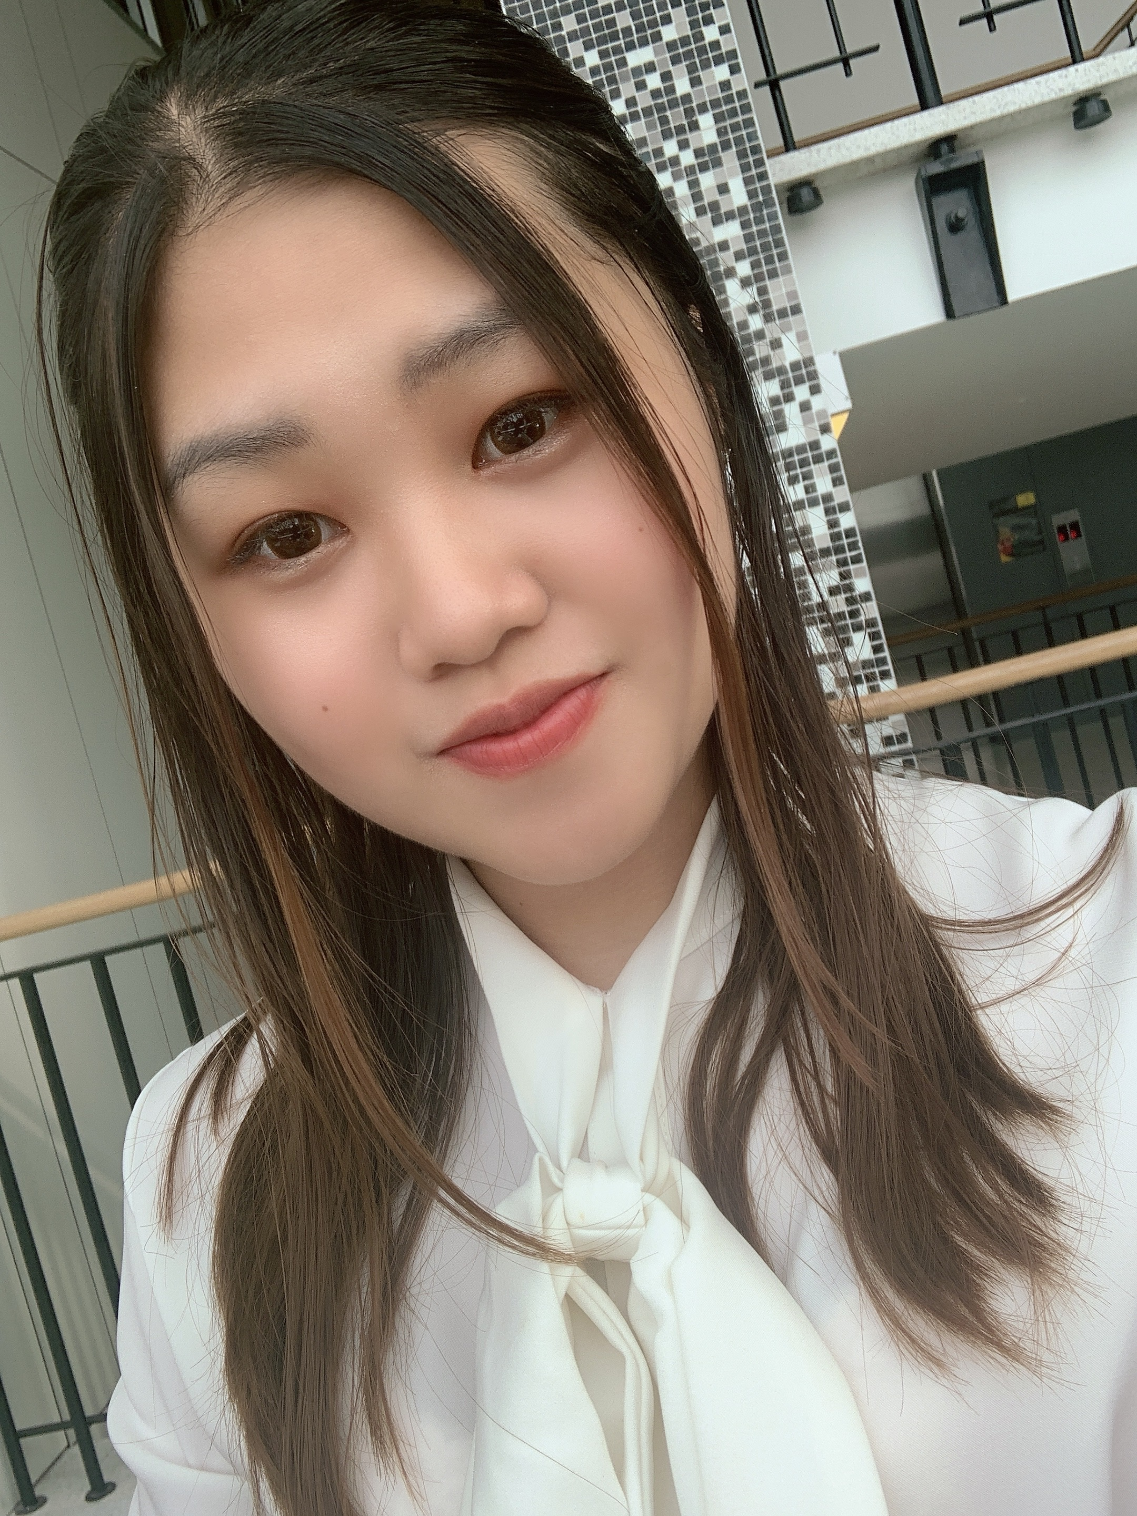
19423627
Daphne CHAN

Hi, it’s Daphne! I’m studying for a double degree in Bachelor of Law/ Bachelor of Business in my third year. It was a remarkable opportunity for me to gain positive values and experiences in UWS community. I would love to utilize what I have learnt and maybe I could benefit my peers and help people.
I consider myself to have a strong sense of responsibility, a pleasing personality and trustworthy. I also have a multicultural background: Hong Kong and Australia, which allows me to understand cultural differences and have excellent cultural intelligence.
A few thoughts:
1. Not all lectures room have charging pods
2. Create UWS reusable coffee cup and offer discount
3. Parking capacity problem
4. Kitchen facility
And I promise I will actively collect student’s opinions.
150 words are not enough to express myself. I wish you could allow me an opportunity to contribute to our uni. Thanks!
BALLOT: VICE-PRESIDENT (UNDERGRADUATE)
CHESTERS, Cameron

19836052
Cameron CHESTERS

My name is Cameron Chesters and I’m seeking to join the Student Representative Council!
I’m currently the founder and president of The WSU Fun Club and an executive for the WSU Law Society.
I’m very committed to making uni fun for every single student.
With me elected you can be sure any university social event you could dream of will be fought for by me.
If there is anything that has ever annoyed you about uni, I will also be very excited to fight for a solution.
Thank you for trusting me to be a part of the SRC!
BALLOT: VICE-PRESIDENT (UNDERGRADUATE)
CUPITT Sarah

19760041
Sarah CUPITT
Hi! I'm Sarah Cupitt, an ambitious 3rd-year student studying a Bachelor of Communication (Journalism & PR), playing a vital role in student advocacy relating to university-wide issues, working on programs and services that offer a range of student opportunities. I want to continue representing student's rights and interests at WSU alongside my team, Strength & Integrity. I'm a creative young leader and have held various student positions such as; Director of Student Publications, SRC Vice-President, Multimedia Editor, SRC Online Rep, and NUS delegate since 2019. I founded WSU's first writing community Modern Ink, and am an exec of 7 other clubs and a recipient of various leadership awards from WSU and the local community. This year, my goal is to connect students in shaping the systems that affect their learning experiences. To ensure equity for students, transparency for SSAF, ongoing policy change, and more club funding, please vote for me!

BALLOT: VICE-PRESIDENT (UNDERGRADUATE)
ESPINAS, Jonathan
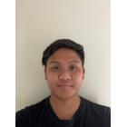
19346029
ESPINAS Jonathan
I, Jonathan Espinas, a third year nursing student, would like to run for Student Representative Council.
The position I would like to run for is Vice President (Undergraduate), otherwise I am happy to run for any other positions. I have been participated in many activities across all campuses including social sports games, Pizza night at Campelltown Campus and I also am currently a Secretary for the student club WSU Nursing & Midwifery Student Society (NaMSS).
Some things you might want to know about me, I love trying new things, exploring anything that is possible and always like a challenge. Throughout my life I participated in a range of activities including learning musical instruments (i.e. guitar, piano), dance (participated in Dance Championships Both Nationally and Internationally).
But that’s enough about me. The reason why I would like to run for Student Representative Council, is I would like student’s voice other than
BALLOT: VICE-PRESIDENT (UNDERGRADUATE)
FERRER, Natasha

19795371
Natasha FERRER
As the founder and current president of the Nursing and Midwifery Student’s Society (NaMSS), I have cultivated a passion for student advocation and creation of student platforms. As the Vice-President Undergraduate, I plan to focus on student voice towards education. I believe education is powerful and pivotal for the development of inspirational and successful graduates of Western Sydney University. Students deserve to have their voice listened to. Creation of student advisory groups for all academic schools will be promoted and advocated for. I also plan to create relationships between student bodies and academic staff. Encouragement of student-based course specific societies will be done as well as educational social media platforms that encourage collaboration, information distribution and community. As a student in her final months of university, I strive to make a positive change that future student generations will benefit from. Vote for me and the dream team!
BALLOT: VICE-PRESIDENT (UNDERGRADUATE)
HADER, Alannah

20379865
Alannah HADER

I, Alannah Hader am nominating myself to run for the Undergraduate Vice President position in WSU Young Labor club I am a dedicated and passionate young woman who believes strongly in equality and equity, seeking to make a difference in the community around me. Currently, I am studying a Bachelor of Psychology (honours), where I envision myself one day to be able to enable a higher quality of life for those who seek my assistance, while being a voice for those who are in need of help that they may not be able to reach due to limitations causing an increase in need for mental health aid. Vote jumpstart.
BALLOT: VICE-PRESIDENT (UNDERGRADUATE)
MANOS, Maria
20176974 Maria MANOS
I would be honoured to be responsible for representing and promoting the interests of students to the University and the wider community. My diligence, motivation and passion for leadership has been reflected in my active involvement during my school years until the present day (including, SRC, Social Justice Leader, Director/Founder of Justice in Action (newly founded non-profit), speaker at many conferences, consistent volunteering, church youth leader, Student of the Year (consecutively) and many more. I currently hold positions of Liverpool Student Representative & President of Strong Sisters Assemble (SSA) at WSU.
I am eager to implement change in the world in which we are immersed in at the present, but also to leave a significant impact and contribution for the future generations through carefully planned SRC meetings. I would like to encourage all students within the SRC and beyond, to work collaboratively in unity, to respect each other, instil a
BALLOT: VICE-PRESIDENT (UNDERGRADUATE)
MATIC, Nikodin
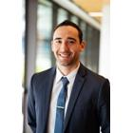
17236007
Nikodin MATIC

After playing sports at a national level, I returned to University to continue my Bachelor of Business/ Bachelor of Laws and have been heavily involved in all aspects of University including academically, sport and student clubs.

Last year, I ran on the promise to help our Student Clubs and increase the quality and variety of activities available. As the SRC Vice President – Activities, I have made SSAF bids for an eSports Lounge and an upgrade to the multi-purpose courts at Kingswood. I have made $10,000 of funding available to our Student Clubs to help them host better events. I organised the $1000 Kahoot with over 13 clubs and oversaw the purchase of several items to boost student engagement and make events and their University life more enjoyable. These include a professional outdoor laser tag set (12 units) that can fire accurately up to 200m away, 3 x racing simulators with
BALLOT: VICE-PRESIDENT (UNDERGRADUATE)
PARKAR, Rameez
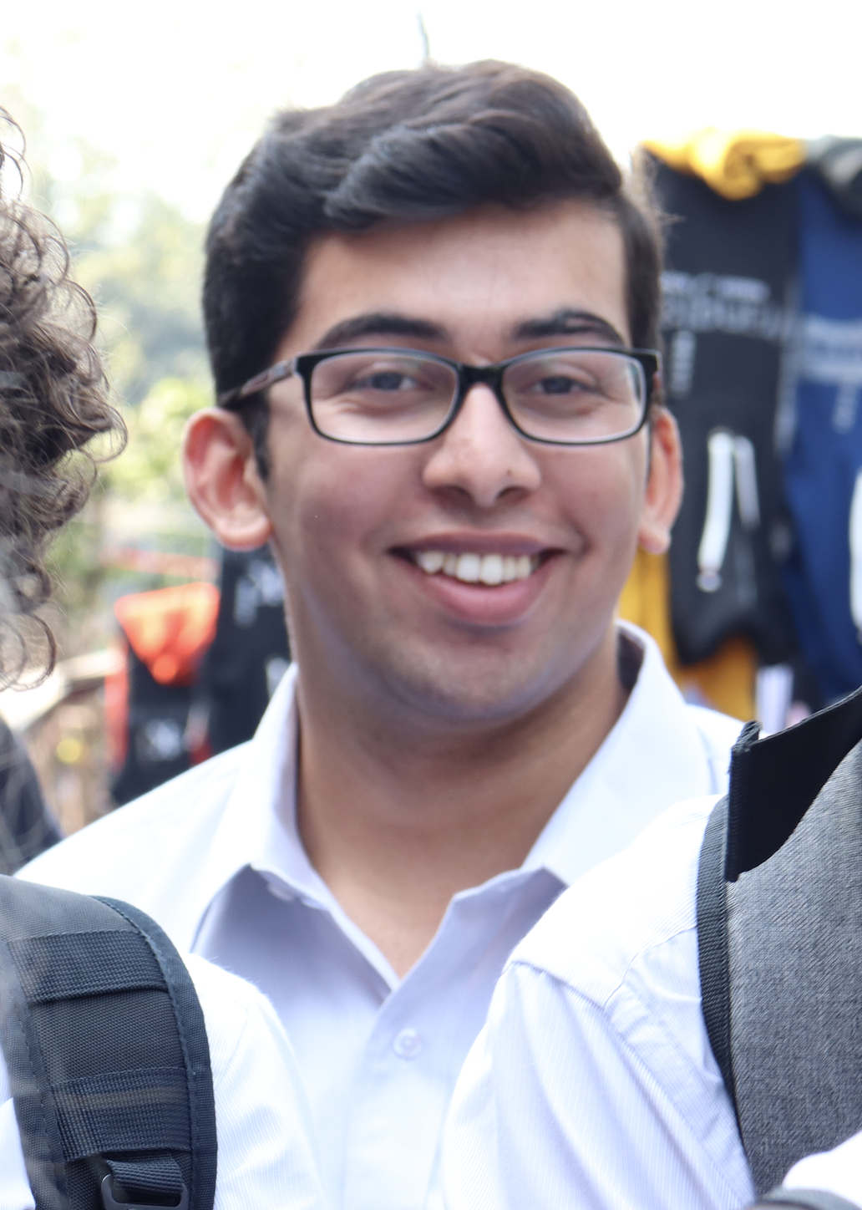
19290573
Rameez PARKAR

Hi I’m Rameez. I never thought I would ever run for the Western SRC but I don’t think I could sit by quietly any longer. That’s why I put my hand up to be a representative. For too long now the students of Western Sydney University have had their interests ignored. Like many students, my “uni life” consists of coming to class and going home because there is not enough to do on campus. That is why I started a student club and that’s why I’ve run for the SRC. I think that so much can be done to serve the interests of students and that is what I have been doing over the last year as a representative. There has never been a more important time for strong progressive, principled and pragmatic students representatives fighting for us! Let’s make WSU even better! Vote [1] Rameez Parkar and JUMPSTART!
BALLOT: VICE-PRESIDENT (UNDERGRADUATE)
SANDHU, Angad

18993064
Angad SANDHU
As a second generation Indian Australian I feel a new perspective could be given to the Academic Senate. In my perspective for these University elections to represent the university there should be more voices of colour on the table. From my understanding diversity and inclusion is the gathering of people with different backgrounds, genders, political views, and cultures. However, more than just being gathered in a workplace, they each give their opinions and thoughts in the matter at hand to come up with the best possible result. All this being done with respect and without prejudice.
BALLOT: VICE-PRESIDENT (UNDERGRADUATE)
WEEKS, Sean
20143028
Sean WEEKS
To represent my fellow peers as the vice president of the Student Representative Council poses a very important role in that all voices can be heard and communicated between potentially disadvantaged students in particular. As a result, through that position, the needs of all individuals can be best addressed to ensure proper and equal treatment, access, and advancement within and throughout the university. The betterment of facilities in addition to this, as well as creating more and better spaces especially based on necessity poses an equally significant role in this in that all students have the opportunity to better their path of education, as well as a better degree of engagement with university life as well as an important degree of inclusiveness to embrace all students within their desired aspects of university life, and bettering education access and opportunities where possible and needed. To represent students within this context is
BALLOT: VICE-PRESIDENT (POSTGRADUATE)
ABBAS, Muhammad
NO IMAGE AVAILABLE

19968663
Muhammad ABBAS
My name is Muhammad Nouman. I am an International student who started the university with Master’s degree in Electrical Engineering in Feb 2020. The question is always raised about the trust and the capability of new students becoming the member of Student Council and today I want to prove them wrong with my beliefs, my power and my faith in achieving the highest mark. Being a young graduate, I have come across many issues in different processes which I would like to make them notified under the management and one of those issues is the sustainability of the environment which we are neglecting upon. I accept the challenge and I will prove myself that the young and new talent has much more capacity, ability, energy and enthusiasm to compete to raise awareness among our people to have a healthy and sustainable environment.
BALLOT: VICE-PRESIDENT (POSTGRADUATE)
ARMSTRONG-MENSAH, Rosina
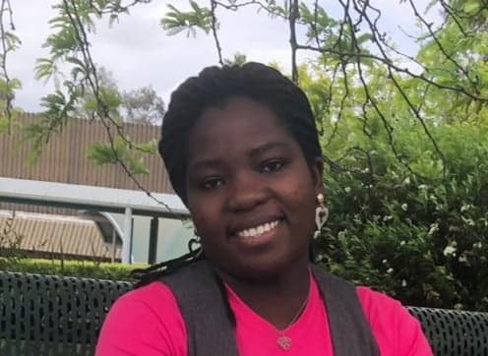
18581498
Rosina ARMSTRONG MENSAH

My name is Rosina Armstrong-Mensah doing my master’s in international criminology. I have built up my engagement and connection with the Western Sydney University in different ways such being part of the student leadership and other university community engagement. Believing in my capability I am willing to represent students for their voice to be heard and action taken. Therefore, I have nominated myself to take on the Vice-President Postgraduate position to support students throughout their studies and networking.
Thank you.
BALLOT: VICE-PRESIDENT (POSTGRADUATE)
BONATTI, Daniel

19257310
Daniel BONATTI

I Daniel Bonatti the current SRC Vice President Postgraduate Education wish to renominate for the position. Please vote for me for my reliability and experience in University Affairs. I am enrolled in a Master in Building Surveying doing my Research Project-B, Bachelor of Con.Mgmt.(Hons.) major Building-surveying and sub-major Sustainability and the Academy BALCT. I have achieved for WSU:
• Academy Citizen Scholar Award
• The Golden Key International Honours Society Award
• LinkedLn student Champion participant
I am involved in student affairs, want quality in education and learning, and a fair go, my experience : Executive, Remuneration, Student Leaders SRC Clubs & Activities, Budget, Student COVID-19 Taskforce, Equity Collectives, SSAF, Communication Strategy. CISA Council International Student Association, CAPA Council of Australian Postgraduate Associations, TEQSA Tertiary Education Quality Standards Agency delegate, National Union of Students (NUS), SAC - School Academic Committee, STEM & HASS - Cluster Boards and Clubs -President Golden-Key, EWB & CAPS(acting).
BALLOT: VICE-PRESIDENT (POSTGRADUATE)
KAPOOR, Anushka

19925527
Anushka KAPOOR

I would like to express my interest for the position of Vice President-postgraduate.
This unique opportunity at Student Representative Council (SRC) will give me a platform to officially make a different for everyone in the University. This role brings many perspectives with it; like helping students voice out their opinions and making sure they are heard by the right crowd, bridging the gap between faculties and students to help each other understand the worth of knowledge and experience. I am a Media and Communications Officer at Council of Australian Postgraduate Association (CAPA) since 2019. I have been managing the entire media scale, working closely with senior members, creating contents, creating I strategic plans for student by use of various media platforms etc. I am certain to be dedicated towards working for student’s interest & use this opportunity to collaborate SRC with CAPA and other affiliates.
BALLOT: VICE-PRESIDENT (ACTIVITIES)
ELIGIBLE CANDIDATES LISTED ON THIS PAGE HAVE NOT SUPPLIED A CANDIDATE IMAGE OR CANDIDATE STATEMENT

Muhammad SAIFUDDIN,
Tiffany SHARPE and
Aakanksha AAKANKSHA
BALLOT: VICE-PRESIDENT (ACTIVITIES)
ABBAS, Muhammad
NO IMAGE AVAILABLE

19968663
Muhammad ABBAS
My name is Muhammad Nouman. I am an International student who started the university with Master’s degree in Electrical Engineering in Feb 2020. The question is always raised about the trust and the capability of new students becoming the member of Student Council and today I want to prove them wrong with my beliefs, my power and my faith in achieving the highest mark. Being a young graduate, I have come across many issues in different processes which I would like to make them notified under the management and one of those issues is the sustainability of the environment which we are neglecting upon. I accept the challenge and I will prove myself that the young and new talent has much more capacity, ability, energy and enthusiasm to compete to raise awareness among our people to have a healthy and sustainable environment.
BALLOT: VICE-PRESIDENT (ACTIVITIES)
CHAN, Daphne
19423627 Daphne CHAN

Hi, it’s Daphne! I’m studying for a double degree in Bachelor of Law/ Bachelor of Business in my third year. It was a remarkable opportunity for me to gain positive values and experiences in UWS community. I would love to utilize what I have learnt and maybe I could benefit my peers and help people.
I consider myself to have a strong sense of responsibility, a pleasing personality and trustworthy. I also have a multicultural background: Hong Kong and Australia, which allows me to understand cultural differences and have excellent cultural intelligence.
A few thoughts:
1. Not all lectures room have charging pods
2. Create UWS reusable coffee cup and offer discount
3. Parking capacity problem
4. Kitchen facility
And I promise I will actively collect student’s opinions.
150 words are not enough to express myself. I wish you could allow me an opportunity to contribute to our uni. Thanks!
BALLOT: VICE-PRESIDENT (ACTIVITIES)
CHESTERS, Cameron
19836052
Cameron CHESTERS

My name is Cameron Chesters and I’m seeking to join the Student Representative Council!
I’m currently the founder and president of The WSU Fun Club and an executive for the WSU Law Society.
I’m very committed to making uni fun for every single student.
With me elected you can be sure any university social event you could dream of will be fought for by me.
If there is anything that has ever annoyed you about uni, I will also be very excited to fight for a solution.
Thank you for trusting me to be a part of the SRC!
BALLOT: VICE-PRESIDENT (ACTIVITIES)
CUPITT, Sarah
19760041
Sarah CUPITT
Hi! I'm Sarah Cupitt, an ambitious 3rd-year student studying a Bachelor of Communication (Journalism & PR), playing a vital role in student advocacy relating to university-wide issues, working on programs and services that offer a range of student opportunities. I want to continue representing student's rights and interests at WSU alongside my team, Strength & Integrity. I'm a creative young leader and have held various student positions such as; Director of Student Publications, SRC Vice-President, Multimedia Editor, SRC Online Rep, and NUS delegate since 2019. I founded WSU's first writing community Modern Ink, and am an exec of 7 other clubs and a recipient of various leadership awards from WSU and the local community. This year, my goal is to connect students in shaping the systems that affect their learning experiences. To ensure equity for students, transparency for SSAF, ongoing policy change, and more club funding, please vote for me!
BALLOT: VICE-PRESIDENT (ACTIVITIES)
HADER, Alannah
20379865
Alannah HADER

I, Alannah Hader am nominating myself to run for the Vice President of Activities position in WSU Young Labor club I am a dedicated and passionate young woman who believes strongly in equality and equity, seeking to make a difference in the community around me. Currently, I am studying a Bachelor of Psychology (honours), where I envision myself one day to be able to enable a higher quality of life for those who seek my assistance, while being a voice for those who are in need of help that they may not be able to reach due to limitations causing an increase in need for mental health aid. Vote jumpstart.
BALLOT: VICE-PRESIDENT (ACTIVITIES)
MATIC, Nikodin
17236007
Nikodin MATIC

After playing sports at a national level, I returned to University to continue my Bachelor of Business/ Bachelor of Laws and have been heavily involved in all aspects of University including academically, sport and student clubs.

Last year, I ran on the promise to help our Student Clubs and increase the quality and variety of activities available. As the SRC Vice President – Activities, I have made SSAF bids for an eSports Lounge and an upgrade to the multi-purpose courts at Kingswood. I have made $10,000 of funding available to our Student Clubs to help them host better events. I organised the $1000 Kahoot with over 13 clubs and oversaw the purchase of several items to boost student engagement and make events and their University life more enjoyable. These include a professional outdoor laser tag set (12 units) that can fire accurately up to 200m away, 3 x racing simulators with
BALLOT: VICE-PRESIDENT (ACTIVITIES)
RAM, Crystal

18702590 Crystal RAM
I'm a candidate at our student elections, and a CURRENT member of the SRC; I want to continue to JUMP START WSU. Currently on the executive of Student Clubs, I want to put my leadership experience to work for all of WSU.
This election is very important because our voice will be listened to. This will happen unless you do not vote. And other students’ ideas and thoughts will be heard. I’m the right person to do this job. In the first place, I’m a very responsible person and I love speaking before an audience. Second, if you vote for me, I will speak out for your complaints and problems that I’m sure you have on campus.
I have a plan for a series of fundraising events where all clubs and societies support one another and bring in new contributions.

Remember CRYSTAL and JUMPSTART when you vote.

BALLOT: VICE-PRESIDENT (ACTIVITIES)

SANDHU, Angad

19601045
Munayet SALIFU
NO STATEMENT AVAILABLE

BALLOT: VICE-PRESIDENT (ACTIVITIES)

WEEKS, Sean
20143028
Sean WEEKS
The role of Vice President (Activities) is a significant role that would hold personal significance should I undertake the role. The purpose and representation that this role undertakes is impacting the student body and can increase morale, create a better degree of engagement, and further ensure inclusiveness of student groups within campus life at university. The organisation of activities and events poses a credible behind-the-scene environment in which students can widen and network with peers and staff from the university, in which a more significant campus life can be established and appeal to all students. This role would hold a personal degree of significance in that fairness, inclusiveness, and diversity can be promoted through organised activities, appealing to varied cultures and identities to diversify the interaction of the student body with various cultures. This role is quite significant in encouraging all sects of the student body to openly express their
BALLOT: GENERAL SECRETARY
ELIGIBLE CANDIDATES LISTED ON THIS PAGE HAVE NOT SUPPLIED A CANDIDATE IMAGE OR CANDIDATE STATEMENT

Brenda TRAN,
Emmanuel WAHAJ and
Zohra WAHAJ
BALLOT: GENERAL SECRETARY
ARMSTRONG-MENSAH, Rosina
18581498
Rosina ARMSTRONG MENSAH

My name is Rosina Armstrong-Mensah doing my master’s in international criminology. I have built up my engagement and connection with the Western Sydney University in different ways such being part of the student leadership. This have assisted me in knowing more about students and the university. With the experience I have gained I hope to represent student for their voice to be heard and well represented. If I am elected as the general secretary, I will effectively communicate with students and all student representatives in a supporting as well as be reliable in all my involvement.
Thank you.
BALLOT: GENERAL SECRETARY
BAKER, Leahanne
19691116

Leahanne BAKER
Hi Everyone! My name is Leahanne Baker and, this is why you should vote for me for SRC General Secretary. I will make a great candidate for this position as I have experience in leadership and teamwork. In 2019 I was in the SRC at Western Sydney University as Campus Representative for Nirimba. This opportunity was a wonderful and life-changing experience. While as Nirimba Campus representatives, we were able to fund some great activities, programs, food and fun day events and opportunities and were able to fix some campus property for the students. I can provide, support, and help more students and make sure students are being listened to for what they want and what they need! When you vote for me, you will see change, growth, and development for all students. VOTE FOR LEAHANNE BAKER No.#1

BALLOT: GENERAL SECRETARY
BEKKER, Frederick
NO IMAGE AVAILABLE

19367402
Frederick BEKKER
Hi there! My name is Frederick W. Bekker and I am keen to be your next elected representative. We all know that although WSU is a great Uni, there are a lot of things that we can improve upon. We are coming together in 2021 to bring you a new and revamped platform which we are hoping will benefit every student. Having a student advisory group on academic school boards, free university supplies such as notebooks and pens for all students because finances should be no barrier to education, and large social events with other universities for increased social collaboration, are just some of the ideas that we want to bring to you this year. This 2021, make sure you vote dream team - not for us – but for your university experience.

BALLOT: GENERAL SECRETARY
CHAN, Daphne
19423627 Daphne CHAN

Hi, it’s Daphne! I’m studying for a double degree in Bachelor of Law/ Bachelor of Business in my third year. It was a remarkable opportunity for me to gain positive values and experiences in UWS community. I would love to utilize what I have learnt and maybe I could benefit my peers and help people.
I consider myself to have a strong sense of responsibility, a pleasing personality and trustworthy. I also have a multicultural background: Hong Kong and Australia, which allows me to understand cultural differences and have excellent cultural intelligence.
A few thoughts:
1. Not all lectures room have charging pods
2. Create UWS reusable coffee cup and offer discount
3. Parking capacity problem
4. Kitchen facility
And I promise I will actively collect student’s opinions.
150 words are not enough to express myself. I wish you could allow me an opportunity to contribute to our uni. Thanks!

BALLOT: GENERAL SECRETARY
CHESTERS, Cameron
19836052
Cameron CHESTERS

My name is Cameron Chesters and I’m seeking to join the Student Representative Council!
I’m currently the founder and president of The WSU Fun Club and an executive for the WSU Law Society.
I’m very committed to making uni fun for every single student.
With me elected you can be sure any university social event you could dream of will be fought for by me.
If there is anything that has ever annoyed you about uni, I will also be very excited to fight for a solution.
Thank you for trusting me to be a part of the SRC!

BALLOT: GENERAL SECRETARY
CUPITT, Sarah
19760041
Sarah CUPITT
Hi! I'm Sarah Cupitt, an ambitious 3rd-year student studying a Bachelor of Communication (Journalism & PR), playing a vital role in student advocacy relating to university-wide issues, working on programs and services that offer a range of student opportunities. I want to continue representing student's rights and interests at WSU alongside my team, Strength & Integrity. I'm a creative young leader and have held various student positions such as; Director of Student Publications, SRC Vice-President, Multimedia Editor, SRC Online Rep, and NUS delegate since 2019. I founded WSU's first writing community Modern Ink, and am an exec of 7 other clubs and a recipient of various leadership awards from WSU and the local community. This year, my goal is to connect students in shaping the systems that affect their learning experiences. To ensure equity for students, transparency for SSAF, ongoing policy change, and more club funding, please vote for me!
BALLOT: GENERAL SECRETARY
ESPINAS, Jonathan
19346029
Jonathan
I, Jonathan Espinas, a third year nursing student, would like to run for Student Representative Council.
The position I would like to run for is General Secretary, otherwise I am happy to run for any other positions. I have been participated in many activities across all campuses including social sports games, Pizza night at Campelltown Campus and I also am currently a Secretary for the student club WSU Nursing & Midwifery Student Society (NaMSS).
Some things you might want to know about me, I love trying new things, exploring anything that is possible and always like a challenge. Throughout my life I participated in a range of activities including learning musical instruments (i.e. guitar, piano), dance (participated in Dance Championships Both Nationally and Internationally).
But that’s enough about me. The reason why I would like to run for Student Representative Council, is I would like student’s voice other than my

BALLOT: GENERAL SECRETARY
FERRER, Natasha
19795371
Natasha FERRER
As the founder and current president of the Nursing and Midwifery Student’s Society (NaMSS), I have cultivated a passion for student advocation and developing a strong team. As the SRC General secretary, I plan to focus on creating a comfortable and organisaed environment for my team. I believe teamwork is powerful and pivotal for the development of inspirational and successful Student Representative members of Western Sydney University SRC. I also plan to create relationships between student bodies and academic staff outside of my role. Encouragement of student-based course specific societies will be done as well as educational social media platforms that encourage collaboration, information distribution and community. As a student in her final months of university, I strive to make a positive change that future student generations will benefit from. Vote for me and the dream team!

BALLOT: GENERAL SECRETARY
HADER, Alannah
20379865
Alannah HADER

I, Alannah Hader am nominating myself to run for the General Secretary position in WSU Young Labor club I am a dedicated and passionate young woman who believes strongly in equality and equity, seeking to make a difference in the community around me. Currently, I am studying a Bachelor of Psychology (honours), where I envision myself one day to be able to enable a higher quality of life for those who seek my assistance, while being a voice for those who are in need of help that they may not be able to reach due to limitations causing an increase in need for mental health aid. Vote jumpstart.

BALLOT: GENERAL SECRETARY
MANOS, Maria
20176974

Maria MANOS
I would be honoured to be responsible for representing and promoting the interests of students to the University and the wider community. My diligence, motivation and passion for leadership has been reflected in my active involvement during my school years until the present day (including, SRC, Social Justice Leader, Director/Founder of Justice in Action (newly founded non-profit), speaker at many conferences, consistent volunteering, church youth leader, Student of the Year (consecutively) and many more. I currently hold positions of Liverpool Student Representative & President of Strong Sisters Assemble (SSA) at WSU.
I am eager to implement change in the world in which we are immersed in at the present, but also to leave a significant impact and contribution for the future generations through carefully planned SRC meetings. I would like to encourage all students within the SRC and beyond, to work collaboratively in unity, to respect each other, instil a
BALLOT: GENERAL SECRETARY
MATIC, Nikodin
17236007
Nikodin MATIC

After playing sports at a national level, I returned to University to continue my Bachelor of Business/ Bachelor of Laws and have been heavily involved in all aspects of University including academically, sport and student clubs.

Last year, I ran on the promise to help our Student Clubs and increase the quality and variety of activities available. As the SRC Vice President – Activities, I have made SSAF bids for an eSports Lounge and an upgrade to the multi-purpose courts at Kingswood. I have made $10,000 of funding available to our Student Clubs to help them host better events. I organised the $1000 Kahoot with over 13 clubs and oversaw the purchase of several items to boost student engagement and make events and their University life more enjoyable. These include a professional outdoor laser tag set (12 units) that can fire accurately up to 200m away, 3 x racing simulators with
BALLOT: GENERAL SECRETARY
PARKAR, Rameez
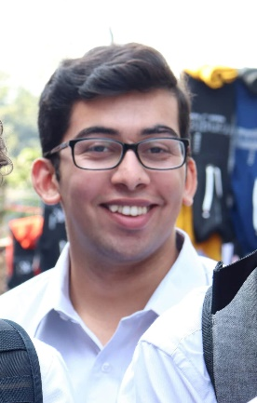
19290573
Rameez PARKAR

Hi I’m Rameez. I never thought I would ever run for the Western SRC but I don’t think I could sit by quietly any longer. That’s why I put my hand up to be a representative. For too long now the students of Western Sydney University have had their interests ignored. Like many students, my “uni life” consists of coming to class and going home because there is not enough to do on campus. That is why I started a student club and that’s why I’ve run for the SRC. I think that so much can be done to serve the interests of students and that is what I have been doing over the last year as a representative. There has never been a more important time for strong progressive, principled and pragmatic students representatives fighting for us! Let’s make WSU even better! Vote [1] Rameez Parkar and JUMPSTART!
BALLOT: GENERAL SECRETARY
REED, Robert

17277873
Robert REED
My name is Robert Reed and I am an undergraduate student studying Podiatric Medicine.
The role of General Secretary is not a position to be taken for granted. It may not have the “glamour” of other positions but is vital to the functioning of any representative body. It is a role that must be free of bias, prejudice and intimidation. Functionality is the key role of the General Secretary. Simple procedure such as note and minute taking within 48 hours of a meeting, not delaying then having to rely on memory on what may or may not have been said or achieved. Allowing members adequate time to prepare for meetings by indicating the nature and content of the upcoming meetings and events whilst maintaining overall transparency with no hidden or covert agenda.
I believe I have the perseverance and integrity to lead students via this role in 2021.
BALLOT: GENERAL SECRETARY
SANDHU, Angad
18993064
Angad SANDHU
As a second generation Indian Australian I feel a new perspective could be given to the Academic Senate. In my perspective for these University elections to represent the university there should be more voices of colour on the table. From my understanding diversity and inclusion is the gathering of people with different backgrounds, genders, political views, and cultures. However, more than just being gathered in a workplace, they each give their opinions and thoughts in the matter at hand to come up with the best possible result. All this being done with respect and without prejudice.
BALLOT: GENERAL SECRETARY
WEEKS, Sean
20143028
Sean WEEKS
This position plays a critical and important role within the SRC and the lives of students in that they can have a network that is effective in communicating and proposing appropriate action and solutions in that these issues are either lessened or solved, and the opportunities, access, and inclusion of all components of the student body comprised within the SRC and that these can be interrelated to the relevant components of the SRC and wider university. This role is an important cog in the machine that drives positive change for the betterment of opportunity, access, and livelihoods of all students, especially those that are disadvantaged and are in need. The SRC as a body organisation drives important change and betterment of student livelihoods in diverse fields of importance with especial coexistence with university leadership and similar bodies of leadership and importance. This role holds personal importance in that I would
BALLOT: CAMPBELLTOWN CAMPUS REPRESENTATIVE
BAKER Leahanne
19691116
Leahanne Baker
Hi Everyone! My name is Leahanne Baker and, this is why you should vote for me for SRC Campbelltown Campus Representative. I will make a great candidate for this position as I have experience in leadership and teamwork. In 2019 I was in the SRC at Western Sydney University as Campus Representative for Nirimba. This opportunity was a wonderful and life-changing experience. While as Nirimba Campus representatives, we were able to fund some great activities, programs, food and fun day events, and opportunities for the students. I can provide, support, and help more students and make sure students are being listened to for what they want and what they need! When you vote for me, you will see change, growth, and development for all students. VOTE FOR LEAHANNE BAKER No.#1

BALLOT: CAMPBELLTOWN CAMPUS REPRESENTATIVE
REED, Robert
17277873
Robert REED
My name is Robert Reed and I have been a student at Western since 2011 studying Podiatric Medicine. Additionally, I have been a representative of the Disability Collective for the past four years. During this time, I have learnt about the urgency and need for advocacy and for the rights of students from a policy level.
Campbelltown needs a representative who will actively listen to the concerns of students, bring a voice to the representative level and allow for sustained positive change. Previously, this representation has been sorely lacking in both University events and decision making. If elected I will be a representative who will not take credit for the work of others but work collaboratively with students and representatives to bring about the much-¬‐ needed change for the campus environment by not shying away from the responsibility.
I believe I have the perseverance and integrity to lead students in 2021.

BALLOT: HAWKESBURY CAMPUS REPRESENTATIVE

ELIGIBLE CANDIDATES LISTED ON THIS PAGE HAVE NOT SUPPLIED A CANDIDATE IMAGE OR CANDIDATE STATEMENT

Inayat, Inayat
BALLOT: HAWKESBURY CAMPUS REPRESENTATIVE
ESPINAS, Jonathan

19346029
Jonathan ESPINAS
The position I would like to run for is Hawkesbury Campus President, otherwise I am happy to run for any other positions. I have been participated in many activities across all campuses including social sports games, Pizza night at Campelltown Campus and I also am currently a Secretary for the student club WSU Nursing & Midwifery Student Society (NaMSS).
Some things you might want to know about me, I love trying new things, exploring anything that is possible and always like a challenge. Throughout my life I participated in a range of activities including learning musical instruments (i.e. guitar, piano), dance (participated in Dance Championships Both Nationally and Internationally).
But that’s enough about me. The reason why I would like to run for Student Representative Council, is I would like student’s voice other than my own to be heard, and I hope I can achieve this. Throughout my time at

BALLOT: PARRAMATTA CITY CAMPUS REPRESENTATIVE
ELIGIBLE CANDIDATES LISTED ON THIS PAGE HAVE NOT SUPPLIED A CANDIDATE IMAGE OR CANDIDATE STATEMENT

Emmanuel WAHAJ
BALLOT: PARRAMATTA CITY CAMPUS REPRESENTATIVE
ABBAS, Muhammad
NO IMAGE AVAILABLE

19968663
Muhammad ABBAS
My name is Muhammad Nouman. I am an International student who started the university with Master’s degree in Electrical Engineering in Feb 2020. The question is always raised about the trust and the capability of new students becoming the member of Student Council and today I want to prove them wrong with my beliefs, my power and my faith in achieving the highest mark. Being a young graduate, I have come across many issues in different processes which I would like to make them notified under the management . I accept the challenge and I will prove myself that the young and new talent has much more capacity, ability, energy and enthusiasm to compete to raise awareness among our people to have a healthy and sustainable environment.
BALLOT: PARRAMATTA SOUTH CAMPUS REPRESENTATIVE
ELIGIBLE CANDIDATES LISTED ON THIS PAGE HAVE NOT SUPPLIED A CANDIDATE IMAGE OR CANDIDATE STATEMENT

Brenda CHAN,
Cheyanne LYNCH and
Ashley FLOCKHART
BALLOT: PARRAMATTA SOUTH CAMPUS REPRESENTATIVE
ARMSTRONG-MENSAH, Rosina
18581498
Rosina ARMSTRONG MENSAH

My name is Rosina Armstrong-Mensah doing my master’s in international criminology. I have built up my engagement and connection with the Western Sydney University in different ways such being part of the student leadership. This have assisted me in knowing more about students and the university. With the experience I have gained I hope to represent Parramatta south campus for their voice to be heard and well represented. I believe when am given the chance I will do my very best to engage and lift the spirit of the campus.
Thank you.
BALLOT: PARRAMATTA SOUTH CAMPUS REPRESENTATIVE
CHAN, Daphne
19423627 Daphne CHAN

Hi, it’s Daphne! I’m studying for a double degree in Bachelor of Law/ Bachelor of Business in my third year. It was a remarkable opportunity for me to gain positive values and experiences in UWS community. I would love to utilize what I have learnt and maybe I could benefit my peers and help people.
I consider myself to have a strong sense of responsibility, a pleasing personality and trustworthy. I also have a multicultural background: Hong Kong and Australia, which allows me to understand cultural differences and have excellent cultural intelligence.
A few thoughts:
1. Not all lectures room have charging pods
2. Create UWS reusable coffee cup and offer discount
3. Parking capacity problem
4. Kitchen facility
And I promise I will actively collect student’s opinions.
150 words are not enough to express myself. I wish you could allow me an opportunity to contribute to our uni. Thanks!

BALLOT: PARRAMATTA SOUTH CAMPUS REPRESENTATIVE
CHESTERS, Cameron
19836052
Cameron CHESTERS

My name is Cameron Chesters and I’m seeking to join the Student Representative Council!
I’m currently the founder and president of The WSU Fun Club and an executive for the WSU Law Society.
I’m very committed to making uni fun for every single student.
With me elected you can be sure any university social event you could dream of will be fought for by me.
If there is anything that has ever annoyed you about uni, I will also be very excited to fight for a solution.
Thank you for trusting me to be a part of the SRC!

BALLOT: PARRAMATTA SOUTH CAMPUS REPRESENTATIVE
DANG, Verbena
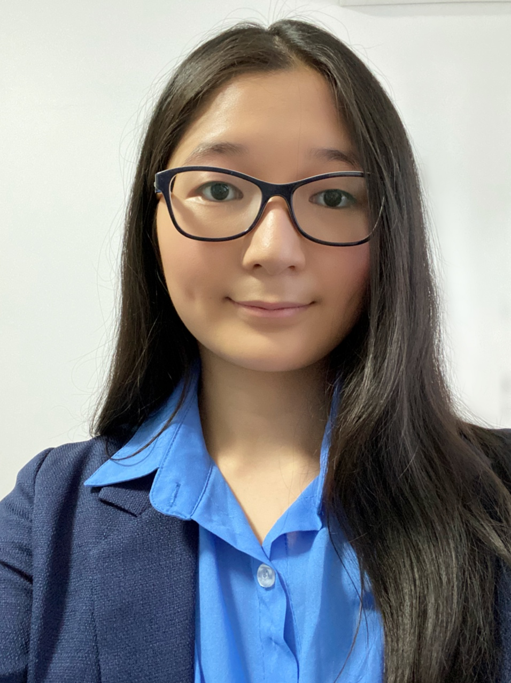
19869836
Verbana DANG

I am currently studying the Bachelor of Medical Science and my course is based at Parramatta South campus. I am a former student representative and understand the system at src. I believe as a student representative; you must have a strong passion for helping others and achieving the best for them. I would greatly appreciate the opportunity to work at western with a wonderful team that work towards improving the learning experience at western and increasing academic success.
BALLOT: PARRAMATTA SOUTH CAMPUS REPRESENTATIVE
MATIC Nikodin
17236007
Nikodin MATIC

After playing sports at a national level, I returned to University to continue my Bachelor of Business/ Bachelor of Laws and have been heavily involved in all aspects of University including academically, sport and student clubs.

Last year, I ran on the promise to help our Student Clubs and increase the quality and variety of activities available. As the SRC Vice President – Activities, I have made SSAF bids for an eSports Lounge and an upgrade to the multi-purpose courts at Kingswood. I have made $10,000 of funding available to our Student Clubs to help them host better events. I organised the $1000 Kahoot with over 13 clubs and oversaw the purchase of several items to boost student engagement and make events and their University life more enjoyable. These include a professional outdoor laser tag set (12 units) that can fire accurately up to 200m away, 3 x racing simulators with
BALLOT: PARRAMATTA SOUTH CAMPUS REPRESENTATIVE
POLARA, Razin
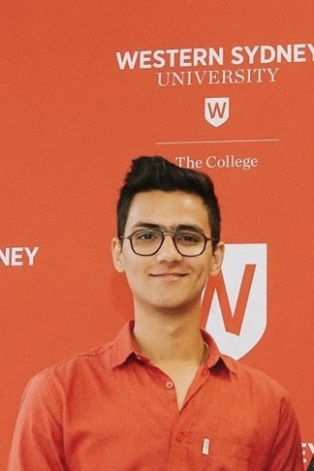
19668228

Razin POLARA

Hi, my name is Razin and I am the current SRC for the parramatta south campus. Apart from the representative role I have also been involved in many other activities in the university. This includes President of Western Sydney Hikers club, secretary of Western Shooters Football Club etc. and also a MATES mentor. In terms of study I am currently doing Bachelor of Nursing.
I have been in the representative role since 2 years. I have tried my best to involve in and participate in the university as a SRC. Due to my leadership skills and enough experience towards the university and its processes I would like to run for the Parramatta south representative position again and want to do much more activities and fun in the university. To help and students is still my number one priority.

Your vote to me will make a new change to the university.
BALLOT: PARRAMATTA SOUTH CAMPUS REPRESENTATIVE
PARKAR, Rameez
19290573
Rameez Parkar
Hi I’m Rameez. I never thought I would ever run for the Western SRC but I don’t think I could sit by quietly any longer. That’s why I put my hand up to be a representative. For too long now the students of Western Sydney University have had their interests ignored. Like many students, my “uni life” consists of coming to class and going home because there is not enough to do on campus. That is why I started a student club and that’s why I’ve run for the SRC. I think that so much can be done to serve the interests of students and that is what I have been doing over the last year as a representative. There has never been a more important time for strong progressive, principled and pragmatic students representatives fighting for us! Let’s make WSU even better! Vote [1] Rameez Parkar and JUMPSTART!

BALLOT: PARRAMATTA SOUTH CAMPUS REPRESENTATIVE
TATO, Elsie
NO IMAGE AVAILABLE

20514815
Elsie TATO

Hi my name is Elsie. I nominate myself for Vice president (undergraduate)! It's currently my first year in University and it has been a big change, in a good way. I believe I have the skills to be a great model for my peers. To be the voice of the needs of my peers. To listen to every opinion and try my best to cater to the needs of others and not just myself. I am reliable and am willing to take any risks and take time out of my day to do what is needed for this position. Thank you.

BALLOT: PARRAMATTA SOUTH CAMPUS REPRESENTATIVE
URIGWE, Timothy
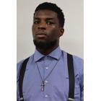
18632125
Timothy URIGWE
Parramatta needs a hero and that hero is not me, it's us. Together we can create a better future and learning experience for each other and those to come. I believe in the power of unity. Together with the dream team can make Parramatta great again. My name is Timothy. I believe the students should be supported by the SRC. We want to know what we can do to support you. If you’re tired of seeing mistakes of the past repeat, and watching valuable student resources wasted with no benefit to you, vote the Dream Team 2020.

BALLOT: PENRITH REPRESENTATIVE
HADER, Alannah
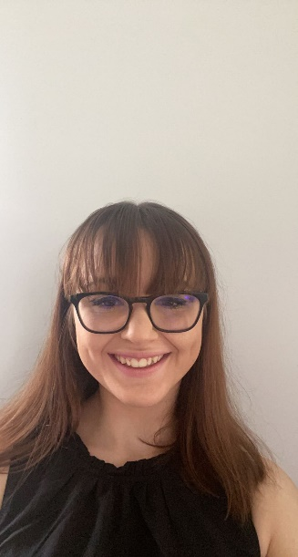
20379865
Alannah HADER

I, Alannah Hader am nominating myself to run for the Kingswood Campus Representative position in WSU Young Labor club I am a dedicated and passionate young woman who believes strongly in equality and equity, seeking to make a difference in the community around me. Currently, I am studying a Bachelor of Psychology (honours), where I envision myself one day to be able to enable a higher quality of life for those who seek my assistance, while being a voice for those who are in need of help that they may not be able to reach due to limitations causing an increase in need for mental health aid. Vote jumpstart.

BALLOT: PENRITH REPRESENTATIVE
PREUSS-KEARNEY, Simon
18638811
Simon PREUSS-KEARNEY
Being a member of the SRC is about taking responsibility for your campus and for ourselves.
To achieve this a representative must be a voice for all students at their campus. As a previous Kingswood representative, I bring experience and a sense of humour to the role. It has been my commitment to support Kingswood student by standing up for us - to get what we deserve as paying University students!
My goals for Kingswood begin with:
• Promoting events on Kingswood campus,
• Being approachable – with a joke ready at all times,
• Advocating for live graduations and getting the ‘live-education’ we deserve,
• Improved support for disability,
• Paid student opportunities and,
• An improved club funding system.
These goals are not tokenistic, as too often these statements are. They are real and considered – and they are only the start.
Vote for strength and integrity, as action starts with us.

BALLOT: PENRITH REPRESENTATIVE
WEEKS, Sean
20143028
Sean WEEKS
Representing the Kingswood campus of WSU would hold a personal degree of significance in that I would be able to best see the advance of the campus as a whole, and ensure that fruitful cooperation with other campuses allows crucial needs and changes to be identified and a plan of approach to ensure that Penrith campus is appropriately represented. By ensuring that I act in accordance with the role of Penrith Campus Representative I would be able to see fit the role is filled to the best of my abilities. Through this role, I would be able to ensure the accessibility, diversification, and principles of equity are best represented on my own campus as an example of an aspect that I hold true as the Representative of Penrith Campus. This role contains a great degree of personal significance in that I am able to represent the campus I call home

BALLOT: INTERNATIONAL REPRESENTATIVE
ELIGIBLE CANDIDATES LISTED ON THIS PAGE HAVE NOT SUPPLIED A CANDIDATE IMAGE OR CANDIDATE STATEMENT

Inayat, Inayat
BALLOT: INTERNATIONAL REPRESENTATIVE
Aakanksha AAKANKSHA

NO IMAGE AVAILABLE
20436979

Aakanksha AAKANKSHA
I, Aakanksha from India, am an undergraduate enrolled in Bachelor of Business. Being an international student myself who comes from the land of diversity, I believe embracing differences and working for common good is how we all grow. Owing to this very thought, I am contesting for the role of International Representative to be in a position where I can bring my thoughts into action. I’ve always believed in teamwork and during my schooling I have also worked on my leadership and organizational skills. I think that I am a person who likes to listen and understand others, which makes me favourable for this role. I hope I get to be the voice of the international students and try to create an amicable atmosphere with the domestic students and help the international students in every way possible.
BALLOT: INTERNATIONAL REPRESENTATIVE
MURAVU, Loore
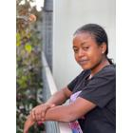
19223865
Loore MURAVU
Hi there! My name is Loore Muravu and I am keen to be your next elected international representative. As a former ambassador for the WSU college at Parramatta, I know that all know that although WSU is a great Uni, there are a lot of things that we can improve upon. We are coming together in 2021 to bring you a new and revamped platform which we are hoping will benefit every student. Having a student advisory group on academic school boards, free university supplies such as notebooks and pens for all students because finances should be no barrier to education, and large social events with other universities for increased social collaboration, are just some of the ideas that we want to bring to you this year. This 2021, make sure you vote dream team - not for us – but for your university experience.

BALLOT: DISABILITIES REPRESENTATIVE
ELIGIBLE CANDIDATES LISTED ON THIS PAGE HAVE NOT SUPPLIED A CANDIDATE IMAGE OR CANDIDATE STATEMENT

Tiffany SHARPE
BALLOT: DISABILITIES REPRESENTATIVE
REED, Robert
17277873
Robert REED
My name is Robert Reed and I am an undergraduate student studying Podiatric Medicine. Having been a representative of the Disability Collective for the past four years, I have learnt about the urgency and need for advocacy and for the rights of students from a policy level.
Disabilities is an area that I am greatly passionate about for many years. With an ever-­‐‑ increasing population, there needs to be a voice for all with disability, regardless of its nature. There needs to be a greater awareness, not only amongst students, but staff and administrators, to curtail the stigma and discrimination that those with disability face on a daily basis. We need to ensure that those tasked with helping those with disability are accountable in their actions and practice rather than making grandstand gestures and empty afterthoughts.
I believe I have the perseverance and integrity to lead students again in 2021.
BALLOT: ENVIRONMENT REPRESENTATIVE
ELIGIBLE CANDIDATES LISTED ON THIS PAGE HAVE NOT SUPPLIED A CANDIDATE IMAGE OR CANDIDATE STATEMENT
Tiffany SHARPE

BALLOT: ENVIRONMENT REPRESENTATIVE
RAM, Crystal
18702590
Crystal RAM
I'm a candidate at our student elections, and a CURRENT member of the SRC; I want to continue to JUMP START WSU. Currently on the executive of Student Clubs, I want to put my leadership experience to work for all of WSU.
This election is very important because our voice will be listened to. This will happen unless you do not vote. And other students’ ideas and thoughts will be heard. I’m the right person to do this job. In the first place, I’m a very responsible person and I love speaking before an audience. Second, if you vote for me, I will speak out for your complaints and problems that I’m sure you have on campus.
I have a plan for a series of fundraising events where all clubs and societies support one another and bring in new contributions.

Remember CRYSTAL and JUMPSTART when you vote.
BALLOT: ENVIRONMENT REPRESENTATIVE
WOLF, Danielle


17646882
Danielle WOLF

As a returning representative, I’m eager to build on past achievements, and cultivate new ways of achieving equity for Nature, and people as part of it. I am committed to our right to live in a healthy environment, and about Nature's right to be recognised as inherently valuable. I’m here to help empower you to take small steps for big impact toward environmental well-being, responsible consumption and production, and to foster community. We will continue holding DIY workshops (supplying ingredients), showcasing easy eco-friendly actions with big impact, continuing our campus food garden projects, holding Western accountable to its commitments, and developing partnerships. I’ll leverage available resources to make your time at Western environmentally and sustainably fruitful, eye-opening, and life-changing. This isn’t about an “apocalypse”. It’s about hope, passion, compassion, flourishing, friendships, and FUN. Life is full of promise and opportunity. Together we are changing the course of the future.

BALLOT: ETHNO-CULTURAL REPRESENTATIVE
ARMSTRONG-MENSAH, Rosina
18581498
Rosina ARMSTRONG-MENSAH

My name is Rosina Armstrong-Mensah doing my master’s in international criminology. I am originally from Ghana the west Africa. I believe when I am elected as the ethno-cultural representative, I will support the growth of diversity in Western Sydney University. I will use my previous experience in engagement and leadership to boost the level of achievement aimed by collective expectance.
Thank you.

BALLOT: ETHNO-CULTURAL REPRESENTATIVE
BAKER, Leahanne
19691116
Leahanne BAKER
Hi Everyone! My name is Leahanne Baker and, this is why you should vote for me for SRC Ethno-culture representative. I will make a great candidate for this position as I have experience in leadership and teamwork and understand the struggles being a person of a ethic-minority. In 2019 I was in the SRC at Western Sydney University as Campus Representative for Nirimba. This opportunity was a wonderful and life-changing experience. While as Nirimba Campus representatives, we were able to fund some great activities, programs, food and fun day events, and opportunities for the students. I can provide, support, and help more students and make sure students are being listened to for what they want and what they need! When you vote for me, you will see change, growth, and development for all students. VOTE FOR LEAHANNE BAKER No.#1

BALLOT: ETHNO-CULTURAL REPRESENTATIVE
PARKAR, Rameez
19290573
Rameez Parkar
Hi I’m Rameez. I never thought I would ever run for the Western SRC but I don’t think I could sit by quietly any longer. That’s why I put my hand up to be a representative. For too long now the students of Western Sydney University have had their interests ignored. Like many students, my “uni life” consists of coming to class and going home because there is not enough to do on campus. That is why I started a student club and that’s why I’ve run for the SRC. I think that so much can be done to serve the interests of students and that is what I have been doing over the last year as a representative. There has never been a more important time for strong progressive, principled and pragmatic students representatives fighting for us! Let’s make WSU even better! Vote [1] Rameez Parkar and JUMPSTART!

BALLOT: ETHNO-CULTURAL REPRESENTATIVE
RAM, Crystal
18702590
Crystal RAM
I'm a candidate at our student elections, and a CURRENT member of the SRC; I want to continue to JUMP START WSU. Currently on the executive of Student Clubs, I want to put my leadership experience to work for all of WSU.
This election is very important because our voice will be listened to. This will happen unless you do not vote. And other students’ ideas and thoughts will be heard. I’m the right person to do this job. In the first place, I’m a very responsible person and I love speaking before an audience. Second, if you vote for me, I will speak out for your complaints and problems that I’m sure you have on campus.
I have a plan for a series of fundraising events where all clubs and societies support one another and bring in new contributions.

Remember CRYSTAL and JUMPSTART when you vote.
BALLOT: WOMEN’S REPRESENTATIVE
ELIGIBLE CANDIDATES LISTED ON THIS PAGE HAVE NOT SUPPLIED A CANDIDATE IMAGE OR CANDIDATE STATEMENT
Tiffany SHARPE and
Inayat INAYAT

BALLOT: WOMEN’S REPRESENTATIVE
ARMSTRONG-MENSAH, Rosina
18581498 Rosina ARMSTRONG MENSAH

My name is Rosina Armstrong-Mensah doing my master’s in international criminology. I have built up my engagement and connection with the Western Sydney University in different ways such being part of the student leadership. This have assisted me in knowing more about students and the university. With the experience I have gained I hope to represent women student for their voice to be heard and well represented. I believe when am given the chance I will do my very best to abide and follow the necessary policies governing the women collective role.
Thank you..
BALLOT: WOMEN’S REPRESENTATIVE
CUPITT, Sarah
19760041 Sarah CUPITT
Hi! I'm Sarah Cupitt, an ambitious 3rd-year student studying a Bachelor of Communication (Journalism & PR), playing a vital role in student advocacy relating to university-wide issues, working on programs and services that offer a range of student opportunities. I want to continue representing student's rights and interests at WSU alongside my team, Strength & Integrity. I'm a creative young leader and have held various student positions such as; Director of Student Publications, SRC Vice-President, Multimedia Editor, SRC Online Rep, and NUS delegate since 2019. I founded WSU's first writing community Modern Ink, and am an exec of 7 other clubs and a recipient of various leadership awards from WSU and the local community. This year, my goal is to connect students in shaping the systems that affect their learning experiences. To ensure equity for students, transparency for SSAF, ongoing policy change, and more club funding, please vote for me!

BALLOT: WOMEN’S REPRESENTATIVE
RAM, Crystal
18702590
Crystal RAM
I'm a candidate at our student elections, and a CURRENT member of the SRC; I want to continue to JUMP START WSU. Currently on the executive of Student Clubs, I want to put my leadership experience to work for all of WSU.
This election is very important because our voice will be listened to. This will happen unless you do not vote. And other students’ ideas and thoughts will be heard. I’m the right person to do this job. In the first place, I’m a very responsible person and I love speaking before an audience. Second, if you vote for me, I will speak out for your complaints and problems that I’m sure you have on campus.
I have a plan for a series of fundraising events where all clubs and societies support one another and bring in new contributions.

Remember CRYSTAL and JUMPSTART when you vote.

