APPENDIX 2- WORKING FROM HOME WHS & WELLBEING CHECKLIST
This checklist is to be completed by workers requesting to work from home. This checklist must be completed by the worker and be reviewed by the supervisor prior to commencement of a working from home arrangement to determine if the home work area is appropriate. The staff member must also complete the 4 mandatory online WHS training modules available through MyCareer Online. Photos of the workplace can be attached to demonstrate compliance with the checklist.

Name | Date of Self-Assessment:
Actions or Equipment Required:
List any actions, equipment or workspace modifications required. (eg. Document holder, monitor stand) or modifications (eg. Workstation adjustments) noting that these must be supplied by the staff member and will not be supplied by the University

Supervisor to Complete
I have reviewed the risk assessment(s) provided with this checklist | Yes | No
I have confirmed that the staff member has completed the online WHS & Wellbeing training modules in the last 12 months | Yes | No
Other Comments:

 | Signatures:
 | Employee: |  |  |  |  | Signature: |  |  |  | Date:
 | Supervisor: |  |  |  |  | Signature: |  |  |  | Date:
 |  |  |  | A. Environment |  |  | Yes |  |  |  |  | No
 |  |  |  | Do you find the noise level conducive to concentration?
 |  |  |  | Is the lighting level adequate for the task/s being performed?
 |  |  |  | Are light sources located so that shadows on the desktop work area are minimised?
 |  |  |  | Are sources of glare controlled to prevent reflections in your field of vision (lights, windows etc.)
 |  |  |  | Is the room appropriately located in the house (aspect) with some means of ventilation/airflow?
 |  |  |  | Can the room climate be artificially controlled by air conditioning or heaters? (the temperature should be between 20 and 26 degrees Celsius in the winter and 2 degrees lower in the summer)
 |  |  |  | Is the desk positioned so that your line of vision is parallel to windows? (You should not be seated either directly facing, or with the computer screen directly facing a window)
Comments
 |  |  |  |  | B. Chair |  |  |  | Yes |  |  |  | No
 |  |  |  |  | Is the chair easily adjusted from a seated position?
 |  |  |  |  | Can you get close to the workstation without impediment? (Check that the desktop is thin, chair arms are not in the way and there is clear legroom.)
 |  |  |  |  | Is the seat height adjusted so that your thighs are parallel to the floor with feet resting on the floor or on a footrest? (See section D if a footrest is required)
 |  |  |  |  | Is the backrest height adjusted to fit into the small of your back and adequately support the spine? (The small of the back is near the belt line).
 |  |  |  |  | Is the backrest angle adjusted so that you are sitting upright while typing? (You are encouraged to change backrest position when not typing.) Comfortable pressure should be placed on the lower back without the backrest pushing you too far forward (there should be at least 2 fingers clearance between the front of the chair and the back of the knee)
 |  |  |  |  | Does the chair have a stable five star base?
 |  |  |  |  | Is there adequate seat padding?
 |  |  |  |  | Is the chair in good working order?
Comments
 |  |  |  |  | C. Desk |  |  |  | Yes |  |  |  | No
 |  |  |  |  | When typing, are your forearms parallel with the floor or angled slightly downward? (This can be achieved by lowering the desk or with a fixed-height desk, raising or lowering the chair.)
 |  |  |  |  | Is the desk height easily adjustable or can you adjust your chair to suit the desk height and maintain the seated posture described in (B)? If no, do you have a footrest?
 |  |  |  |  | Is there enough space under the desk to permit movement and stretching of the legs?
 |  |  |  |  | Are all surfaces of the desk (including the underside of the desk-top) free of sharp edges or corners, pinch points or projections that could cause injury?
 |  |  |  |  | Is the desk sufficiently robust to support the equipment?
Comments
 |  | D. Footrest (If applicable) |  |  |  |  |  | NA |  |  |  | No |  | Yes
 |  | If a footrest is used, is it large enough to support both feet and allow a change of position?
Comments
 |  |  |  |  | E. Documents (If applicable) |  |  | NA |  |  | Yes |  |  |  | No
 |  |  |  |  | If typing from documents, do you have a document holder?
 |  |  |  |  | If yes, can it be freely adjusted to a comfortable viewing position and support all source documents ?
Comments
 |  |  | F. Monitors |  |  |  |  |  |  |  |  | Yes |  |  |  | No
 |  |  | When sitting tall and looking straight ahead, are you able to read the monitor without bending or twisting your neck?
 |  |  | Is the monitor positioned so that the top of the monitor is level with, or slightly lower than, your eyes?
 |  |  | Is the monitor at a comfortable viewing distance? (Start with the monitor around one arm’s length from the seated position and move closer or further as required)
 |  |  | Is the monitor tilted to an angle which provides the most effective viewing plane?
 |  |  | Is the monitor free from glare and reflection?
Diagram
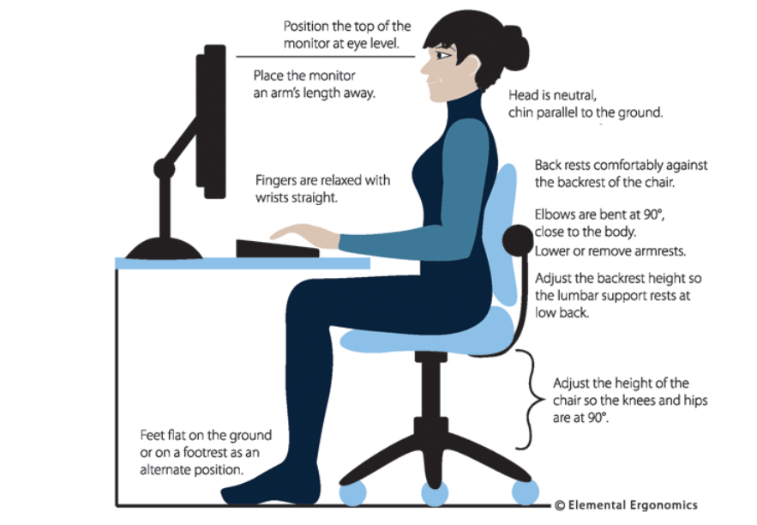
Comments
 |  |  |  | G. Keyboard and Mouse |  |  |  |  | Yes |  | No
 |  |  |  | Is the keyboard thin enough for comfortable positioning of the arms? (It should be less than 30mm thick at the home (ASDF) row)
 |  |  |  | Can the angle of the keyboard be adjusted?
 |  |  |  | Is there a rest area for the wrists when not typing?
 |  |  |  | Is the keyboard positioned centrally between you and the monitor?
 |  |  |  | Is the mouse comfortable to the size of your hand, and when in use does not require your wrist to be bent at an uncomfortable angle?
Comments
 |  | H. Laptop Computers (if used for extended periods) |  |  |  |  | NA |  |  | Yes |  | No
 |  | Is a separate mouse and keyboard available for use?
 |  | When using an external keyboard are you able to raise the display to a comfortable eye level or use an external monitor??
Comments
 |  |  |  | I. Workstation layout |  |  |  |  | Yes |  | No
 |  |  |  | Are regularly used items within easy reach of your normal seating position? (They should be within normal arm reach with minimum body movement)
 |  |  |  | Is there sufficient space for large documents, completed work or writing?
 |  |  |  | Is the workstation designed to prevent undue twisting of the neck or body?
 |  |  |  | Is there adequate and appropriate storage space for work and personal items?
Diagram |  |  |  |  |  | Comments:
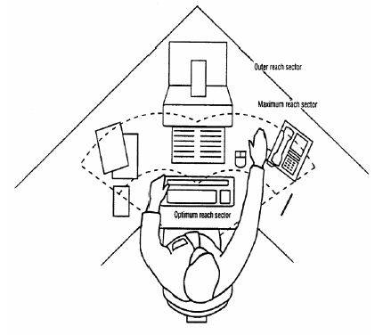 |  |  |  |  |  | ___________________________________________________  ___________________________________________________  ___________________________________________________  ___________________________________________________  ___________________________________________________  ___________________________________________________  ___________________________________________________  ___________________________________________________  ___________________________________________________
 |  | J. Headsets |  |  |  |  | NA |  |  | Yes |  | No
 |  | Is the headset lightweight, adjustable and comfortable?
 |  | Does the telephone equipment include easily adjustable volume controls?
Comments
____________________________________________________________________________________________________

___________________________________________________________________________________________________
 |  |  | K. Safety |  |  |  |  |  | Yes |  | No
 |  |  | Is the work area free of trip, slip and fall hazards?
 |  |  | Are power and communication cables adequately protected against damage?
 |  |  | Are electrical switches and plugs in good condition and free from cracks, splits and punctures?
 |  |  | Are sufficient power points available at the workstation?
 |  |  | Are all electrical leads out of the way or taped down?
 |  |  | Is the home office electrical supply protected by a Residual Current Device (Safety Switch)?
 |  |  | Are first aid items readily available? (Minimum requirement is a Type C kit or 50 adhesive plastic strips; 1 x 50mm gauze bandage; 2 disposable gloves; 1 wound dressing; 2 plastic bags; 1x100mm gauze bandage; 1x110mm triangular bandage)
 |  |  | Is the home fitted with smoke detectors?
 |  |  | Are exit paths from the designated work area to outside of the building clear and accessible?
Comments
____________________________________________________________________________________________________

____________________________________________________________________________________________________
Summary
 | List the safety actions required to eliminate or control these hazards:
Name: |  |  |  |  | Signature: |  |  | Date:

Note: Completed forms are to be returned to your line manager, who will forward to whs@westernsydney.edu.au.

