|  |
| --- |
| **MiSeq Sample Submission Guide**  **Next-Generation Sequencing Service**  **Contact: Rhea Cornely**  **Phone: 02 4570 1784**  **Email:** [**ngs@westernsydney.edu.au**](mailto:ngs@westernsydney.edu.au) |

# **Metagenomics Sequencing Requirements**

Please read the following submission guidelines carefully and prepare your samples accordingly.

**Failure to follow submission guidelines may result in the rejection of submitted samples or might incur additional costs.**

## Prior to submission

* Custom primer projects which require case-specific optimisation **must be discussed with the NGS Facility staff** prior to sample submission.
* Samples must be submitted **one month prior** to the scheduled library preparation start date to enable sufficient time for sample QC.
* **Amplicon samples** must be submitted on **separate plates** from any **genomic DNA samples** and the nature of the amplicons must be discussed with the NGS Facility staff.
* Download and fill in
  + MiSeq_Sample_Submission_Sheet_(MSSS)_V3
* Fill out online
  + MiSeq Sample Submission Form (MSSF)
* Upload (online) your completed
  + MiSeq_Sample_Submission_Sheet_(MSSS)_V3
* Print out to send with your DNA/amplicon samples your completed
  + MiSeq Sample Submission Form (MSSF) and
  + MiSeq_Sample_Submission_Sheet_(MSSS)

**All fields in the sample submission form must be completed. Incomplete submissions will not be accepted.**

# Format of submitted samples

The preferred format for all sample submissions are Eppendorf 96-well PCR plates. For small numbers of samples (≤ 24), 1.5ml tubes are acceptable.

* ≤ 24 samples may be submitted in either,
  + 1.5 mL LoBind tubes (Eppendorf Cat No.022431021) or
  + 0.2ml PCR tube strips (Eppendorf Cat No. 951010022)
  + in a fully skirted 96-well plate (Eppendorf Cat No. 0030128648) with flat caps

(Eppendorf Cat No. 0030124847)

* ≥ 25 samples must be submitted in Eppendorf fully skirted 96-well plates (available from the WSU NGS Facility on request) following the plate layout detailed below with no well gaps.

**Please note: If wells gaps occur, each gap will be charged as a standard library preparation**.

A fee for sample transfer will be charged for > 24 samples not submitted in Eppendorf fully skirted 96-well plates.

## Labelling

* Samples in 1.5 ml tubes must be labelled “customer initials - sample number” (eg BH – 1 or BH 1)
* Samples in plates must be labelled on the front rim of each plate with “customer initials – plate number – date” (eg BH – P1 – 20190616 or BH – Plate 1 – 16/6/2019)

## Required 96-well plate format

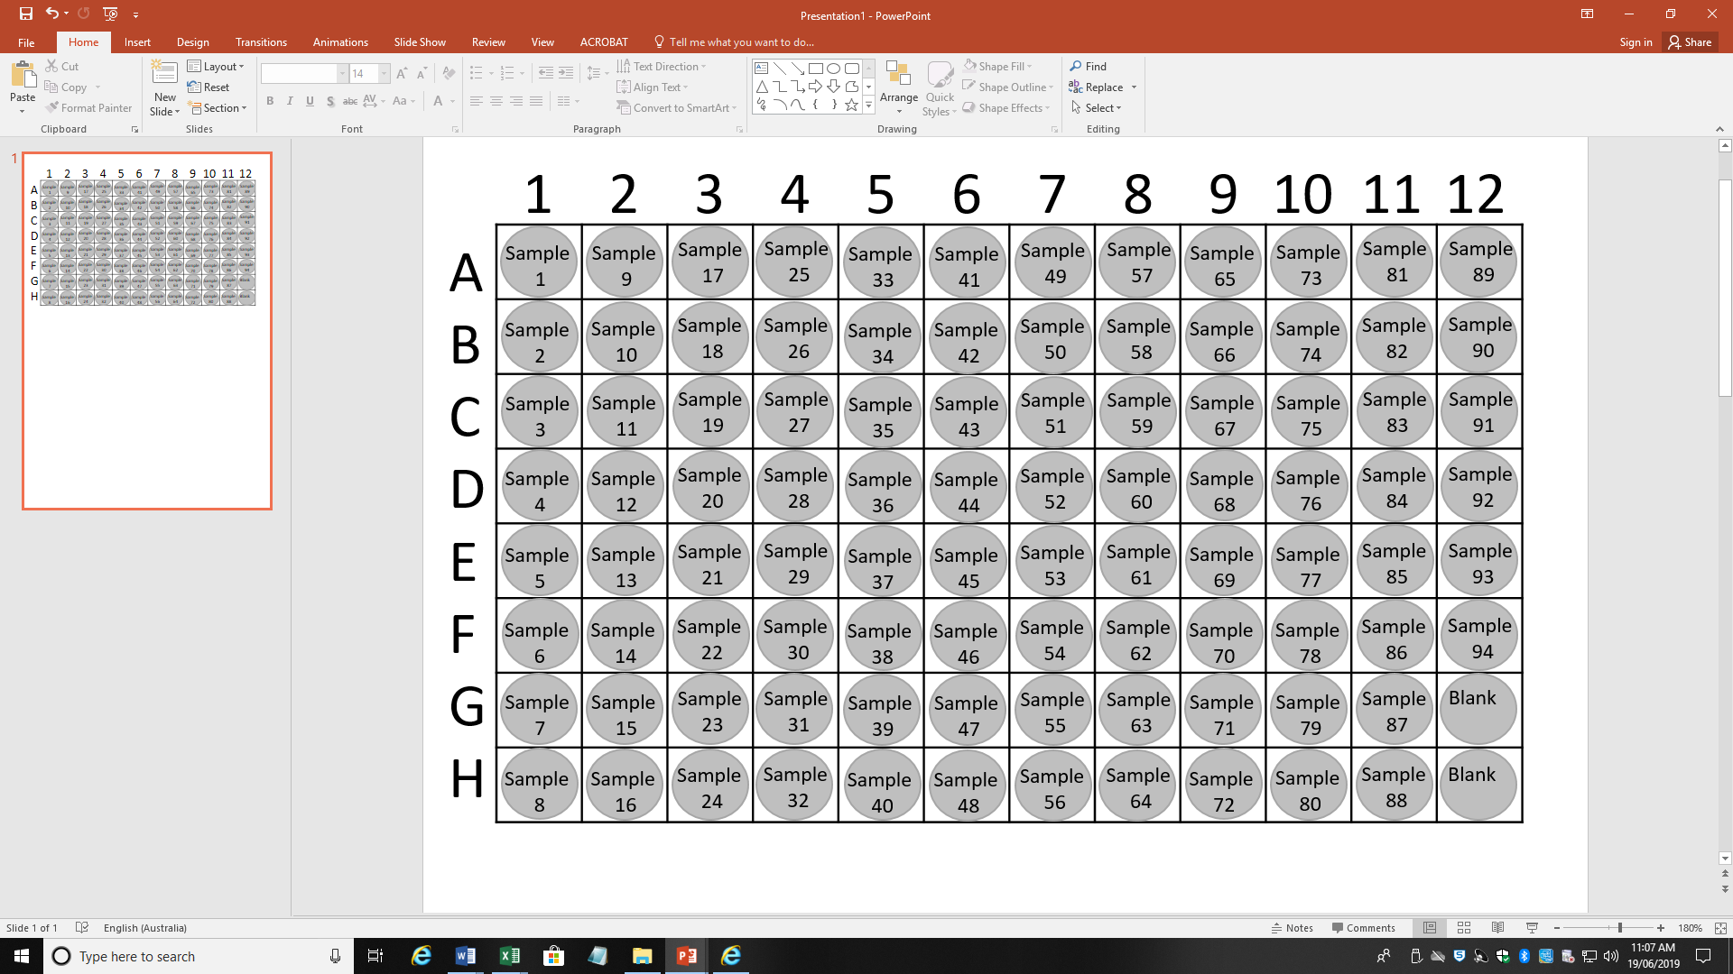The plate layout must be followed to conform with our epMotion automated pipetting systems.

**Please note: any well gaps will incur an additional charge.**

# Preparing samples for submission

## Elution buffer

Please elute your samples in **nuclease-free water**. Elution of DNA in buffers other than water may necessitate a purification step*. If this is not possible, a tube with the elution buffer has to be included in the submission, otherwise the submission will be rejected.

## Genomic DNA Requirements for sequencing run

* Please ensure that samples are of similar concentrations to enable optimal normalisation.
* It is preferable if all submitted samples are around 30-50 ng/ul.
* Environmental and plant samples can be discoloured which interferes with quantification measurements and downstream assays. A purification step* will be added prior to processing these samples.
* The total DNA amount **must not be below 450 ng** (eg. 30ul of 15ng/ul DNA).
* If the DNA concentration is **< 15ng/µl,** but the total amount of DNA is sufficient, a purification and concentration step* **will be done** before QC.

**\* A concentration and/or purification step will incur an additional charge /sample and is applied to all submitted samples. Please enquire for the price.**

|  |  |  |  |  |  |
| --- | --- | --- | --- | --- | --- |
| Total amount | Concentration | Minimum Volume | A260/280 | A260/230 | Buffer |
| ≥450 -1500 ng | **15ng/µl –150ng/µl** | >30µl | 1.8-2.0**^** | >1.8**~** | Nuclease- free water |

## Customer prepared amplicons per sequencing run

* The Illumina overhang adapter sequence must be added to locus-specific sequences for the region to be targeted (please contact us for further guidance at [ngs@westernsydney.edu.au](mailto:ngs@westernsydney.edu.au)).

|  |  |  |  |  |
| --- | --- | --- | --- | --- |
| Input material | Concentration* | Minimum Volume | Purity | Buffer |
| ≥150ng | ≥10ng/µl | 30ul | Purified PCR free of primers/primer dimers | Nuclease- free water |

* Concentration must be assessed using fluorescence-based quantification method (Qubit or Picogreen).

^ A low 260/280 ratio (below 1.8) indicates protein contamination of nucleic acids.

~ A low 260/230 ratio (below 1.8) indicates organic or carbohydrate compound contamination of nucleic acids.

## Quality Values for Metagenomic Samples

Metagenomic samples can often have A260/230 ratios lower than 1.8. Whilst this is not unusual with these sample types, it may be indicative of inhibitors being present in the samples and may prevent successful amplification. It is our standard procedure to flag poor A260/230 values to customers in their sample QC report and confirm that you wish to proceed with library preparation regardless of the indicated low ‘quality’ values.

## Supporting data

* If submitting concentration values based upon Nanodrop results, please submit the RAW DATA only – 260/280 and 260/230 values only (and do not complete the concentration column in the sample submission form).
* Gel images demonstrating successful PCR amplification of the submitted samples must be supplied with the sample submission.

# Shipping of samples

Ensure samples are shipped in leak-proof containers (either tightly-sealing tubes or well-sealed 96 well plates. Cross-contamination of samples can occur during shipping if containers are incorrectly sealed).

Please be aware that samples can be delayed in shipping and pack samples appropriately.

Please send your samples by courier to the address below:

Attention to: Dr Caroline Janitz

Next-Generation Sequencing Facility

Western Sydney University – Richmond Campus

Building L9, R1.14-1.18

50 Bourke St

Richmond, NSW 2753

Metagenomic Primer Sets

Bacterial Primers (16S)

341 Forward and 805 Reverse (Bacterial 16S 341F/805R)

16S variable regions v3 and v4

Name Sequence

341F 5’ CCTACGGGNGGCWGCAG

805R 5’ GACTACHVGGGTATCTAATCC

515 Forward and 806 Reverse (Bacterial 16S 515F/806R)

16S variable region v4

Name Sequence

515F 5’ GTGCCAGCMGCCGCGGTAA

806R 5’ GGACTACHVGGGTWTCTAAT

27 Forward and 519 Reverse (Bacterial 16S 27F/519R)

16S variable regions v1, v2 and v3

Name Sequence PCR

27F 5’ AGAGTTTGATCMTGGCTCAG

519R 5’ GWATTACCGCGGCKGCTG

799 Forward and 1193 Reverse (Bacterial 16S 799F/1193R)

16S variable region v5, v6 and v7

Name Sequence

799F 5’ AACMGGATTAGATACCCKG

1193R 5’ ACGTCATCCCCACCTTCC

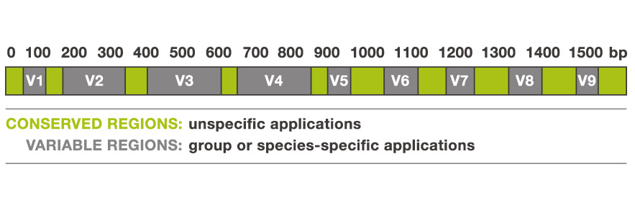

Fungal Primers (ITS)

fITS7 Forward and ITS4 Reverse (Fungal ITS2 fITS7/ITS4)

amplifying ITS2

Name Sequence

fITS7 5’ GTGARTCATCGAATCTTTG

ITS4 5’ TCCTCCGCTTATTGATATGC

ITS1oo Forward and ITS4 Reverse (Fungal ITS1 ITS1f/ITS2)

amplifying ITS1 and 2

ITS1oo FWD – 5’ GGAAGGATCATTACCACA

ITS4 – 5’ TCCTCCGCTTATTGATATGC

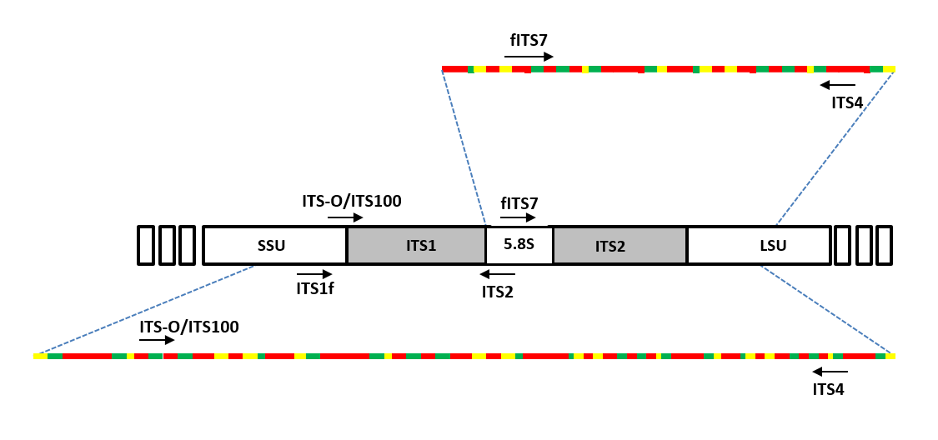

ITS1f Forward and ITS2 Reverse (Fungal ITS1&2 ITS1oo/ITS4)

amplifying ITS1

ITS1f – 5’ CTTGGTCATTTAGAGGAAGTAA

ITS2 – 5’ GCTGCGTTCTTCATCGATGC