Application of Blended Learning to Enhance Learning of Engineering Students

R K Smith^{1,*}, A R Sen², P R Xiang² and N Ahmed¹

¹School of Engineering, New West University, Australia
²School of Science, University of New Island, Canada
*Presenting author: E-mail: smith@yahoo.com

Abstract: This paper presents how blended learning can effectively be adopted in teaching engineering students. Blended learning uses the best aspects of face-to-face and online delivery of engineering courses. The length of abstract should be 200 to 250 words. There should be three to five keywords. Font size: 12 Times New Roman, single line space, no reference, table and figure in the abstract. Authors should use this template to prepare the abstract.

Keywords: Engineering education, blended learning, online delivery, students

- Introduction
Mine rehabilitation is an important exercise which aims to help environment. It involves many branches of sciences and law.

The length of full paper should be 5 to 8 pages long including all the tables and figures. Font size: 12 Times New Roman with single line space. A blank line should be inserted between paragraphs, section heading should be bold and equations, tables and figures should be numbered as shown in this template. Authors should use this template in preparing the manuscript.

- Method
This paper uses a Bayesian network method to carry out mine site assessment. It considers uncertainty at each stage of modelling by assuming a normal distribution. The paper adopted a methodology as suggested by Smith (1980), Smith and Jones (2008), Smith et al (2010), Sydney Water (2011) and ABS (2012). It is shown in equation 1.

(1)

- Data Preparation
The study focuses on a mine site located in Western Australia. Data is collected by setting up of a data collection network as discussed in Honnes et al (2004).

- Results
  - Arsenic concentration
It is found that arsenic is not a major issue in the plants near the mine site. Figure 1 plots the arsenic levels in plant tissues, which show that these are below the acceptable limits set by regulatory authorities in Australia.
    - Arsenic in water samples
There are lots of arsenics in water samples. Investigation was made to find their sources. Samples were collected from water and soil samples and tested at weekly intervals for one complete year.

It was then found that arsenic level exceeded at many water samples as well as plant cells. A field survey was made to find out the transport route of arsenic.

Table 1 Arsenic contamination in soil near the mine site
Site | Arsenic levels (mg/L) | Comments
1 | 0.02 | Below recommended level
2 | 0.08 | Above recommended level
3 | 0.004 | Below recommended level

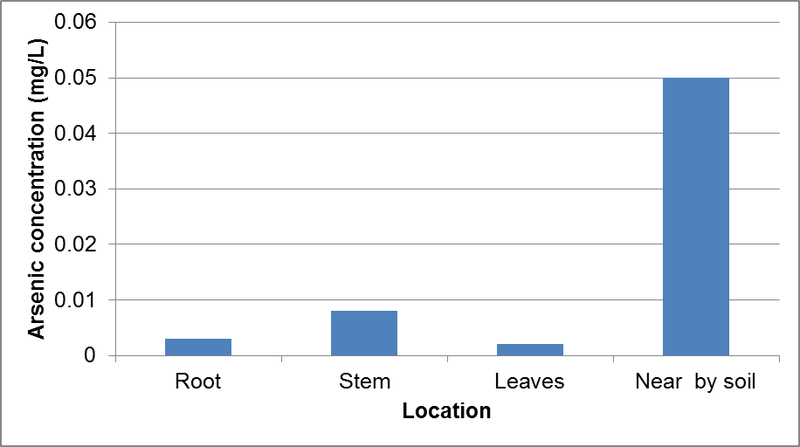
Figure 1 Arsenic level in plant body and adjacent soil

- Conclusion
It has been found that arsenic levels are much higher than the recommended levels in some soil samples and plant tissues. It is recommended that appropriate arsenic control measures need to be undertaken.

Acknowledgements
The authors acknowledge the contributions made by the laboratory assistants Mr David Bowman and the reviewers of the paper.

References
Imrose K, Jones D (2013). Water price in Australia – a comparative study considering data during 1950 to 1998, Accessed via www.waterprice.australia on 22 Jan 2012.
Pulman PR, Rahman A (2012). A new regional flood estimation technique for north Australia considering region of influence and catchment characteristics data, Technical report, University of Western Sydney, 46 pp.
Park BN, Rahman A, Haddad K, Robinson CR (1999). Towards a new regional flood methods in Australia based on canonical correlation analysis, Australian Journal of Water Resources, 4, 23-32.
Yang X, Lu KML, Henry R (2011). Water data analysis, 3rd ed, Wiley, 306 pp.
Newman PKT (2015). An innovation in engineering education, In Proc. 3rd Engineering Education Conference, Melbourne, Australia, 3-5 May 2015, 153-160.

