Application of Blended Learning to Enhance Learning of Engineering Students

R K Smith^{1,*}, A R Sen², P R Xiang² and N Ahmed¹

¹School of Engineering, New West University, Australia
²School of Science, University of New Island, Canada
*Presenting author: E-mail: smith@yahoo.com

Extended Abstract: Authors should use this template to prepare the extended abstract. Extended abstract should be one page long including one figure (maximum) and/or one table (maximum). It may include a list of references, if needed. There should be no separate sections for introduction, methodology and conclusion. Font size: 12 Times New Roman and single line space. References should be quoted like: as found by Smith (1980), Smith and Jones (2008), Smith et al (2010), Sydney Water (2011) and ABS (2012).

Keywords: Engineering education, blended learning, online delivery, students

Table 1 Arsenic contamination in soil near the mine site
Site | Arsenic levels (mg/L) | Comments
1 | 0.02 | Below recommended level
2 | 0.08 | Above recommended level

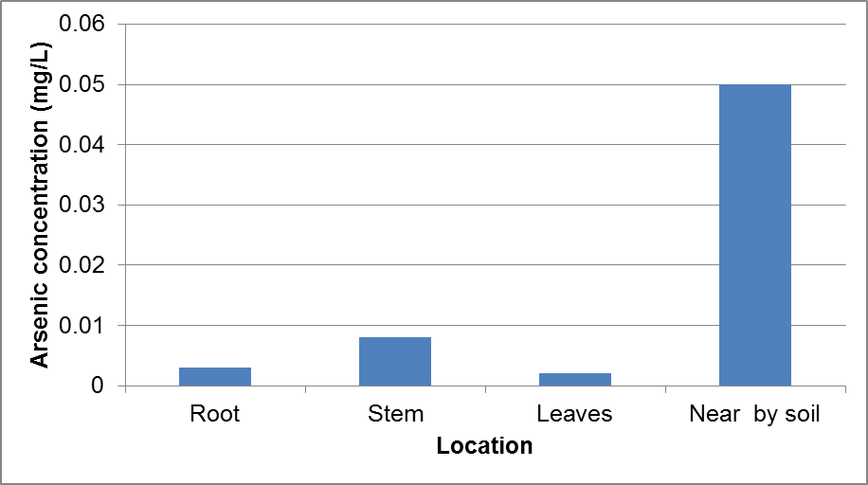
Figure 1 Arsenic level in plant body and adjacent soil
References
Imrose K, Jones D (2013). Water price in Australia – a comparative study considering data during 1950 to 1998, Accessed via www.waterprice.australia on 22 Jan 2012.
Pulman PR, Rahman A (2012). A new regional flood estimation technique for north Australia considering region of influence and catchment characteristics data, Technical report, University of Western Sydney, 46 pp.
Park BN, Rahman A, Haddad K, Robinson CR (1999). Towards a new regional flood methods in Australia based on canonical correlation analysis, Australian Journal of Water Resources, 4, 23-32.
Yang X, Lu KML, Henry R (2011). Water data analysis, 3rd ed, Wiley, 306 pp.
Newman PKT (2015). An innovation in engineering education, In Proc. 3rd Engineering Education Conference, Melbourne, Australia, 3-5 May 2015, 153-160.

