

Report on the International Conference on Human Rights Education: Educating for Human Rights, Peace and Intercultural Dialogue 4- 6 November 2010

University of Western Sydney Parramatta Campus, Sydney, Australia

UWS was proud to initiate, organise and host an international conference on issues relating to human rights education (HRE), with the involvement of Australian and international speakers from all continents.

Conference objectives
- To examine and support UN objectives in HRE
- To explore the role of HRE in advancement of peace, democracy and multicultural understanding around the world
- To highlight HRE international best practice, key trends and achievements
- To foster HRE across the Asia Pacific region and to build networks and dialogue
- To seek advancement of HRE in Australia through incorporation of best international practice in school curricula

Conference details
The Conference was held at its Parramatta Campus on the 4th, 5th and 6th November 2010. The Conference was composed of 1 oration, 7 plenary sessions, 9 concurrent sessions and 3 workshops. Some 80 speakers addressed the Conference audience on a range of HRE issues. Please see the Conference Booklet for the Conference Program, list of participants and organisations, sponsors and partners.

Conference Outcomes
Program
The Conference program presented a mix of scholarly and practical lectures and workshops covering a broad range of HRE issues across all continents.

Topics
- Global Trends in human rights education
- Human Rights as Unifying Standards for Society
- Human Rights Education – regional perspectives
- Trends in HRE
- HRE in Schools
- HRE Pedagogy
- Will Human Rights Shape Civilisation in the 21st Century?
- How to Nourish a Human Rights Culture – Australian experience
- Advancing Human Rights Internationally through Education
- Peace and Human Rights Education
- Educating Professions about Human Rights
- Combating Social Prejudice with Human Rights Education
- HRE – Children, Young People and our Communities
- Addressing Human Rights Education Challenges in Asia
- Breaking Barriers with Human Rights Education
- Human Rights, Indigenous People and Development
- Where do we go to from here?
- Human Rights and Advocacy Train-the-trainer Workshop
- Use of Human Rights Education to Create Change at Community Level
- Human Rights Education: Finding Magic for the Children

Keynote Speakers
The Conference attracted high quality national and international speakers with diverse backgrounds and expertise – from leaders of national human rights organisations and well known HRE experts and researchers to NGO practitioners and students working in the area of HRE. Twenty-two speakers were from developing nations, including 8 sponsored by Aus AID. Below are examples of some of the keynote speakers.
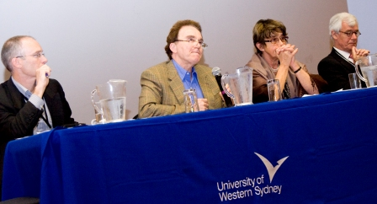

Australian Political Leaders

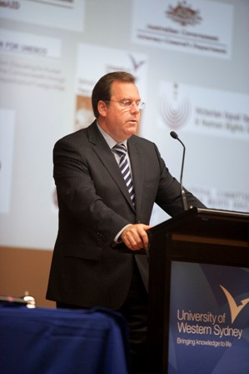
The Honourable Robert McClelland, Federal Attorney General
What is Human Rights Education all about and why do we need it?

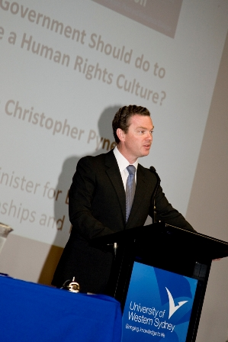

The Honourable Christopher Payne MP
What Government should do to advance a human rights culture?

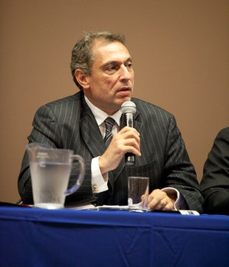

The Honourable John Hatzistergos MLC
Human Rights Without a Charter: Human Rights in Australia post the National Consultation on Human Rights

Australian Public Opinion Leaders & Experts
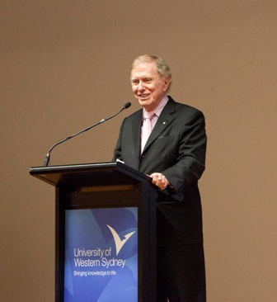

The Honourable Michael Kirby
Will Human Rights Shape Civilisation on the 21st Century?

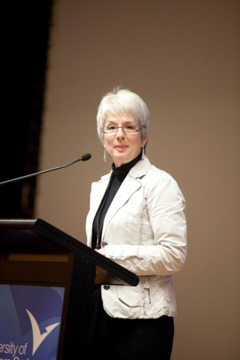

The Honourable Catherine Branson QC, President, Australian Human Rights Commission
From International Principles to Everyday reality – HRE in Australia
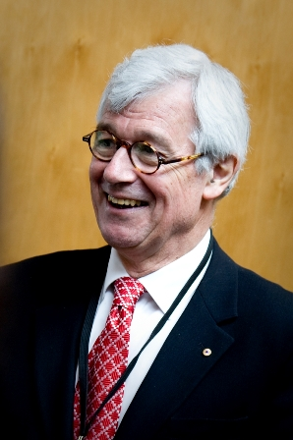

Julian Burnside AO QC
The role of government and civil society’s contribution to HRE

International HRE Experts

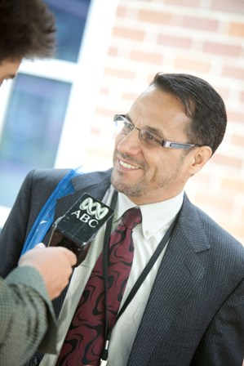

Ahmad Fahim Hakim, Deputy President, Afghanistan Independent Human Rights Commission
HRE In Muslim Societies – Afghan Experience

Dr Ana Rodino, Inter-American Institute of Human Rights, Costa Rica
Human Rights Education in Latin America

Professor John C. Mugangizi, Deputy Vice-Chancellor, The University of Kwa Zulu-Natal, South Africa
A culture of Human Rights in the face of Cultural Diversity – the South African Experience

Dr Mariko Akuzawa, Associate Professor of Hyogo and Member of the Asia-Pacific Human Rights Information Centre, Osaka, Japan
HRE in Schools: Progress in Institutionalization and beyond – Review of Southeast and Northeast Asian Experiences

Dr Reinhild Otte, Expert on Education for Democratic Citizenship and Human Rights, Council of Europe

International HRE practitioners and civil society representatives
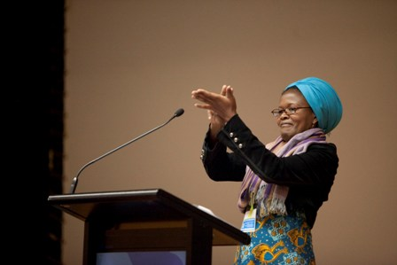
Sarah Tobhi Motha, Coordinator Human Rights Education Centre and Umphakatsi Ecovillage, South Africa
HRE – community based approaches and holistic development
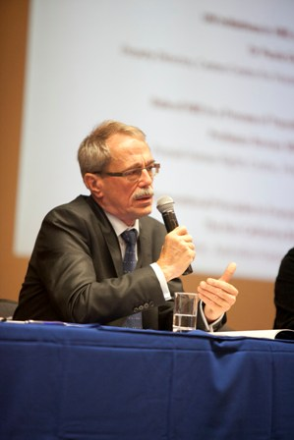

Prof Roman Wieruszewski, Director, Poznan Human Rights, Polish Academy of Science, Poland
Role of HRE in a Process of Transition – Polish Experience

Australian HRE practitioners and civil society representatives

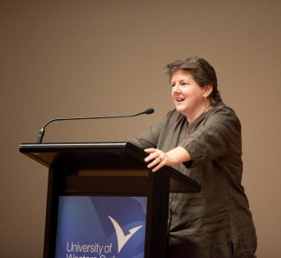
Dr Paula Gerber, Deputy Director, Castan Centre for Human Rights Law Monash University
UN Initiatives in HRE and their impact

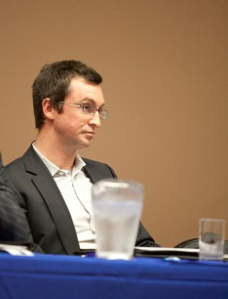

Phil Lynch, Director, Human Rights Law Resource Centre, Melbourne
The Debate about an Australian Bill of Rights

Participants
The large number and diversity of participants, as well as the quality of the presentations and discussion at the Conference can be used as a measure of success for the project.
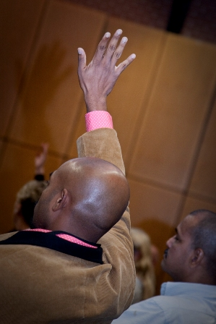
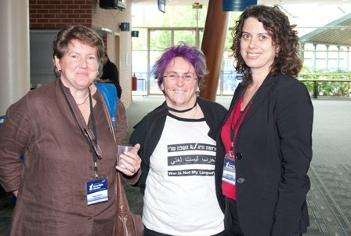
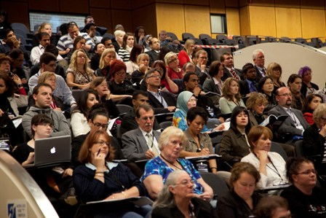
There were over 360 participants, from 35 countries and every continent, with 150 being men and 210 women. There were 69 international delegates with 30 being from developing nations and 17 sponsored by Aus AID. There was a broad representation of civil society with large numbers of students, activists, human rights advocates, NGO workers, HRE practitioners, government representatives, teachers, academics and others interested in human rights education. Such a diversity of participants would not have been possible without the support of the Federal Attorney General’s Department, the National Commission for UNESCO, Aus AID ad the Japan Foundation.
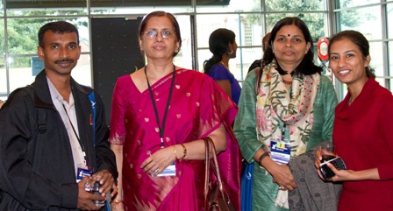
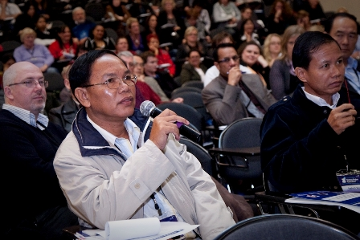

Opportunity to network
The Conference provided an opportunity for participants and presenters to network and discuss issues pertaining to human rights education, to share knowledge and skills in the facilitation of human rights education and best practice ideas in the area of human rights, peace and social justice. One of the most prevalent comments at the Conference was appreciation of the opportunity to network with like-minded practitioners and academics. The request for further networking has been addressed by referring all participants to the existing Human Rights Education Network at http://www.hrea.org/.

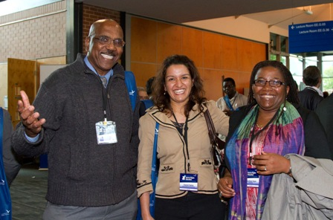
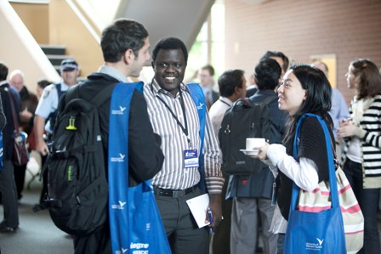

Resolution
Further, the Conference was successful at developing a resolution that calls on all Australian governments to further develop the human rights education agenda and prioritise the introduction of human rights education into the national curriculum and Australia’s aid programs. This resolution has been sent to the Prime Minister, the Federal Attorney General, The UN Secretary General, Ministers of Education, and the Commonwealth Secretary General. See attached Resolution and Communiqué.

Publications
The Conference papers will all be published either on the Conference website, in a James Nicholas Publishers book and in a couple of Journals, including Education and Society. The promulgation of the Conference papers in this way will promote academic and policy inclusion of the Conference content and will further the progress of human rights education in Australia and beyond.
Promotion of HRE
The human rights education theme of the Conference was promoted widely across a broad range of mediums, an extensive media and communications strategy that included media releases, articles and advertisements in internal and external publications, web presence was maintained via the Conference website, Facebook, Twitter, The Punch, and national and international newsletters such as FECCAS’ Mosaic Magazine. There was media coverage on SBS radio, BBS World Service, the Epoch times, ABC News 24’sThe World Program and Lawyers Weekly. Michael Kirby’s speech was recorded by ABC Big Ideas and will be screened on national television early next year.

Conference organisation
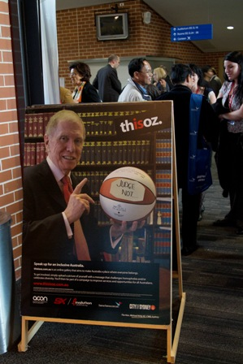
The Conference ran extremely well facilitating the enjoyment and participation of 360 delegates with a diverse range of needs. The facilities provided for the Conference was well used and we provided access to a Multifaith Room, Quite Space and Computer Room. We also provided space for stalls to be set up for people to share materials, information and purchase book in the area of HRE.

Cultural and social events
A This is Oz: speak up for an inclusive Australia slide show was screened during the Conference Reception. (http://www.thisisoz.com.au/)

UWS Music Students performed a multicultural fusion piece during the Conference Reception

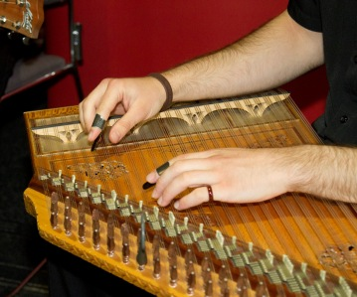
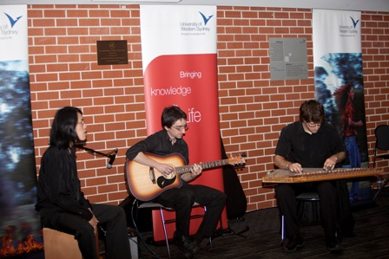

The Conference Dinner attended by over 200 Conference participants, at which the Prana Dance Company performed a Multicultural Dance piece.

Conference Organisers
The organisation of the Conference was led by Sev Ozdowski and implemented by various people and teams, as outlined below.

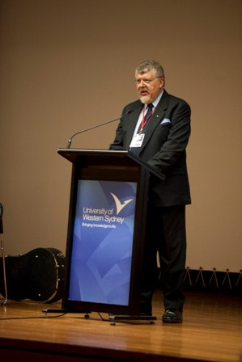
Conference Convenor
Dr Sev Ozdowski OAM FAICD
Director,
UWS Equity and Diversity

Conference Executive Officer
Ms Tatiana Lozano
Manager, Education
UWS Equity and Diversity

Conference Advisory Committee
Prof Linda Briskman, CU, Perth
Dr Nina Burridge, UTS, Sydney
Prof Kevin M Dunn, UWS Sydney
Dr Paul Hine, AHISA, Adelaide
Mr Paul Oliver, AHRC, Sydney
Dr Helen Watchirs, ACT HRC, Canberra
A/Prof. Joseph Zajda, ACU, Melbourne


Conference Organiser
Conference Online
http://www.conferenceonline.com.au/

Support team
UWS Equity and Diversity
www.uws.edu.au/equity

Brenda Burnard
Craig Hinley
Leanne Kent
Jolanta Krzywanska
Diane Le Huray
Debbie Mey
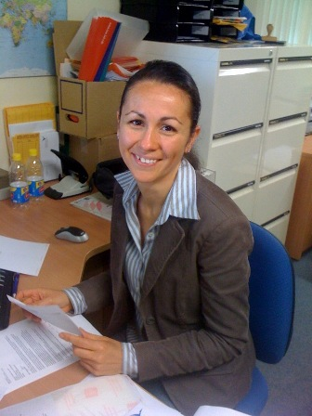
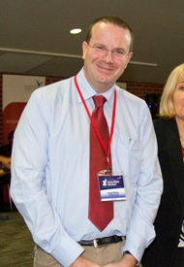
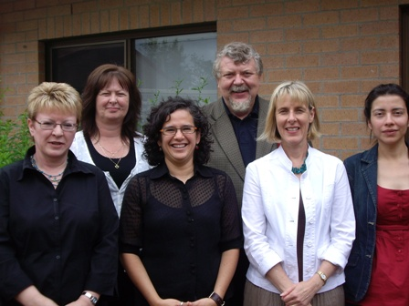

Evaluation
The Conference was evaluated in terms of pre-conference processes, conference content and facilities and catering. Out of 99 participants that evaluated their overall impression with the Conference 82% rated it as better than very good. 50% of the 79 participants that rated the quality of the speakers thought they were good to very good and out of 98 evaluations of the Conference program 80% deemed it very good.

The qualitative analysis of the Conference reflects high satisfaction with the Conference and particular value obtained from the diversity of speakers, networking and the opportunity to learn more about human rights education. Many delegates expressed their interest in another such Conference in the future. The constructive feedback included more time for dialogue/discussion as opposed to so many speakers and the need for better transport coordination.

Future
Due to the successful nature of the Conference, UWS Equity and Diversity is considering hosting another such conference in 2012. The next Conference will benefit from the feedback received from this Conference and the familiarisation with experts in the human rights area as well as the pertinent issues of interest to participants. Arising from the networking and discussions at the Conference, there has been an expression of interest by Canada and South Africa to put on a Conference on human rights education in 2011.

As a result of the Conference there were regional development such as the proposal by the Vanuatu Council of Women to host a conference in 2011 on Towards Human Rights if Pacific Women: achieving equal status and combating violence.

The Conference organisers hope that the Conference’s resolution will mean that HRE will be integrated into more areas of work by the various levels of government in Australia and overseas, including nation states and international bodies like the UN and the Council of Europe.

Thanks
The Conference team is grateful to all the people and organisations that made the Conference possible and such a success. In particular, we would like to thanks our Sponsors and Partners:

- Australian Government Aus AID
- Australian Government Attorney-General’s Department
- Australian National Commission for UNESCO
- En Masse
- Japan Foundation
- National Committee for Human Rights Education
- UWS School of Social Sciences, peace and Development Studies
- Federation of Ethnic Communities’ Councils of Australia
- Australian Human Rights Commission
- University of Technology Sydney

We would also like to thank all the speakers and chairs, many of who travelled long distances to attend the Conference and the early endorsements by the Prime Minister, Leader of the Opposition and Governor General, as well as numerous Universities who provided letters of support.

The Conference was also a great success due to the volunteer work of many students and UWS staff, as well as the general support of the Equity and Diversity team. Special thanks go to the University of Western Sydney for the support to hold such significant Conference on their campus and in particular, to the Deputy Vice Chancellor (Corporate Strategy and Services) Rhonda Hawkins for her leadership and ensuring that all UWS services combined to make the Conference a success.



Resolution adopted at the 2010 International Conference on Human Rights Education

The 360 participants attending the 2010 International Conference on Human Rights Education, who came from 27 countries, and comprised human rights experts from diverse professions and academic disciplines:

Recognise that human rights education is essential to the full realisation of human rights and fundamental freedoms and contributes significantly to promoting equality, respect for human dignity, preventing discrimination and enhancing participation in democratic processes,

Recall the United Nations commitment to Human Rights Education as articulated in the Universal Declaration of Human Rights, various treaties and the current World Programme for Human Rights Education (2005 - ongoing),

Endorse the Australian Government’s commitment to Human Rights Education as the core objective of the National Human Rights Framework (April 2010),

Call on Australian Governments (Federal, State and Territory) to:

- Include human rights education in the new National Action Plan on Human Rights being developed under Australia’s Human Rights Framework;
- Ensure that education in human rights and indigenous issues is embedded in the new national curriculum for schools;
- Adequately resource, and allocate responsibility for the implementation of human rights education, particularly for teachers and educators, civil servants, law enforcement officials, judicial officers, health practitioners and military personnel;
- Foster opportunities for learning and sharing information about human rights from indigenous peoples’ knowledge frameworks;
- Take up a human rights based approach to Australia’s overseas development assistance, including by prioritizing the integration of human rights education into its programs, particularly in conflict and post-conflict situations like Afghanistan;
- Recognise that human rights education and human rights legislation are complementary and mutually reinforcing and to consider the enactment of comprehensive federal, state and territory human rights laws, including a national Human Rights Act.

Call on the United Nations High Commissioner on Human Rights

To submit the report of this Conference to the open-ended intergovernmental working group, responsible for drafting the United Nations Declaration on Human Rights Education and Training by March 2011.

Call on the Commonwealth Secretary-General

To give priority to preparing a Commonwealth Action Plan for Human Rights Education and Training, for consideration at the Commonwealth Heads of Government Meeting (CHOGM) in Perth, Western Australia in October 2011.

Remain committed

To working with Governments and international organizations, at global regional and national levels, to promote and protect universal human rights, notably by developing and implementing Action Plans for Human Rights Education and Training.

Signed on behalf of conference delegates by

Dr Sev Ozdowski OAM
Conference Convener
University of Western Sydney
Australia

6 November 2010

Call for Human Rights Education to be integrated in aid programs

The Federal Government has been called on integrate human rights education within aid and development programs, under a resolution passed by the International Human Rights Education Conference held at the University of Western Sydney.

The International Human Rights Education Conference brought together government officials, academics and aid workers from more than 20 countries to discuss how to best increase human rights education in developing and developed nations.

The conference unanimously adopted the resolution calling on the Federal Government to ensure human rights education is integrated within overseas development assistance, particularly in conflict and post conflict situations such as Afghanistan.

The conference organiser, UWS Director of Equity and Diversity Dr Sev Ozdowski OAM, says a greater focus on human rights education abroad will help bring about change to marginalised societies.

“Countries such as Afghanistan are in desperate need of books, schools and teachers, and we must make sure Australia is training and educating more people besides soldiers,” Dr Ozdowski says.

“By making sure Human Rights Education is promoted by Australian aid programs we can teach our shared values, such as democracy and the rule of law, to children who have grown up knowing little more than oppression, war and the loss of human dignity.”

The resolution also urges the Federal and state governments to ensure human rights education is included in the national curriculum.

“The drafting of a national curriculum must take into account the role that human rights education can play in providing our children with a minimum set of standards to apply when faced with difficult life choices,” Dr Ozdowski says.

“We must make sure human rights education also takes centre stage in any future ethics classes, as opposed to relativism, which provides the perfect platform for communities and countries to sacrifice basic human rights in the name of concepts such as religion, culture and philosophy.”

The resolution from the Human Rights Education conference will be presented to the United Nations High Commissioner on Human Rights.

4 – 6 November 2010

Ian and Nancy Turbott Auditorium

University of Western Sydney Parramatta Campus

Sydney, Australia

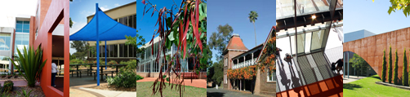

Thursday 4th November 2010
8.30 | Registration
9:00 – 9:20 |  | Conference Opening – Main Auditorium
Chair
Dr Sev Ozdowski OAM
Conference Convener

Welcome to Country
Aunty Sandra Lee, Darug Elder
Accompanied by Aunty Jacinta Tobin, Darug Elder

Welcome to the University of Western Sydney
Prof Janice Reid AM
Vice Chancellor and University President
9:20 - 9:40 |  | Opening Address - Main Auditorium
What is Human Rights Education all about and why do we need It?
The Hon Robert McClelland MP
Federal Attorney General
9:40 - 11:00 |  | Plenary Session 1 – Main Auditorium - Global Trend in Human Rights Education (HRE)
Chair
Sarah Tobhi Motha
Coordinator, HRE Centre & Umphakatsi Peace Ecovillage
South Africa

UN Initiatives in HRE and their Impact
Dr Paula Gerber
Deputy Director, Castan Centre for Human Rights Law, Monash University

Role of HRE in a Process of Transition – Polish Experience
Prof Roman Wieruszewski
Director, Poznań Human Rights Centre, Polish Academy of Sciences
Poland

From International Principles to Everyday Reality - HRE in Australia
The Hon Catherine Branson QC
President, Australian Human Rights Commission

11.30 – 13.00 |  | Plenary Session 2 – Main Auditorium  Human Rights as Unifying Standards for Society
Chair - Pera Wells
Former Secretary-General,The World Federation of United Nations Associations

Universal Values versus Religious Specificity
Prof Gary Bouma
Asia Pacific UNESCO Chair in Interreligious & Intercultural Relations Asia Pacific, Monash University

Human Rights Without a Charter: Human Rights in Australia Post the National Consultation on Human Rights
The Hon John Hatzistergos MLC
Attorney General, Minister for Citizenship and Minister for Regulatory Reform

The Debate about an Australian Bill of Rights
Phil Lynch
Director, Human Rights Law Resource Centre, Melbourne

Values in Education: Human Rights, Peace, Cultural Diversity and Intercultural Dialogue
Dr Helen Szoke
Commissioner, Victorian Equal Opportunity and Human Rights Commission
13:00 – 14.00 |  | Lunch Break

14:00 –15:30 |  | Plenary Session 3 – Main Auditorium  Human Rights Education – Regional Perspectives
Chair
Prof Pierre De Vos
Claude Leon Foundation Chair in Constitutional Governance, University of Cape Town
South Africa

Recent Developments in the Field of Education for Democratic Citizenship and Human Rights – European Perspective
Dr Reinhild Otte
Expert on Education for Democratic Citizenship and Human Rights, Council of Europe

HRE in Schools: Progress in Institutionalization and beyond - Review of Southeast and Northeast Asian Experiences
Dr Mariko Akuzawa
Assoc Prof University of Hyogo and Member of the Asia-Pacific Human Rights Information Centre, Osaka
Japan

Human Rights Education in Latin America
Dr Ana Maria Rodino
Researcher, National Distance University & Inter-American Institute of Human Rights
Costa Rica

From Political Education to HRE – a Missing Link of the Change of the Regime
Prof Máté Szabó
Eötvös Loránd University & Parliamentary Commissioner for Human Rights
Hungary
15:30 – 16.00 |  | Afternoon Break
16:00 –17:30 |  | Concurrent Sessions
 |  | Session 1 – Main Auditorium  Trends in HRE  Chair  Prof Daniella Coetzee  Director, Centre for Education Development University of the Free State  South Africa  The Extraordinary Rise of HRE - A Critical and Probing Gaze  Dr Danielle Celermajer  University of Sydney  European Achievements in HRE  Dr Peter Kirchschlaeger  Co-Founder and Co-Director, Centre of Human Rights Education, University of Teacher Education, Lucerne  Switzerland  Educational Approaches to Reduce Prejudice – A Core Element of HRE in Pluralistic Societies  Mario Peucker  Senior Researcher, European Forum for Migration Studies  Germany  HRE: Four Components and Expected Outcomes  Assoc Prof Yehudi Webster  California State University Los Angeles  USA | Session 2 – Room EEG.03  HRE in Schools  Chair  Dr Paul Hine  Board Director AHISA & AHISA Chair in SA & NT;  Principal, Sacred Heart College, Adelaide  Approaches to HRE: a Study of School and Teacher Education Programs  Dr Nina Burridge  Senior Lecturer, Faculty of Arts and Social Science, University of Technology Sydney  HRE – Best Practice Model for Secondary Schools  Dr Kerry Ang  Lecturer, Australian Catholic University  Melbourne  Cultural Literacy and Social Justice - Enabling Human Rights in and Beyond the Classroom  Prof Baden Offord  Chair, Australian Studies, The University of Tokyo, Japan & Southern Cross University &  John Ryan  Head of English Kingscliff High School  Freelance Academic  Building Human Rights Culture in Schools - a New Zealand Initiative  Ced Simpson  Director, Human Rights Education Trust  New Zealand | Session 3 – Room EEG.36  HRE Pedagogy  Chair  Tatiana Lozano  Manager Education, Equity & Diversity  University of Western Sydney  The Experience of the Development of HRE in Early Childhood in Chile - Dictatorship and Social Protection  Adj Prof Maria Estela Ortiz Rojas  Early Childhood Education Consultant for the Inter-American Development Bank  Chile  More than a Game: Using Sport and Fair Play to Promote HRE  Tanja Kovac  Co-ordinator, the Human Rights are Aussie Rules Project, Melbourne  Reflections on a Post-Graduate Human Rights Programme in Asia  Assistant Prof Kelley Loper  Faculty of Law, University of Hong Kong  China  Play and Dance for Human Rights  Visakesa Chandrasekaram  Doctoral Candidate  Australian National University  Canberra
17:30 – 19:00 |  | Welcome by Mark Dean  Reception Sponsored by En Masse
19:00 – 20:00 |  | CONFERENCE ADDRESS  Will Human Rights Shape Civilisation in 21st Century?  The Hon Justice Michael Kirby AC CMG

Friday 5th November 2010
9:00 – 9:30 |  | Plenary Address – Main Auditorium
Chair
Dr Sev Ozdowski OAM
Conference Convenor

What Government Should do to Advance a Human Rights Culture?
The Hon Christopher Pyne MP
Shadow Minister for Education, Apprenticeships and Training

9.30 – 11.00 |  | Plenary Session 4 – Main Auditorium  How to Nourish a Human Rights Culture - Australian Experience
Chair
Dr Helen Watchirs OAM
ACT Human Rights and Discrimination Commissioner, Canberra

What is the Culture of Human Rights?
Assoc Prof Joseph Zajda
Australian Catholic University, Melbourne & Research Fellow, Eidos Institute

The Role of Governments and Civil Society’s Contribution to HRE
Julian Burnside AO, QC
Barrister, Melbourne

Australian Views about Human Rights
Prof Kevin M Dunn
University of Western Sydney

Some Reflections on HRE in the XXI Century Europe
Prof Boguslawa Bednarczyk
Jagiellonian University & A.F Modrzewski Kraków University College, Cracow
Poland

11:00 – 11:30 |  | Morning Break
11:30 – 13:00 |  | PLENARY SESSION 5 - Main Auditorium  Advancing Human Rights Internationally through Education
Chair
Prof Máté Szabó
Eötvös Loránd University & Parliamentary Commissioner for Human Rights
Hungary

HRE in Muslim Societies - Afghan Experience
Ahmad Fahim Hakim
Deputy President, Afghanistan Independent Human Rights Commission
Afghanistan

A Culture of Human Rights in the Face of Cultural Diversity - The South African Experience
Prof John C. Mubangizi
Deputy Vice-Chancellor, the University of KwaZulu-Natal
South Africa

Public Human Rights Education and the Killing of Falun Gong for their Organs
Adj Prof David Matas
Faculty of Law, University of Manitoba
Canada

HRE - Community Based Approaches and Holistic Development
Sarah Tobhi Motha
Coordinator Human Right Education Centre & Umphakatsi Peace Ecovillage,
South Africa
13:00 – 14:00 |  | Lunch Break
14:00 – 15:30 |  | Concurrent Sessions
 |  | Session 4 – Main Auditorium  Peace and Human Rights Education  Chair  Assoc Prof Jake Lynch  Centre of Conflict and Peace Studies University of Sydney  Global Peace Index  Camilla Schippa  Director, Institute for  Economics and Peace, Sydney  HRE as a Mechanism for Building Peace: Inculcating Human Rights Ideals through Peace Education  Maneesha Wanasinghe-Pasqual  Lecturer, University of Colombo  Sri Lanka  Peaceful Pedagogy - Teaching Human Rights Across the Curriculum  Dr Julie McLeod  Senior Lecturer, University of Newcastle  Impact of HRE in Peace Making  Mohamed Mowjoon Atham Bawa  Post- graduate Student  University of Technology, Sydney | Session 5 - Room EE.G.03  Educating Professions about Human Rights  Chair  Prof Surya Prasad Sharma Dhungel  Adviser to the President on Constitutional and Legal Affairs & Attorney at Law  Nepal  Educating Lawyers in Human Rights in Post-Conflict Countries: Lessons from Iraq, Palestine, Libya, Afghanistan and Swaziland  Dr Phillip Tahmindjis  Acting Director, Human Rights Institute, London  United Kingdom  A Human Rights Approach to Adult Learning in Organisations  Dr Liz Branigan  Academic Program Director, Australian Centre for HRE, RMIT University, Melbourne  Promoting Social Goodness - Enhancing Professionals Responses to Human Rights Abuse  Dr Fran Gale  Research Fellow & Lecturer, University of Western Sydney  Educating the Police and the Military on Human Rights  Ana Elzy Ofreneo  Director, Commission on Human Rights of the  Philippines | Session 6 - Room EE.G.36  Combating Social Prejudice with Human Rights Education  Chair  Prof Pranati Panda  National University of Education  Planning and Administration  India  Homosexuality is “un-African”: a contemporary analysis of human rights consequences of being Lesbian, Gay, Bisexual, Transgender or Intersex in Africa  Prof Allister Butler  Social Work Department, North West University, Mmabatho  South Africa  Recognising Difference -  HR Sexualities and Refugee Law  Senthorun Raj  Manager, Policy & Development, Gay & Lesbian Rights Lobby, Sydney  Human Rights in Action for Women Prisoners  Debbie Kilroy OAM  Director, Sisters Inside, Brisbane  HRE and Obstacles to Women’s Education  Dr Madeleine Mattarozzi Laming  Faculty of Education, Australian Catholic University, Melbourne
15:30 – 16:00 |  | Afternoon Break
16:00 – 17:30 |  | Concurrent Sessions
 |  | Session 7 – Main Auditorium  Human Rights Education – Children, Young People & Our Communities  Chair  Mathews Philip  Executive Director, SICHREM  India  Creating a Human Rights Culture at  Community Level  Dr Diane Sisely  Director, Australian Centre for Human Rights Education, RMIT University  Blogging for Human Rights – the Use of the Internet in Human Rights Education  Prof Pierre De Vos  Claude Leon Foundation Chair in Constitutional Governance  University of Cape Town, South Africa  Teaching Fairness, Respect and Inclusiveness through Sport  Paul Oliver  Former Director, Public Affairs  Australian Human Rights Commission  HRE by Amnesty International  Don McArthur  Human Rights Education Coordinator, Amnesty International Australia | Session 8 - Room EE.G.03  Addressing Human Rights Education Challenges in Asia  Chair  Dr Lynda-Ann Blanchard  Lecturer, Centre of Conflict and Peace Studies, University of Sydney  HRE in Burma  Mike Paller  Deputy Director, Human Rights Education Institute of Burma  Thailand  The Need for HRE through Schools in Pakistan  Parvez Pirzado  Masters Student, University of Sydney  Deathbound Diaspora - Iraqi Bodies, Memories and Texts in Sydney  Farid Farid  Doctoral Candidate, Centre for Cultural Research, University of Western Sydney  On the Ways to Increase Awareness of North Korea Defectors’ Human Rights  Seongwoo Park  Senior Researcher, Hankuk Academy of Foreign Studies, Seoul South Korea | Session 9 - Room EE.G.36  Breaking Barriers with Human Rights Education  Chair  Dr Peter Kirchschlaeger  Co-Founder and Co-Director, Centre for Human Rights Education, University of Teacher Education, Lucerne, Switzerland  Facilitating Student Commitment to Social and Ethical Practice in the  Undergraduate Curriculum  Dr Denise Wood  Senior Lecturer, University of South Australia  Mental Health Legal Services Pilot Project  Sharny Chalmers  Project Co-ordinator, Public Interest Advocacy Centre  Educational Rights for Students with Visual Impairments in Tertiary Education: the Gap between Legislation and Practice  Muna Al Hammadi  Doctoral Candidate, Deakin University, United Arab Emirates  Geographies of Disability, Resilience and Social Justice  Lesley Lewis  Doctoral Candidate, University of Sydney
19:00 –23:00 |  | Conference Dinner  PARKROYAL Parramatta  (formerly Crowne Plaza)  Master of Ceremonies  Stephen Sim  After Dinner Speaker  Assoc Prof Peter van Onselen  Contributing Editor, The Australian  Entertainment  Prana Dance Company


Saturday 6th November 2010
9:00 - 10:30 |  | Plenary Session 6 – Main Auditorium  Human Rights, Indigenous People and Development
Chair
Dr Wendy Holland
Assoc Professor, Badanami Centre for Indigenous Education
University of Western Sydney

How Can HRE Benefit Indigenous Australians?
Dr Tom Calma
Former Indigenous Social Justice Commissioner & Race Discrimination Commissioner
Australian Human Rights Commission

New Zealand’s HRE and Maori People
Chief Commissioner Rosslyn Noonan & Senior Maori Manager Paula Pirihi
Aotearoa/New Zealand Human Rights Commission
New Zealand

Human Rights Education for Indigenous Filipinos
Claire Lacdao
Paralegal, Community Coordinator, Legal Assistance Centre for Indigenous Filipinos
Philippines
10.30 – 11.00 |  | Morning Break
11:00 –12:25 |  | Plenary Session 7 – Main Auditorium  Where do we go from here?
Chair - Dr Sev Ozdowski OAM
Director, Equity & Diversity, UWS & Adj Prof, University of Sydney

Panellists

Dr Nina Burridge
Senior Lecturer, University of Technology, Sydney

Ahmad Fahim Hakim
Deputy President, Afghanistan Independent Human Rights Commission
Afghanistan

Dr Peter Kirchschlaeger
Co-Founder and Co-Director, Centre of Human Rights Education, University of Teacher Education, Lucerne
Switzerland

Sarah Tobhi Motha
Coordinator, Human Right Education Centre & Umphakatsi Peace Ecovillage
South Africa

Cameron Murphy
President, NSW Council for Civil Liberties & Secretary, Australian Council for Civil Liberties

Dr Ana Maria Rodino
Researcher, National Distance University & Inter-American Institute of Human Rights
Costa Rica

Savita Bhakhry
Initiatives of NHRC-India on Human Rights Education
India
12.25 – 12.30 |  | LAUNCH
Future Justice Education Initiative for Secondary & Tertiary Students
Alison King
Associate Lecturer, Institute of Legal Studies, Australian Catholic University

12:30 – 13.30 |  | Lunch Break
13.30 – 15.30 |  | Concurrent Sessions
 |  | Session 10 – Main Auditorium  Workshop 1 - Human Rights & Advocacy Training - a Train-the-Trainer Course  Facilitator  Brenda Bailey  Senior Policy Officer, Public Interest Advocacy Centre (PIAC)  PIAC will conduct a train-the-trainer course, ‘Protecting Human Rights in Australia’.  The first session will highlight the essential elements of a successful human rights training program for the community sector, using homelessness as a case study.  The second session builds on the first, as participants experience interactive activities used in the training, and brainstorm how we can all ‘turn on the light’ when it comes to human rights education for the community sector. This double session will introduce participants to key principles used in PIAC’s human rights training, and provide a taste of some of the interactive exercises that have been used. We will also explore the framework needed to support participants to take action based on new learning, and build on lessons learnt. | Session 11 - Room EE.G.03  Workshop 2 - Use of Human Rights Education to Create Change at Community Level  Facilitators  Gavin Rennie  Consultant, the NZ Human Rights Commission, New Zealand  Carla Klink, Paula Pirihi, Christine Morrison  Taku Manawa Human Rights facilitators, New Zealand Human Rights Commission  Gavin will facilitate an innovative human rights community development program, Taku Manawa, being run in Aotearoa/New Zealand through the NZ Human Rights Commission. With human rights education at is core, Taku Manawa works with communities to build their ability to identify, advocate for, and resolve local human rights issues. It came from the realization that communities did not know about human rights, nor how to use them as leverage for action, and to legitimise their voice in decision-making. This workshop demonstrates the story of how the NZHRC has used human rights education to create meaningful and sustainable change – to build human rights capability amongst those most vulnerable to human rights violations, and to build understanding amongst those most able to violate, or defend, those rights. | Session 12 – Room EEG.36  Workshop 3 – Human Rights Education: Finding the Magic for the Children  Facilitators  Nicole Cardinal  Policy Research and Advocacy Adviser  Jennie Hammet  Education Coordinator  Penny Lee  Education Coordinator  Save the Children, Australia  What does human rights education for children look like in practice? Since 2006, Save the Children has implemented several human rights education programs in Australia. This workshop explores the successes and challenges of three programs based on the UN Convention on the Rights of the Child: Speaking Out, Art for Advocacy and Finding My Magic.  In particular, this workshop shares Save the Children’s journey in developing Finding My Magic, an innovative and engaging animated series for young children. A new initiative by Save the Children, Finding My Magic aims to not only teach children about human rights but also ensure that they develop the necessary skills, attitudes and behaviours to stand up for their rights and the rights of others.  This interactive workshop will allow participants to experience how human rights can be translated into meaningful real-life contexts for young children. So come prepared to participate and have some fun!
 |  | Conference Ends

13.30 – 15.30 |  | Building EB Room G.02  Annual General Meeting  National Committee on Human Rights Education  Chair  Dr Sev Ozdowski OAM  President, National Committee for Human Rights Education
For poster presentation please contact conference organizers via website
http://www.humanrightseducationconference2010.com.au/

As a result on the tremendous interest in presenting at the conference, the intended workshops as displayed on the conference website have been changed. The will know be concurrent session and all participants will be able to select to attend any of the sessions. In addition three specific skills building workshops have been added to the program on Saturday.

