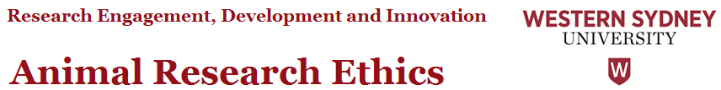
Overarching Principle and Intent
Western Sydney University complies with the Australian Code for the Care and Use of Animals for Scientific Purposes (2013) and the New South Wales Animal Research Act (1985) and its regulations. Other policies, guidelines and codes that are complied with include those published by the Animal Research Review Panel (ARRP), NHMRC and the Office of the Gene Technology Regulator (OGTR).

Alternatives to Using Animals

The Australian Code for the Care and Use of Animals for Scientific Purposes, 8th edition (2013), requires that techniques which totally or partly replace the use of animals in research and teaching must be used wherever possible. The following list presents a range of options to help reduce or replace animal use. These sources should be carefully reviewed when planning work that involves animals.

Medical Advances Without Animals (MAWA Trust)

The MAWA Trust is an Australian initiative which works closely with the research community in a positive environment to promote alternatives to the use of animals. A range of substantial grants are offered.

Animals Ethics Infolink

Animal Ethics Infolink is a NSW Department of Primary Industries and Animal Research Review Panel initiative. It provides a comprehensive list of alternatives to animal use.

Altweb

Altweb is a comprehensive database of alternatives to animal use. This is highly recommended when preparing ACEC applications.

Serum-free Culture Media

The use of foetal calf serum for in vitro cell culture has raised concerns because of the possible welfare impact. Possible alternatives to foetal calf serum can be found at Serum-free culture media and Focus on alternatives

National Centre for the Replacement, Refinement and Reduction of Animals in Research (NC3Rs)

NC3Rs is a major, multi-disciplinary effort to advance the 3Rs through improved education, research and public information.

Alternatives in Education

InterNICHE is a comprehensive, online network for bringing together information on alternatives to the use of animals in education.

European Centre for the Validation of Alternative Methods (ECVAM)

ECVAM is a major initiative by the European Commission with a particular emphasis on reducing animal use in the regulatory testing of new products. A similar organization, NICEATM-ICCVAM, has been established in the USA.

AltTox

Altox is highly informative site on the use of animals in toxicological testing. Overseen by an independent board to maintain objectivity, AltTox is a good example of the pharmaceutical industry and animal protection community working towards common goals.

Acknowlegement: University of Sydney, August 2014

Animal research ethics guidance documents available from REDI

- ACEC Frequently Asked Questions
- ACEC Amendment Guidelines
- ACEC Species, Purpose and Procedure Descriptions
- Alternatives to Using Animals
- Tips for Improving the Quality of Your ACEC Application
Animal Research Ethics Team Contact: AnimalEthics@westernsydney.edu.au
Guidance on Data Storage and Retention Questions in the NEAF

