

Western Sydney University

Global Learning

**Critical Incident Management Plan**

|  |
| --- |
|  |

Name of Project

|  |
| --- |
|  |

Host Country

|  |
| --- |
|  |

Month(s) and Year of activity, e.g. January 2024

1. Introduction

This document enables Western Sydney University staff to complete a Critical Incident Management Plan for Learning Abroad programs. This is attached to the Project Proposal and the information can be used during predeparture information sessions.

**Multiple Countries**

This form is designed for one country only. If you are visiting multiple countries (not including transit), you are required to complete a plan for each location.

1. Staff Participants

Main Project Lead

|  |  |
| --- | --- |
| Name |  |
| Position |  |
| School / Institute |  |
| Phone |  |
| Email |  |

Staff member 2

|  |  |
| --- | --- |
| Name |  |
| Position |  |
| School / Institute |  |
| Phone |  |
| Email |  |

Staff member 3

|  |  |
| --- | --- |
| Name |  |
| Position |  |
| School / Institute |  |
| Phone |  |
| Email |  |

1. Main Contacts in Host Location

Contact 1

|  |  |
| --- | --- |
| Name |  |
| Position |  |
| Organisation |  |
| Phone |  |
| Email |  |

Contact 2

|  |  |
| --- | --- |
| Name |  |
| Position |  |
| Organisation |  |
| Phone |  |
| Email |  |

1. Local Emergency and Consular Contacts

|  |  |
| --- | --- |
| Fire and Rescue Services |  |
| Medical Emergencies |  |
| Police |  |

Australian Embassy / Consulate

|  |  |
| --- | --- |
| Address |  |
| Phone |  |

To find the Local emergency contacts and Consular contacts for the host location, go to [Smartraveller](https://www.smartraveller.gov.au/destinations" \t "_blank) website. The following video will show you how to find the information. [](https://youtu.be/6VsCEV8KJlg)Need assistance, click on the video image below.

1. Corporate Travel Insurance

Students and staff that travel overseas on approved university activities are covered by the corporate travel insurance for the official component of a trip. The cover is limited and does not include personal travel before or after a program or participating in extreme or high-risk activities.

* All travellers are advised to review the information provided on the WSU [corporate travel insurance](http://www.westernsydney.edu.au/finance_office/finance/uws_insurances/overseas_travel_insurance) webpage.
* Endorsement for activities in countries with a DFAT risk level of 3 or 4 will unlikely be granted.
* Students that register on the [Go Global Application Portal](https://westernsydney.edu.au/globalmobility/goglobal/home/staff/go_global_portal), will be provided with information about travel insurance and utilising International SOS.

1. Medical, Security and Emergency Assistance

All students and staff participating in overseas activities are registered with [International SOS](https://www.internationalsos.com/). If a participant requires assistance while overseas they can contact the ISOS Sydney Assistance Centre available 24/7 (contact number **+612 9372 2468**). The Western Sydney University ISOS membership number is **12AGDA915576.**

Before going abroad, travellers should download the ISOS App and use the QR code below:



Once downloaded, ensure the Location and Notification Settings are turned on. The App can be used for:

* Easy access to the local Assistance Centre, in an emergency and for everyday advice.
* Expert medical, security and travel assistance.
* Receive the latest information about your destination.

**ISOS Services include:**

**Medical Services**

* Pre-trip information on travel health issues
* Emergency and routine medical advice
* Medical and dental referrals
* Inpatient admission and identification of receiving physician
* Outpatient referrals for minor medical incidents
* Coordination with your insurance provider and claims assistance
* Coordination of communication to loved ones in the event of an incident

**Security Services**

* Security and travel information on 850 cities and 239 countries
* Immediate help and advice from security experts by phone or chat during a security incident
* Timely email alerts and push notifications with advice and guidance in response to significant travel security incidents and local security developments
* Coordination of debrief and counselling following a security incident
* Coordination of communication to loved ones in the event of an incident

**Additional Services**

* Translations and interpreters available as needed
* Support and advise in the event of lost documentation

1. First Aid Training

It is advised that all project leaders have a current First Aid Certificate prior to going abroad. Western staff may have the option of First Aid training via [My Career Online](https://www.westernsydney.edu.au/staffonline). Some students may also require a First Aid certificate for participation in particular units and/or fieldwork, research or clinical placements. Information about training can be found on the [National Training Information Service website](http://training.gov.au/).

1. Preventing Sexual Exploitation, Abuse and Harassment (PSEAH)

Western Sydney University and the Australian Government have a zero-tolerance policy towards sexual exploitation, abuse, or harassment. The Department of Foreign Affairs and Trade's (DFAT) Preventing Sexual Exploitation, Abuse and Harassment (PSEAH) policy establishes clear behaviour expectations and standards for all individuals and organisations, both in Australia and abroad. Under this policy, university project leaders and partner organisations must engage in comprehensive due diligence and risk mitigation, adhering to the [DFAT SEAH policy](https://westernsydney.edu.au/globalmobility/goglobal/home/ILP/areas/seah) and the [Western Sydney University Sexual Harassment Prevention Policy](https://www.westernsydney.edu.au/equity-and-diversity/rights_and_protections/sexual_harassment). Students at Western Sydney University are obligated to:

* Read the  [DFAT SEAH policy](https://westernsydney.edu.au/globalmobility/goglobal/home/ILP/areas/seah).
* Complete the WSU  [Respectful Relationships training](https://www.westernsydney.edu.au/respectful-relationships/respectnowalways).

For support, students aware of or personally experiencing unwanted incidents can access services through the Office of Equity and Diversity. There are two avenues for reporting incidents:

* [The Australian Government SEAH website](https://www.dfat.gov.au/international-relations/themes/preventing-sexual-exploitation-abuse-and-harassment/Pages/default)
* [WSU Sexual Harassment and Sexual Assault](https://www.westernsydney.edu.au/equity-and-diversity/rights_and_protections/sexual_harassment)

If a SEAH incident does occur during a program it must be reported in the WSU [Sexual Offences Reporting Portal](https://policies.westernsydney.edu.au/download.php?id=873&version=1&associated) (SORP) either directly by the student/staff themselves or on their behalf.

These measures ensure a committed approach to preventing and addressing sexual misconduct within the university community.

Students that register on the Go Global Application Portal are provided with this information. To find out more about PSEAH, watch the following video.

[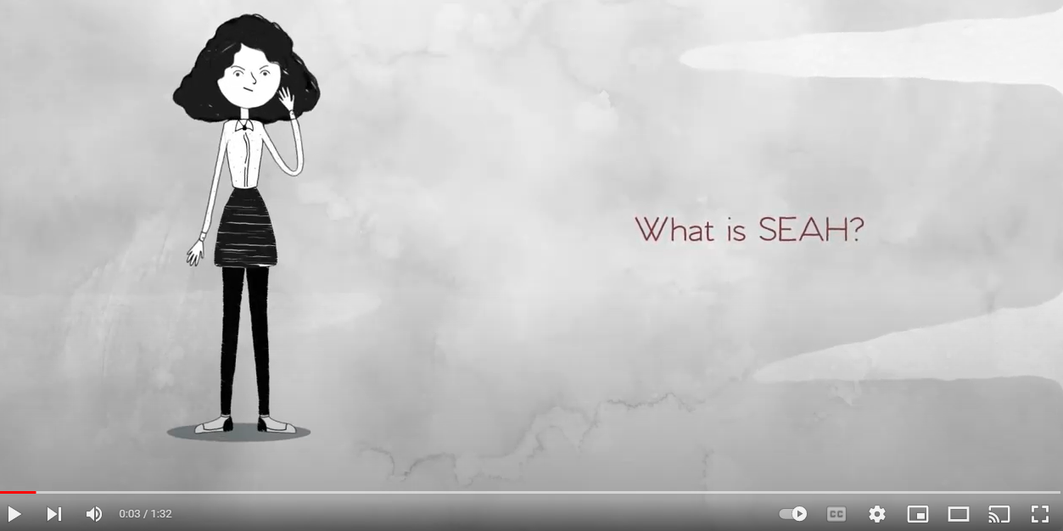](https://youtu.be/EQAGv_RgeGM)

1. Child Protection

Australia is a signatory to the United Nations Convention on the Rights of the Child. DFAT is committed to upholding the rights of the child and Australia’s obligations under this convention. In all actions concerning children, the best interests of the child shall be a primary consideration.

Participants in a Global Learning project must recognise that it is the shared responsibility of all adults to prevent child exploitation. If a learning abroad program involves working with children, all staff and students are required to comply with the Western Sydney University [Working with Children (Workers and Students) Policy](https://policies.westernsydney.edu.au/document/view.current.php?id=134) and Australian Government [Child Protection Policy](https://westernsydney.edu.au/globalmobility/goglobal/home/ILP/concept_and_risks/child_protection).

**Defining Child Abuse and Exploitation**

The term “child abuse” includes physical, emotional and sexual abuse, and neglect. The phrase “exploitation” can cover a multitude of situations or practices. If you are unsure about what constitutes child exploitation and abuse, contact the Child Protection Compliance Section for confidential advice via telephone +61 2 6178 5100 or email [childprotection@dfat.gov.au](mailto:childprotection@dfat.gov.au).

**Reporting Child Exploitation**

**Western Sydney University**

The University has an obligation under the Act to notify the Office of the Children's Guardian of any finding by the University that a Worker has engaged in sexual misconduct committed against, with or in the presence of a Child, including grooming of a Child; or any serious physical assault of a Child. For further information about reporting an incident see the [Working with Children web page](https://www.westernsydney.edu.au/human_resources/ohr/your_employment/working_with_children).

**Department of Foreign Affairs and Trade**

To report an instance, suspicion or allegation of child exploitation and/or abuse, you may do so by using the form available on the [DFAT website](https://www.dfat.gov.au/international-relations/themes/child-protection/Pages/child-protection). Child exploitation and abuse is not tolerated by DFAT and attracts criminal penalties under Australian legislation.

Students that register on the Go Global Application Portal are provided with this information. To find out more about PSEAH, watch the following video.

[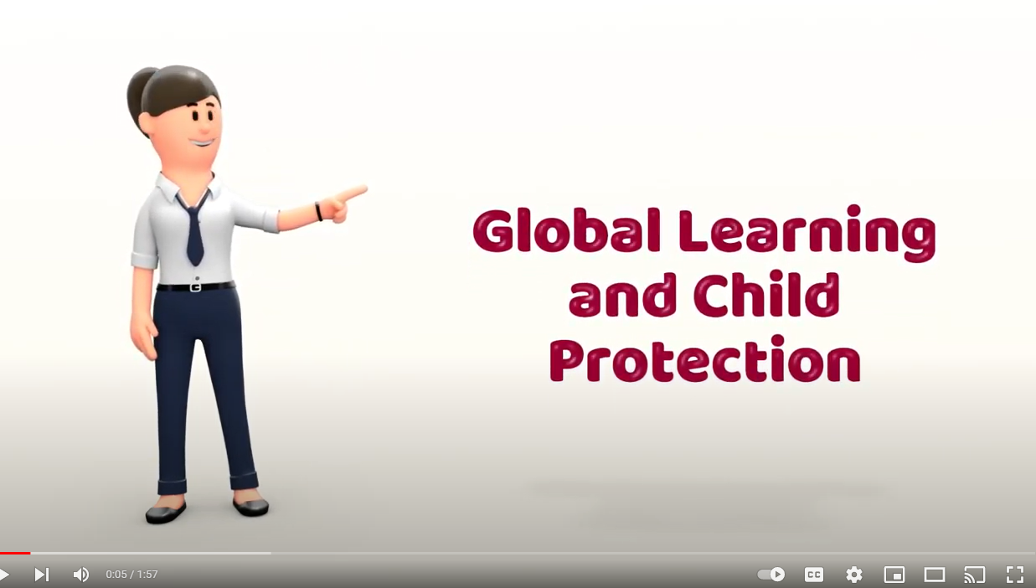](https://youtu.be/s6VcGxyJ3kw)

1. Countering Foreign Interference

Under the [Australian Foreign Relations (States and Territory Arrangements) Act 2020](https://www.foreignarrangements.gov.au/), Western Sydney University is required to report foreign arrangements (agreements) between the University and any non-autonomous foreign entity, and to work towards the mitigation of efforts by foreign governments which may be considered counter to Australia’s national interests.   
  
Western has taken efforts to evaluate and assess partnership agreements to ensure that our staff and students are protected against potential threats, however, in the situation where a student or staff member feels they have been targeted, harassed, or intimidated by a potential foreign political entity or individual, they are encouraged to submit a complaint via our [Complaints Management and Resolution unit.](https://www.westernsydney.edu.au/complaints/complaints_management_and_resolution)   
  
If further information or guidance is needed, students or staff may reach out to the [Foreign Arrangements team](mailto:dfatreporting@westernsydney.edu.au) for confidential guidance.