This document has been developed for the purposes of WHS & Wellbeing evaluation – Please note, this is one part of your travel application. All risk scores recommended by WHS & Wellbeing Unit may be escalated for review by your Senior Delegate. Please complete the below risk assessment and checklist with your Supervisor/Line Manager approval and email the completed documentation to whs@westernsydney.edu.au.
Staff Members Name:  Staff ID:  Position: | Duration of Travel:  Or staff member employed overseas?  ☐ Yes ☐ No | List Country/s Travelling to: | What work is being completed?
Contact Details for Emergency Purposes  Mobile Number:  Personal email: | Overseas Workplace details for Emergency Purposes  Address:  Country:  ZIP or Post Code: | Supervisor/Line Manager Details  Name:  Position:  Mobile Number: | Staff Members Emergency Contact Person  Name:  Mobile Number:  This will only occur if attempts to reach you have failed. | Do you give your supervisor permission to contact this person in the event of an emergency?  ☐ Yes ☐ No
WSU Emergency Contact:  WHS Director  Name: Paolo Spinetti  Work Number: (02) 9852 5177  Mobile: 0466 061 696 | Supervisor/Line Manager approval:  ☐ Yes ☐ No | HR Approval:  ☐ Yes ☐ No | Date Completed:

Part A: State of Connection
Please answer the following questions to determine the staff members State of Connection under the NSW Workers Compensation Act 1987.

- Is the staff member travelling for the purposes of work or are they being employed outside of the state of NSW?

- Is this a temporary arrangement? e.g. Will the staff member be returning to NSW?
☐ Yes ☐ No
Part B: Potential Health Risk
- Do you currently have a Reasonable Adjustment Plan (RAP) with your current work arrangements?
☐ Yes ☐ No If yes, please attach the RAP to this Risk Assessment, along with a signed medical certificate from your treating medical practitioner.
- Do you have a current medical condition that restricts you from flight travel? (If someone on your behalf is answering this question, they must have expressed authority to do so).
☐ Yes ☐ No If yes, please attach a signed medical certificate from your treating medical practitioner

Please select the relevant control measures that will be put in place and advise who is responsible for implementing them.
Item | Hazard description | How exposed to hazard | Risk Rating – before controls  (High/Medium/ Low) | Recommended risk control measures  (when implemented these controls are designed to reduce risk to as low as reasonably achievable) |  | Select controls to be incorporated | By whom
1 | Illness/ Injury | - Pandemic  - Epidemic  - Foreign Diseases  - Negative impact on pre-existing injury/illness |  | - For overseas appointees proof of insurance must be presented to HR/Recruitment. |  | ☐
 |  |  |  | - Do you have any pre-existing medical conditions?  - WHS & Wellbeing is required to review with your manager. |  | ☐
 |  |  |  | - Have you had a double dose of a COVID-19 vaccination? |  | ☐
 |  |  |  | - Is the staff member considered at-risk/vulnerable to COVID-19 Covid-19 Advice?  - WHS & Wellbeing has been contacted and a personal risk assessment has been facilitated |  | ☐
 |  |  |  | - Consultation with supervisor and GP on vaccinations and medical advice (including advice on the destination food and water quality, COVID-19 vaccinations) |  | ☐
 |  |  |  | - Follow advice from the Australian Department of Foreign Affairs and Trade (DFAT) Smartraveller and the University’s procedures in the event of an epidemic or global pandemic. |  | ☐
 |  |  |  | - Do you have an active Workers compensation claim?  - Approval has been sought from your case manager and the Injury Management Coordinator has been notified |  | ☐
 |  |  |  | - If pregnant, seek approval from your obstetrician |  | ☐
 |  |  |  | - If an injury or incident occurs, contact your supervisor and complete the Incident Notification Form |  | ☐
 |  |  |  | - Add other controls unique to your travel. |  | ☐
2 | Natural or unforeseen disasters  Civil unrest | - Earthquake  - Terrorism  - Hurricanes etc. |  | - Register with DFAT Smartraveller to receive warnings |  | ☐
 |  |  |  | - Contact your supervisor and complete the Incident Notification Form |  | ☐
 |  |  |  | - Add other controls unique to your travel. |  | ☐
3 | Ground transportation | - Travel to isolated or remote areas |  | - Utilise transport options such as taxis or hire cars organised at the airport or through hotels where possible. Confirm bookings prior to pick-up. |  | ☐
 |  |  |  | - Use hand sanitiser or sanitising wipes and a mask when using transport |  | ☐
 |  |  |  | - Will you be travelling off road?  - Is your mode of transportation appropriate for the terrain?  - Do you have an Emergency First Aid Kit?  - Do you have appropriate communication devices? |  | ☐
 |  |  |  | - Add other controls unique to your travel. |  | ☐
4 | Security/Violence | - Mugging  - Pick pocketing  - Personal confrontations |  | - Keep copies of important documents in several places. |  | ☐
 |  |  |  | - Plan your routes carefully as a pedestrian avoiding known problem areas |  | ☐
 |  |  |  | - Do not carry large visible sums of money or other valuables (conceal from sight if it is necessary to carry) |  | ☐
 |  |  |  | - Travel in pairs or groups if possible and seek advice from local hotel staff about safe places to visit. |  | ☐
 |  |  |  | - Contact your supervisor and complete the Incident Notification Form |  | ☐
 |  |  |  | - Add other controls unique to your travel. |  | ☐
5 | Fatigue | - Long haul flights  - High workload/long hours  - Inadequate rest breaks  - Frequent travel |  | - Prepare itinerary incorporating work schedule, travel time, rest breaks and Leave ahead of departure. |  | ☐
 |  |  |  | - Break up flights where possible with stopovers. |  | ☐
 |  |  |  | - Limit the number of long-haul flights per year for frequent travellers. |  | ☐
 |  |  |  | - When returning from overseas, follow the State or Territory’s Quarantine requirements – Department of Health information for International Travellers |  | ☐
 |  |  |  | - Add other controls unique to your travel. |  | ☐
6 | Carrying medically prescribed drugs through customs | - Customs may not recognise prescribed drugs |  | - Consult GP to request written advice confirming the legitimacy to carry medicine into a foreign country or returning to Australia |  | ☐
 |  |  |  | - Ensure all medication is clearly labelled. |  | ☐
 |  |  |  | - Add other controls unique to your travel. |  | ☐
7 | Socio-cultural and work environment | - Unfamiliar with laws, culture, customs  - Hostile environment or climatic extremes  - Working alone or in isolated area  - Workplace of host/partner organisation |  |  | - Utilise DFAT Smartraveller to educate yourself on the local environment and culture. | ☐
 |  |  |  |  | - Plan and implement sound communication strategies relevant to the level of risk of the location, work environment and skill level (mobile, email, satellite, landline access). | ☐
 |  |  |  |  | - Request induction to host or partner organisation workplace (including locations of emergency egress) and comply with local safe work practices. | ☐
 |  |  |  |  | - Use suitable workstation where provided.  - Tips for working from Home | ☐
 |  |  |  |  | - Add other controls unique to your travel. | ☐
8 | Manual Handling, Slips/Trips | - Heavy or awkward luggage  - Carrying equipment or work materials  - Poor work posture/setup  - Unsafe ground surface  - Inadequate footwear  - Carrying items that obscure view or distract concentration |  |  | - Dispatch equipment or materials prior to travel. | ☐
 |  |  |  |  | - Divide loads into smaller sizes. | ☐
 |  |  |  |  | - Utilise airport, hotel or personal trolleys. | ☐
 |  |  |  |  | - Purchase ultra-light overhead luggage. | ☐
 |  |  |  |  | - Apply ergonomic principles when using laptops in hotel rooms. | ☐
 |  |  |  |  | - Choose appropriate footwear, safe paths of travel and maintain concentration while moving from point to point. | ☐
 |  |  |  |  | - Add other controls unique to your travel. | ☐
9 | Psychological Injury | - No regular contact with Supervisor  - No Access to support network.  - Lone work. |  |  | - Organise regular meetings on zoom etc with supervisor.  - The staff member and Manager will complete the following as a guide:  Day Time Communication Method  Monday DD/MM/YYYY Please confirm Please Confirm  XXXXX | ☐
 |  |  |  |  | - Complete Appendix 1 and 2 of the Working from Home Agreement and Checklist  - Does the staff member have all the tools and connectivity to allow her to complete tasks required as per her job description?  - Contact WHS & Wellbeing for more information or visit Working from Home by SafeWork Australia | ☐
 |  |  |  |  | - Does the staff member have the contact information for the Employee Assistance Program (Access EAP)?  - Information on Western Sydney University’s Wellbeing programs and additional Resources | ☐
 |  |  |  |  | - Add other controls unique to your travel. | ☐

Risk Assessment Matrix – The risk matrix below is used to determine the level of risk for each hazard.
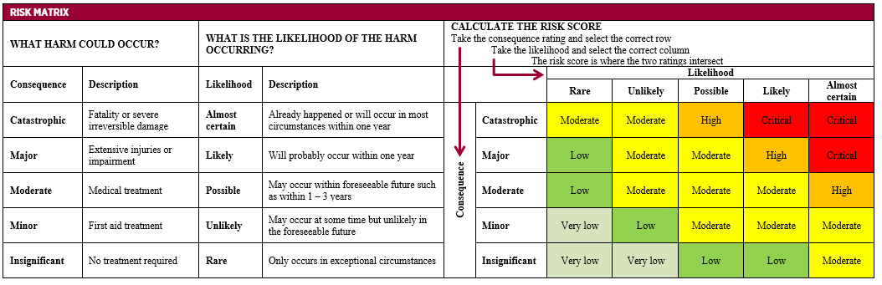
Supervisor/Line Manager to Complete
I have reviewed the risk assessment(s) provided | ☐ Yes | ☐ No
Other Comments:

Signatures:
Staff Member: | Signature: | Date:
Supervisor/Line Manager: | Signature: | Date:

