Western Sydney University Student Elections Guide
Student Editors
2020

ABDELLATIF, Shayma
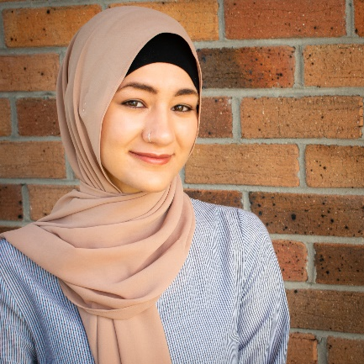
18754647
Shayma ABDELLATIF
I’m a fourth-year student majoring in journalism. I’m running for a student editor position in W’SUP.
Being part of W’SUP, since February, has been an amazing experience, and I would appreciate your vote to continue in this role and help our publication grow.
I appreciate the University’s diverse atmosphere and I would like my work to reflect the different perspectives and experiences of WSU students. With a passion in human rights, social justice, politics, and culture, I hope to write about a wide range of topics that concern students most. My aim is to communicate complex ideas effectively in a manner that is easily understood by all.
Being involved with student clubs and organising events, has given me a better understanding of students, their interests and concerns that I hope to explore in my articles.
I promise to support students’ contribution to W’SUP, to the best of my ability.

Da SILVA, Clare
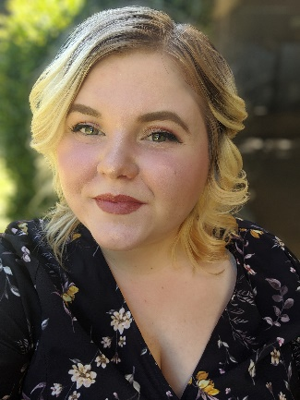
18659027
Clare Da SILVA
My name is Clare and I am studying a Bachelor of Arts/Bachelor of Laws. My fascination with the power of words and ideas intertwined with my desire to be an advocate for those in need is why I am running for Student elections. Students need opportunities to prepare for their future workplaces, to have fun on campus and have their voices heard. My previous experience as Parramatta South Campus Representative this year has equipped me with the tools and connections to advocate further for students. In addition, I have held other representative roles on campus including President of the Debating Union, 21C Student Partner and more. I hope to use my skills and experience gained in these areas to further assist students as well as the development of student clubs through consistent advocacy if given the opportunity to lead in this space. Vote for Clare, the candidate that cares.
FOCAS, Vlad
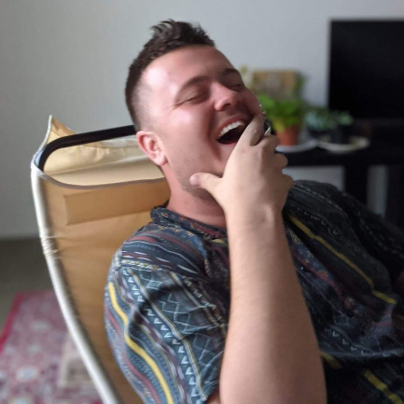
19028848
Vlad FOCAS
“Journalism is what maintains democracy; It’s the force for progressive social change” – Andrew Vacchs. Power I am a firm believer in the power and affect of a single voice, the impetus underlying my passion for empowering the student voice was propagated when I attended a talk hosted by Nobel Peace Prize laureate Malala Yousufzai. After listening to the bravery of Malala, who stood up to the Taliban for her education, I summoned my latent voice, and represented my community by serving as the executive secretary on the Bankstown Student Civic Committee and om Bankstown Campus Representative on the student representative council. I am wholeheartedly passionate about delivering informative, thought-provoking and insightful articles to the students of Western Sydney University. I solemnly swear to wholeheartedly integrate the student voice and make it an integral basis for every publication. By voting for me, you are voting for the evolution of society and
GRANERO, Isabella
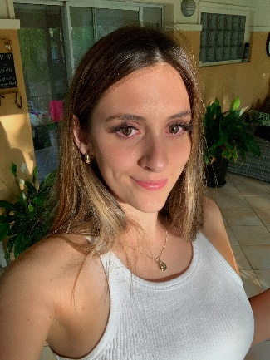
19283861
Isabella GRANERO
I would love to continue my role as student editor for W’SUP as I am passionate about promoting W’SUP and its opportunities for student involvement. So far, I have published a story and promoted W’SUP on social media to encourage students to pitch stories, art and other creative ideas. I recognise diversity as one of Western Sydney’s strengths, and this is why I want to encourage an all-inclusive environment – where students from all religions, ethnic backgrounds and sexual orientations feel seen and heard. I believe that my writing and editing skills, combined with my enthusiasm for Western Sydney will help me to write content that is beneficial to students.
HAQUE, Ishmamul
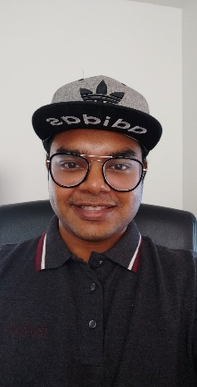
19478584
Ishmamul HAQUE
Hi, I am running for student editor and would love your support. I want to make W’SUP more student focused by including more articles on stress and health management because that is a growing concern for students. The website would include a “Positive Story of the Day” to balance all the negativity around us. Particularly to tackle events such as COVID-19, I want a timeline of advice from the Uni which would summarise and put the information from the emails in one place. I am also looking to produce an environmentally friendly digital magazine to reduce the paper in printing W’SUP. I would reach out to more students from disciplines such as business, psychology, education, nursing because these voices should also be heard alongside communications students. Finally, I want to focus more on campus clubs and activities to help students find their own communities and friends to grow with!
KHAITAN, Ishita
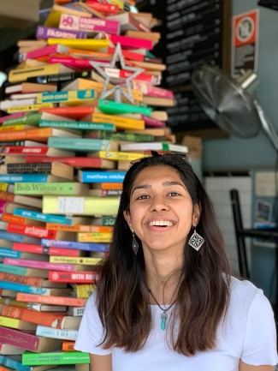
20008619
Ishita KHAITAN
Hi, my name is Ishita and I am hoping to be the Student Editor for 2020. I am a first year student of Master’s in Business Analytics. I currently teach and also volunteer at LifeLine.
Through this opportunity, I want to ensure that the voice of students does not go unheard. I hope to give more students the opportunity to get noticed, talk about difficult topics and make relevant issues both on and off campus heard.
I also want to take this opportunity to raise awareness in students about the events and activities organized on campus. I also hope to create a streamlined ‘events calendar’ – to keep students updated.
MUHAMMAD, Radia
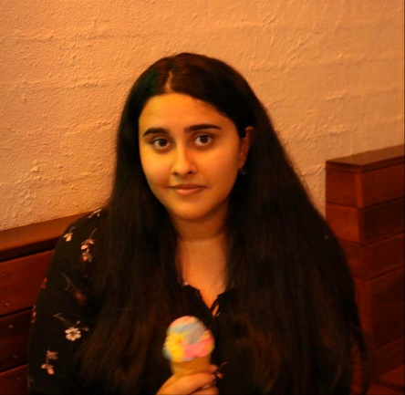
19761767
Radia MUHAMMAD
I have been a member of the student editorial team at WSU since last year’s elections. Working as an editor for W’Sup has allowed me the opportunity to develop my skills in writing and explore my interest in journalism. I am enthusiastic and well-natured which has allowed me to work well in teams and create strong connections with others. I have a keen interest in exploring different cultures and creating content that is in the interest of the people at WSU. Additionally, I hope to touch the hearts of the readers and to become a bridge between their concerns and give them a voice. As an artistic person I want to create content that will comfort and engage the readers, and be a part of creating something important. My experience as a student editor for the past year makes me a suitable candidate for this role.
PARKAR, Rameez
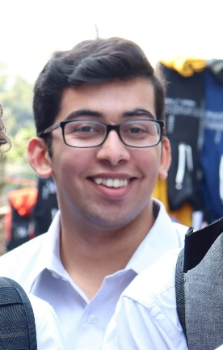
19290573
Rameez PARKAR
Hi I’m Rameez. I never thought I would ever run for the Western SRC but I don’t think I could sit by quietly any longer. For too long now the students of Western Sydney University have had their interests ignored. Like many students I have met my “uni life” consists of coming to class and going home because there is not enough to do on campus. That is why I started a student club and that’s why I’m now running for the SRC. I think that so much can be done to serve the interests of students rather than spending hundreds of thousands of dollars on merchandise that the vast majority of the 45,000 Western students have never seen. There has never been a more important time for strong progressive, principled and pragmatic students representatives fighting for us! Let’s make WSU even better! Vote [1] Rameez Parkar and JUMPSTART!
PHAM, Emily

19411460
Emily PHAM
To be an editor for university’s newspaper, besides writing and editing skills, one should have a writing style that suits students’ interest, and an eye for detail. As a third year Communication student, I ‘m confident that I have skill and experience on writing as well as editing news and stories to be a WSUP Editor. Having written stories for WSUP before, I realized this was such a perfect platform for me to express my skill and knowledge, and I believe I can be a fresh element in the WSUP team by contributing stories and opinions from the City campus. Also, as an editor, I’d be able to help students create interesting stories and share them to public.
ROUMIEH, Dania
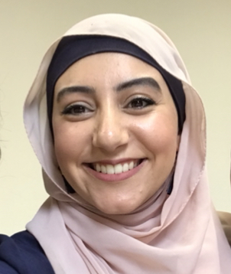
19002415
Dania ROUMIEH
As part of the Strength and Integrity SRC team, I would be honoured to be the Student Editor represent for 2020. I am Dania Roumieh, and currently in my last year studying Bachelor of Communications (Journalism) at Western Sydney University. To be elected as Student Editor would be a privilege position to encourage student voice to be heard equally and respectfully. I am passionate in writing, editing and publishing articles concerning diverse and controversial issues, and would love to invest my journalistic skills and abilities in the team’s production and distribution of the W’SUP newsletter. I have had multiple years of experience with leadership, and most recently as Vice-president of the WSU MSA (Muslim Student’s Association) and Head of Promotions and Head of Programming of a Tutoring centre. The position would be used to empower students to speak up and be heard.
Van Der MEULEN, Kiara

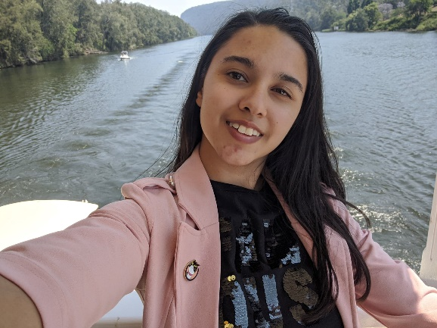
19703754
Kiara van der MEULEN
I want to be a student editor because I think it will be enjoyable and I would be good at it. I study a Bachelor of Arts majoring in Creative Writing and a Bachelor of Creative Industries majoring in Graphic Design, so naturally I have some qualities of an editor. My home campus is Parramatta South and you can often find me reading or writing in the library or the cottage. I am sure there are a lot of slogans or promises I could say to make people vote for me but in all honesty I am just a writer; elections are usually popularity contests and I have no idea if this one is any different. I can only hope that I get a chance to do something I want to do. Thanks to anyone who read my candidate statement.

