WESTERN SYDNEY UNIVERSITY   
Quick Reference Guide (QRG)  
Managing AskWestern Knowledge Articles in

WESTERN**NOW**

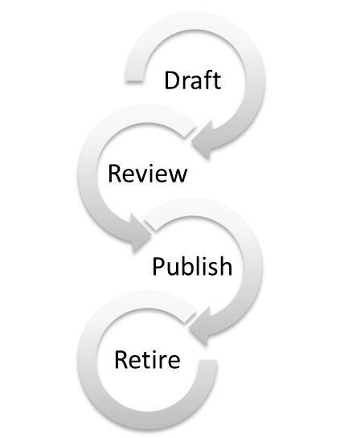

Version 2.0

Student Experience Office

Author: Bryan Williams

Contents

INTRODUCTION 3

WESTERNNOW and AskWestern 3

AskWestern Roles, Responsibilities, Security and Permissions in WESTERNNOW 4

Browse and search for AskWestern knowledge articles in WESTERNNOW 4

ASKWESTERN KNOWLEDGE BASE IN WESTERNNOW 6

Create a Student AskWestern Knowledge Article in WESTERNNOW 7

Peer Review and Publish a Student AskWestern Knowledge Article in WESTERNNOW 10

Change or Correct a Student AskWestern knowledge article in WESTERNNOW 11

Retire a Student AskWestern knowledge article in WESTERNNOW 12

= This will change = Useful tip  = Important note

## INTRODUCTION

This quick reference guide (QRG) covers the basics about how to manage AskWestern knowledge articles within the WESTERN**NOW** platform.

It includes:

1. How to use WESTERN**NOW** to manage your knowledge
2. Workflow
   1. Functionality of WESTERN**NOW** in Drafting, Approving, Publishing and Retiring knowledge articles
   2. Managing voice of the customer ~ feedback from staff and students (VOS)



Refer to Knowledge Management Playbook in the Knowledge Management SharePoint site for collateral about guidelines, templates, style, tone, process.

NOTES: - Information in this QRG will change with scaled maturity of knowledge management capability. MC900437797[1]

MC900437797[1]

### WESTERNNOW and AskWestern

WESTERN**NOW** is the technology platform that contains several knowledge bases. See below cathedral diagram.

**API’s**

**Others***(genre Knowledge base)*

**My IT Portal***(IT related knowledge base)*

**AskWestern** *(student knowledge base)*

WESTERNNOW

### AskWestern Roles, Responsibilities, Security and Permissions in WESTERNNOW

The below table outlines AskWestern’s roles and responsibilities within WESTERN**NOW**

|  |  |  |
| --- | --- | --- |
| **Role/System** | **Security & Permissions** | **Responsibility** |
| User  AskWestern | * Read (view only) | Read only access (Students, Staff and Public) |
| Knowledge Developer WESTERNNOW | * Read (view only) * Write (create & develop) * Edit (update, change & correct) | Initiators create, develop and author articles.   * Can author articles * Must assign a knowledge champion as peer reviewer to publish |
| Peer Reviewer WESTERNNOW | * Review and Read (view only) | Approve or reject knowledge developer articles for publishing |
| Knowledge Champions WESTERNNOW | * Read (view only) * Write (create & develop) * Edit (update, change, correct, approve, reject, publish & retire | Curators are responsible for article integrity.   * Can author, develop and peer review articles. |
| Knowledge Manager WESTERNNOW | * Read (view only) * Write (create & develop) * Edit (update, change, correct, approve, reject, publish & retire) * Configure (manage the knowledge base). | Administrators have full access   * Can assign categories, pin articles, amend the approvals workflow for the entire knowledge base, and formulate user groups.   Staff with this access also receive notifications from WESTERN**NOW** for any article lifecycle events (approved/rejected/published/retired/commented)  * Best practice:- Restrict access to 1 or 2 people per knowledge base. |

### Browse and search for AskWestern knowledge articles in WESTERNNOW

1. Click on AskWestern

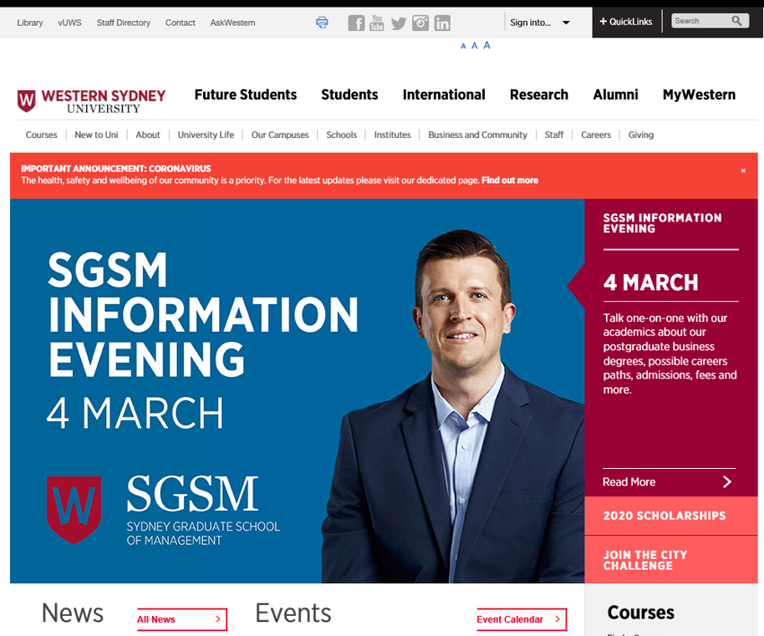

NB: - Navigating to AskWestern can also be done via MyWestern and Student Central web pages

1. AskWesternbrowse and search navigation

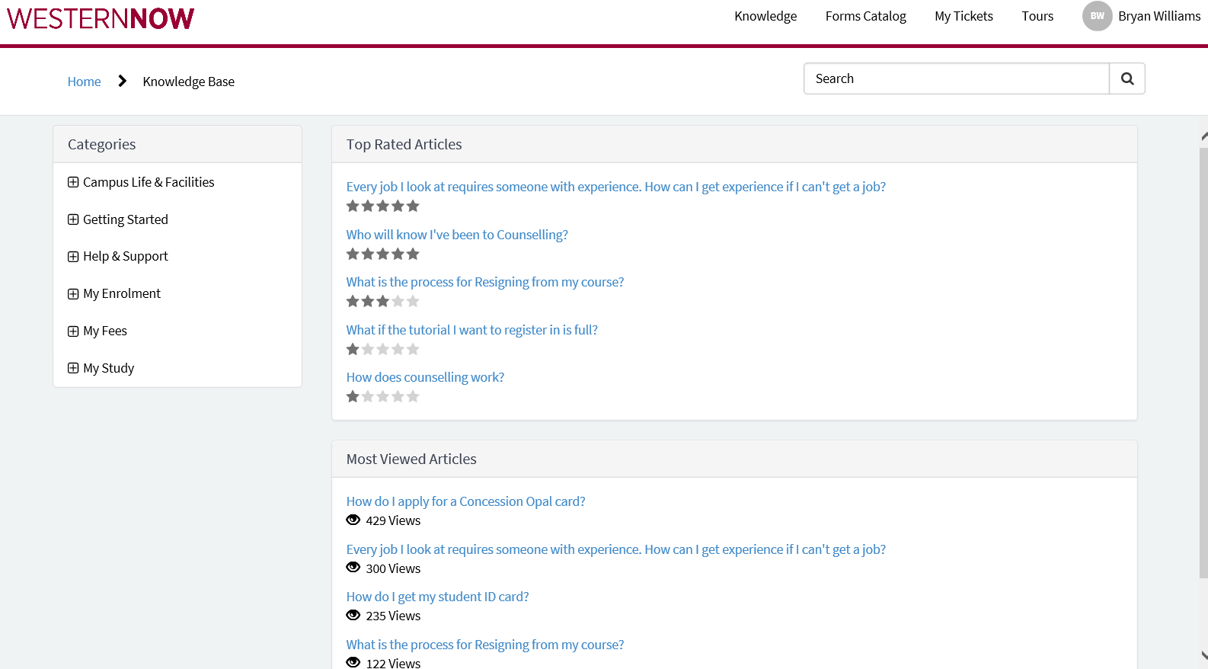

|  |  |  |
| --- | --- | --- |
| # 1 | **Ribbon Tabs** | A number of ‘Tabs’ will appear above the site page content to indicate what actions you can perform. |
| # 2 | **Personal Menu** | This is your profile menu. |
| # 3 | **Site Search** | This is another way you can find content that exists within WESTERN**NOW**. This menu allows you to search for knowledge articles. Articles can be found with keyword(s) of an article title or of in article content. Articles can also be found using the article number (usually starts with KB followed by 7 digits) |
| # 4 | **Categories** | This is another way you can find content that exists within WESTERN**NOW**. Use this to navigate by category filter to find information. |
| # 5 | **Top Rated Articles** | This shows you the top rated articles based on current usage. |
| # 6 | **Most Viewed Articles** | This shows you the most viewed articles based on current usage. |

## ASKWESTERN KNOWLEDGE BASE IN WESTERNNOW

If you try to create an article with more than 2 MB of data, the article might fail to create because of the Now Platform limitation.

1. Go to and log in to WESTERN**NOW**
   1. <https://wsu.service-now.com>
      1. Username = STAFF ID #
      2. Password = Windows login

#### AskWestern Knowledge Base navigation in WESTERN**NOW**

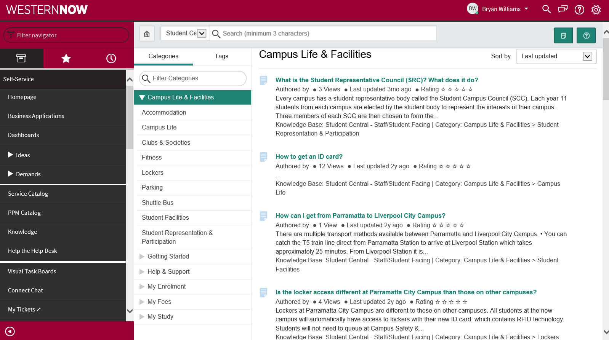

|  |  |  |
| --- | --- | --- |
| # 1 | **Filter Navigation** | A number of filters can be applied to navigate easier. |
| # 2 | **Site Search** | This is another way you can find content that exists within WESTERN**NOW**. This menu allows you to search for knowledge articles. Articles can be found with keyword(s) of an article title or of in article content. Articles can also be found using the article number (usually starts with KB followed by 7 digits) |
| # 3 | **Personal Menu** | This is your profile menu. |
| # 4 | **Filter Categories** | This is another way you can filter and find content that exists within WESTERN**NOW**. Use this to navigate by category to find information. |
| # 5 | **Search Results** | This shows you the search results. |
| # 6 | **Sort by** | This allows you to sort search results. |
| # 7 | **Command Controls** | These are your administrator command controls (Create and Q&A) |

### Create a Student AskWestern Knowledge Article in WESTERNNOW

1. Navigate to Self Service
2. Click on Knowledge in the filter navigation
   * You can view only the knowledge bases to which you have access.
3. Click on Student Central – Staff/Student Knowledge Base

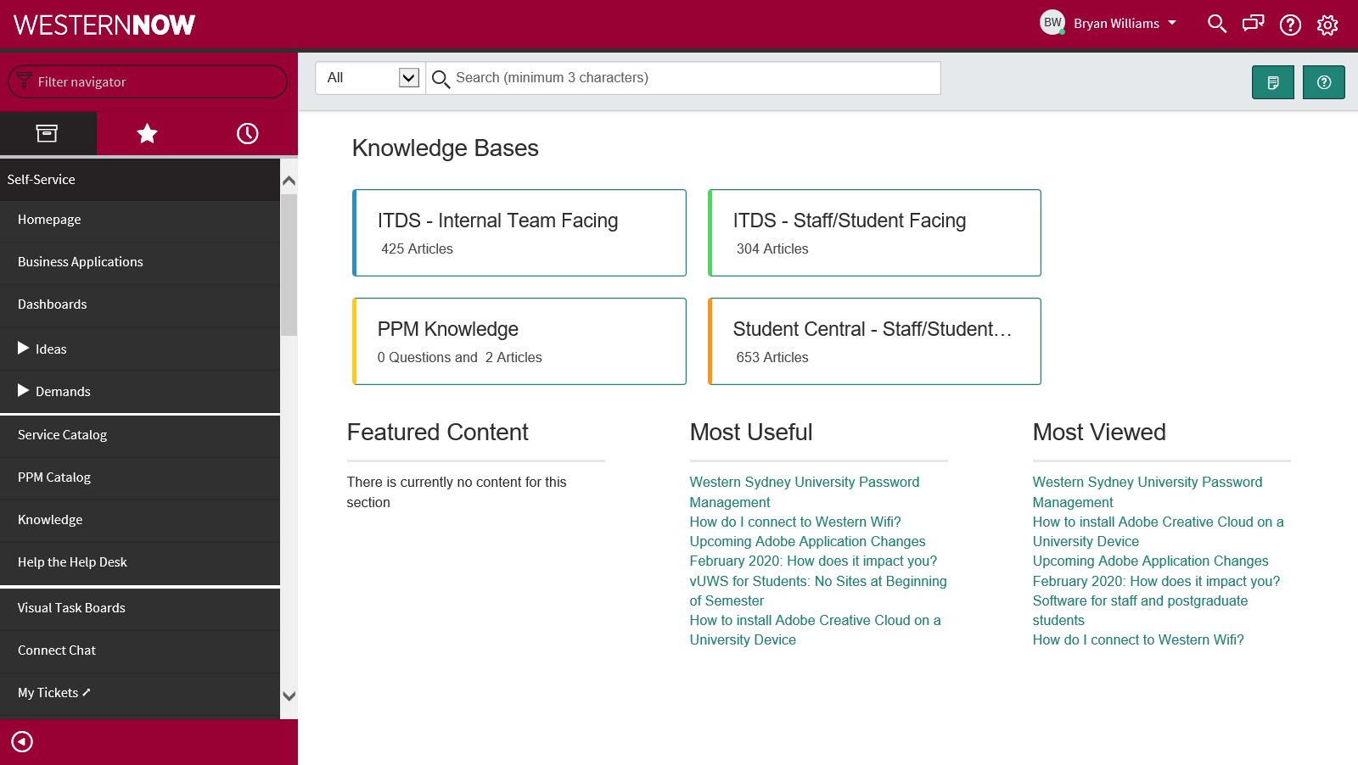

1. Click on Create an Article (in the top right hand corner)



1. Fill in the required fields on the form.



The Knowledge form is displayed based in the digital article template.

Refer to the Knowledge Playbook for template and principles.

Make sure Student Central knowledge base is selected

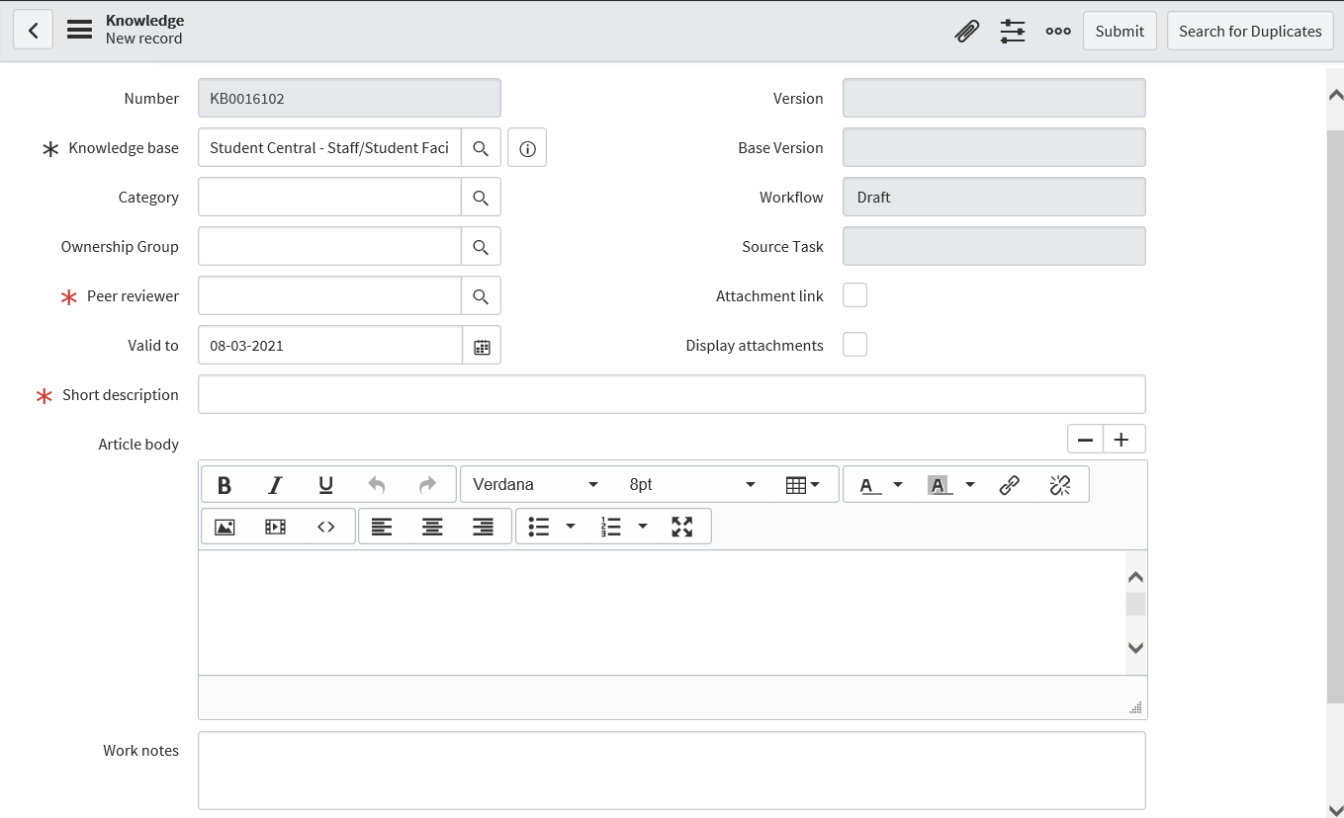



| **Field** | **Description** |
| --- | --- |
| Knowledge Base | Make sure Student Central – Staff/Student Facing is the selected knowledge base |
| Category | Allocate the category for this article. Your category is your line of business. Refer to the Knowledge Champion Article List to identify the category.  **Note:** Articles without a category appear on the knowledge homepage in the (empty) category, which limits the articles findability in search. |
| Author | **Author** must be an existing WSU employee who has knowledge of the information content, preferably the article creator/knowledge developer. |
| Ownership Group | The ownership group for this knowledge article.  **Note:** If no ownership group is assigned, the article automatically goes to the knowledge administrator and knowledge manager for approval. |
| Peer Reviewer | **Peer reviewer** must be a knowledge champion. Preferably from the same line of business. |
| Valid to | The date this knowledge article expires. The default validity is 12 months post creation and amendment. |
| Attachment link | Check box for downloading an attached file automatically when a user accesses the article, instead of opening the article view. Add one or more attachments to the article to use this option. **Note:** You may attach multiple files, but most web browsers permit users to download only the first one. To ensure download of all the files, bundle them into an archive, such as with WinZip, and attach the archive. The Attachment link option applies to articles accessed from search links only. Articles accessed from links within other knowledge articles will not automatically download an attached file. |
| Display attachments | Check box for displaying attachments to users viewing this knowledge article. Attachments appear below the article text. Add one or more attachments to the article to use this option. |
| Short description / Title | Refer to the Knowledge Playbook. **Article titles are best written as short descriptions and must state the obvious. Keep it simple. Remove confusing and ambiguous jargon. A Novus should be able to understand what the article is.** The title of the article appears at the top of the article and when browsing and searching knowledge. **Note:** If contextual search is enabled, the knowledge articles similar to the entered short description text appear in the Knowledge results section. |
| Article body | Refer to the Knowledge Playbook. **Keep it simple. Answer the question immediately. Put yourself in the customers’ shoes. Their intent is to find information so they can take action. Article content orientates the message to get readers from point A to point B as quickly as possible. The content must be objective. Remove emotive wording, confusing and ambiguous jargon, including uncommon acronyms.** Content for the article. Use the [HTML editor](https://docs.servicenow.com/bundle/newyork-platform-administration/page/use/using-forms/reference/r_EditingFunctions.html) to create content. |



1. Click Submit

Clicking submit workflows the article to the Peer Reviewer for approval or rejection.

### Peer Review and Publish a Student AskWestern Knowledge Article in WESTERNNOW

1. Author creates article, clicks “Submit” OR Author amends article, clicks “Publish”
   1. Workflow routes the article to the Peer Reviewer via email
2. Peer reviewer receives an email notifying a peer review is required of an article.
   1. Email notification includes brief description of the content and a hyperlink to the content to be reviewed.
      1. Peer reviewer reviews (*Peer Reviewer cannot edit*)
      2. Peer Reviewer clicks “Approve” or "Reject”.
         * When rejecting an article, a comment is required. *This is emailed to the author.*
         * When an article is approved the article is published *(no email notification is sent to the author)*

### Change or Correct a Student AskWestern knowledge article in WESTERNNOW

Amend an article when information within the content of an article is inaccurate and requires changing.

1. Search, identify, locate and open the Knowledge Article
   1. To open an article, click on the title in the search results or workflow notification



1. Click **Edit**  
   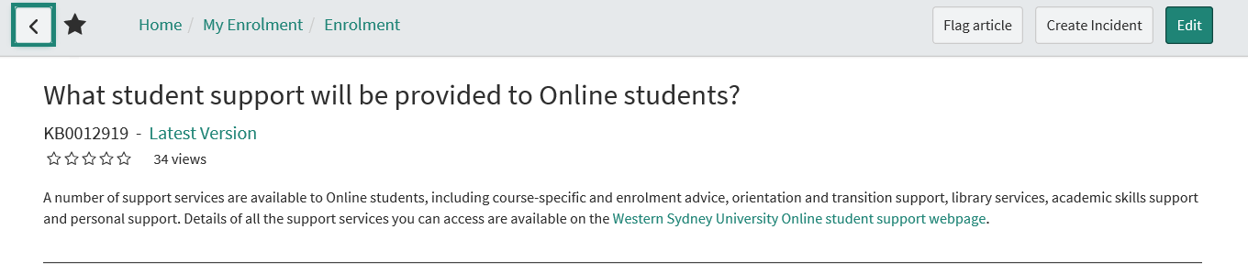
2. Click the **Checkout** button (in the top right corner)**.**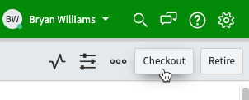
   1. A new version of the article is created and assigned to you for editing.
   2. Make the content changes as required and adhere Knowledge Playbook
      1. **Author** must be an existing WSU employee, preferably the article creator/developer who has knowledge of the information content.
      2.  Enter a **Peer Reviewer** to approve the article.  
         Your peer reviewer must be knowledge champion.   
         (*This is mandatory. Workflow publishing approval or rejection is sent to the Peer Reviewer).*
3. Click **Publish.**

**Note:** Once you checkout an article, no one else can edit it. The article must be published before someone else can make amendments.

### Retire a Student AskWestern knowledge article in WESTERNNOW

1. Knowledge articles are official records and must be kept in the recordkeeping system.
   1. Make a Word document copy of the article
   2. Place the word doc in HPE Content Manager folder: - **19/008614** 
      1. Include in the title “**Retired Knowledge Article – ARTICLE TITLE**”
   3. Don’t have HPE Content Manager?
      1. Email [Bryan.williams@westernsydney.edu.au](mailto:Bryan.williams@westernsydney.edu.au) a copy of the article(s) to retire
         1. Bryan will put them in the recordkeeping system
      2. After emailing Bryan, retire the articles as per below.
2. Search, identify, locate and open the Knowledge Article
   1. To open an article, click on the title in the search results



1. Click **Edit**  
   
2. Click the **Retire** button (in the top right corner)**.**