Dragon Professional.

­

Managing Dragon Vocabulary

Support Manual 4 of 7

Contents

Dictating measurement units and words that contain numerals 2

Flow rate measurements 2

Creating an abbreviated form 2

Training your Dragon 3

Associating numerals to new measurement unit 4

Adding words with combinations of letters and numerals 6

# Dictating measurement units and words that contain numerals

Refer to the supporting video [*04. Managing Vocabulary Part 2*](https://westernsydney.ap.panopto.com/Panopto/Pages/Viewer.aspx?id=c2b5110f-eef5-48f2-a745-abc90183c608)*.*

## Flow rate measurements

It can be a challenge to get Dragon to correctly write down measurement units and words containing numerals. There are only basic measurement units programmed into Dragon. Some of the measurement units already available in Dragon include 60 km/h, 2 m/s and 6800 kPa.

Flow rate measurements are not in Dragon’s vocabulary and are transcribed as 2 L per hour. This measurement is expressed in text format.

### Creating an abbreviated form

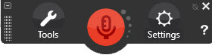

1. Click ‘Tools’ on the Dragon bar.
2. Click ‘Vocabulary Center’.
3. Click ‘Add new word or phrase’.
4. Enter the abbreviated form “L/hr” as the word and in the spoken form field enter the words to be spoken “litres per hour”.
5. Click ‘Add’ and importantly, train the new word. Continue to the next section for the steps to train your Dragon.

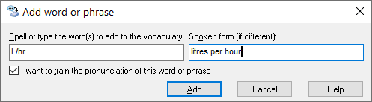

# Training your Dragon

The ‘Train words’ dialogue box is accessed via the steps below:

1. Click ‘Tools’ on the Dragon bar.
2. Click ‘Vocabulary Center’.
3. Click ‘Add new words or phrase’.
4. Select the tick box ‘I want to train the pronunciation of this word or phrase.’
5. Click ‘Add’.

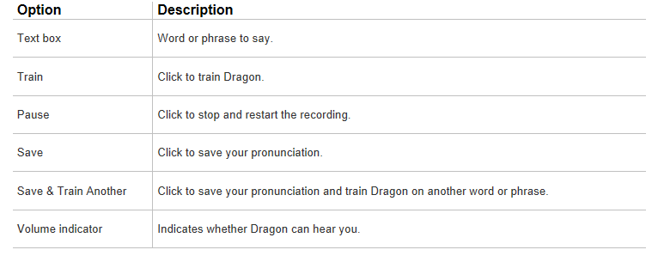

After adding a new word to the Vocabulary Center it is important to train your Dragon so that it reflects the new word correctly.

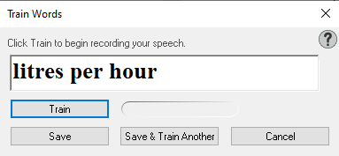

1. After completing the steps to add the new word, click ‘Train’.
2. Click ‘Train’.
3. Repeat the word highlighted, in this example, “litres per hour”.
4. Click ‘Save’.

Dragon will now dictate the abbreviated form.

# Associating numerals to new measurement unit

Numerals are dictated as words e.g seven L/hr. To associate numerals to the new measurement unit, the properties of this new word need to be modified.

1. Click ‘Tools’ on the Dragon bar.
2. Click ‘Vocabulary Center’
3. Click ‘Open Vocabulary Editor’.
4. From the ‘Display’ drop down box at the bottom of the ‘Vocabulary Editor’, select the ‘Custom Words only’ option.
5. Select the entry from the custom vocabulary list and click the ‘Properties’ button located on the right-hand side of the ‘Vocabulary Editor’.

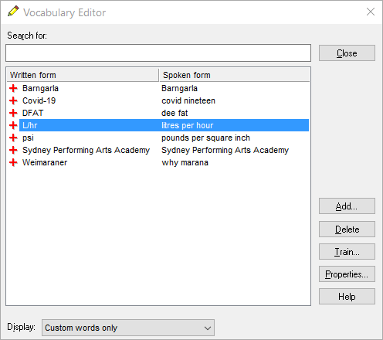

1. There are several formatting options available. To change the formatting to numerals, change the preceding numbers format to numerals.
2. Click ‘OK’ and close the Vocabulary Editor.

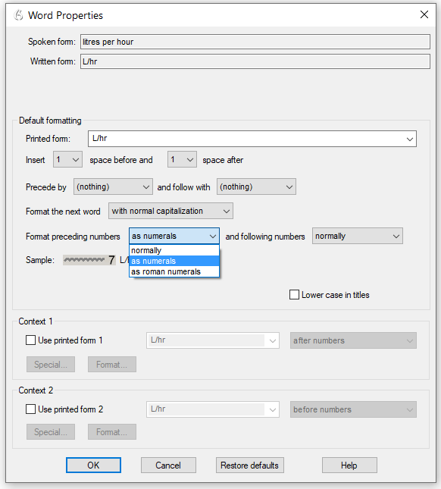

## Adding words with combinations of letters and numerals

Dragon also has a comprehensive listing of vocabulary that has a combination of letters and numerals. E.g. Vitamin B12 and B12. As shown in the screenshot below, it is important to note that numerals must be entered as words in the spoken form field.

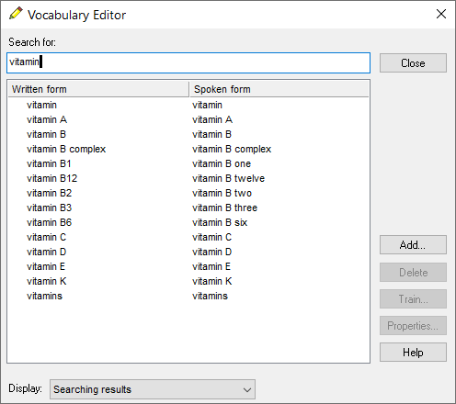

Let's add a new word that's recently come into our language. Covid-19. The correct spelling includes a hyphen so adding spoken form is important to avoid having to say “Covid hyphen nineteen”.

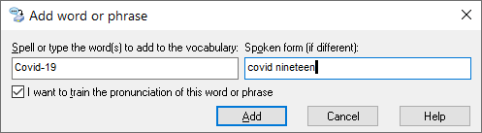

To reduce the need for corrections and editing it is recommended that words not known to Dragon be added to your custom list of words. Spoken form should be added to words that are not spelt as a sound. In this example it is also important to add the hyphen which is not spoken, but is written.

1. Click ‘Tools’ on the Dragon bar.
2. Click ‘Vocabulary Center’.
3. Click ‘Add new words or phrase’.
4. In the ‘Spell or type’ box enter “Covid-19”.
5. In the spoken form of the word enter “covid nineteen’.
6. Select the tick box ‘I want to train the pronunciation of this word or phrase.’
7. Click ‘Add’.
8. Click ‘Train’.
9. Say the word highlighted, in this example, “covid nineteen”.
10. Click ‘Save’.

*More information is located on the Dragon Training and Support page* [www.westernsydney.edu.au/dragon-training](http://www.westernsydney.edu.au/dragon-training).