SPECIAL CONSIDERATION AND DEFERRED EXAM EFORM
How to guide for students

Table of contents

Overview – Guide on how to submit online Special Consideration and Deferred Exam applications 2
About this guide 2
Helpful tips 2
Using Internet Explorer 8 2
Need more help? 4
Submitting an application 4
Step A – log in 4
Step B – select the form 5
Step 1 – personal details 7
Step 2 – unit selection 7
Step 3 – checklist for application 7
Step 4 – Exam Information 8
Step 6 – reasons for application 10
Step 7 –supporting documentation 11
Step 8 – complete your application 13

OVERVIEW – GUIDE ON HOW TO SUBMIT ONLINE SPECIAL CONSIDERATION AND DEFERRED EXAM APPLICATIONS

Western Sydney University has developed an online process which allows students to submit Special Consideration and Deferred Exam applications online.

About this guide

This guide outlines the process for submitting an online Special Consideration or Deferred Exam application using the eForms system.

Helpful tips

- You can click ‘Save’ (in the bottom left of each screen) at any time. Once your application is saved, you can logout and come back to it at another time (via the ‘Draft/Saved Forms’ option)
- You can select ‘Previous’ (in the bottom left of each screen) at any time to change or view previous screens of the form
- Some fields in the form will be marked with a red asterisk (*), which indicates that the field is mandatory. That means you must enter information into that field

Using Internet Explorer 8

Note: If you are using Internet Explorer 8 to submit your Special Consideration/Deferred Exam eForm, you will need to complete the following procedure.

- Open Internet Explorer and click ‘tools’ in the top right corner

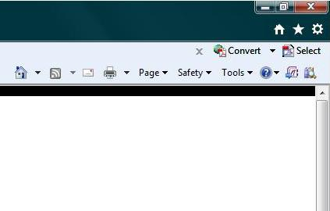
Click here

- Select ‘compatibility view settings’ from the list that appears

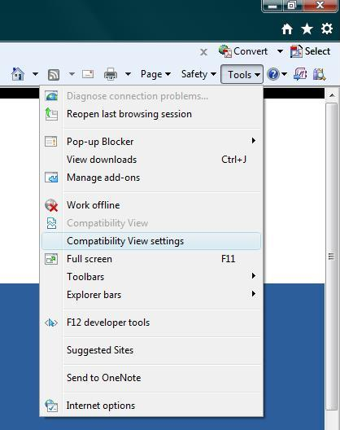
Click here

- The following box will appear. Make sure all three boxes at the bottom are unchecked. Then click ‘close’

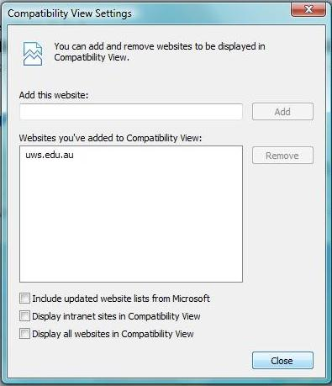
Click ‘close’
Uncheck all boxes

Need more help?

Information about the Special Consideration and Deferred Exam online form is available at www.westernsydney.edu.au/forms. If you need help submitting your form, please contact Student Central in one of the following ways:

Phone: 1300 668 370
Email: studentcentral@westernsydney.edu.au
Drop in: Student Central locations and opening times are available at www.westernsydney.edu.au/studentcentral

Submitting an application

Step A – log in

Log in to the MySR student portal at https://www.westernsydney.edu.au/mywestern using your student ID number and password.

Click on ‘eForms’ in the list of links on the left side of the screen. The following screen will appear.
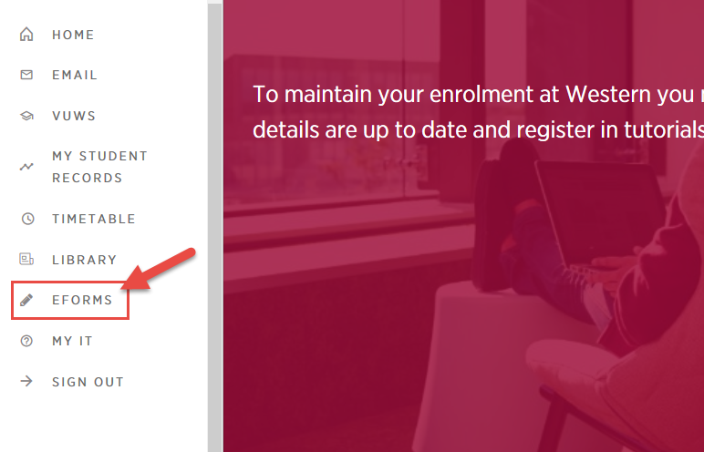

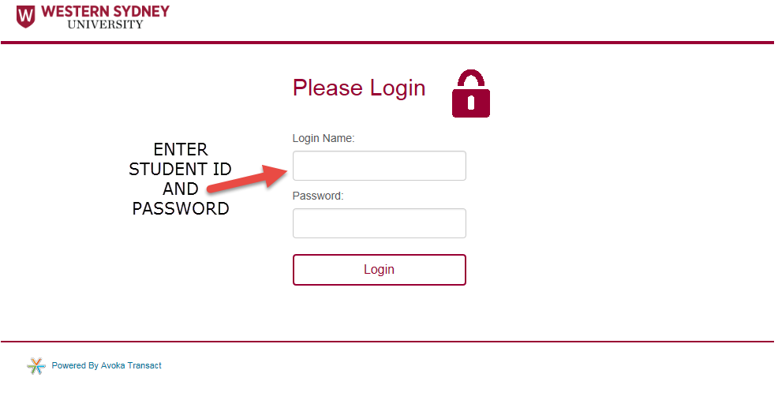

Step B – select the form

To start a new application, click on the ‘Find Forms’ box
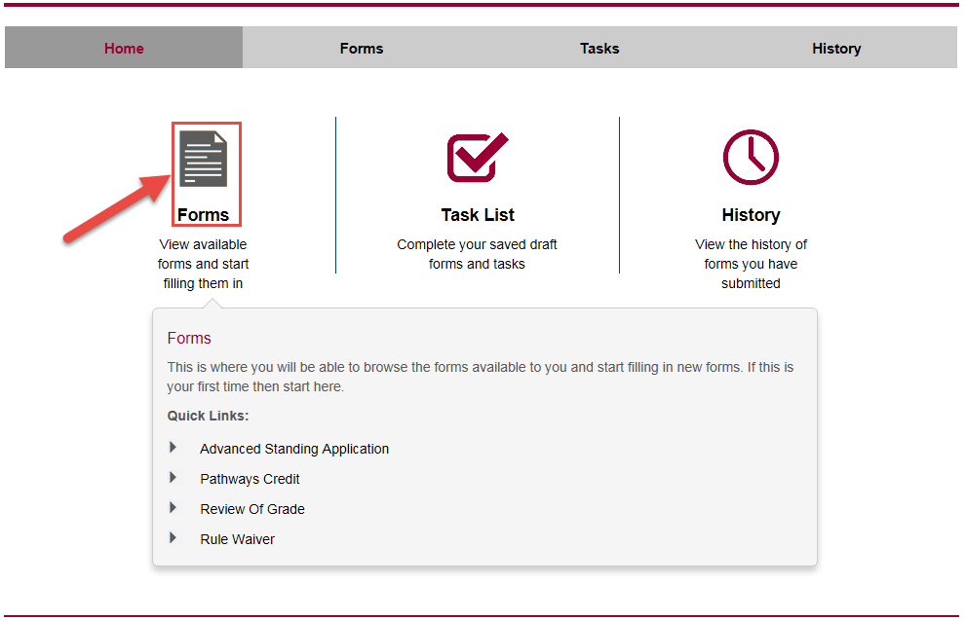

A list of different eForms will appear. Click the ‘Open Form’ button next to the ‘Special Consideration/Deferred Exam’ form.
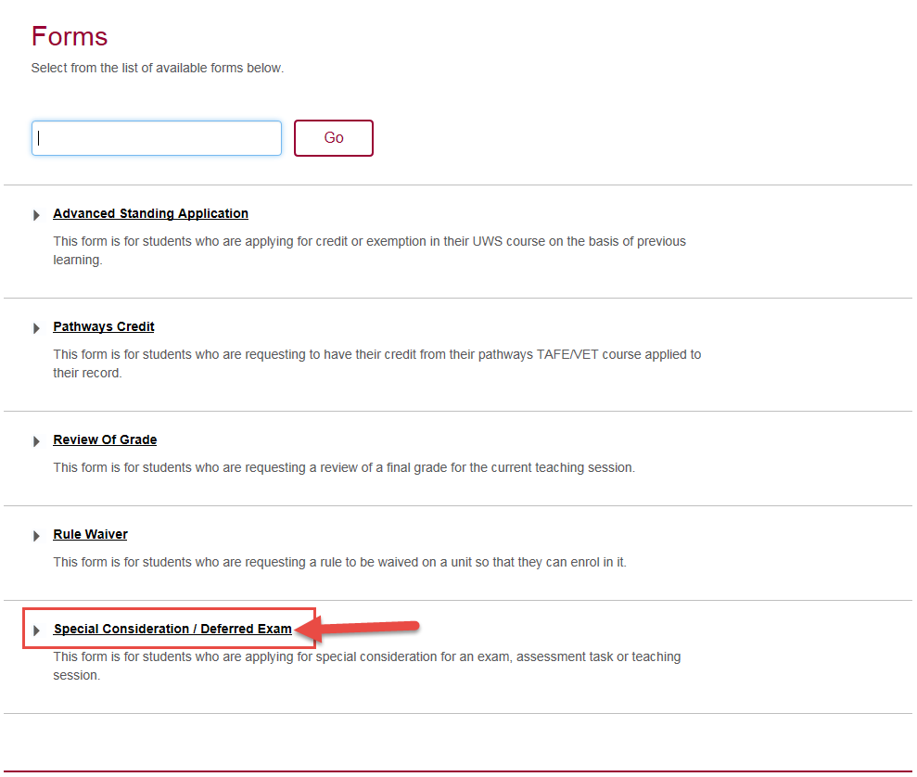

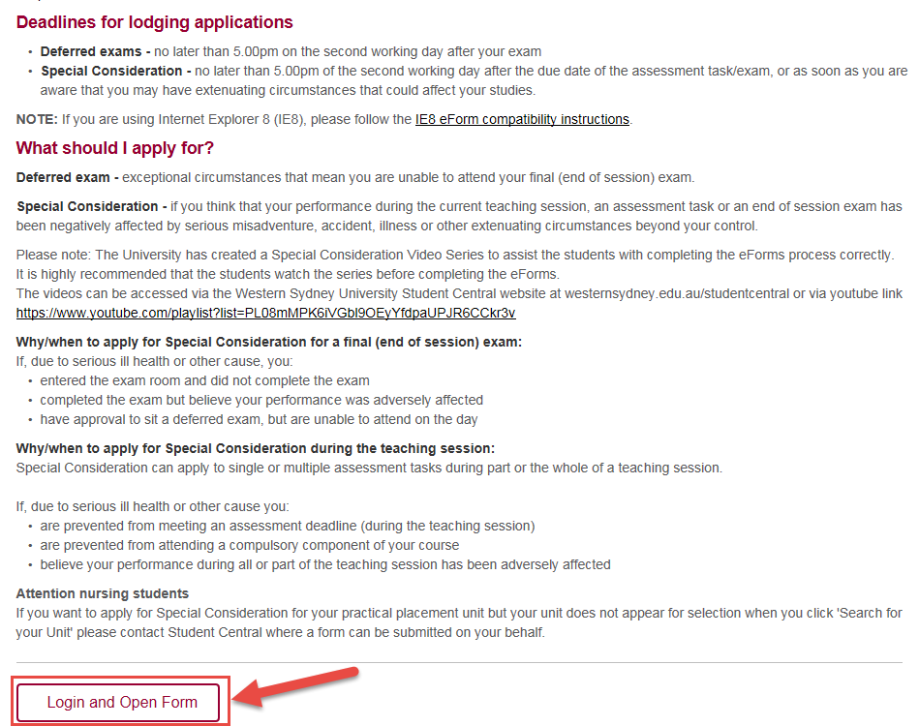

You will again be prompted to enter your student ID and password to login.

NOTE:
Please note that if you entered the exam room, you are not eligible to submit a Deferred Exam and should be applying for special consideration.

Step 1 – personal details

Once logged in, the following screen will appear. Please put in your student ID number and select Lookup. This will populate your name. There are only two fields you can change on this page. Both of them are marked with a red asterix. These fields are also mandatory – you must complete them in order to move on to the next step of the application.

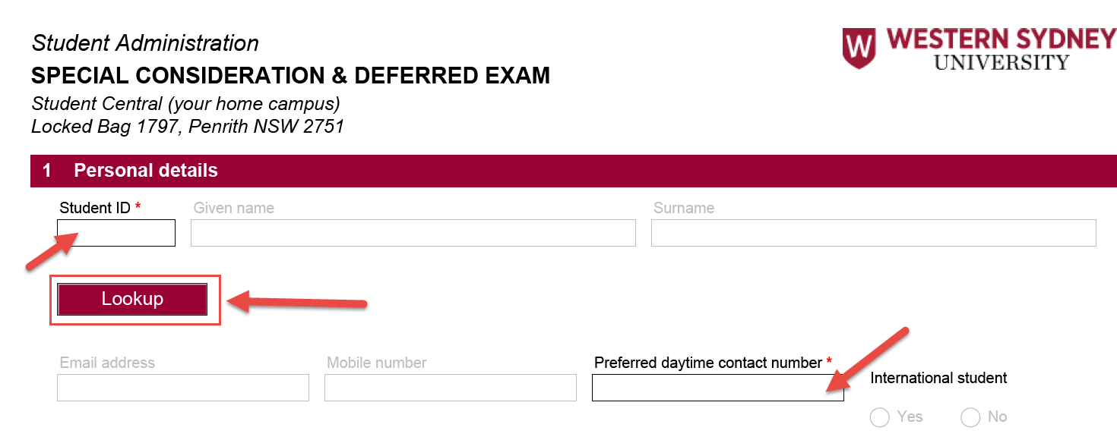
Note: If one of the mandatory fields is not completed, an error message will appear. It will tell you what the error is and indicate where the error is on the page by highlighting it in red.

Step 2 – unit selection

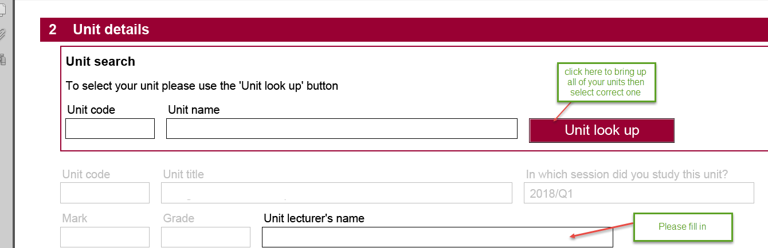

Step 3– Checklist

The below questions will be populated only after you answer each question. Please ensure you answer each question as shown below to ensure your application goes through as a Deferred Exam application.

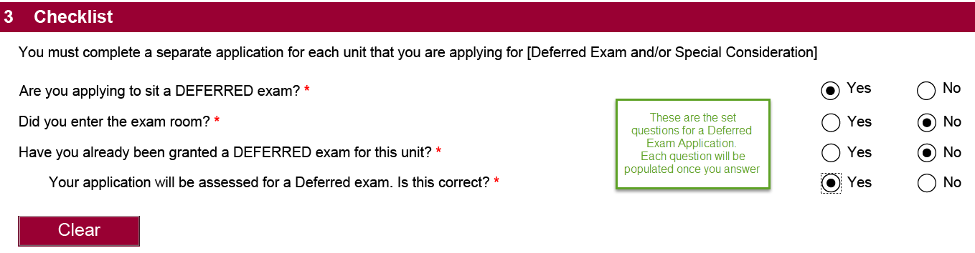

Step 4– Exam Information

Please fill in both boxes as indicated below.
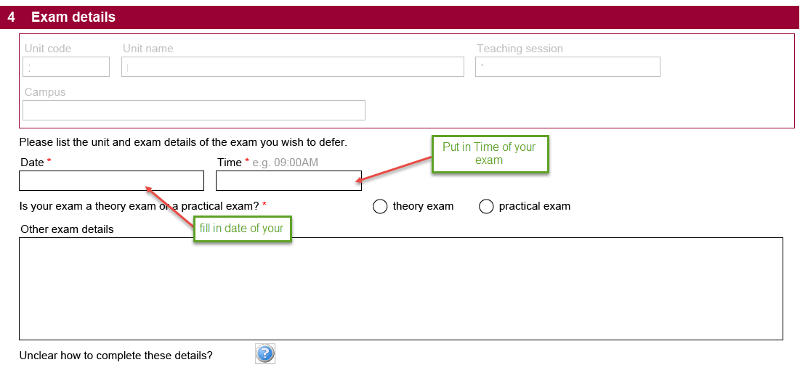

Step 6 – reason for application

At this step, you will see a list of possible reasons for your application. You need to select at least one reason from the list. Please note you can select a couple of reasons if you need to.

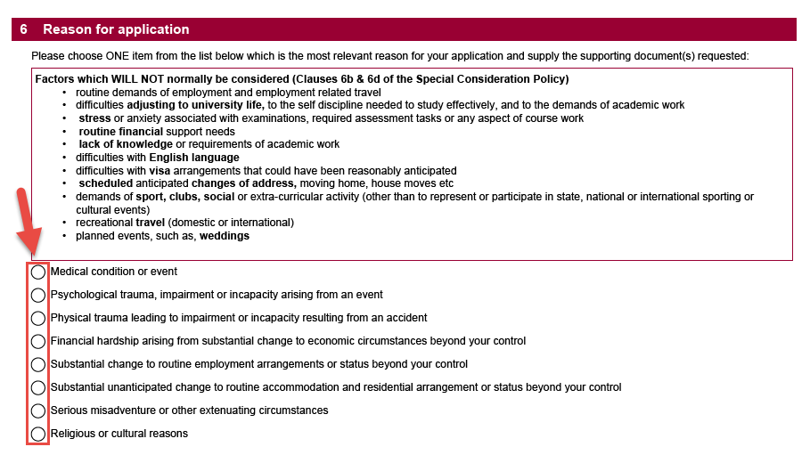
Select one of these options

Once you select one of these options it will populate a box (as shown below) where you are required to write a statement.

Step 7a – Examples of Supporting Documentation
Under each option there are examples of supporting documents that you could attach to your application.

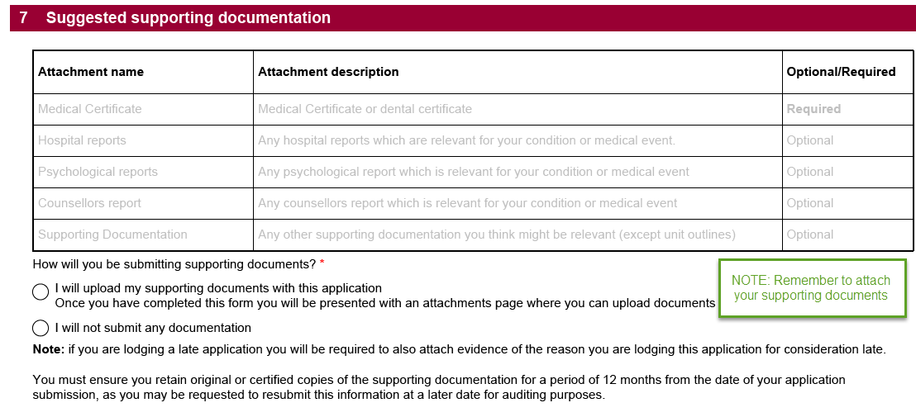

Step 7b – upload supporting documentation

To upload a file, click ‘Attach a file’ next to the most relevant document type.

The following screen will appear. Click ‘Choose file’ and select the file from where it is saved on your computer. You can enter a description if you want to and then click ‘Attach’.

Repeat this process for each document you are attaching.

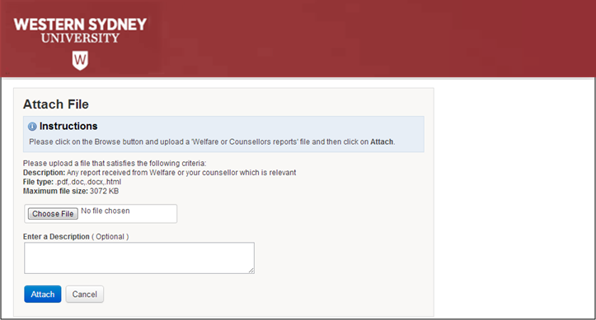

Each successfully uploaded document will appear at the bottom of the screen.

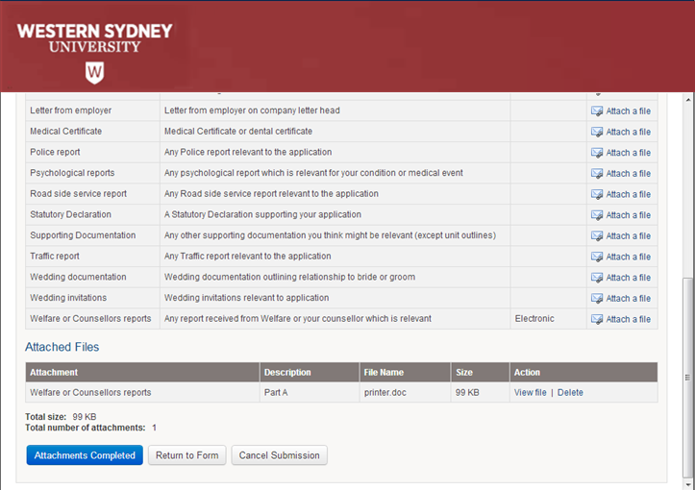

Once all your documents have been attached, click ‘Attachments Completed’.

Important: For auditing purposes you must keep either the original or certified copy of all supporting documentation you attach. The University conducts audits to validate the information students provide in their applications. You may be contacted anytime within 1 year of submitting your application and required to produce either the original or a certified copy of all supporting documentation.

Step 8 – complete your application

Once all documentation attached to your application please select the submit button.

The following screen will appear. This means your application is complete and has been submitted. From this screen you can choose to save a PDF copy of your application.

