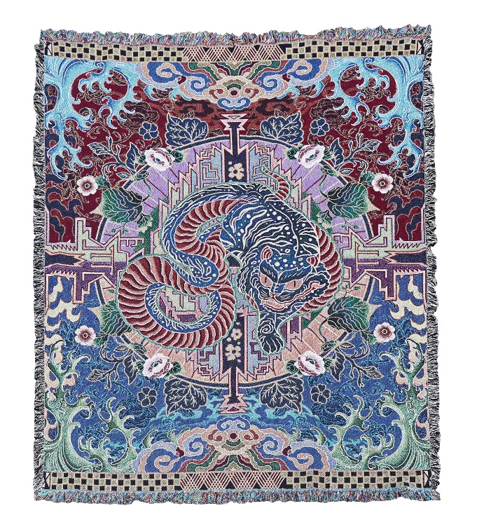
Crossing line-2021
Woven Cotton Yarn
183 cm x 137 cm or 72 x 54 inches

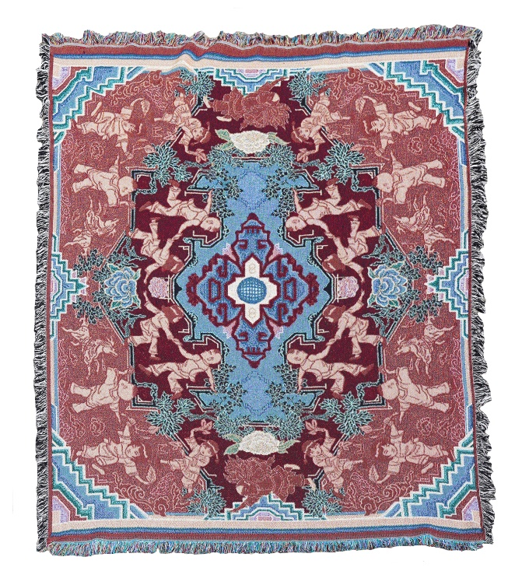

Mirror ball -2021
Woven Cotton Yarn
183 cm x 137 cm or 72 x 54 inches

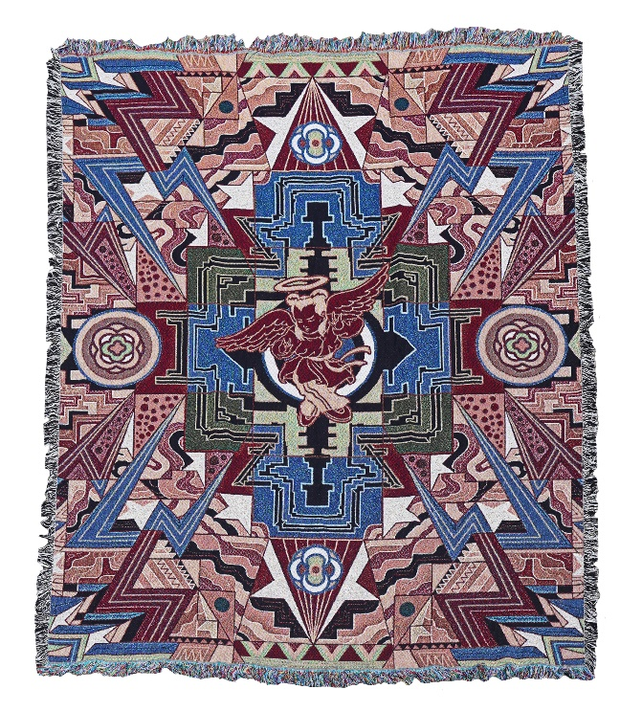
Angels in play-2021
Woven Cotton Yarn
183 cm x 137 cm or 72 x 54 inches

