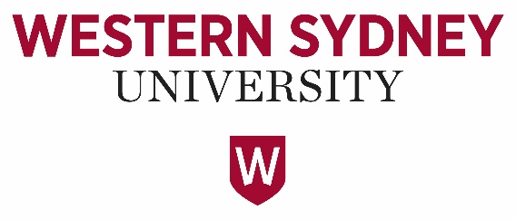

Western Sydney University Student Elections Guide
Student Representative Council (SRC)
2020

POSITIONS CONTESTED
PRESIDENT
VICE PRESIDENT UNDERGRADUATE
VICE PRESIDENT ACITVITIES
GENERAL SECRETARY
RESIDENTIAL REPRESENTATIVE
INTERNATIONAL REPRESENTATIVE
WOMENS REPRESENTATIVE
DISABILITIES REPRESENTATIVE
ETHNOCULTURAL REPRESENTATIVE
ENVIRONMENT REPRESENTATIVE
CAMPBELLTOWN REPRESENTATIVE
HAWKESBURY REPRESENTATIVE
LIVERPOOL REPRESENTATIVE
NIRIMBA REPRESENTATIVE
PARRAMATTA SOUTH REPRESENTATIVE
PARRAMATTA CITY REPRESENTATIVE
PENRITH REPRESENTATIVE

CHUNG, Mary-Pearl
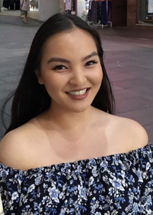
19951124
Mary-Pearl CHUNG
I’m a student in the Bachelor of Communication (Dean’s Scholars) course at Penrith campus. I am running for various SRC/ leadership positions within the university.
Throughout my student life I have been actively involved in a range advocacy and leadership experiences, such as having been awarded an Australian Defence Force Long Tan Youth Leadership Award in 2018, school captaincy, and youth ambassadorship in Multicultural Youth Affairs Network (MYAN) NSW, Youth Action (Young Women Lead- Western Sydney program), Vinnies Youth Social Justice, PLAN International Australia Youth Activist Leader— to name a few.
My passions include art, music, food and social justice. I consider myself a very positive-minded and understanding person, and I would love to create and maintain a great university experience for all my peers by encouraging involvement, diversity and tolerance. If given the opportunity, I will do my best to contribute to a dynamic and inclusive university student life.
CUPITT, Sarah
19760041
Sarah Jane Cupitt
Hi, I'm Sarah Cupitt, and I want to continue representing student's rights and interests at WSU alongside my team 'Strength & Integrity'. I'm an ambitious 2nd-year student studying a Bachelor of Communication (Journalism & PR) playing a vital role in student advocacy relating to university-wide issues, collaborating on programs and services that offer a range of student opportunities. During my first year at Western, I was the SRC Online Students Representative, NUS delegate, became an exec of 8 student clubs and was last years recipient of the Western Sydney University Community Scholarship and the winner of The Academy's Emerging Leader Award. Recently, as the Vice President of Education (Undergraduate), I've been able to make a further positive impact on student engagement. This year in the SRC, my goal is to connect students to ensure optimal participation by including students in shaping the policies and practices that affect their learning experiences.
DAOUD, Tony
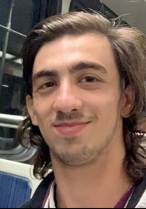
19398336
Tony DAOUD
Hi I’m Tony. I came to the realisation that inaction is a part of the problem. Criticising others while sitting on the sidelines isn’t good enough and so I will actively be taking part in this campaign. I take this role very seriously and the only promise I will make is that I will do all that I can to the very best of my abilities. The truth is often pushed aside for mistruths and white lies especially by people in positions of trust and power but that will not be the case with me. I take inspiration from my mentor Donald Trump and will be as open and upfront about all activities and ensure an open forum is present between us all so that we can work together to finally bring about a better university experience for us all. So Vote [1] Tony Daoud for President and for JUMPSTART.

MATIC, Nikodin
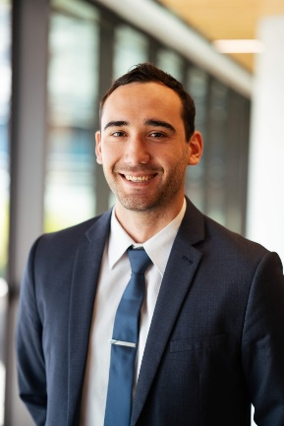
17236007
Nikodin MATIC
After playing sports at a national level, I returned to University to continue my Bachelor of Business/ Bachelor of Laws and have been heavily involved in all aspects of University including academically, sport and student clubs.
After founding and leading a successful executive team as President of Western Sydney Sports Business Society (WSSBS) who won Best New Club, Best Overall Club, Best Student Leader (Tied) and Best Event of 2019, I have the necessary experience and knowledge to fight for WSU students’ in the following areas:
Sport: Will address the lack of facilities across our campuses.
Student Clubs: I will aim to help our student clubs have access to more funding along with other benefits including cutting the red tape, accessing facilities and promoting clubs to enable more vibrant and entertaining events and activities across our campuses.
Academically: Improve student services, educational standards and the range of electives available.
NEWTON, Josh
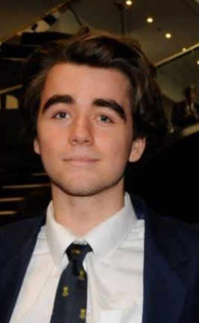
19724528
Josh NEWTON
In my time representing the Hawkesbury Campus on the SRC I have advocated for more events, student services and student voice. I have brought therapy dogs on campus twice in the past month, in collaboration with the Student Welfare Team. I have been working to increase on campus crisis housing and I hope to turn the University Campus Villages into a Co-op.
As the President of the SRC there are a number of Initiatives that I would aim to implement:
1. Increasing the size of the student voice on all campuses
2. Introduce therapy dog events once monthly on all campuses- in collaboration with student welfare (This is a great way for students to be introduced to the services the university offers whilst meeting some very cute dogs)
3. Transforming the university campus villages into a co-op
4. Promoting and assisting the collectives in there various endeavours (ie queer prom,
RENIER-CLARK, Vicky-Rae
19071435
Vicky-Rae RENIER-CLARK
My name is Vicky-Rae Renier-Clark, I am a current Undergraduate Student at Western Sydney University, currently studying a Bachelor of Arts as well as a Bachelor of Health Sciences.
I have been heavily involved in Student Representation at Western for 4 years in various roles. These include the SRC, academic committees, equity collectives, executive planning committees as well as the formulation of my student club, Bankstown Student Civic Committee. I was also the winner of the 2018 Student Voice (Advocacy) Award.
I believe I am a well-disciplined student with a great passion for people and sustainable issues well beyond the expectations of my representative roles developing ethical and equitable outcomes to many of the situations experienced by students. I believe I have proven myself time and again to have the perseverance, initiative and passion to lead any project and the opportunity to lead students again in 2020.
WILSON, Tyler
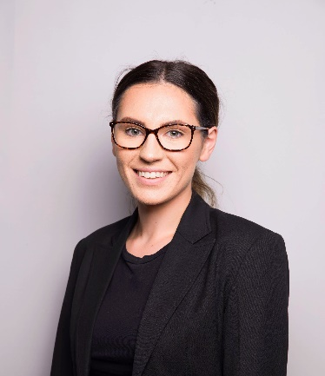
19179591
Tyler WILSON
My name is Tyler Wilson, I am a third year Bachelor of Business student based at the Campbelltown campus. I have been studying at Western Sydney University since 2017 and have gained strong insight into the operation of the university and how it influences our tertiary studies. I am currently a member of the Wollondilly Youth Advisory Committee which serves youth in my LGA and believe my skills and experiences in this domain would translate effectively into acting as an ambassador for the university but primarily on behalf of the students. I take active involvement in my education as well as extra-curricular activities meaning I am dedicated to playing my part in the improvement of the university experience and will dedicate my efforts to ensuring that all students are represented, heard and accommodated for. We get out what we put into this experience and I’m willing to make that contribution.
ARMSTRONG-MENSAH, Rosina
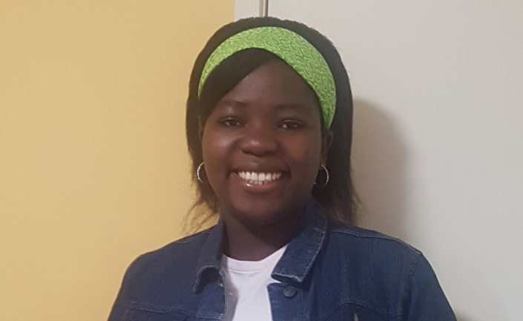
18581498
Rosina ARMSTRONG-MENSAH
My name is Rosina Armstrong-Mensah studying Bachelor of Social Science. I have gotten to know more about the student and university which is the reason I look forward to representing my fellow student by making their voice heard.
I promise to effective, reliable, punctual, trustworthy and respect everyone. With my experience previously as a general representative for Campbelltown Student Campus Council, Liverpool women’s collective this made me more involved in university programs and activities. I find it less intimidating when students are talking to their fellow student therefore, I believe this opportunity will be a great one for me to connect and represent my colleague in the university.
I appreciate the opportunity given to apply for this position to represent my colleagues. When given the chance I will do my very best to abide and follow the necessary policies governing the role. Thank you.

BONATTI, Daniel
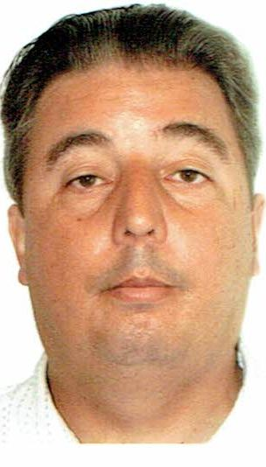
19257310
Daniel BONATTI
I Daniel Bonatti enrolled in a Bachelor of Construction Management (Honours). I am currently WSU - Vice President (Education) Postgraduate, Student Representative Council, seeking election, as the Vice President undergraduate. Thus, have experience in this role. My qualifications CertIV BdgCon(Bdg), DipProjMgmt, DipBdgCon(Bdg), AsDipEng(Civ), BTech (Civ)(Hons.), GradCert, MDesSc (Bdg) (Hons.) MDesSc (Bdg Serv), MBA Chifley Business School
CURRENT EXPERIENCE –
• Western Sydney University - Vice President (Education) Postgraduate, Student Representative Council, which includes NUS, CAPA, TEQSA, SRC Executive Committee, Remuneration Committee, SRC Budget Committee $160k, Communication Strategy Committee, SSAF Committee 5.9 million.
• EWB Engineers Without Borders, Vice President WSU Chapter, 2019-2020.
• National Union of Students (NUS) Western Sydney University delegate, 2019-2020.
• National Committee Engineering Heritage Australia (EHA) 2017-2019
• National Membership Services Committee Member. 2019-2020
• NSW AIB Chapter Committee, Committee member and minutes scribe, 2019-2020
• SFS Society of Fire Safety Engineering, Committee member, 2019-2020
• CLM College Leadership & Management, Newcastle division Committee 2020
BURGESS, Griffen
19360052
Griffen BURGESS
Hi, my name is GRIFFEN BURGESS and I’m running for Vice President Education (Undergraduates) on Western Sydney University’s 2020 SRC. I want to JUMP START our University and get involved with our students because I see extraordinary potential with both students and University, but most importantly be the voice for the those that haven’t been heard.
I’m running for this position because I’m passionate about opportunity, experience and the safety of our students regardless of the situation. Being a student myself I know what an average student goes through on a day to day basis, and I’ve been very fortunate to have met amazing, intelligent and humbled individuals from both staff and students. Having this experience and what my journey has been like so far, I’m proud to say that ‘I’m a Western Sydney University student’.
Thank you and remember. Vote 1, GB for VP
CHUNG, Mary-Pearl
19951124
Mary-Pearl CHUNG
I’m a student in the Bachelor of Communication (Dean’s Scholars) course at Penrith campus. I am running for various SRC/ leadership positions within the university.
Throughout my student life I have been actively involved in a range advocacy and leadership experiences, such as having been awarded an Australian Defence Force Long Tan Youth Leadership Award in 2018, school captaincy, and youth ambassadorship in Multicultural Youth Affairs Network (MYAN) NSW, Youth Action (Young Women Lead- Western Sydney program), Vinnies Youth Social Justice, PLAN International Australia Youth Activist Leader— to name a few.
My passions include art, music, food and social justice. I consider myself a very positive-minded and understanding person, and I would love to create and maintain a great university experience for all my peers by encouraging involvement, diversity and tolerance. If given the opportunity, I will do my best to contribute to a dynamic and inclusive university student life.
CUPITT Sarah
19760041
Sarah Jane CUPITT
Hi, I'm Sarah Cupitt, and I want to continue representing student's rights and interests at WSU alongside my team 'Strength & Integrity'. I'm an ambitious 2nd-year student studying a Bachelor of Communication (Journalism & PR) playing a vital role in student advocacy relating to university-wide issues, collaborating on programs and services that offer a range of student opportunities. During my first year at Western, I was the SRC Online Students Representative, NUS delegate, became an exec of 8 student clubs and was last years recipient of the Western Sydney University Community Scholarship and the winner of The Academy's Emerging Leader Award. Recently, as the Vice President of Education (Undergraduate), I've been able to make a further positive impact on student engagement. This year in the SRC, my goal is to connect students to ensure optimal participation by including students in shaping the policies and practices that affect their learning experiences.

Da SILVA, Clare
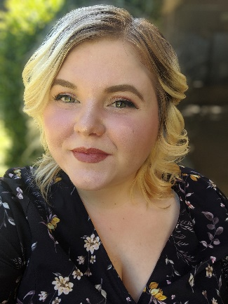
18659027
Clare Da SILVA
My name is Clare and I am studying a Bachelor of Arts/Bachelor of Laws. My fascination with the power of words and ideas intertwined with my desire to be an advocate for those in need is why I am running for Student elections. Students need opportunities to prepare for their future workplaces, to have fun on campus and have their voices heard. My previous experience as Parramatta South Campus Representative this year has equipped me with the tools and connections to advocate further for students. In addition, I have held other representative roles on campus including President of the Debating Union, 21C Student Partner and more. I hope to use my skills and experience gained in these areas to further assist students as well as the development of student clubs through consistent advocacy if given the opportunity to lead in this space. Vote for Clare, the candidate that cares.

GADALLA, Akmal
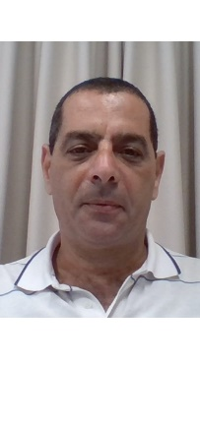
Akmal GADALLA
17961077
I am a mature aged undergraduate student. I have been representing the students at Paramatta South campus as the Student Campus Council representative for the year ending 2018. During my life journey, I have gained a lot of experience which enabled me to act on behalf of my colleagues. I enjoy serving the community and like to listen to my classmates’ suggestions or otherwise complaints and delegate them to the university administrative or managerial staff. I am expressing my interest to apply for the SRC Committee, to carry out what I have started in the past. I would like to always do my best to serving the student’ community and step up with it until we all “working together” get to the standards our students’ community deserves. Thank you in advance for taking the time to read my statement. Looking forward to join forces together until we achieve our goals.
HAMMOND, Hollie
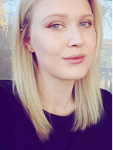
16727869
Hollie HAMMOND
Hi folks! I bet you’re wondering why you should vote for me as your 2020 VPU? Candidate statements can be a little dry, so let’s dive straight in. Your VPU represents every undergraduate student at WSU; they chair meetings, engage with students and help the SRC to function. But more importantly, why should you care? What can they do for you? Ever been stuck with a problem at uni that nobody seems to get how to fix? Ever needed to advocate for yourself with an academic or School but you aren’t sure where to start? Ever needed somebody to translate policy jargon into something straightforward? That's where a good VPU can help. So why me? With my experience on Academic Senate, SRC and clubs, I have already used university policy to improve procedure around tutorial allocation. Policy is my thing, so it doesn’t have to be yours!
RENIER-CLARK, Vicky-Rae
19071435
Vicky-Rae RENIER-CLARK
My name is Vicky-Rae Renier-Clark, I am a current Undergraduate Student at Western Sydney University, currently studying a Bachelor of Arts as well as a Bachelor of Health Sciences.
I have been heavily involved in Student Representation at Western for 4 years in various roles. These include the SRC, academic committees, equity collectives, executive planning committees as well as the formulation of my student club, Bankstown Student Civic Committee. I was also the winner of the 2018 Student Voice (Advocacy) Award.
I believe I am a well-disciplined student with a great passion for people and sustainable issues well beyond the expectations of my representative roles developing ethical and equitable outcomes to many of the situations experienced by students. I believe I have proven myself time and again to have the perseverance, initiative and passion to lead any project and the opportunity to lead students again in 2020.
WILSON, Tyler
19179591
Tyler WILSON
My name is Tyler Wilson, I am a third year Bachelor of Business student based at the Campbelltown campus. I have been studying at Western Sydney University since 2017 and have gained strong insight into the operation of the university and how it influences our tertiary studies. I am currently a member of the Wollondilly Youth Advisory Committee which serves youth in my LGA and believe my skills and experiences in this domain would translate effectively into acting as an ambassador for the university but primarily on behalf of the students. I take active involvement in my education as well as extra-curricular activities meaning I am dedicated to playing my part in the improvement of the university experience and will dedicate my efforts to ensuring that all students are represented, heard and accommodated for. We get out what we put into this experience and I’m willing to make that contribution.

ARMSTRONG-MENSAH, Rosina
18581498
Rosina ARMSTRONG-MENSAH
My name is Rosina Armstrong-Mensah studying Bachelor of Social Science. I have gotten to know more about the student and university which is the reason I look forward to representing my fellow student by making their voice heard.
I promise to effective, reliable, punctual, trustworthy and respect everyone. With my experience previously as a general representative for Campbelltown Student Campus Council, Liverpool women’s collective this made me more involved in university programs and activities. I find it less intimidating when students are talking to their fellow student therefore, I believe this opportunity will be a great one for me to connect and represent my colleague in the university.
I appreciate the opportunity given to apply for this position to represent my colleagues. When given the chance I will do my very best to abide and follow the necessary policies governing the role. Thank you.
CHUNG, Mary-Pearl
19951124
Mary-Pearl CHUNG
I’m a student in the Bachelor of Communication (Dean’s Scholars) course at Penrith campus. I am running for various SRC/ leadership positions within the university.
Throughout my student life I have been actively involved in a range advocacy and leadership experiences, such as having been awarded an Australian Defence Force Long Tan Youth Leadership Award in 2018, school captaincy, and youth ambassadorship in Multicultural Youth Affairs Network (MYAN) NSW, Youth Action (Young Women Lead- Western Sydney program), Vinnies Youth Social Justice, PLAN International Australia Youth Activist Leader— to name a few.
My passions include art, music, food and social justice. I consider myself a very positive-minded and understanding person, and I would love to create and maintain a great university experience for all my peers by encouraging involvement, diversity and tolerance. If given the opportunity, I will do my best to contribute to a dynamic and inclusive university student life.
CUPITT Sarah
19760041
Sarah Jane CUPITT
Hi, I'm Sarah Cupitt, and I want to continue representing student's rights and interests at WSU alongside my team 'Strength & Integrity'. I'm an ambitious 2nd-year student studying a Bachelor of Communication (Journalism & PR) playing a vital role in student advocacy relating to university-wide issues, collaborating on programs and services that offer a range of student opportunities. During my first year at Western, I was the SRC Online Students Representative, NUS delegate, became an exec of 8 student clubs and was last years recipient of the Western Sydney University Community Scholarship and the winner of The Academy's Emerging Leader Award. Recently, as the Vice President of Education (Undergraduate), I've been able to make a further positive impact on student engagement. This year in the SRC, my goal is to connect students to ensure optimal participation by including students in shaping the policies and practices that affect their learning experiences.
Da SILVA, Clare
18659027
Clare Da SILVA
My name is Clare and I am studying a Bachelor of Arts/Bachelor of Laws. My fascination with the power of words and ideas intertwined with my desire to be an advocate for those in need is why I am running for Student elections. Students need opportunities to prepare for their future workplaces, to have fun on campus and have their voices heard. My previous experience as Parramatta South Campus Representative this year has equipped me with the tools and connections to advocate further for students. In addition, I have held other representative roles on campus including President of the Debating Union, 21C Student Partner and more. I hope to use my skills and experience gained in these areas to further assist students as well as the development of student clubs through consistent advocacy if given the opportunity to lead in this space. Vote for Clare, the candidate that cares.

FERRER, Natasha
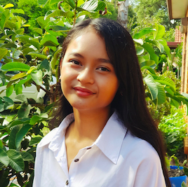
19795371
Natasha FERRER
Energise your SRC! As your current Liverpool Campus Student Representative it has been a privilege and joy to advocate and answer the needs, wants and concerns of my students. Primarily, during my tenure, I have provided a Facebook discussion group platform for students to be informed and have a voice on, created a plant event to help destress students and have secured a weekly study and relaxation zone (delayed due to COVID-19).
I am passionate towards the issues of mental, spiritual and physical health, social isolation and student safety. If I am re-elected into my position, once permitted, I will raise awareness to these issues and create events such as therapy animals, gaming zones, academic-based initiatives and will encourage the creation of clubs and societies. I will also reach out to local businesses and councils to provide more discounts, opportunities and events for my students. Vote for me and energise
GADALLA, Akmal
Akmal Gadalla
17961077
I am a mature aged undergraduate student. I have been representing the students at Paramatta South campus as the Student Campus Council representative for the year ending 2018. During my life journey, I have gained a lot of experience which enabled me to act on behalf of my colleagues. I enjoy serving the community and like to listen to my classmates’ suggestions or otherwise complaints and delegate them to the university administrative or managerial staff. I am expressing my interest to apply for the SRC Committee, to carry out what I have started in the past. I would like to always do my best to serving the student’ community and step up with it until we all “working together” get to the standards our students’ community deserves. Thank you in advance for taking the time to read my statement. Looking forward to join forces together until we achieve our goals.
MATIC, Nikodin
17236007
Nikodin MATIC
After playing sports at a national level, I returned to University to continue my Bachelor of Business/ Bachelor of Laws and have been heavily involved in all aspects of University including academically, sport and student clubs.
After founding and leading a successful executive team as President of Western Sydney Sports Business Society (WSSBS) who won Best New Club, Best Overall Club, Best Student Leader (Tied) and Best Event of 2019, I have the necessary experience and knowledge to fight for WSU students’ in the following areas:
Sport: Will address the lack of facilities across our campuses.
Student Clubs: I will aim to help our student clubs have access to more funding along with other benefits including cutting the red tape, accessing facilities and promoting clubs to enable more vibrant and entertaining events and activities across our campuses.
RAM, Crystal
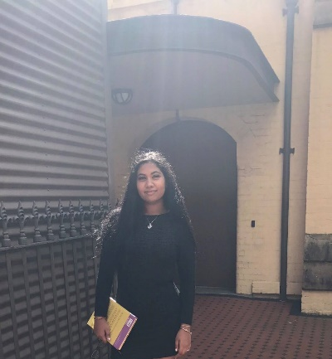
18702590
Crystal RAM
Hi, everyone! I'm Crystal, I'm a candidate at our student elections, and I want to JUMP START WSU. Currently on the executive of Student Clubs, I want to put my leadership experience to work for all of WSU.
This election is very important because our voice will be listened to. This will happen unless you do not vote. And other students’ ideas and thoughts will be heard. I’m the right person to do this job. In the first place, I’m a very responsible person and I love speaking before an audience. Second, if you vote for me, I will speak out for your complaints and problems that I’m sure you have on campus.

If you elect me and empower me with your trust, I will make several changes to the current leadership team. We plan on adopting and introducing more diverse and varied events, widening options for students, this will
RENIER-CLARK, Vicky-Rae
19071435
Vicky-Rae RENIER-CLARK
My name is Vicky-Rae Renier-Clark, I am a current Undergraduate Student at Western Sydney University, currently studying a Bachelor of Arts as well as a Bachelor of Health Sciences.
I have been heavily involved in Student Representation at Western for 4 years in various roles. These include the SRC, academic committees, equity collectives, executive planning committees as well as the formulation of my student club, Bankstown Student Civic Committee. I was also the winner of the 2018 Student Voice (Advocacy) Award.

I believe I am a well-disciplined student with a great passion for people and sustainable issues well beyond the expectations of my representative roles developing ethical and equitable outcomes to many of the situations experienced by students. I believe I have proven myself time and again to have the perseverance, initiative and passion to lead any project and the opportunity to lead students again in 2020.
SALIFU, Naya
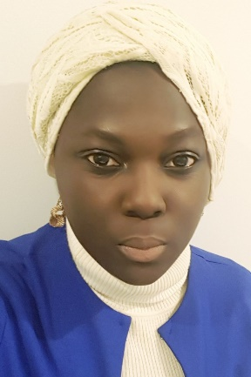
19601045
Munayet SALIFU
My name is Munayet Salifu (Naya), a second year Bachelor of Laws (Graduate Entry) student and vying for the position of the SRC Vice President Activities in the 2020/2021 academic year.
First, I will ensure the interests and welfare of the students are considered number one in the university and impediments such as harassment and racism and is minimized. Second, I will ensure the coordination of recreational clubs and organising educational programs and events towards building friendly campuses and a better study environment. Third, I will liaise with relevant authorities to ensure the provisions such as parking concerns are resolved.
As the world gears towards inclusivity, I hope to be part of a team that embraces differences and recognises that diversity is power. There is a need to change from a community where people are victimized.
Thank you.

ABBAS, Muhammad
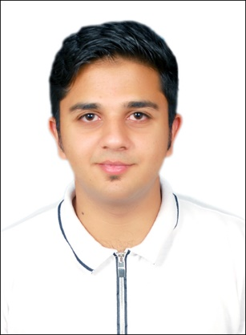
19968663
Muhammad ABBAS
I am an International student who has just started the university with Master’s degree in Electrical Engineering. The question is always raised about the trust and the capability of new students becoming the member of Student Council and today I want to prove them wrong with my beliefs, my power and my faith in achieving the highest mark. My aim would not be what ordinary everyone tries to claim, I want to be different and I will prove it considering my past experiences, my efforts and my Progress. Being a young graduate, I have come across many issues in different processes which I would like to make them notified under the management and one of those issues is the commuting service between campuses due to which students have to suffer and as a result, they often get late from their classes. I accept the challenge and I will prove myself
BONATTI, Daniel
19257310
Daniel BONATTI
I am enrolled in an Undergraduate and Postgraduate degrees Bachelor of Construction Management and Graduate Diploma in Building Surveying. I have experience doing administration duties and possess a Master of Business Administration degree.
I am WSU- Vice President (Education) Postgraduate, Student Representative Council, which includes, NUS, CAPA, TEQSA, Committees - SRC Executive, Remuneration, SRC Budget, Communication Strategy, SSAF.
I have experience writing minutes currently at Australian Institute of Building NSW chapter doing that for over three years. At Torrens University Australia in Adelaide 2016 I wrote the minutes for SRC.
This year we saw the importance of minutes, with monthly minutes blocked, unconfirmed for 5 months, May to November It was alleged they were inaccurate. Ironically like PM Whitlam our funding supply stopped, hence could not help students I have never had that happen to me after writing minutes believe my experience will pass minutes if elected as General secretary.
CHUNG, Mary-Pearl
19951124
Mary-Pearl CHUNG
I’m a student in the Bachelor of Communication (Dean’s Scholars) course at Penrith campus. I am running for various SRC/ leadership positions within the university.
Throughout my student life I have been actively involved in a range advocacy and leadership experiences, such as having been awarded an Australian Defence Force Long Tan Youth Leadership Award in 2018, school captaincy, and youth ambassadorship in Multicultural Youth Affairs Network (MYAN) NSW, Youth Action (Young Women Lead- Western Sydney program), Vinnies Youth Social Justice, PLAN International Australia Youth Activist Leader— to name a few.
My passions include art, music, food and social justice. I consider myself a very positive-minded and understanding person, and I would love to create and maintain a great university experience for all my peers by encouraging involvement, diversity and tolerance. If given the opportunity, I will do my best to contribute to a dynamic and inclusive university student life.
Da SILVA, Clare
18659027
Clare Da SILVA
My name is Clare and I am studying a Bachelor of Arts/Bachelor of Laws. My fascination with the power of words and ideas intertwined with my desire to be an advocate for those in need is why I am running for Student elections. Students need opportunities to prepare for their future workplaces, to have fun on campus and have their voices heard. My previous experience as Parramatta South Campus Representative this year has equipped me with the tools and connections to advocate further for students. In addition, I have held other representative roles on campus including President of the Debating Union, 21C Student Partner and more. I hope to use my skills and experience gained in these areas to further assist students as well as the development of student clubs through consistent advocacy if given the opportunity to lead in this space. Vote for Clare, the candidate that cares.
GADALLA, Akmal
Akmal Gadalla
17961077
I am a mature aged undergraduate student. I have been representing the students at Paramatta South campus as the Student Campus Council representative for the year ending 2018. During my life journey, I have gained a lot of experience which enabled me to act on behalf of my colleagues. I enjoy serving the community and like to listen to my classmates’ suggestions or otherwise complaints and delegate them to the university administrative or managerial staff. I am expressing my interest to apply for the SRC Committee, to carry out what I have started in the past. I would like to always do my best to serving the student’ community and step up with it until we all “working together” get to the standards our students’ community deserves. Thank you in advance for taking the time to read my statement. Looking forward to join forces together until we achieve our goals.
HAMMOND, Hollie
16727869
Hollie HAMMOND
Greetings! Policy/admin can be a bore, so prop your eyelids open and let me earn your vote! The SRC needs to engage all WSU students; everyone should feel listened to and heard. I can support the SRC in communicating honestly with students as part of a diverse, transparent, accountable SRC - with YOU at the centre of every decision! My background is administration for NSW Health, so I’m a pro at minutes, agendas and working within institutional policy - i.e. the GenSec role! I’ve also held rep roles from Senate to student clubs, so I know the rules and can get to work without wasting a second. Finally, I’ve advocated for students and achieved positive policy change; something I’ll continue to do quickly and professionally. I’ll collaborate, communicate and compromise to get things done. Hollie #1 if you want a GenSec with passion, experience and integrity.
JIWANI, Adeem
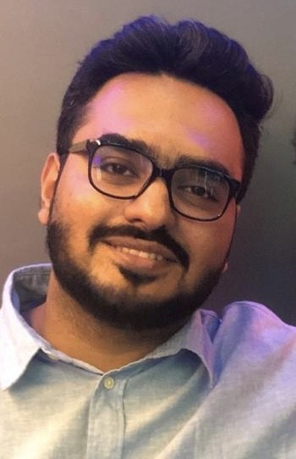
19533719
Adeem JIWANI
My name is Adeem Jiwani, I'm a final year MBA Student. I believe I am suitable candidate to be the General Secretary as I possess the qualities and skills required and have considerable experiences in leadership. I consider myself a good team player, quick learner and a detailed-oriented person. I believe that being a part of the SRC, I would play an important role in building bonds amongst the members, administration and the students. Working as a NUS Delegate has given me the exposure to student advocacy where we’ve focused on raising concerns of our students at the national conference, and also my previous experiences in student council’s back in India have made me capable of handling difficult situations. I have an abundance of experiences working on campus as I’m working as an “Ask-Us-Assistant”. I would like to have the honour of working as the General Secretary of the SRC.

PARKAR, Rameez
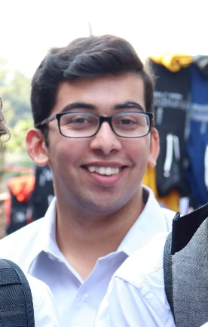
19290573
Rameez PARKAR
Hi I’m Rameez. I never thought I would ever run for the Western SRC but I don’t think I could sit by quietly any longer. For too long now the students of Western Sydney University have had their interests ignored. Like many students I have met my “uni life” consists of coming to class and going home because there is not enough to do on campus. That is why I started a student club and that’s why I’m now running for the SRC. I think that so much can be done to serve the interests of students rather than spending hundreds of thousands of dollars on merchandise that the vast majority of the 45,000 Western students have never seen. There has never been a more important time for strong progressive, principled and pragmatic students representatives fighting for us! Let’s make WSU even better! Vote [1] Rameez Parkar and JUMPSTART!
REED, Robert
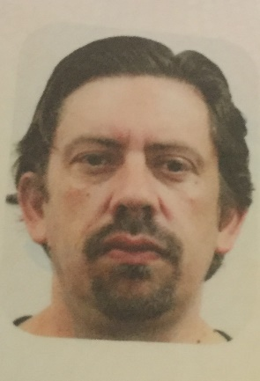
17277873
Robert REED
My name is Robert Reed, I am a current Undergraduate Student at Western Sydney University, currently studying a Bachelor of Podiatric Medicine
I have been involved in Student Representation at Western for 4 years as Disability Officer for the Campbelltown Campus. During this time, my advocacy for the rights of students with carer responsibilities has seen provision been made in the form of AIP accommodations to this cohort which was not previously afforded.
I believe I have a passion for people and reducing inequalities in the academic arena, having lived experience of many of the situations of students. I believe I have the perseverance and integrity to lead students again in 2020.
SALIFU, Naya
19601045
Naya SALIFU
My name is Munayet Salifu, a second year Bachelor of Laws (Graduate Entry) student. I intend to run as your SRC secretary in the 2020/2021 academic year.
As the general secretary, synchronizing the plan of actions to ensure the smooth running of the SRC body will be my main focus. I will ensure that the pressing needs of the student body are what is addressed and presented to the school administration. I will also ensure that all students are represented, regardless of their background, sex, religion or race. I aim to make the SRC body as responsive as it should to be, while establishing accountability to all students. This is the only way we as SRC representatives can close the chapter of operating behind closed doors.
Choose transparency. It is the only way we can acknowledge that our concerns are heard.
Thank you.
WILSON, Tyler
19179591
Tyler WILSON
My name is Tyler Wilson, I am a third year Bachelor of Business student based at the Campbelltown campus. I have been studying at Western Sydney University since 2017 and have gained strong insight into the operation of the university and how it influences our tertiary studies. I am currently a member of the Wollondilly Youth Advisory Committee which serves youth in my LGA and believe my skills and experiences in this domain would translate effectively into acting as an ambassador for the university but primarily on behalf of the students. I take active involvement in my education as well as extra-curricular activities meaning I am dedicated to playing my part in the improvement of the university experience and will dedicate my efforts to ensuring that all students are represented, heard and accommodated for. We get out what we put into this experience and I’m willing to make that contribution.

CUPITT Sarah
19760041
Sarah Jane CUPITT
Hi, I'm Sarah Cupitt, and I want to continue representing student's rights and interests at WSU alongside my team 'Strength & Integrity'. I'm an ambitious 2nd-year student studying a Bachelor of Communication (Journalism & PR) playing a vital role in student advocacy relating to university-wide issues, collaborating on programs and services that offer a range of student opportunities. During my first year at Western, I was the SRC Online Students Representative, NUS delegate, became an exec of 8 student clubs and was last years recipient of the Western Sydney University Community Scholarship and the winner of The Academy's Emerging Leader Award. Recently, as the Vice President of Education (Undergraduate), I've been able to make a further positive impact on student engagement. This year in the SRC, my goal is to connect students to ensure optimal participation by including students in shaping the policies and practices that affect their learning experiences.
MOON, Declan
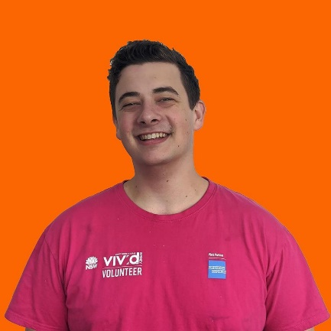
19284284
Declan MOON
As an on-campus Resident Assistant at the Parramatta since 2018, I have been involved with every aspect with student living. I have seen so many students go through incredibly difficult situations whilst studying at university, including myself, and If elected I would do everything I could to ensure the best possible outcomes for students struggling living on campus and out of home. A positive environment at home is one of the biggest factors related to a prosperous outcome at your time at university, and I’ll do my best to help any western student struggling with this.
VIERIK, Sean
18879937
Sean VIERIK
Hi, my name is Sean Vierik, and I would like the opportunity to represent residential students at Western Sydney University. I am currently studying a Bachelor of Design: Visual Communication, with this being my 4th year living on campus and 2nd year working here as a residential assistant. With my experience living on campus I am proficient in creating large social events for residents with great health and safety management.
With my experience as a residential assistant I mix with a wide range of social groups and am regularly the first point of contact to various university groups in dire situations.
With a background in design I am used to creative and fast problem solving; I also value honesty and fortitude in the face of adversity.
I am striving to create a safe, enjoyable and diverse village experience that can be enjoyed by both domestic and international students.
WESTLEY, Morgan
19022097
Morgan WESTLEY
Strength and integrity
Fix the Shuttle Buses
One of the largest quality of life challenges for students is the low frequency and irregularity of university shuttle buses. I will do everything in my power to cajole WSU into:
1. putting on more buses, and
2. creating a bus schedule that allows students to get to class on time.
Representation
I will engage with students to find out how WSU can make the residential experience better. I will ensure that your voice is heard.

JIWANI, Adeem
19533719
Adeem JIWANI
My name is Adeem Jiwani, I'm a final year MBA Student. I believe I am suitable candidate to be the International Student Representative as I possess the qualities and skills required and have considerable experiences in leadership. I believe in unity and giving everyone an equal opportunity irrespective of gender, nationality, religion or belief. I would like to create more interaction between the SRC and students on campus in both campus life and matters. I have an abundance of experiences working on campus as I’m working as a NUS Delegate and “Ask Us Assistant”. I’ve lately witnessed that there was no work done in consideration of the international students and the voice of the internationals was not put forward. I would like to have the honour of representing the international student community. I promise no more sitting there and focus on moving forward and creating change for my peer internationals.
KHAITAN, Ishita
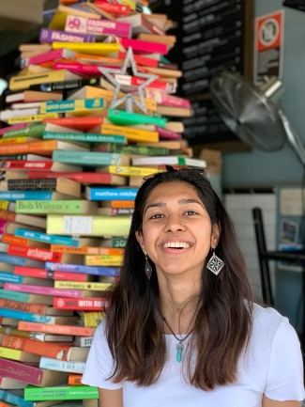
20008619
Ishita KHAITAN
Hi, my name is Ishita and I am hoping to be your International Student Representative for 2020.
Being an international student myself, I understand how difficult it can be in the initial stages to ‘fit in’. It is challenging to get outside your comfort zone, fit into a whole new world, plus try to make the most of university experience!
If elected through various engaging events and opportunities, I hope to collaboratively help you get through the challenges. I will also ensure that students get the academic and peer support they need, through the various events that I will organize.
Further, I stand to ensure that fairness and equality of international students is not compromised.
RAMEGOWDA, Rohith
19671114
Rohith RAMEGOWDA
Currently pursuing my Master’s in Business Analytics, I have 4 years of working experience as an SAP Program Manager for ATOS and as a Risk Analyst for Amazon. As a student Curriculum Developer for the Universities 21C Program and a Resident Assistant for the Western Sydney Village, I have been constantly trying to give back to the University and student community. Being an International Student Representative, I would love to be able to bridge the gap between University and students while promoting a state of mental wellbeing and ensuring that majority of the students University experiences remain positive. It’s an honor to work with such a diverse crowd and I aim to make the most of it. SRC is an example of one of the greater initiatives Western Sydney University has undertaken to ensure the relevance of student’s voice while also supporting a student’s transition from University to Workplace.
SAHNI, Manika
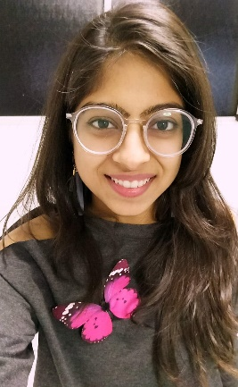
19668257
Manika Sahni
As a passionate international student representative, I want to build a strong community of well-informed and competitive students. My aim is to bridge the gap between students and university facilities, provide equitable opportunities to students, foster an environment where students feel secure voicing their opinions and ensure quick resolution of concerns raised through a well-established feedback mechanism.
To create an impact at personal level, I volunteer as Event Manager at Western Sydney International Student Club and as MATES Mentor with Student Engagement Program.
I deeply understand the struggle that international students face. There were many people who guided me to the right path and through this role, I want to pay back and help my fellow mates. Being from a culturally diverse country, I have a deep understanding and respect for all cultures. At western, I want our multiculturalism to thrive and be a source of creating opportunities and success.
SALIFU, Naya
19601045
MUNAYET SALIFU
My name is Munayet Salifu, a second year Bachelor of Laws (Graduate Entry) student. I am an international student who fits directly in your shoes as a student in a foreign country. I intend to represent the international students body in the 2020/2021 academic year.
First, I will take measures that will improve communication and boost morale of student who feel communication has become a barrier in their academic development. Second, I will ensure to bring to the student body, information about the ways and means of getting around your finances to ensure debts do not accrue during your stay in Australia. Lastly, I will liaise with school administration to ensure international students get entitled to concession cards.
I look forward to creating an inclusive campus environment.
Thank you.
SUNDAY-JEREMIAH, Rita
19991607
Rita Sunday-Jeremiah
My name is Rita Sunday-Jeremiah, l wants to serve you as the International representative, l will be putting in my leadership and teamwork skills acquired through work experience to ensure that our voices and concerns are heard and responded to. I hope to advocate for the implementation of a range of student issues designed to provide increased level of professional exposure and opportunity for all international students. Through this representation, l will be working closely with other executive members to make sure the interest of all international students is well represented.

ARMSTRONG-MANSAH, Rosina
18581498
Rosina ARMSTRONG-MENSAH
My name is Rosina Armstrong-Mensah studying Bachelor of Social Science. I have gotten to know more about the student and university which is the reason I look forward to representing my fellow student by making their voice heard.
I promise to effective, reliable, punctual, trustworthy and respect everyone. With my experience previously as a general representative for Campbelltown Student Campus Council, Liverpool women’s collective this made me more involved in university programs and activities. I find it less intimidating when students are talking to their fellow student therefore, I believe this opportunity will be a great one for me to connect and represent my colleague in the university.
I appreciate the opportunity given to apply for this position to represent my colleagues. When given the chance I will do my very best to abide and follow the necessary policies governing the role. Thank you.

CUPITT Sarah
19760041
Sarah Jane Cupitt
Hi, I'm Sarah Cupitt, and I want to continue representing student's rights and interests at WSU alongside my team 'Strength & Integrity'. I'm an ambitious 2nd-year student studying a Bachelor of Communication (Journalism & PR) playing a vital role in student advocacy relating to university-wide issues, collaborating on programs and services that offer a range of student opportunities. During my first year at Western, I was the SRC Online Students Representative, NUS delegate, became an exec of 8 student clubs and was last years recipient of the Western Sydney University Community Scholarship and the winner of The Academy's Emerging Leader Award. Recently, as the Vice President of Education (Undergraduate), I've been able to make a further positive impact on student engagement. This year in the SRC, my goal is to connect students to ensure optimal participation by including students in shaping the policies and practices that affect their learning experiences.

REED, Robert
17277873
Robert REED
My name is Robert Reed, I am a current Undergraduate Student at Western Sydney University, currently studying a Bachelor of Podiatric Medicine
I have been involved in Student Representation at Western for 4 years as Disability Officer for the Campbelltown Campus. During this time, my advocacy for the rights of students with carer responsibilities has seen provision been made in the form of AIP accommodations to this cohort which was not previously afforded.

I believe I have a passion for people and reducing inequalities in the academic arena, having lived experience of many of the situations of students. I believe I have the perseverance and integrity to lead students again in 2020.
RENIER-CLARK, Vicky-Rae
19071435
Vicky-Rae RENIER-CLARK
My name is Vicky-Rae Renier-Clark, I am a current Undergraduate Student at Western Sydney University, currently studying a Bachelor of Arts as well as a Bachelor of Health Sciences.
I have been heavily involved in Student Representation at Western for 4 years in various roles. These include the SRC, academic committees, equity collectives, executive planning committees as well as the formulation of my student club, Bankstown Student Civic Committee. I was also the winner of the 2018 Student Voice (Advocacy) Award.

I believe I am a well-disciplined student with a great passion for people and sustainable issues well beyond the expectations of my representative roles developing ethical and equitable outcomes to many of the situations experienced by students. I believe I have proven myself time and again to have the perseverance, initiative and passion to lead any project and the opportunity to lead students again in 2020.

ARMSTRONG-MENSAH, Rosina
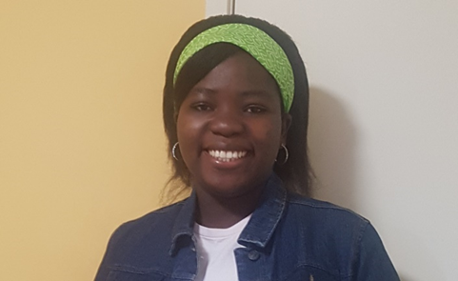
18581498
Rosina ARMSTRONG-MENSAH
My name is Rosina Armstrong-Mensah studying Bachelor of Social Science. I have gotten to know more about the student and university which is the reason I look forward to representing my fellow student by making their voice heard.
I promise to effective, reliable, punctual, trustworthy and respect everyone. With my experience previously as a general representative for Campbelltown Student Campus Council, Liverpool women’s collective this made me more involved in university programs and activities. I find it less intimidating when students are talking to their fellow student therefore, I believe this opportunity will be a great one for me to connect and represent my colleague in the university.
I appreciate the opportunity given to apply for this position to represent my colleagues. When given the chance I will do my very best to abide and follow the necessary policies governing the role. Thank you.

GADALLA, Akmal
17961077
Akmal Gadalla
I am a mature aged undergraduate student. I have been representing the students at Paramatta South campus as the Student Campus Council representative for the year ending 2018. During my life journey, I have gained a lot of experience which enabled me to act on behalf of my colleagues. I enjoy serving the community and like to listen to my classmates’ suggestions or otherwise complaints and delegate them to the university administrative or managerial staff. I am expressing my interest to apply for the SRC Committee, to carry out what I have started in the past. I would like to always do my best to serving the student’ community and step up with it until we all “working together” get to the standards our students’ community deserves. Thank you in advance for taking the time to read my statement. Looking forward to join forces together until we achieve our goals.
PARKAR, Rameez
19290573
Rameez PARKAR
Hi I’m Rameez. I never thought I would ever run for the Western SRC but I don’t think I could sit by quietly any longer. For too long now the students of Western Sydney University have had their interests ignored. Like many students I have met my “uni life” consists of coming to class and going home because there is not enough to do on campus. That is why I started a student club and that’s why I’m now running for the SRC. I think that so much can be done to serve the interests of students rather than spending hundreds of thousands of dollars on merchandise that the vast majority of the 45,000 Western students have never seen. There has never been a more important time for strong progressive, principled and pragmatic students representatives fighting for us! Let’s make WSU even better! Vote [1] Rameez Parkar and JUMPSTART!

FISARA-FITZPATRICK, Fletcher
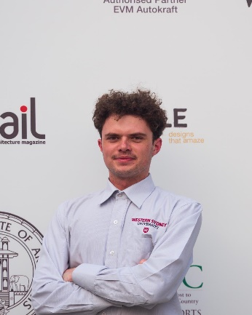
19033756
Fletcher FISARA-FITZPATRICK
Hey all, I’m fletcher and this year I’ll be running for SRC along with my colleagues from JumpStart WSU.
But why pick me?
Well, having proven myself to the harshest critics in society, local pub veterans have gone as far to say I’m an exceptional athlete, communicator, visionary and all-round top bloke.
With 2020 as of far being nothing short of a big kick in the marbles, it’s time to hit reset and bring back the roaring 20s into 2020. With your vote, I’ll strive to improve our campus community and let your ideas be heard. It’s time to better our community; environmentally and socially.
Just remember to vote Fletcher and the JumpStart Team.
WOLF, Danielle
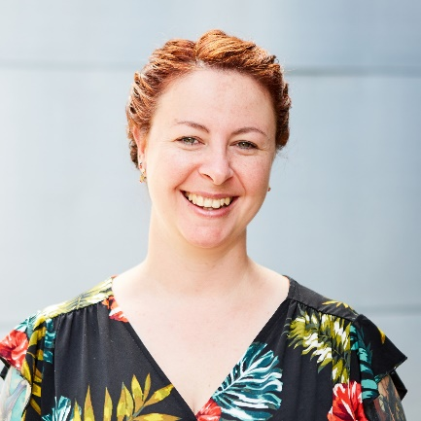
17646882
Danielle WOLF
I’m eager to reprise my role as Environment Rep, to build on past achievements, and cultivate new ways of achieving equity for Nature, and people as part of it. This year we’ll empower students to take small steps for big impact toward environmental well-being at Western, and in local communities. But this isn’t about an “apocalypse”. It’s about hope, passion, compassion, flourishing, friendships, and FUN. So, we’ll have DIY luxurious beauty product workshops, grow and harvest food to share, hold competitions with cool prizes, give fabulous welcome packs, and play in dirt together. We’ve protests to attend, skills to build, recognition to attain, and of course, worlds to change. I’ll leverage every resource at my disposal to make your time at Western environmentally and sustainably fruitful, empowering, eye-opening, and life changing. Life is full of promise and opportunity. Together we will change the course of history. In short, PICK ME!

MOHAIDLI, Fatima
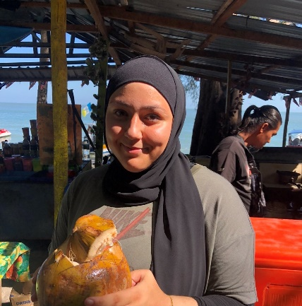
20207537
Fatima MOHAIDLI
Hi everyone, I’m running to be a Campbelltown representative. Just like everyone else, I’m an ordinary student, and my scarf does define me! I’m a young Australian striving for a better future, for myself, and others too.
I understand that your opinions may have been disregarded over the years, and to this I say, ‘the line must be drawn here’. I stand here today, with my arms and ears wide open for every single one of you, ready to listen to your concerns, and help improve the university.
I strive to promote Australian values and aim for us to work together to make the universities environment the best possible one. I believe in using power for good, and good only, and vow to support everyone equally. I may not be able to make a nationwide change, but help me in taking the first step here at Western Sydney University!
REED, Robert
17277873
Robert REED
My name is Robert Reed, I am a current Undergraduate Student at Western Sydney University, currently studying a Bachelor of Podiatric Medicine
I have been involved in Student Representation at Western for 4 years as Disability Officer for the Campbelltown Campus. During this time, my advocacy for the rights of students with carer responsibilities has seen provision been made in the form of AIP accommodations to this cohort which was not previously afforded.

I believe I have a passion for people and reducing inequalities in the academic arena, having lived experience of many of the situations of students. I believe I have the perseverance and integrity to lead students again in 2020.
RENIER-CLARK, Vicky-Rae
19071435
Vicky-Rae RENIER-CLARK
My name is Vicky-Rae Renier-Clark, I am a current Undergraduate Student at Western Sydney University, currently studying a Bachelor of Arts as well as a Bachelor of Health Sciences.
I have been heavily involved in Student Representation at Western for 4 years in various roles. These include the SRC, academic committees, equity collectives, executive planning committees as well as the formulation of my student club, Bankstown Student Civic Committee. I was also the winner of the 2018 Student Voice (Advocacy) Award.
I believe I am a well-disciplined student with a great passion for people and sustainable issues well beyond the expectations of my representative roles developing ethical and equitable outcomes to many of the situations experienced by students. I believe I have proven myself time and again to have the perseverance, initiative and passion to lead any project and the opportunity to lead students again in 2020.
SELVAKUMAR, Sharon
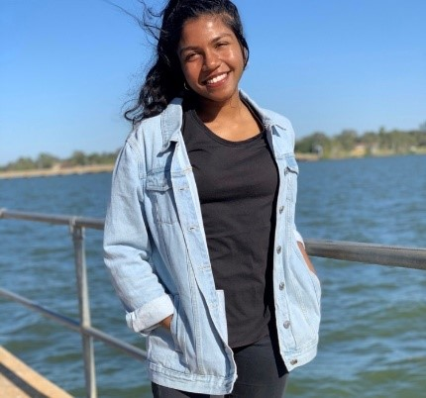
19740834
Sharon Selvakumar
I am an undergraduate student studying Bachelor of Physiotherapy. Having years of experience in organising student events, as well as serving as an executive member of numerous clubs and societies such as Amnesty International, I believe my wealth of experience will make me a suitable student representative for the Campbelltown campus in 2020. I am an energetic individual who desires to gather student feedback then raise issues, concerns and opinions of students. I believe it is important for students, new and old to have a strong connection with the university. I’d love the opportunity to serve my peers in 2020 and am enthusiastic to carry forward the views of the student voice in Campbelltown and to engage students and student leaders in discussion.
TRAN, Tracey
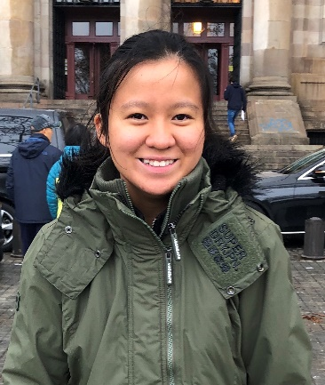
19768683
Tracey TRAN
Evident through my active involvement in clubs at school such as the Social Justice committee, the Kind Club and the High Resolves Leadership program as well as being a student representative, I believe I am a good fit for the role. Around campus, others would describe me as an organised, punctual, committed, positive and a mostly energetic soul (although maybe not at an 8AM tutorial class). I’m approachable and happy to help!. I am passionate about helping out with first year students and building a more vibrant campus life at the university like picnics by the lake or bbqs. I hope to meet new people and engage everyone in the conversation of how university life could be improved.

FICARRA, Veronica
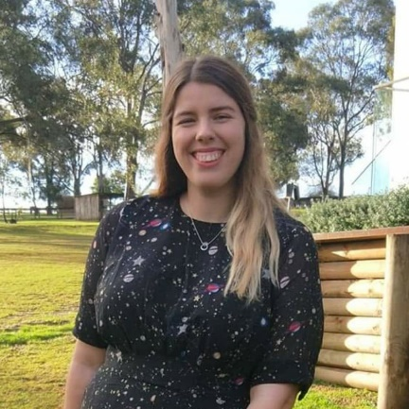
19980137
Veronica FICARRA
My name is Veronica Ficarra, I’m a second year Sustainable Agriculture and Food Security student, and I want to Jumpstart our Hawkesbury Campus! I love Hawkesbury campus – it is an enriching and inspiring place to study, but our campus definitely misses out on the fun that the rest of the university experiences! I want to see more social activities and student services on campus, and I would advocate heavily for this. I am a huge believer in good governance and responsible management of student funds, and I would hold myself to this high standard if elected as your Hawkesbury Campus Representative. Hawkesbury Campus deserves a better share of the pie, and if you agree with me, I would really appreciate your support. Please vote Veronica Ficarra for Hawkesbury Campus Rep and JUMPSTART for all other SRC positions!
GADALLA, Akmal
Akmal Gadalla
17961077
I am a mature aged undergraduate student. I have been representing the students at Paramatta South campus as the Student Campus Council representative for the year ending 2018. During my life journey, I have gained a lot of experience which enabled me to act on behalf of my colleagues. I enjoy serving the community and like to listen to my classmates’ suggestions or otherwise complaints and delegate them to the university administrative or managerial staff. I am expressing my interest to apply for the SRC Committee, to carry out what I have started in the past. I would like to always do my best to serving the student’ community and step up with it until we all “working together” get to the standards our students’ community deserves. Thank you in advance for taking the time to read my statement. Looking forward to join forces together until we achieve our goals.
NEWTON, Josh
19724528
Josh NEWTON
In my time representing the Hawkesbury Campus on the SRC I have advocated for more events, student services and student voice. I have brought therapy dogs on campus twice in the past month, in collaboration with the Student Welfare Team. I have been working to increase on campus crisis housing and I hope to turn the University Campus Villages into a Co-op.
As the Hawkesubry Campus Representative on the SRC there are a number of Initiatives that I would aim to implement:
1. Increasing the size of the student voice on campus
2. Introduce therapy dog events once monthly on campus in collaboration with student welfare (This is a great way for students to be introduced to the services the university offers whilst meeting some very cute dogs)
3. Transforming the university campus villages into a co-op
4. Introduction of more social sport on campus

ARMSTRONG-MENSAH, Rosina
18581498
Rosina ARMSTRONG-MENSAH
My name is Rosina Armstrong-Mensah studying Bachelor of Social Science. I have gotten to know more about the student and university which is the reason I look forward to representing my fellow student by making their voice heard.
I promise to effective, reliable, punctual, trustworthy and respect everyone. With my experience previously as a general representative for Campbelltown Student Campus Council, Liverpool women’s collective this made me more involved in university programs and activities. I find it less intimidating when students are talking to their fellow student therefore, I believe this opportunity will be a great one for me to connect and represent my colleague in the university.
I appreciate the opportunity given to apply for this position to represent my colleagues. When given the chance I will do my very best to abide and follow the necessary policies governing the role. Thank you.
FERRER, Natasha
19795371
Natasha FERRER
Energise your SRC! As your current Liverpool Campus Student Representative it has been a privilege and joy to advocate and answer the needs, wants and concerns of my students. Primarily, during my tenure, I have provided a Facebook discussion group platform for students to be informed and have a voice on, created a plant event to help destress students and have secured a weekly study and relaxation zone (delayed due to COVID-19).
I am passionate towards the issues of mental, spiritual and physical health, social isolation and student safety. If I am re-elected into my position, once permitted, I will raise awareness to these issues and create events such as therapy animals, gaming zones, academic-based initiatives and will encourage the creation of clubs and societies. I will also reach out to local businesses and councils to provide more discounts, opportunities and events for my students. Vote for me and energise

BAKER, Tash
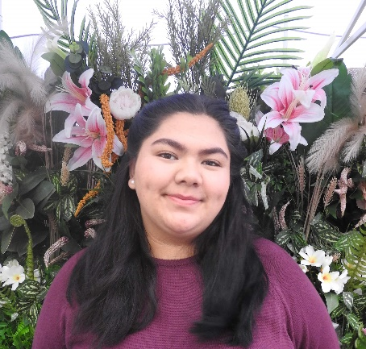
20111739
Tash BAKER
My name is Natasha Baker. I am writing to apply for a position for Student Representative Council at Nirimba campus. I am a recent high school graduate and I am currently in my first year and I am studying a Diploma in Health Science Extended. I would like to use this as an opportunity to prosper and advocate for the needs of the student body. I may not have any experience of being a member of School Representative Council, but I am eager to learn. I am confident that the School Representative Council at Nirimba Precinct is the perfect opportunity to develop and facilitate newfound skills whilst taking up this leadership role. I wish to contribute and advocate social and cultural inclusion and to have their voices heard.
I look forward to hearing from you. Thank you for your time and consideration.
RAM, Crystal
18702590
Crystal RAM
Hi, everyone! I'm Crystal, I'm a candidate at our student elections, and I want to JUMP START WSU. Currently on the executive of Student Clubs, I want to put my leadership experience to work for all of WSU.
This election is very important because our voice will be listened to. This will happen unless you do not vote. And other students’ ideas and thoughts will be heard. I’m the right person to do this job. In the first place, I’m a very responsible person and I love speaking before an audience. Second, if you vote for me, I will speak out for your complaints and problems that I’m sure you have on campus.

If you elect me and empower me with your trust, I will make several changes to the current leadership team. We plan on adopting and introducing more diverse and varied events, widening options for students, this will
BONATTI, Daniel
19257310
Daniel BONATTI
I Daniel Bonatti enrolled in a BConMgmt & GradDip in Building Surveying. I wish this opportunity to nominate as Under/Postgraduate Parramatta. I won this role last year. I need your vote again. I have DipprojMgmt, DipBdgCon, As.Dip.Civ.Eng, B.Tech, GradCert, MDesSc(Bdg)(Hons), MDesSc(Bdg Serv), MBA
I am currently WSU - Vice President (Education) Postgraduate, SRC. In this role I represented SRC on, NUS, CAPA, TEQSA Tertiary Education Quality Standards Agency, Academic Senate, SRC Committees - Executive, Remuneration, SRC Budget $160k, Communication Strategy, SSAF 5.9 million, and chaired two SRC meetings.
I have advocated for students at alleged misconduct and to get access to resources off campus. Helped in policy changes. I was in-charge of the NSW CAPA campaign for International concession travel has had effects with Vice Chancellor committee giving two opal cards worth $400. I have had otherwise disengaged students involved in Campus life making CAPS and involvement in EWB clubs/societies.
DAOUD, Tony
19398336
Tony DAOUD
Hi I’m Tony. I came to the realisation that inaction is a part of the problem. Criticising others while sitting on the sidelines isn’t good enough and so I will actively be taking part in this campaign. I take this role very seriously and the only promise I will make is that I will do all that I can to the very best of my abilities. The truth is often pushed aside for mistruths and white lies especially by people in positions of trust and power but that will not be the case with me. I take inspiration from my mentor Donald Trump and will be as open and upfront about all activities and ensure an open forum is present between us all so that we can work together to finally bring about a better university experience for us all. So Vote [1] Tony Daoud for President and for
JUMPSTART.
GADALLA, Akmal
Akmal Gadalla
17961077
I am a mature aged undergraduate student. I have been representing the students at Paramatta South campus as the Student Campus Council representative for the year ending 2018. During my life journey, I have gained a lot of experience which enabled me to act on behalf of my colleagues. I enjoy serving the community and like to listen to my classmates’ suggestions or otherwise complaints and delegate them to the university administrative or managerial staff. I am expressing my interest to apply for the SRC Committee, to carry out what I have started in the past. I would like to always do my best to serving the student’ community and step up with it until we all “working together” get to the standards our students’ community deserves. Thank you in advance for taking the time to read my statement. Looking forward to join forces together until we achieve our goals.
MOON, Declan
19284284
Declan MOON
Parramatta South Campus has been my primary campus for more than 2 years, I've seen so many students come through it and achieve so much. As a student who lives on campus at Parramatta North, I'm never more than 5 minutes walk away. The facilities at Parramatta south are unmatched by any other campus in my opinion, and I'd be proud to represent it and do my best to help any student there who needed it.
PARKAR, Rameez
19290573
Rameez PARKAR
Hi I’m Rameez. I never thought I would ever run for the Western SRC but I don’t think I could sit by quietly any longer. For too long now the students of Western Sydney University have had their interests ignored. Like many students I have met my “uni life” consists of coming to class and going home because there is not enough to do on campus. That is why I started a student club and that’s why I’m now running for the SRC. I think that so much can be done to serve the interests of students rather than spending hundreds of thousands of dollars on merchandise that the vast majority of the 45,000 Western students have never seen. There has never been a more important time for strong progressive, principled and pragmatic students representatives fighting for us! Let’s make WSU even better! Vote [1] Rameez Parkar and JUMPSTART!
POLARA, Razin
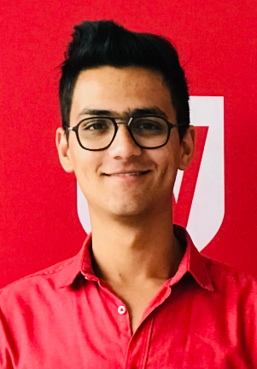
19668228
RAZIN POLARA
Hello! My name is Razin. I am running for the position of the Member of the Student Representative Council (SRC) of Parramatta south campus. Currently, I am pursuing bachelor of nursing and am also one of the ‘MATES Mentor’ cause I want to play an active role in the ongoing improvement of our university and reaching out the new students and letting them to experience the wide and bright environment of WSU. I really enjoy helping people and involving myself in the university. This is the main reason I was the part of SRC in 2019 at Parramatta city and I want to share my knowledge and experience again this year. I would heartily appreciate your vote for me, Razin Polara, to serve on the student Representative council.
SALIFU, Naya
19601045
MUNAYET SALIFU
My name is Munayet Salifu, a second year Bachelor of Laws (Graduate Entry) student. I intend to run as your Vice President Activities in the 2020/2021 academic year.
Together with other student leaders, I am ready to take on significant accomplishment which has been at the heart of Parramatta South campus students such as concerns regarding parking, socialization, available services to help students cope with campus pressure and the likes.
What is most important to me is creating a platform that creatively involves all students and representatives through which pressing needs can be identified and resolved. This is the best way to represent the views of my fellow students and resolve issues.
I find it a privilege to be involved in making decisions that will rectify the problems that some of us have faced on this campus.
Thank you.
SHRESTHA, Bhabish
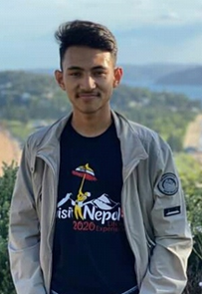
20050753
Bhabish SHRESTHA
I am interested to be the Student Representative of Parramatta Campus to be the students voice and voice of voiceless. I will ensure to unite the emerging leaders of our campus in the days to come. I will try my best to elaborate and create domestic and international network for peace, cooperation, mutual understanding and sustainable development across the campus and our community. I assure we will together work for the peace, meaningful participation of every student and innovation. I whole-heartedly reckon that we shall gain invaluable knowledge regarding the critical youth and global issues and the meaningful cum effective way to solve them from whole new perspective, to learn new tips and tactis for the sustainable development via different activities in our campus. My main objective will be to create student friendly environment throughout our campus and make sure that everyone gets equal opportunity for their growth and development.

BURGESS, Griffen
19360052
Griffin BURGESS
Hi, my name is GRIFFEN BURGESS and I’m running for Vice President Education (Undergraduates) on Western Sydney University’s 2020 SRC. I want to JUMP START our University and get involved with our students because I see extraordinary potential with both students and University, but most importantly be the voice for the those that haven’t been heard.
I’m running for this position because I’m passionate about opportunity, experience and the safety of our students regardless of the situation. Being a student myself I know what an average student goes through on a day to day basis, and I’ve been very fortunate to have met amazing, intelligent and humbled individuals from both staff and students. Having this experience and what my journey has been like so far, I’m proud to say that ‘I’m a Western Sydney University student’.
Thank you and remember. Vote 1, GB for VP
JIWANI, Adeem
19533719
Adeem JIWANI
My name is Adeem Jiwani, I'm a final year Master of Business Administration Student. I am running for National Union of Students Delegate because I am currently working as a NUS delegate and I am aware of the student advocacy. I have been a regular participant in student activities on campus and have been working as an "Ask Us Assistant" for a while now. I would like to ask you for your support to be elected as an NUS Delegate of the Westerns Sydney University for 2020, so we can continue to embrace to take our point of view and ideologies at WSU to the National Conference and create a place that is welcoming, warm and courteous to students and bringing equality to students. I promise no more sitting there! It’s about moving forward and creating change for my peers.
KHAITAN, Ishita
20008619
Ishita KHAITAN
Hi, my name is Ishita and I am hoping to be your Parramatta City Campus Representative for 2020. I am a first year student of Master’s in Business Analytics. I currently teach and also volunteer at LifeLine.
Keeping in mind that the position holds strong values, if elected, I want to create a real sense of community within the Parramatta City campus. I will do so not only by hosting more networking events but also more fun and social events so that students do not miss out on the holistic university experience.
SUNDAY-JEREMIAH, Rita
19991607
Rita SUNDAY-JEREMIAH
I am running for this position because it is my wish to place student’s needs at the forefront, I will strive to take a stand against the stigma surrounding mental health; build strong relationships with the Western Sydney University to promote a supportive and encouraging environment and culture of success for all university students. I aspire to also address the concerns and ideas of the students of Parramatta Campus and be an avenue for their voices to be heard. I plan on working constructively with the SRC’s to ensure all their issues are addressed as quickly as possible.
CHUNG, Mary-Pearl
19951124
Mary-Pearl CHUNG
I’m a student in the Bachelor of Communication (Dean’s Scholars) course at Penrith campus. I am running for various SRC/ leadership positions within the university.
Throughout my student life I have been actively involved in a range advocacy and leadership experiences, such as having been awarded an Australian Defence Force Long Tan Youth Leadership Award in 2018, school captaincy, and youth ambassadorship in Multicultural Youth Affairs Network (MYAN) NSW, Youth Action (Young Women Lead- Western Sydney program), Vinnies Youth Social Justice, PLAN International Australia Youth Activist Leader— to name a few.
My passions include art, music, food and social justice. I consider myself a very positive-minded and understanding person, and I would love to create and maintain a great university experience for all my peers by encouraging involvement, diversity and tolerance. If given the opportunity, I will do my best to contribute to a dynamic and inclusive university student life.
PREUSS-FEARNEY, Simon
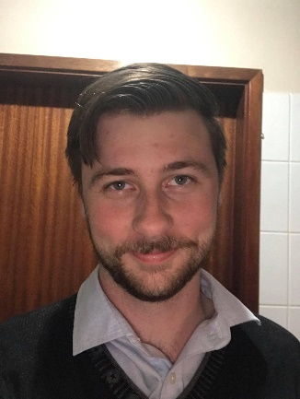
18368811
Simon PREUSS-FEARNEY
While we do study different degree at our Penrith campus, we all have one thing in common. We want to become something more exciting and impressive. We want to do something with our lives. That’s the point of attending University.
I believe an SRC representative should act to support that ambition, by assisting student clubs, and being approachable, for anyone to get information from. By voting for me you will be voting for someone who wants to support you in your studies and goals beyond.
I am studying Psychology (Honours). Also, I am Penrith Psychology Society Treasurer (S.Club).
Additionally, I held the Penrith SRC Representative previously (Caretaker Position) and have been organising future projects for Penrith during that time.
What I bring to the role is the ability to actually listen, and to fight for what you believe in.
Together, let us reshape the University, in way we want it.

