WSU NGS Facility Metagenomic Primer Sets

Bacterial Primers (16S)

341 Forward and 805 Reverse
amplifying 16S variable regions v3 and v4
341F – 5’ CCTACGGGNGGCWGCAG
805R – 5’ GACTACHVGGGTATCTAATCC

27 Forward and 519 Reverse
amplifying 16S variable regions v1 and v2
27F – 5’ AGAGTTTGATCMTGGCTCAG
519R – 5’ GWATTACCGCGGCKGCTG

515 Forward and 806 Reverse
amplifying 16S variable region v4
515F – 5’ GTGCCAGCMGCCGCGGTAA
806R – 5’ GGACTACHVGGGTWTCTAAT

799 Forward and 1193 Reverse
amplifying 16S variable region v4 and v5
799F – 5’ AACMGGATTAGATACCCKG
1193R – 5’ ACGTCATCCCCACCTTCC
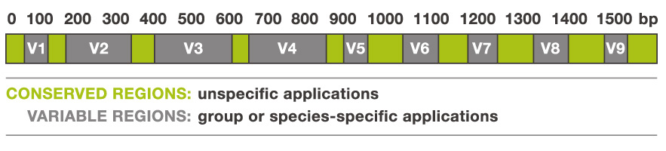

Fungal Primers (ITS)

fITS7 Forward and ITS4 Reverse
amplifying ITS2
fITS7 – 5’ GTGARTCATCGAATCTTTG
ITS4 – 5’ TCCTCCGCTTATTGATATGC

ITS1oo Forward and ITS4 Reverse
amplifying ITS1 and 2
ITS1oo FWD – 5’ GGAAGGATCATTACCACA
ITS4 – 5’ TCCTCCGCTTATTGATATGC

ITS1f Forward and ITS2 Reverse
amplifying ITS1
ITS1f – 5’ CTTGGTCATTTAGAGGAAGTAA
ITS2 – 5’ GCTGCGTTCTTCATCGATGC

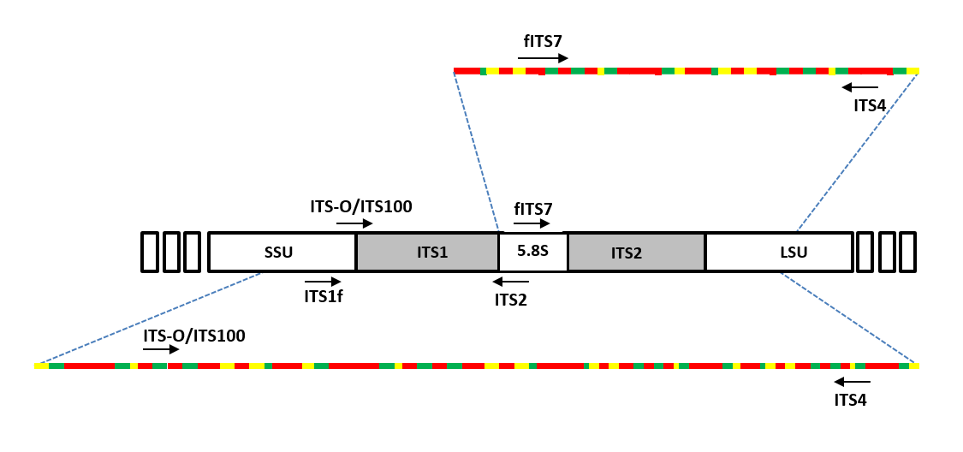

Protist Primers (18S)

18S forward (Euk_1391f forward primer) and 18S (EukBr reverse primer) reverse
amplifying SSU rRNA gene V9 hypervariable region
- 18Sf (Euk_1391f) – 5’ GTACACACCGCCCGTC
- 18Sr (EukBr reverse) – 5’ TGATCCTTCTGCAGGTTCACCTAC

