Dragon Professional.

Managing Dragon Vocabulary

Support Manual 3 of 7

Contents

The Vocabulary Editor 2

About the Vocabulary Editor 2

Adding new words to the vocabulary 3

Spoken form 3

Correcting capitalisation 5

Option 1 – Using the keypad 5

Option 2 – Using Voice Control 6

Adding acronyms 6

# The Vocabulary Editor

Refer to the supporting video [*03. Managing Dragon vocabulary Part 1*](https://westernsydney.ap.panopto.com/Panopto/Pages/Viewer.aspx?id=6e3b2e4b-01d0-4fa1-bc62-abc90183c600)

## About the Vocabulary Editor

Dragon has an extensive vocabulary that includes thousands of words, phrases, abbreviations, and acronyms. These are listed in the Vocabulary Editor.

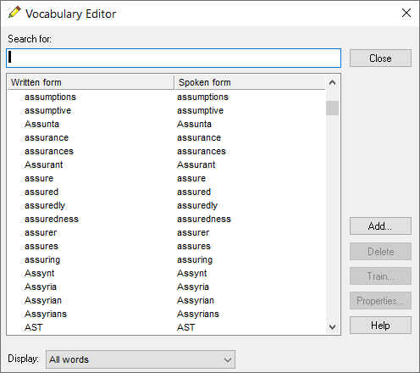

If a word you dictate is not in this list, Dragon will not be able to write it for you. No matter how clearly you pronounce it.

## Adding new words to the vocabulary

It many cases, it is possible to instantly add new words by using the correction window while dictating and typing in the complete word. However, that option only works when adding single words. Phrases and single words with unusual spelling and pronunciation should be added via the Vocabulary Editor.

1. Click ‘Tools’.
2. Click ‘Vocabulary Center’.
3. Open ‘Vocabulary Editor’.
4. Click the ‘Add’ button.
5. Enter the word, in this example use “Weimaraner” (a breed of dog).

### Spoken form

The screenshot on the following page also shows that spoken form has been added. Though not usually required, there are some occasions when you need to include spoken form. Spoken form is basically **a phonetic map of the pronunciation**. The check box to train the word should be ticked to train the pronunciation of this new word. The rest of the process can be done by mouse or with voice commands.

The voice command sequence would be;

1. Say “Open Vocabulary Editor”
2. Say “Click Add”
3. Spell out loud “W e i m a r a n e r”
4. Say “Click I want to train the pronunciation of this word or phrase”,
5. Say “Click Spoken form”
6. Type or spell out loud the phonetic version of the word “why marana”
7. Say “Click Add”
8. Say “Click train”
9. Repeat the word out loud
10. Say “Click save”.

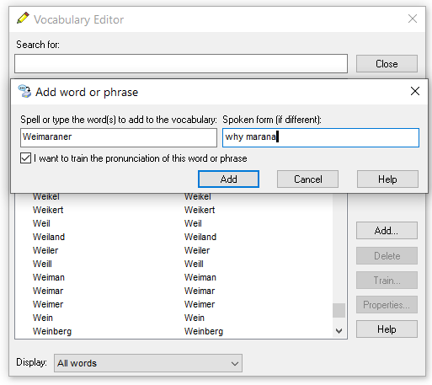

The word Weimaraner is now added to the custom list of words in your user profile.  
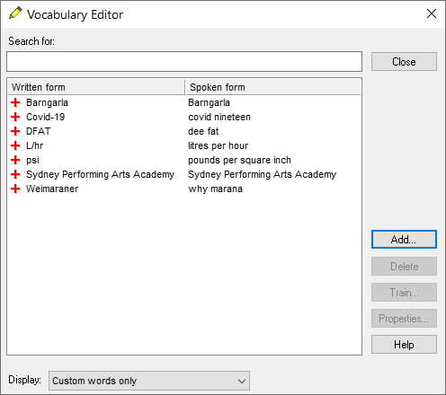

## Correcting capitalisation

Dragon’s vocabulary includes names of entities and events such as Department of Health, Australia Day and Anzac Parade. There will be times when names of entities are not capitalised. For example, Sydney performing arts academy. The correction command could be used to capitalise this phrase.

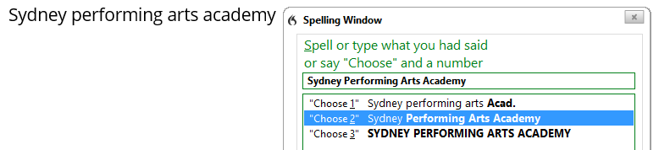

However, the capitalisation issue will persist, so this phrase needs to be added to Dragon’s vocabulary. There are two ways to add this capitalised phrase:

### Option 1 – Using the keypad

1. Click ‘Tools’.
2. Click ‘Vocabulary Center’.
3. Click ‘Add new word or phrase’.
4. Type the word into the box on the left.
5. Type the word into the spoken form box.
6. Ensure the ‘I want to join the pronunciation of this word or phrase’ is selected.
7. Click ‘Add’.
8. Click ‘Train’.
9. Repeat the word and click ‘Save’.

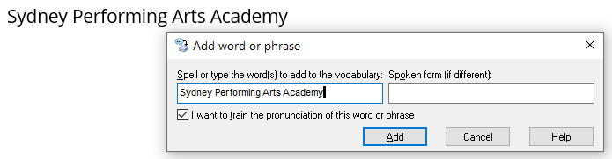

### Option 2 – Using Voice Control

As you cannot dictate in this box you would need to type it or spell it by voice and then click “Add”. That is fine for single words, but this is a lot of typing. There is a quicker alternative using the following sequence of voice commands:

1. Say “Select Sydney Performing Arts Academy” (the capitalised version).
2. Say “Copy that”.
3. Say “Add a new word”.
4. Say “Paste that”.
5. Say “Click Spoken form”.
6. Say “Sydney Performing Arts Academy”.
7. Say “Click I want to train the pronunciation of this word or phrase”.
8. Say “Click Add”.
9. Click ‘Save’.

## Adding acronyms

Dragon has little difficulty with acronyms if they are spelt as they sound. For example, Dragon’s vocabulary includes WHO, RSPCA and the UN. But spoken form would be required for the acronym DFAT. This is the acronym for the Department of Foreign Affairs and Trading. The screenshot below indicates one way to manage the phonetic map of this acronym.

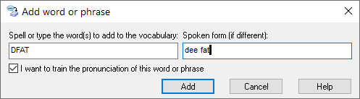

Dragon's vocabulary also includes basic units of measurement and words that include numerals such as sixty kilometres per hour and vitamin B12. Adding vocabulary of this nature is covered [Managing Dragon Vocabulary Part 2.](https://westernsydney.ap.panopto.com/Panopto/Pages/Viewer.aspx?id=c2b5110f-eef5-48f2-a745-abc90183c608)

*More information is located on the Dragon Training and Support page* [www.westernsydney.edu.au/dragon-training](http://www.westernsydney.edu.au/dragon-training).