Dragon Professional.

Dictation Principles

Support Manual 2 of 7

Contents

Dictation principles and voice correction 2

Overview 2

Correcting errors 2

Adding to Dragons vocabulary 4

Accessing the Vocabulary Editor 5

Final Note 5

# Dictation principles and voice correction

Refer to the supporting video [*02. Voice correction*](https://westernsydney.ap.panopto.com/Panopto/Pages/Viewer.aspx?id=a15ee3da-0152-47a4-82d7-abc90184edbe)*.*

## Overview

Dragon is highly accurate with a low threshold of errors. When dictation errors do occur, it is important to resist going straight to your keyboard to correct the word. Dragon is engineered with machine learning to continually analyse your voice profile to improve accuracy. To activate the machine learning, it is extremely important to use the voice correction window to correct errors. Dragon uses the correction window to log your corrections and learn from them to improve accuracy.

## Correcting errors

Once a passage of text is dictated, use the voice command ‘correct <word>’ to bring up the Correction window. If the correct word is suggested in the list, select it by voice or mouse click. If the word is not in the list, start to type the word until it is listed and select accordingly.

For example, dictate “Travel along the Eyre Highway and you will come to Port Lincoln; a town famous for its seafood and white pointer sharks”. When ‘Eyre’ is incorrectly typed as ‘air’ the three-step voice command sequence to correct is:

1. ‘correct air’.
2. ‘choose 3’.
3. ‘click OK’.

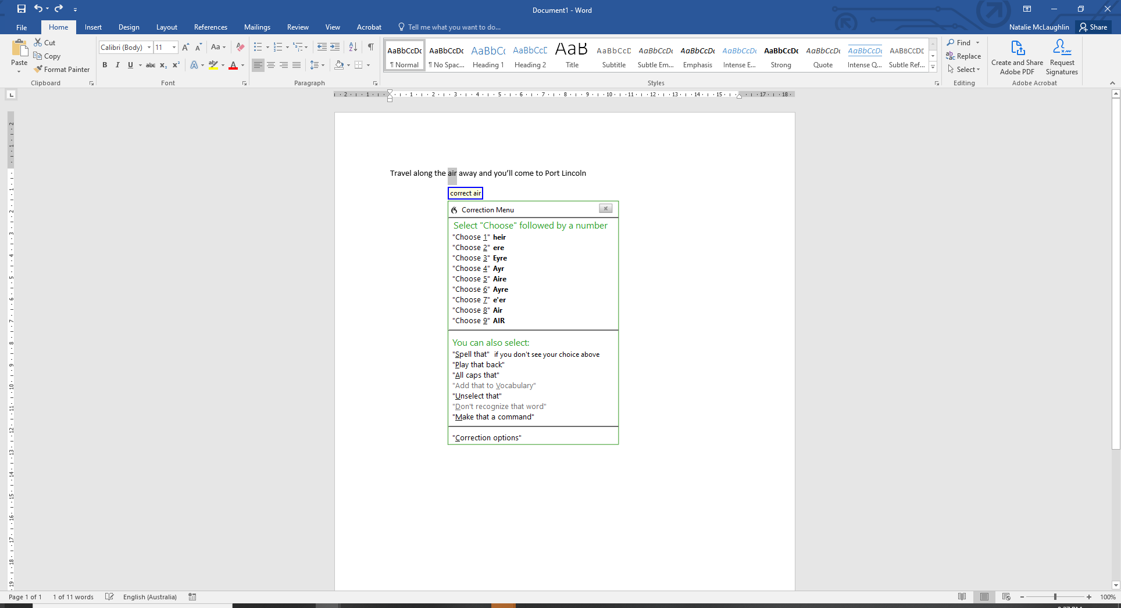

Dragon has now learnt the correct word usage of air based on pronunciation and context.

## Adding to Dragons vocabulary

Dragon has an extensive vocabulary of thousands of words. If a word you dictate is not in its vocabulary, Dragon will not be able to write. No matter how clearly pronounce it is pronounced.

As per the video, the following sentence contains a word that does not exist in Dragon’s vocabulary. ‘The local indigenous people in Port Lincoln are known as the Barngarla people’. It is important to **say the word that appears on the screen** when correcting. i.e ‘correct bungalow’. Type the correct word and say ‘choose 1’.

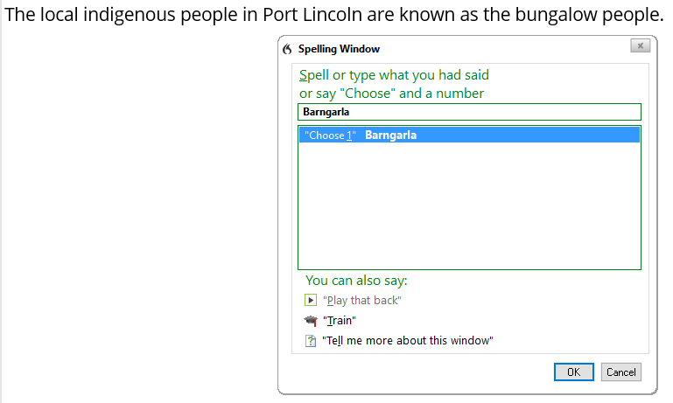

Not only is the word corrected but it has now been included as a custom word in your user profile vocabulary. This can be verified in the Vocabulary Editor.

## Accessing the Vocabulary Editor

The Vocabulary Editor can be accessed from the Dragon Bar.

1. Click ‘Tools’
2. Click ‘Vocabulary Center’
3. Click ‘Open Vocabulary Editor’.

Perform a search for the new word in the general vocabulary. Alternatively click on the Custom words only display option. Any words with a red plus sign indicate it is a custom word.

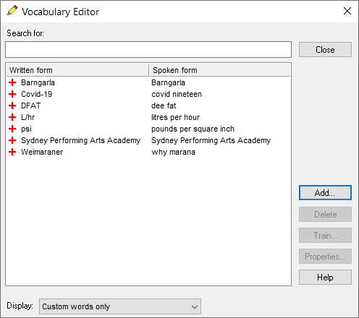

## Final Note

Using voice correction to manage errors is an essential process to improve accuracy. Over time, Dragon will become highly personalised to your voice profile resulting in greater writing fluency.

*More information is located on the Dragon Training and Support page* [www.westernsydney.edu.au/dragon-training](http://www.westernsydney.edu.au/dragon-training)*.*