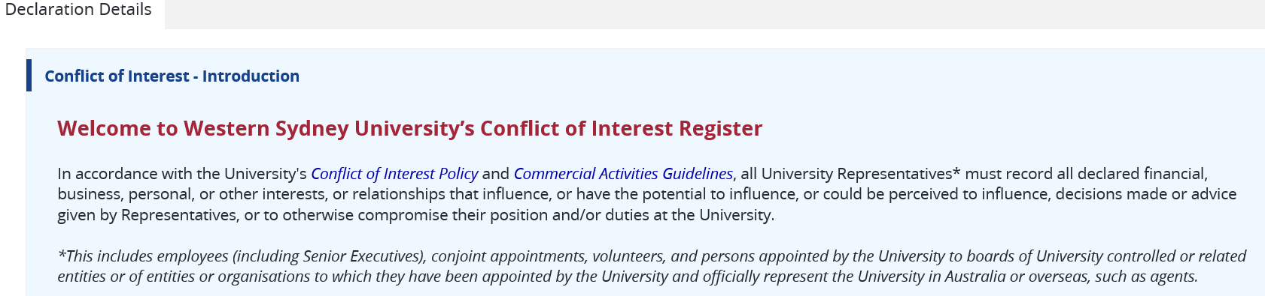

- Representative Name (name of the person declaring the interest)

- Representative Email

- Representative Type (please choose from the following)
☐University employee
☐University Senior Executive
☐Board / Board Committee member

- Type of Conflict of Interest Declaration
☒ Continual Disclosure
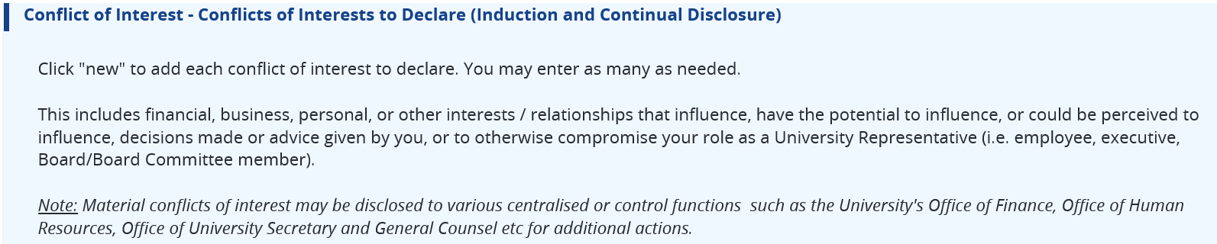

- Type of Interest (please choose from the following)
☐Family (child/ren, parent, spouse, stepchild/ren) ☐Former colleague
☐Former spouse ☐Friend
☐Rival and/or competitor ☐Relatives of any of the aforesaid
☐Committee Membership ☐Company directorships or partnerships
☐Contractual arrangements or obligations ☐Employment
☐Gifts ☐Investments
☐Private business ☐Self-managed superannuation funds involvement
☐Shareholdings ☐Significant equity holdings with influence
☐Significant liabilities ☐Social, political or religious group
☐Trusts or nominee companies ☐Voluntary activities
☐Other (including any significant sources of income), please specify:

- Description of Interest - Please describe the conflict (real, perceived, potential, material) and the association with the University, including name of the organisation or group or individual:

- Risk Mitigation Strategy - to manage the interest in time of conflict (please choose all that applies)
☐Modify or transfer the delegation
☐Absence from decisions or voting
☐Request for independent review
☐Restrict access to systems or information
☐Appoint independent members
☐Review access and delegations
☐No direct or indirect responsibility
☐Appoint independent oversight
☐Other
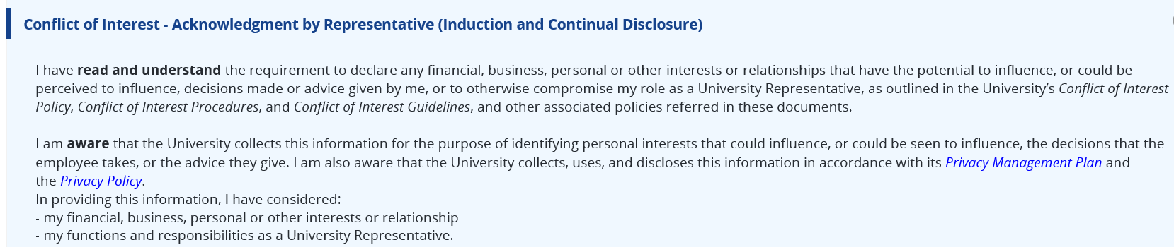
- Acknowledgement
Insert signature and date

__________________________________________________
MANAGER TO CONFIRM
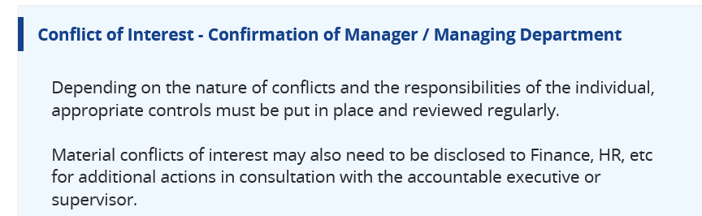
Prior to confirming the declaration and if it is appropriate to do so, you may wish to:
- obtain further information from the person declaring the interest, from the person; or
- escalate the disclosure to the Compliance Program Unit for further investigation and action, particularly for complicated and rare conflicts of interests.

I confirm the declaration including any applicable risk mitigation strategies.
Insert name, signature and date

