UWS Workplace Bullying Prevention Action Plan
2014 - 2016

The University of Western Sydney

UWS Workplace Bullying Prevention Action Plan
2014 – 2016

This Action Plan can be downloaded from the UWS Equity and Diversity website.
It is available in alternative formats upon request, including standard and large print hard copy,
and electronic formats.


Creating a safe workplace
The University of Western Sydney is a large organisation that employs almost 4000 staff and provides higher education to more than 40,000 students.
Workplace bullying creates a risk to the health, safety and wellbeing of staff and students, as well as affecting our ability to maintain a culture of civility. Without psychological safety staff and students are unable to reach their full-potential and achieve excellence.
The best approach to workplace bullying is to prevent it from occurring and to respond appropriately when it does occur. At UWS, we pride ourselves in setting a higher standard of behaviour than that which is stipulated in legislation, so I am very pleased that prior to the introduction of a Federal legal definition of workplace bullying in January 2014, UWS had undertaken extensive work to create a safe and civil organisational culture.
This year UWS has enshrined its commitment to preventing and responding to workplace bullying through the UWS Workplace Bullying Prevention Action Plan 2014-2016. The plan has two overarching goals: to promote a culture of civility and wellbeing, and to improve systems and resources relating to bullying.
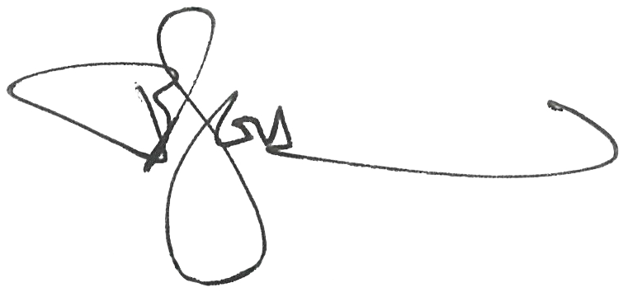
I commend this document to you so that it can guide us in preventing conflict from escalating into harmful behaviour and to take effective steps when we experience, witness or hear of bullying. Let us work together to create an organisation that is built on civility, respect and inclusion and one that takes steps to prevent and respond to incidents of workplace bullying.

Professor Barney Glover
Vice-Chancellor
University of Western Sydney.

CONTENTS

1. Introduction 1
2. Key Stakeholders and Implementation 2
3. Legislative and Policy Framework 3
3.1 New fair work commission jurisdiction 3
3.2 Work Health and Safety Jurisdiction 4
3.3 Other relevant areas of law 4
3.4 UWS Policy and Guidelines 5
4. Action Plan 6
Goals and Objectives 7
5. Recommendations 15
Appendix A Best Practice for Preventing Bullying at UWS 17
A1.1 Evaluating the risk of workplace bullying 17
A1.1.1 Identifying risk factors 18
A1.1.2 Assessing the risks 19
A1.2 Controlling the risk of workplace bullying 20
A1.2.1 Managing the risks in the work environment 20
A1.2.2 Workplace bullying policy 21
A1.2.3 Complaints procedures 22
A1.2.4 Information and training 23
A1.2.5 Encourage reporting 24
Appendix B UWS Bullying Prevention Policy 25
Appendix C UWS Bullying Prevention Guidelines 31

UWS Workplace Bullying Prevention Action Plan
NEW DEFINITION
Workplace Bullying involves repeated unreasonable behaviour towards a worker or a group of workers that creates a risk to health and safety

ACTION PLAN
Goal 1: Promote a culture of civility and wellbeing at UWS
Improve Leadership
Improve Knowledge
Improve Communication
Evaluatethe Risk
Goal 2: Improve systems and resources at UWS
Reviewpolicy and procedure
Designsafe systemsof work
Provide effective resources
Provide adequate support

Click on boxes for relevant section of plan

Introduction
A key goal of the University’s Strategy 2014 – 2016 ‘Making the Difference’ is creating a superior and engaged learning experience which is underpinned by the attraction, retention and development of its staff. The University’s Our People 2015 Staffing Strategic plan and Our Future Program recognises the critical importance of building a culture of civility at UWS. The University is committed to ensuring a safe and positive work environment that is free from workplace bullying.
A range of policies, procedures, resources and support structures have been developed to address workplace bullying and inappropriate behaviours at UWS. During 2009 and 2010, the University, through Equity and Diversity, implemented a University-wide anti-bullying campaign to promote the then new UWS Policy and Guidelines on Bullying Prevention, supported by promotional material, a video and online toolkit. Feedback from staff at the time was positive.
In 2012, the University conducted a staff engagement survey on a range of management and human resource practices. Although 62% of staff agreed that UWS was adequately responding to bullying and abusive behaviours, this was highlighted as a potential area of organisational risk for the University.
Further to the survey response, UWS needs to respond to the introduction of a new legal definition of workplace bullying in 2014 and the requirements of the new Fair Work Commission jurisdiction which can hear applications to stop workplace bullying orders.
This Action Plan aims to improve the University’s capacity to prevent workplace bullying, to effectively respond and reduce incidents of workplace bullying, and to clearly define and communicate what workplace bullying is, and what it is not.
This plan will review existing UWS policies, resources and support, and develop enhanced support and training to prevent and address bullying in the workplace. A key objective of this plan is to communicate a clear message that workplace bullying and other adverse behaviours will not be tolerated at UWS and that breaches of policy are taken seriously and acted upon.

Key Stakeholders and implementation
The success of this Action Plan relies on the following key stakeholders and other players who will be responsible for the endorsement, development, implementation and engagement with the Action Plan.
- Project Sponsor: Rhonda Hawkins (Deputy Vice Chancellor Corporate Strategic plan and Services)
- Project Endorsement and Staff Engagement: Vice Chancellor, Executive, Deans and Directors
- Project Leaders: Sev Ozdowski (Director, Equity and Diversity) and Aggie Lim (Director, Organisational Development)
- Project Mentors: Professor Kevin Dunn and Ann Tout (Executive Director, Office of People and Culture)
- Project Manager: Tatiana Lozano (Equity and Diversity)
- My Voice Working Group – Responding to workplace bullying:
  - Margaret Vickers - academic representative from the School of Business
  - Roberto Parada - academic representative from the School of Education
  - Karen Ardouin (Senior HR Partner) and Alex Tillman (WHS representative) - Office of People and Culture
  - Edith Taylor – Complaints Resolution Unit
  - Melissa O’Leary – Internal Communications
  - Glenn Cooper – Campus Safety and Security
  - Leone Cripps and Kelly Lanfranca - Office of Organisational Development
  - Jennifer Kensey – UWS Student Welfare
This plan is aimed at an organisational level with the goals and objectives applying to the overarching structures and systems of the university. Its implementation at the local level will depend on UWS managers and supervisors developing strategies, in line with this plan, to bring change at the team, division and school level.
Hence, the successful cultural and systemic change required to improve the university’s response to workplace bullying depends on engagement from UWS leaders, staff and students.

Legislative and Policy Framework

New fair work commission jurisdiction
The University is required to comply with Federal and NSW laws. Until recently neither of these laws contained an express definition or prohibition on workplace bullying. In June 2013, the Federal parliament successfully passed a Bill amending the Commonwealth Fair Work Act 2009 which provides a definition of workplace bullying and the ability for employees who are being bullied to apply to the Fair Work Commission for an order to stop the bullying.
Under the new federal definition workplace bullying occurs when:
“an individual or a group of individuals repeatedly behaves unreasonably towards a worker or group of workers at work, AND the behaviour creates a risk to health and safety”
‘Repeated behaviour’ is understood as the persistent nature of the behaviour and can refer to a range of behaviours over time and ‘unreasonable behaviour’ as behaviour that a reasonable person, having regard for the circumstances, would see as victimising, humiliating, undermining or threatening.
A risk to health and safety means the possibility of danger to health and safety, and it is not confined to actual danger to health and safety. The ordinary meaning of ‘risk’ is exposure to the chance of injury or loss.
Balanced against this definition of workplace bullying is the need for managers to be able to undertake management action. Hence, it is important to note that bullying behaviour does not include reasonable management action, carried out in a reasonable manner.
This exclusion is comprised of three elements:
- The behaviour must be management action
- It must be reasonable for the management action to be taken and
- The management action must be carried out in a manner that is reasonable
Under this definition of bullying, the intent of the perpetrator is not required to be established. Workplace bullying can be both intentional and unintentional, and what needs to be established is that there is repeated unreasonable behaviour that causes a risk to health and safety.

Work Health and Safety Jurisdiction
Apart from the federal employment jurisdiction, the legislative framework that best covers the incidence of workplace bullying is the Workplace, Health and Safety (WHS) legislation in each State and Territory. This is because workplace bullying can be seen as a work health and safety issue that poses risks to the health and safety of those employees that are targeted.
Workplace bullying can be categorised as a breach of the NSW Work Health and Safety Act (2011) where the repeat of unreasonable behaviour has created a risk to an employee’s (or another person’s) health and safety and the employer has failed to take all reasonably practical steps to prevent and address it. As such, UWS is bound by WHS legislation to take all reasonable steps to prevent and respond to bullying.
Reasonable steps in the area of bullying include:
- Managing the risks in the environment
- Developing a workplace bullying policy
- Developing effective complaints resolution procedures
- Providing information and training on workplace bullying to staff
- Encouraging reporting of bullying incidents

Other relevant areas of law
Apart from the WHS legislative framework, workplace bullying may also be covered by the following areas of law:
NSW Employee’s Compensation Law – individuals may lodge a claim for weekly payments, medical expenses, and other costs arising from the psychological injury sustained from bullying.
NSW Criminal Law – if the bullying behaviour involves a criminal act such as stalking, actual or threat of physical or sexual assault, intimidation, etc, this can be reported to police who may prosecute under NSW criminal law.
NSW Anti-discrimination Laws – an individual’s right to legal action exists here if the bullying behaviour fits within the protected categories or if an individual has suffered other harm under these laws.
Commonwealth Fair Work Act (2009) – an individual has a right to legal action provided certain breaches have occurred, such as: breach of general protection provisions, adverse action or breach of the enterprise agreement.
Contract Law – an individual has the right to sue for breach of express or implied terms.

UWS Policy and Guidelines
UWS has two policy documents that deal with workplace bullying prevention:
- UWS Bullying Prevention Policy
- UWS Bullying Prevention Guidelines
These operational documents outline the university’s definition of workplace bullying, provide a procedure for dealing with workplace bullying and provide a range of examples and other guiding information on the subject.
These are attached as Appendix B and Appendix C to this plan.

Action Plan
In response to these legislative requirements outlined above, UWS must have a range of policies, resources and support structures to adequately prevent and respond to bullying. This Action Plan aims to undertake an organisational review of the adequacy of UWS policies, resources and support structures and make improvements where required. The plan is not aimed at providing local solutions to bring about cultural change nor to address individual incidents of workplace bullying. However, any local response to workplace bullying should be in line with this plan.
The plan has been strongly informed by the best practice guidelines found in Appendix A.

Goals and Objectives
This section of the Action Plan is divided into two overarching goals:
- Promote a culture of civility and wellbeing at UWS
- Improve UWS systems and resources to prevent and respond to workplace bullying
Each goal is subsequently supported by a number of objectives.
- Promote a culture of civility and wellbeing at UWS
Objective A: Improve leadership in the area of workplace bullying prevention
Strategic aim | Action | Responsibility | Time frame | Measure
Provide an opportunity for UWS leaders to learn about Bullying Prevention at UWS | Facilitate sessions/presentations at relevant learning sites e.g. Senior Staff Forums, Director of Academic Program Forums, School Manager Meetings, Inspire Leadership Programs for Academic and Professional Staff. | Office of Organisational Development and Equity and Diversity or external provider | Long term 2014 - 2016 | Sessions/presentations facilitated
Support leaders to communicate with staff about Bullying Prevention at UWS as part of a Champion program | Develop a Bullying Prevention Champion Program for leaders  Develop a communications plan for leaders who elect to be Champions | Office of Organisational Development and Internal Communications | Long term  2014 - 2016 | Champion System in place  Communication plan implemented
Promote positive leadership styles through recruitment of leaders who are competent at people management | Develop and incorporate a KPI in the area of conflict management for UWS leaders | Recruitment Services, Office of People & Culture | Medium term 2015 | KPI incorporated into leaders’ PDs and/or contracts
Support positive people management through feedback mechanisms | - Include questions on the conduct of managers in exit interviews and employee opinion surveys  - Ensure that the 360 Degrees feedback process includes people management | Office of People & Culture | On-going | Questions included in exit interviews and 360 Degree feedback mechanism
Link to Diagram

Objective B: Improve knowledge in the area of workplace bullying prevention
Strategic aim | Action | Responsibility | Time frame | Measure
Review and improve existing UWS learning opportunities on workplace bullying | - List existing learning opportunities | Equity and Diversity | Short term  2014 | List of learning opportunities
 | - Review training and recommend changes | MyVoice Working Group | Short term  2014 | Summaries of existing training with critical analysis
Update existing learning opportunities | Course content updated by content author | Relevant facilitator | Medium term  2015 | Updated sessions
Increase UWS knowledge  on workplace bullying | Develop and facilitate train-the-trainer training | Equity and Diversity | Medium term  2015 | Facilitation of train-the-trainer session for key UWS staff
 | Roll-out workplace bullying training sessions across UWS, starting with UWS schools | Office of Organisational Development | Long term  2014 - 2016 | Facilitated learning opportunities
Link to Diagram

Objective C: Improve University wide communication in the area of workplace bullying prevention
Strategic aim | Action | Responsibility | Time frame | Measure
UWS wide Communications Plan for Strategy | Development of plan | Internal Communications  and Equity and Diversity | Medium term  2015 | Communications Plan
Clarify the definition of bullying amongst staff | Develop and distribute print materials  across UWS with bullying definition | Working Group and Equity and Diversity | Short term  2014 | Distributed materials
UWS video promoting Bullying Prevention | - Application for funds from WHS Insurance to make a video for website | Work Health & Safety | Short term  2014 | Funds
UWS video promoting Bullying Prevention | - Development of video | UWS Production Unit with input from Equity and Diversity | Medium term  2015 | Video
Website for all UWS information pertaining to Bullying Prevention | - Development of website | Office of Organisational Development | Short term  2014 | Website
 | - Maintenance of web content | Equity and Diversity | Ongoing | Yearly update
Link to Diagram

Objective D: Evaluate the risk of workplace bullying at UWS
Strategic aim | Action | Responsibility | Time frame | Measure
Identify occurrence of workplace bullying | Development of reports on absenteeism, sick leave and staff turnover  Bullying complaints  Exit interviews  WHS Reports on Bullying matters  Employees’ compensation claims associated with workplace bullying | HRIS in Office of People & Culture  Complaints Resolution Unit  Office of People & Culture  Work Health & Safety  Work Health & Safety | Ongoing – on a yearly basis | Reports submitted to UWS Board of Trustees
Link to Diagram

- Improve UWS systems and resources to address workplace bullying prevention
Objective A: Review policies and procedures that address workplace bullying
Strategic aim | Action | Responsibility | Time frame | Measure
Review and improve existing UWS policy and guidelines on bullying prevention | Policy review | External legal team | Medium term  2015 | New policy and guidelines to deal with workplace bullying at UWS
Review and improve existing UWS complaint resolution procedures used to respond to workplace bullying | Procedure review | External legal team | Medium term  2015 | New procedure to deal with workplace bullying at UWS
Review and improve the UWS Code of Conduct in the area of inappropriate behaviours | Ensure that the UWS Code of Conduct reflects the aims of this Strategy | Author of UWS Code of Conduct | Medium term  2015 | Reviewed UWS Code of Conduct
Link to Diagram

Objective B: Design safe systems of work
Strategic aim | Action | Responsibility | Time frame | Measure
Mentor and support new managers and employees with poor people management skills | Incorporate this aim into development of Mentoring strategy | Office of People & Culture | Long term  2016 | Mentoring strategy
Review and monitor workloads and staffing levels in a consultative manner | Academic Workload Committee to consider the risk of workplace bullying when determining workloads | Academic Workload Committee | On-going | Reduced workplace bullying complaints arising from workload issues
Improve consultation and communication about change proposals | Development of a consultation and communication strategy for organisational change proposals | Office of People & Culture – Workplace Relations and Organisational Design | Ongoing | Reduced workplace bullying complaints arising from organisational change
Process for feedback from staff about systems of work | Performance review process to include feedback from staff about concerns about roles and responsibilities | Office of People & Culture and supervisors | Ongoing | Compass to include feedback process
Link to Diagram

Objective C: Provide effective UWS resources in the area of bullying prevention
Strategic aim | Action | Responsibility | Time frame | Measure
Review existing UWS resources addressing Bullying Prevention | - List existing resources | Equity and Diversity | Short term 2014 | List of resources
Review existing UWS resources addressing Bullying Prevention | - Review and update as needed | Equity and Diversity and MyVoice Working Group members | Short term 2014 | Summaries of existing resources with critical analysis
Review existing UWS resources addressing Bullying Prevention | - Discussion of changes required | Working Group members | Short term 2014 | Decision on changes required
Amend existing resources | Changes made where possible by person responsible for resource | Resource author | Medium term  2015 | Updated resources
Develop new resources | Develop new resources  (see recommendations) | TBA | Medium term  2015 | New resources
Distribute new resources | - Identification via a list of where to distribute new resources | Equity and Diversity | Medium term  2015 | List
 | - Distribution of resources | Office of People & Culture and Equity and Diversity | Medium term  2015 | Distributed resources
Provide information to UWS employees on resources available on workplace bullying | Add a resource list to new Bullying Prevention Website | Equity and Diversity | Medium term  2015 | List of services on website
Link to Diagram

Objective D: Provide access to adequate support in the area of workplace bullying
Strategic aim | Action | Responsibility | Time frame | Measure
Review existing UWS support services that can deal with workplace bullying | - List all resources and support services available at UWS in the area of bullying | Equity and Diversity | Short term 2014 | List of services
 | - Provide information/training on Bullying Prevention at UWS to each support area | Office of Organisational Development and Equity and Diversity – maybe external | Medium term  2015 | Distribution of information and/or training
Provide information to UWS employees on support services available in cases of workplace bullying | Add a support services list to new Bullying Prevention Website | Equity and Diversity | Medium term  2015 | List of services on website
Improve the first point of contact for staff with bullying enquiries | Establish a UWS Contact Officers Network | TBA | Medium term  2015 | Contact Officers  Network
Link to Diagram

Recommendations

Learning Opportunities
The following knowledge areas are identified by this Action Plan as integral to the adequate prevention and response to workplace bullying at UWS:
- Defining Workplace Bullying
- Leadership skills
- Effective communication
- Conflict resolution
- Effective management practices including performance management
- Responding to grievances and complaints
- Facilitating teamwork and cooperation
- Developing productive and respectful workplace relationships
- Working with diversity

As outlined in Appendix A of the plan there are numerous ways to facilitate learning about workplace bullying and its impacts.
The plan recommends that the most effective learning method be determined and implemented for each strategic aim that involves learning.
For example:
- Employ a trainer or consultant to facilitate training on Bullying Prevention for UWS leaders
- Facilitate train-the-trainer workshops so that group of UWS staff who can provide Bullying Prevention information sessions across UWS
- Develop an online module specific to UWS on Bullying Prevention
- Organise a Roadshow across UWS on Bullying Prevention

Resources
After the review of existing UWS resources that deal with workplace bullying, the Strategy recommends that new resources be developed to increase awareness about bullying across UWS.
These may include:
- Online resources
- Checklists
- Print resources:
- Postcards describing what workplace bullying is and is not and what to do when dealing with bullying
- a UWS Fact Sheet on Preventing and Responding to Bullying at UWS (one for staff, one for students and one for UWS service providers)
- Visual resources

Support
The development of a Contact Officer system is outlined in Appendix A of the plan. This system would add significantly to the support structures that are currently available at UWS for employees who are dealing with workplace bullying.
The plan recommends the development of such a system.

Appendix A

Best Practice for Preventing Bullying at UWS
This Strategic Plan recommends that UWS work towards best practice in preventing workplace bullying as outlined below.
  - Evaluating the risk of workplace bullying
Evaluating the risk of workplace bullying involves finding all of the things and situations that could potentially contribute to bullying in the workplace and cause harm to people. Although there may be no obvious signs of workplace bullying, this does not mean such behaviour or conduct does not exist.
Sources of information that can assist in identifying whether bullying is, or could be, a problem include:
- patterns of absenteeism, complaints, sick leave and staff turnover
- results from workforce surveys
- direct feedback from employees, managers or supervisors
- work, health and safety reports
- exit interviews
- issues raised by work health and safety representatives, and
- employees’ compensation claims
The presence of bullying in the workplace can be the result of many factors, however bullying is more likely in a workplace culture and environment that allows or encourages (tacitly or explicitly) such behaviours to occur. It can also be the product of poor people management skills and lack of supportive leadership. The risk factors that make it more likely for bullying to occur involve:
- organisational culture
- negative leadership styles
- inappropriate systems of work
- poor workplace relationships, and
- workforce characteristics
    - Identifying risk factors

Organisational culture
The culture of an organisation is made up of shared values, beliefs and assumptions that define how an organisation views itself and its environment. These underlying values may encourage acts of bullying and expect targets to endure the behaviour or make it acceptable for management to ignore bullying complaints, for example, when bullying and aggressive behaviour is seen as necessary to get the job done or to ‘toughen people up’ for the rigours of the industry.
A group within an organisation can differentiate itself from the wider organisational culture, where attitudes and behaviours that are unacceptable in the wider organisation may be established and passed on to new employees in the group.

Leadership styles
Autocratic leadership styles are strict and directive, where employees are not involved in decision-making and may have little control or flexibility over their work. Conversely a leader may have a style that is too relaxed. A relaxed leadership style is characterised by a tendency to avoid making decisions, inadequate or absent supervision of employees, inappropriate delegation of tasks to subordinates and little or no guidance or performance feedback being provided to employees. Misuse of positional power may also be reflective of poor leadership styles and may contribute to workplace bullying.

Systems of work
The way in which work is organised and designed can have a significant impact on stress and conflict in the workplace, which is related to the occurrence of workplace bullying. Inappropriate systems of work that may lead to incidents of bullying include:
- workload and excessive task demands (for example, through unreasonable performance measures or timeframes)
- role conflict (perception of contradictory demands and expectations to carry out the job)
- role ambiguity (being unsure about what tasks are part of one’s own job, as opposed to someone else’s job)
- uncertainty about the way work should be done (for example, through a lack of training)
- job insecurity and change (for example, due to restructuring, downsizing, outsourcing, new rosters or changes in work methods), and
- lack of support systems

Workplace relationships
Poor workplace relationships may be characterised by:
- criticism and other negative interactions
- negative relationships between supervisors and employees
- poor communication or inadequate consultation
- interpersonal conflict, or
- employees being excluded or isolated

Workforce characteristics
Although all employees are potentially at risk of being bullied, the following groups of employees may be at higher risk:
- young or older employees
- new employees
- trainees
- injured employees and employees on return to work plans, and
- employees in a minority group because of ethnicity, religion, disability (including mental health), gender or sexual identity
    - Assessing the risks
A risk assessment can help determine:
- the frequency and severity of bullying behaviours
- whether any existing control measures are effective
- what action should be taken to control the risk, and
- how urgently the action needs to be taken
The risk indicator in Appendix A may help to assess whether factors in the work environment create a risk of bullying. It should be used in consultation with employees and their health and safety representatives. Areas of highest risk revealed in the risk assessment should be addressed first.
When assessing the likelihood of bullying occurring, it is important to recognise the risk factors can be interrelated and therefore should not be considered in isolation.
  - Controlling the risk of workplace bullying
The best way to control bullying risks is to eliminate the factors that can cause it. If that is not reasonably practicable, implement measures to minimise the risk. The following control measures should be considered:
- managing the risks in the work environment (including virtual environment)
- developing a workplace bullying policy
- developing effective complaints resolution procedures
- providing information and training on workplace bullying to employees, and
- encouraging reporting of workplace bullying incidents
A number of control measures should be implemented together to manage the risks of bullying, ensuring complaints are responded to promptly and appropriately. A single control used in isolation is likely to be ineffective or incomplete. Measures may need to be implemented across the whole organisation, as well as in specific work areas.
    - Managing the risks in the work environment

Organisational culture
Creating a culture where everyone in the workplace is treated with dignity and respect and where bullying is not tolerated involves:
- developing and promoting a code of conduct
- raising awareness of unacceptable behaviour and its damaging effects
- a process to adequately respond to reports of unacceptable behaviour and ensure they are dealt with confidentially, fairly and in a timely manner
- developing appropriate human resource policies and procedures, for example relating to recruitment and performance management practices
- training and empowering supervisors and managers to respond effectively to bullying incidents
- facilitating teamwork and cooperation

Leadership styles
- Recruit managers and supervisors who are competent in managing people into management roles
- Provide training for managers, particularly on how to:
  - Communicate effectively and engage employees in decision-making
  - Provide constructive feedback, formally and informally
  - Effectively manage workloads
- Encourage managers to lead by example, demonstrating positive management skills
- Mentor and support new managers and managers with poor people management skills
- Implement and review performance improvement/development plans
- Provide regular feedback on management performance
- Provide regular leadership skills development and support
- Include leadership questions on the conduct and performance of managers in exit interviews and employee opinion surveys

Systems of work
- Review and monitor workloads and staffing levels
- Allow employees to have more autonomy in their work and have input into decision-making
- Clearly define jobs
- Encourage healthy work/life balance
- Seek regular feedback from staff over concerns about roles and responsibilities
- Have plans in place for proposed workplace change such as restructuring or downsizing, consult with employees affected as early as possible, and maintain effective communication throughout workplace change

Workplace relationships
- Develop and implement an issue resolution process, in accordance with the requirements under the WHS Act and Regulations. This may include using mediation to resolve conflict
- Provide training (e.g. equal opportunity, WHS, interpersonal communication skills)
- Ensure supervisors act on inappropriate behaviour in a timely manner

Workforce characteristics
- Develop and implement systems to support and protect employees at higher risk of bullying, for example, a ‘buddy’ or mentoring system for new employees
- Train line managers to support employees at higher risk
- Provide access to external employee support services or implement a contact officer system to provide support and advice
    - Workplace bullying policy
A bullying policy should be developed by the organisation in consultation with employees and their health and safety representatives. It should set out the standards of expected behaviour and make a clear statement that inappropriate behaviour will not be tolerated. A bullying policy should support other risk control measures.
The policy may be developed as a specific bullying policy or incorporated into an existing work health and safety policy or handbook.
A workplace bullying policy should contain:
- a statement that the University is committed to preventing bullying
- the standards of appropriate behaviour,
- a process to encourage reporting, including contact points for informal and confidential discussion
- a definition of bullying with examples of bullying behaviour, and
- the consequences for not complying with the policy
    - Complaints procedures
Developing effective procedures to resolve complaints will help ensure bullying incidents are dealt with in a consistent and fair way. The procedure should be used each time a complaint is made and should be flexible enough to fit the different circumstances of each incident.
The complaints procedure should provide a clear process for reporting and dealing with workplace bullying, including how complaints will be handled, investigated and resolved. It should also nominate the persons in the organisation who are responsible for receiving and investigating complaints.
Like the bullying policy, it must be developed in consultation with employees and their health and safety representatives. All employees should be made aware that procedures exist for resolving bullying in the workplace.
The complaints procedures should:
- be in plain English and, if necessary, available in other languages
- ensure there is no bias and there is a fair hearing
- ensure privacy and confidentiality
- aim to resolve the problem as quickly as possible
- provide the option to make an informal (verbal) complaint or a formal (written) complaint with mechanisms available to address these
- outline what is involved in the complaint handling process, both formal and informal
- include methods for ensuring people are not victimised as a result of lodging a complaint
- clearly state the roles of responsible individuals such as managers and supervisors, contact officers or grievance officers,
- contain review procedures and a process for appeal of outcomes, and
- identify external avenues available to employees where grievances have been unable to be resolved internally
    - Information and training
Information to raise awareness of bullying and its impacts in the workplace may be provided in various ways, for example:
- training and information sessions
- seminars
- team meetings
- newsletters, pamphlets
- payslip attachments
- posters
- intranet announcements, or
- email messages
All employees, managers and supervisors should be trained to recognise and deal with bullying as it occurs. A training program should also cover:
- the workplace policy and procedures
- how to comply with the policy
- how to deal with bullying
- how to report bullying, and
- measures used in the workplace to prevent bullying
Training may need to be tailored to meet the needs of particular employee groups.
Face-to-face training with facilitated role plays, group work and opportunities to ask questions are often most effective. When providing training about bullying, it is not appropriate to include specific examples of bullying incidents that have occurred in the workplace or details of investigation outcomes.
Bullying has been linked to situations of role conflict and ambiguity. Employees should understand their role and have the appropriate skills to do their job. This includes ensuring that employees who manage or supervise others have good communication and people management skills, or if necessary, providing training to acquire these skills before they start supervisory duties.
Employees who have a designated role in handling reports of bullying should undertake specific training to assist them to carry out their role effectively.
Information and training on workplace bullying, including any relevant policies and procedures, should be included in employee inductions.
    - Encourage reporting
Employees should be encouraged to report bullying incidents. This will help ensure intervention occurs as early as possible so prompt assistance and support can be provided to employees. It will also help assess whether bullying prevention measures are working.
Reporting can be encouraged by:
- supervisors and managers promoting reporting
- consistent and effective responses to reports
- regularly providing information (e.g. quarterly) to health and safety committees on numbers of reports made, how they were resolved and what control measures were put in place to address underlying risk factors, and
- making this information available to health and safety representatives and employees

Contact officers
It may be useful to appoint a person within the workplace as a first point of contact for employees who believe they have been bullied at work. A contact officer must be suitably trained to provide employees with confidential information and support about how best to address an incident. They should have access to information about the options for complaints resolution both inside and outside the business and they should understand the bullying policy.
The contact officer’s role involves:
- listening to the person affected and acting as a support person
- maintaining confidentiality and not taking sides
- explaining and providing information about what constitutes bullying
- providing information about the options available to deal with the issue and the likely results
- providing information on rights and duties under WHS Act and Regulations and other relevant laws, and
- referring the person affected to counselling or other support services if necessary

Appendix B

UWS Bullying Prevention Policy
http://policies.uws.edu.au/view.current.php?id=00099
accessed on 5 August 2014
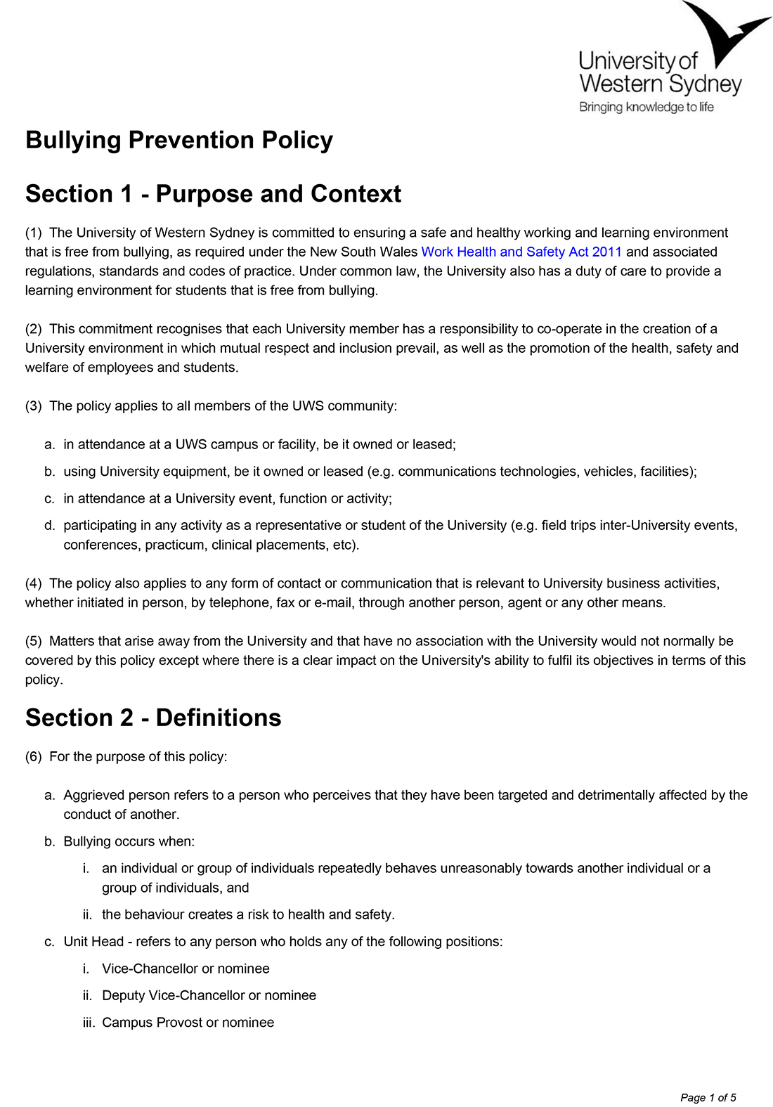

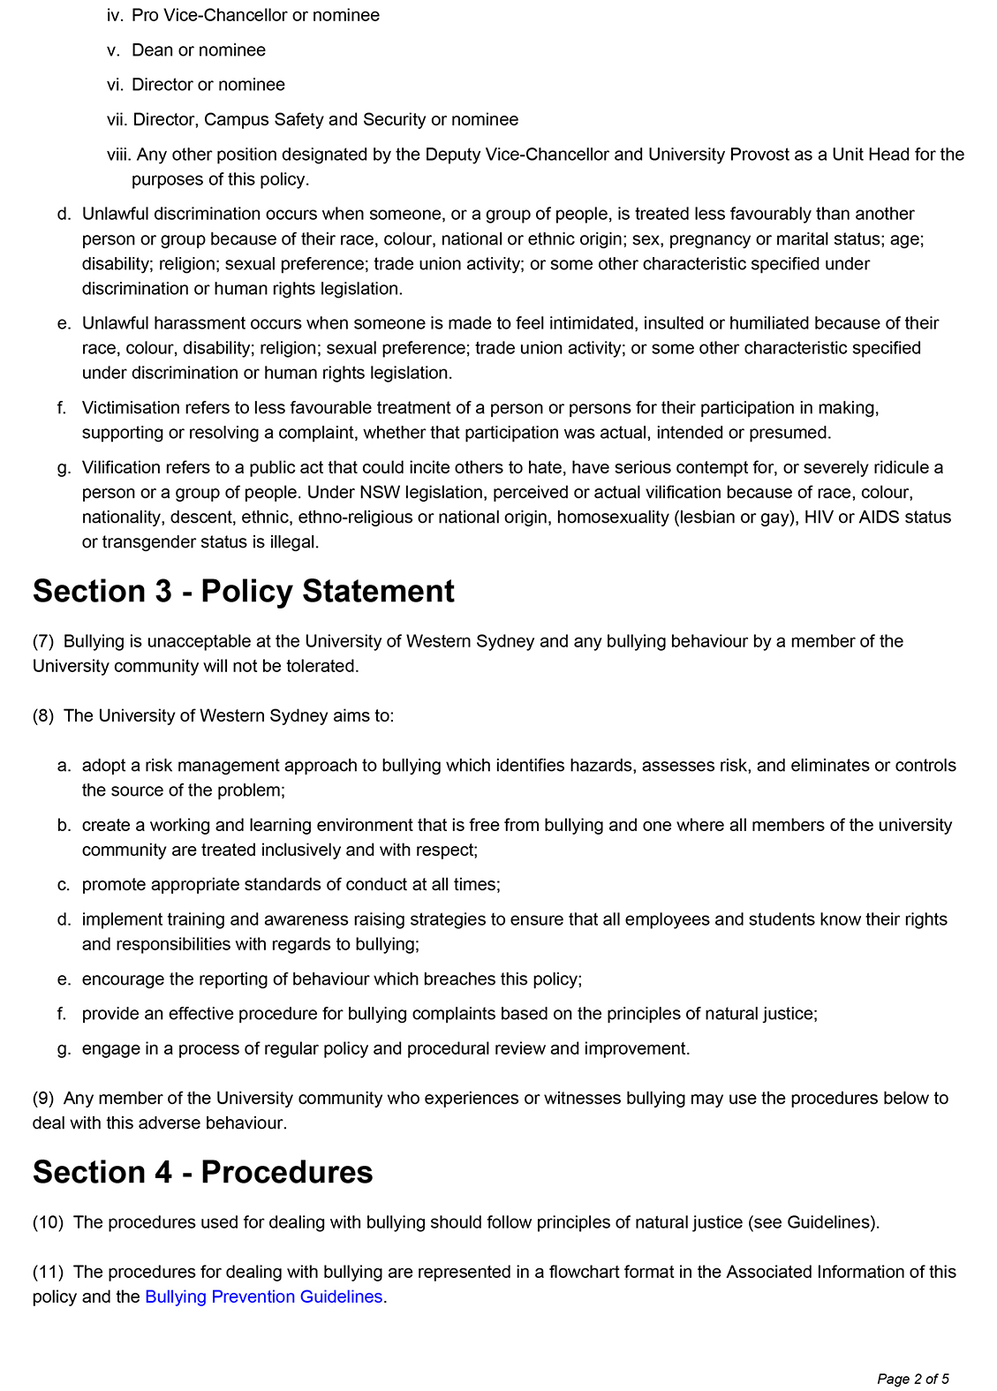

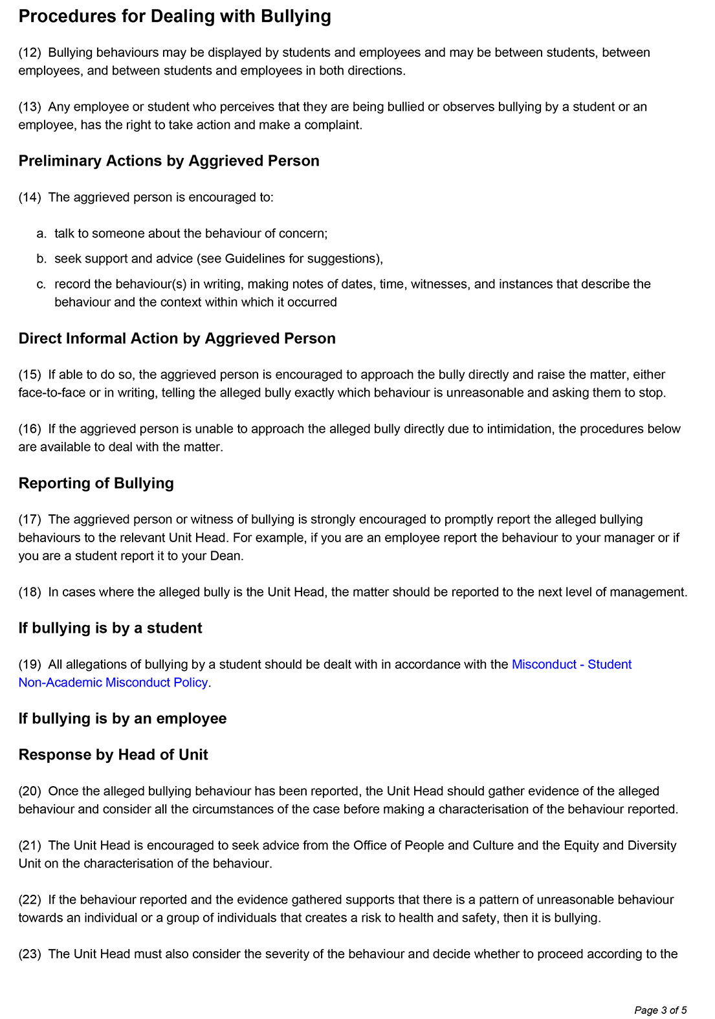

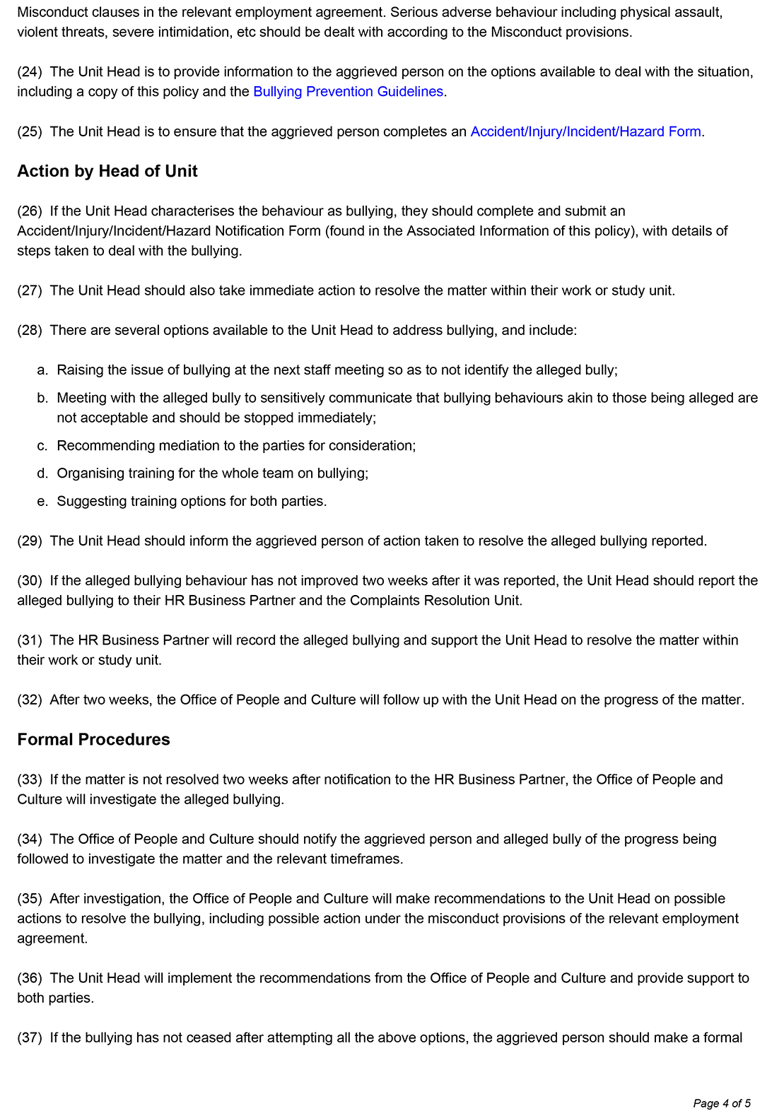

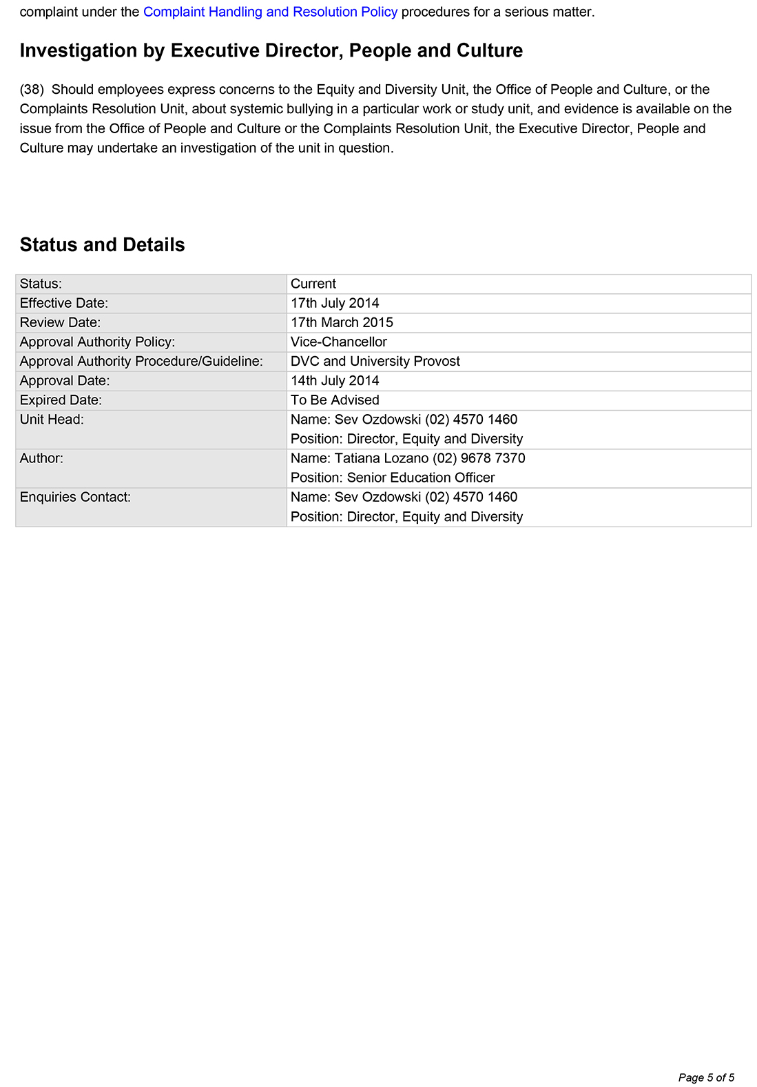

Appendix C

UWS Bullying Prevention Guidelines
http://policies.uws.edu.au/view.current.php?id=00240
accessed on 5 August 2014
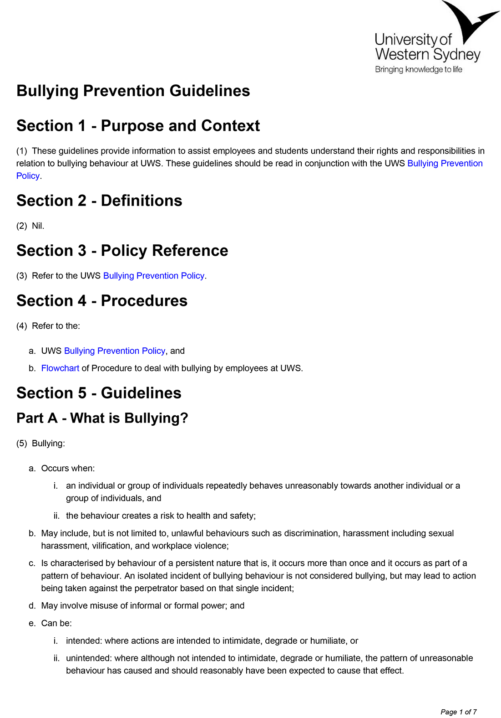

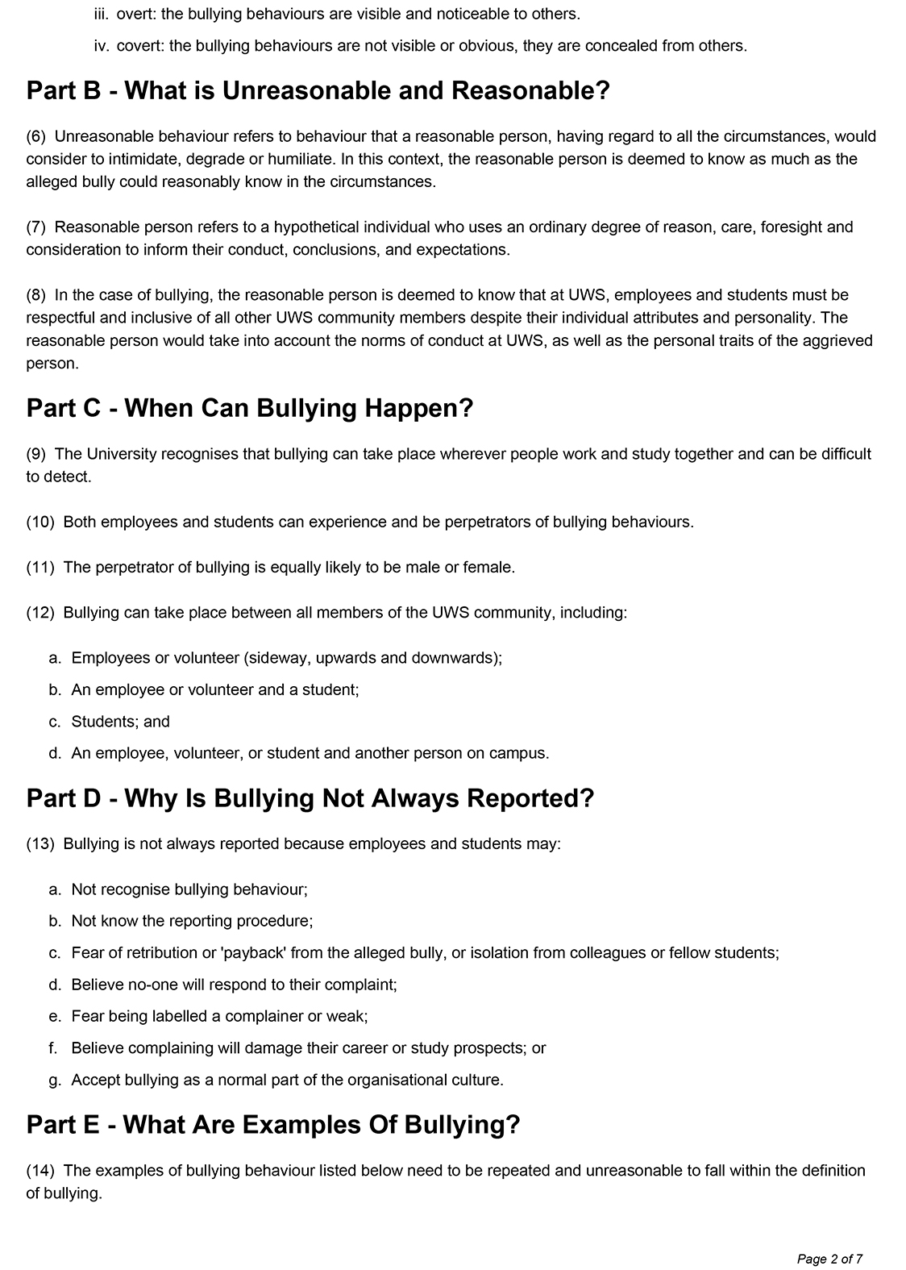

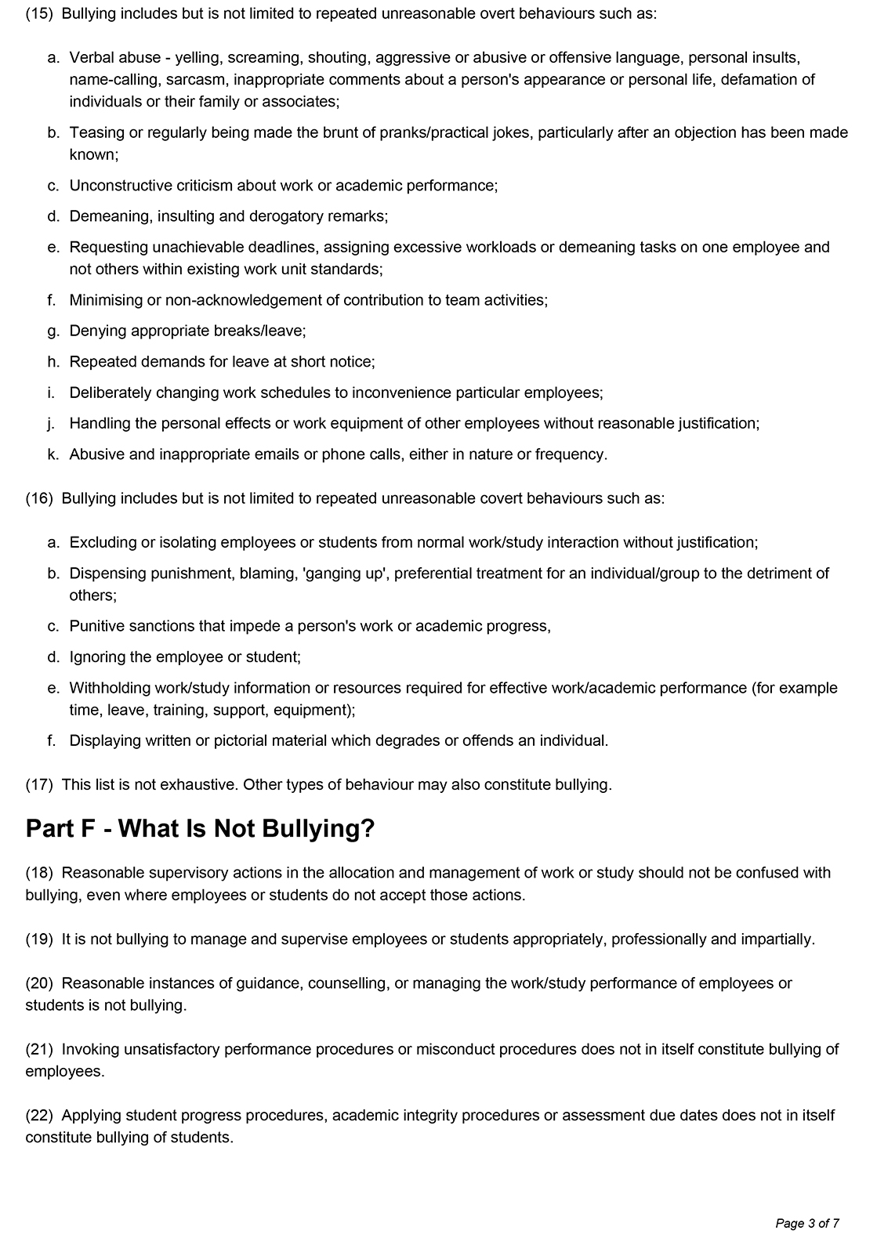

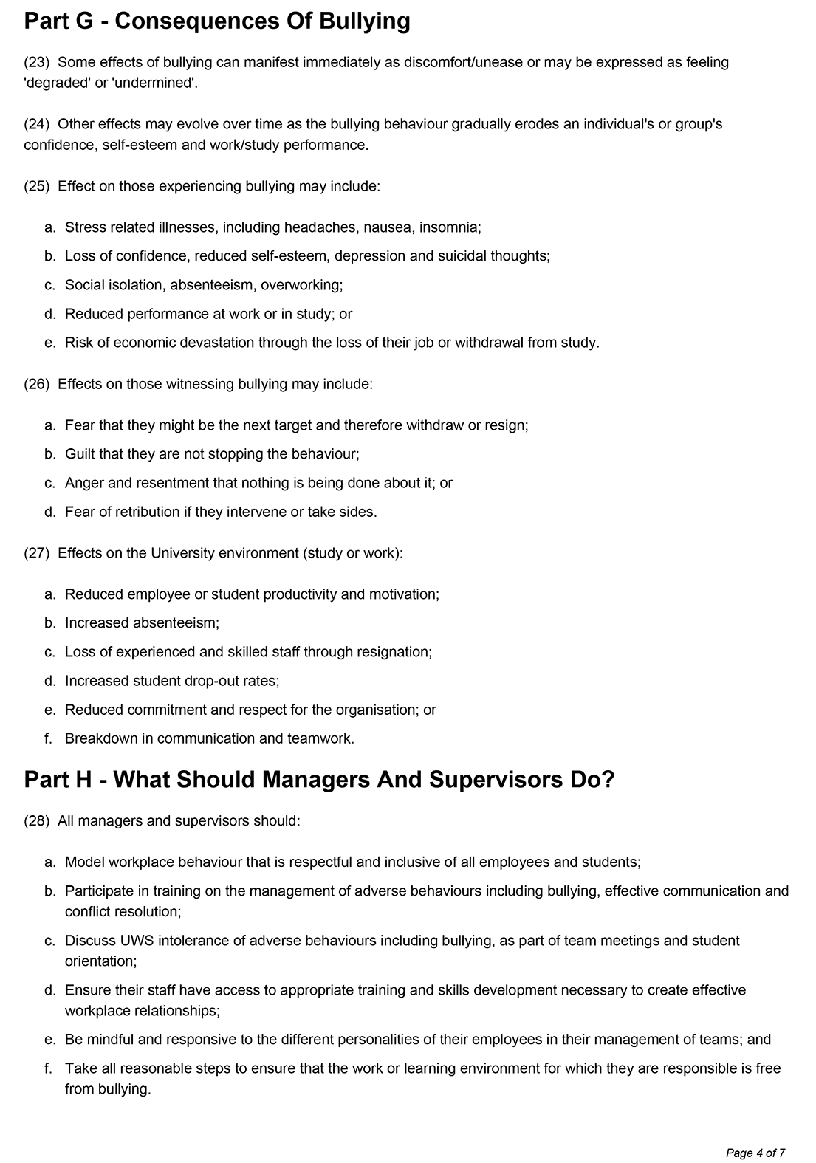

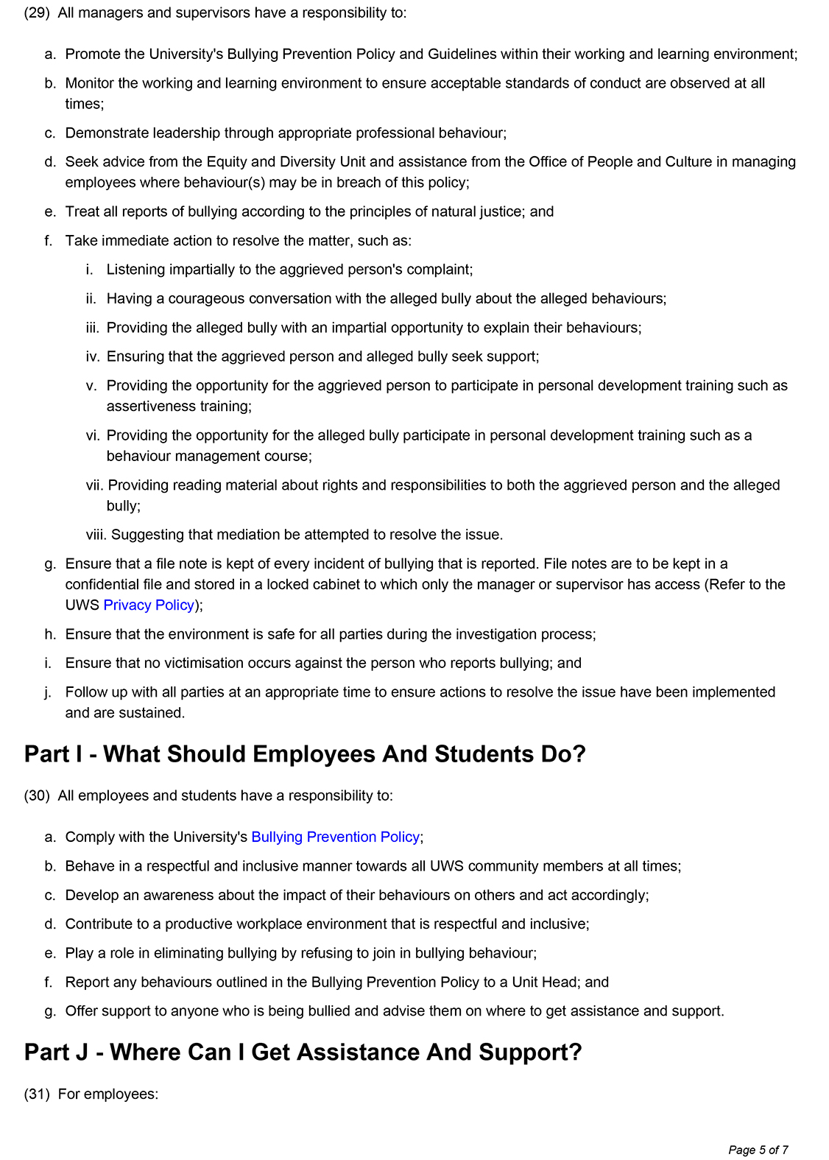

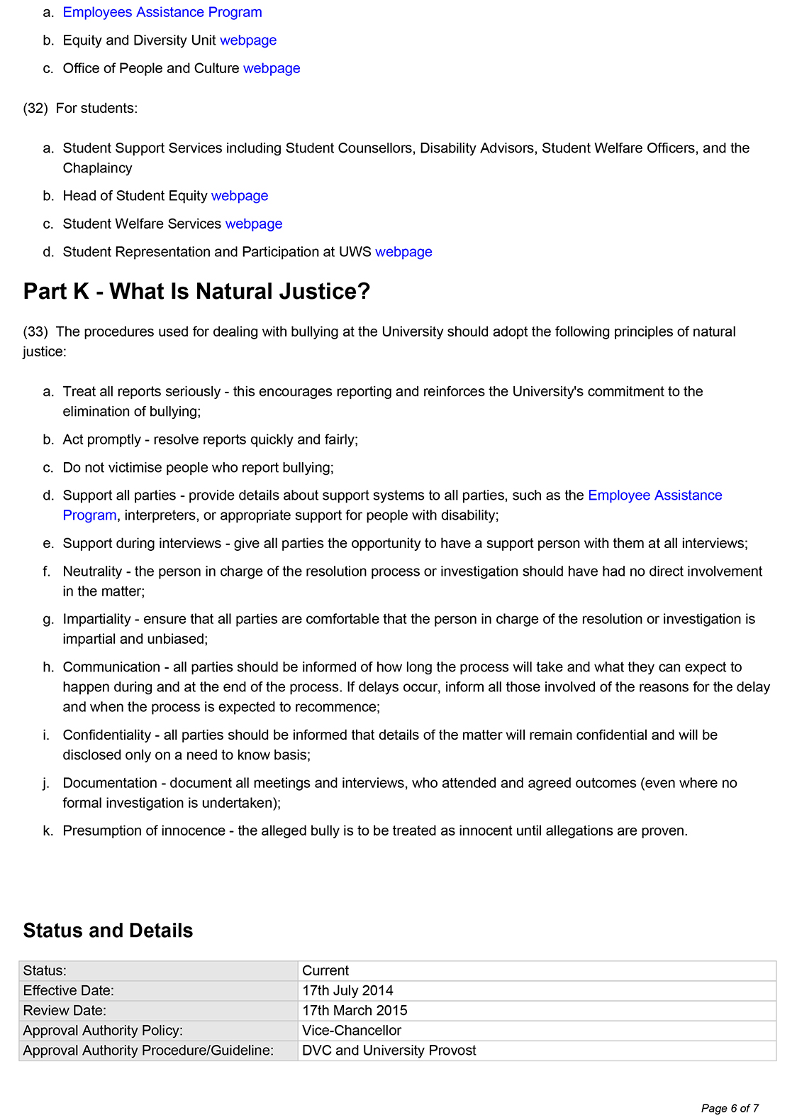

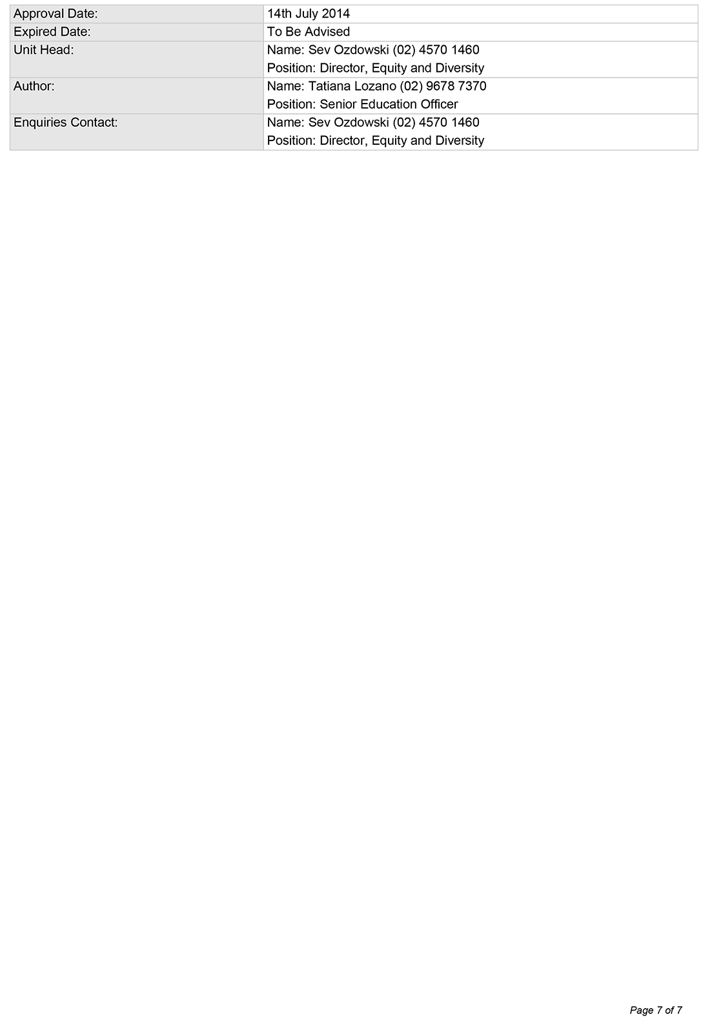

University of Western Sydney
Locked Bag 1797
Penrith NSW 2751 Australia
www.uws.edu.au

Equity and Diversity
Published August 2014

The only State in Australia that has legislated specifically against bullying is Victoria with the introduction, in 2011, of bullying into its criminal stalking legislation. In Victoria repeated acts of bullying, either at work, at school or online, are now punishable by a maximum term of 10 years imprisonment.
See commentary on reasonable management action in the Fair Work Commission’s Anti-Bullying Benchbook, http://benchbooks.fwc.gov.au/anti-bullying/
This best practice approach has been adapted from versions of Safe Work Australia’s Code of Practice: Preventing and Responding to Workplace Bullying. The House of Representatives Report supports the adoption of this approach by organisations.
In cases of conflict at work, which have not yet escalated into bullying, mediation may be a useful tool. Mediation is a voluntary process where an impartial third party (preferably a trained mediator) assists the parties put their respective cases before each other. The role of a mediator is to assist both parties understand the perspective of the other and to find an agreement the parties are willing to abide by. Mediation may be useful for early intervention and may prevent bullying.

