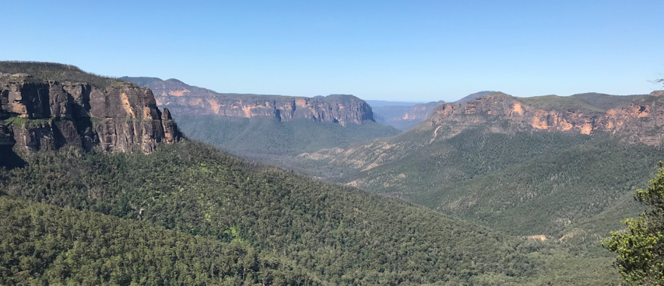
The Blue Mountains Hub for Ecology and Conservation

The Blue Mountains Hub for Ecology and Conservation will bring together world leading expertise in ecology and conservation science to achieve tangible outcomes for the NSW community and environment. The Greater Blue Mountain Area is a World Heritage listed site of outstanding natural value. Spread across eight adjacent conservation reserves, it constitutes one of the largest and most intact tracts of protected bushland in Australia. Its exceptional biodiversity values are complemented by numerous others, including indigenous and post-European-settlement cultural values, geodiversity, water production, wilderness, recreation and natural beauty. The Blue Mountains are also directly adjacent to one of the largest and most rapidly growing urban areas in Australia and contains an important urban corridor between Sydney and western NSW. It has recently seen the devastating consequences of natural disasters (bushfires, drought) related to climate change. The Greater Blue Mountains World Heritage Area is therefore unique, but also uniquely vulnerable to a range of pressures from population growth, urban expansion, and climate change.

Western Sydney University (Western) is now the top ranked university in Australia for the discipline of Ecology and is ranked 13th globally. World leading research at Western carries a central focus on the response of Australian ecosystems to climate change, sustainable urban development, and planetary health. In addition to outstanding achievements in ecological research, Western also works closely with wide range of external partners to deliver end-user targeted outcomes for biodiversity conservation and evidence-based policy development. This includes collaboration on important initiatives such as the Blue Mountains Planetary Health Leadership Centre, support of Citizen Science engagements, and co-funded projects addressing key areas of concern for conservation of threatened flora and fauna.

The central aims of the Blue Mountains Hub for Ecology and Conservation are to:

- Bring together researchers working at Western with representatives from State and Local Government, non-profit organisations, and community groups, to improve measurable outcomes for our wildlife, ecosystems and heritage places.

- To foster and strengthen collaborative research projects within the Greater Blue Mountains World Heritage Area, particularly transdisciplinary research projects that incorporate themes of sustainable development.

- The establishment of a permanent plot network within the Greater Blue Mountains World Heritage Area, with a focus on innovative technologies that allow for real-time ecological monitoring.

The Hub will initially be established as a virtual community of researchers from Western along with representatives from our external partner organisations. The establishment of a permanent plot network within the Greater Blue Mountains World Heritage Area will facilitate ecosystem monitoring across broad environmental gradients (water availability, elevation, temperature). The plot network will incorporate cutting edge sensor technologies that allow for real-time ecological monitoring of fauna and flora. This type of monitoring is essential for evidence-based assessment of environmental vulnerability to range of pressures. It is also vital to improve our capacity for ecological forecasting methods, which will help to predict the timing and magnitude of threats to the natural environment and communities living in the area.

Research activities will facilitate public outreach to Schools and community groups (e.g., environmental education) and development of stronger relationship between Western and external partners. While the hub will be centred on the Greater Blue Mountains World Heritage Area, we envision that it will also incorporate ecological research beyond this area where it aligns with the research priorities of the hub.

Contact
Professor Brendan Choat
Research Theme Champion (Environment and Sustainability)
Hawkesbury Institute for the Environment
email: b.choat@westernsydney.edu.au
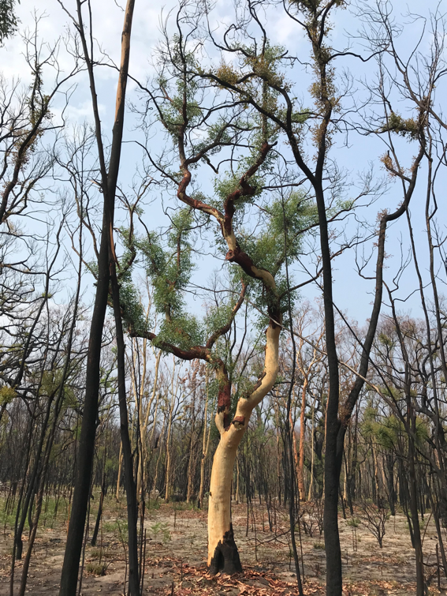
phone: 0475 788 757

