Recording student details for Virtual Delivered projects
When an NCP Mobility project has been varied to permit virtual delivery, the ILO will need to record details of participating students on a spreadsheet, using the template available on ISEO.
ILOs should send the completed spreadsheet to the NCP Secretariat inbox, to be uploaded as a document against the relevant project in ISEO.
Instructions for downloading the spreadsheet template
1 – Open the project and go to the student details tab. The project should have a status of Schedule active (Awaiting student details and Virtual delivery of the project approved.
2 – Click on the ‘Upload Students’ button:
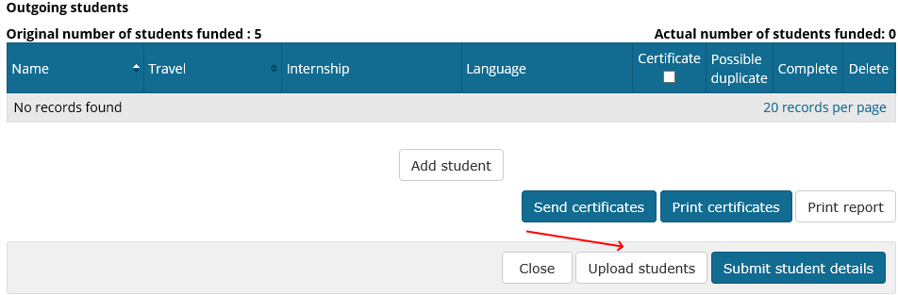
3 –A popup screen will open.. On this screen is an option ‘Download an empty spreadsheet template’:
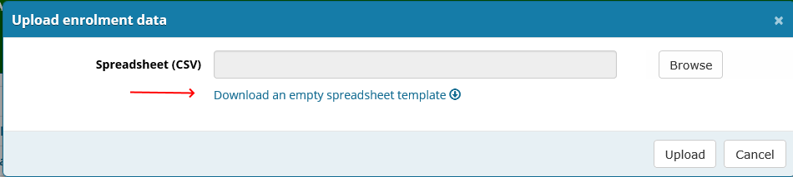
4 – Clicking on this option opens the spreadsheet. The spreadsheet includes many of the variables that apply to the specific project such as location(s), Study experiences, Travel dates, qualifications, etc.
5 – Enter the student details, as you would for uploading.
6- When you save the spreadsheet you will get a message saying the sheet is formatted using CSV format. Please keep this format as it easily allows it to be uploaded into the student details when required.

