Dragon Professional.

The Dictation Box

Support Manual 6 of 7

Contents

The Dictation Box 2

Overview 2

The Dictation Box 3

How to open the Dictation Box. 4

PowerPoint example 5

# The Dictation Box

Refer to the supporting video [*06. The Dictation Box*](https://westernsydney.ap.panopto.com/Panopto/Pages/Viewer.aspx?id=a4a6c3f3-f24e-4491-b6fe-abc90183c66c)*.*

## Overview

Dragon allows you to dictate directly into web pages and unsupported applications such as PowerPoint. However, this can be problematic. Unknown text fields are not properly formatted so correcting or editing text is not possible.

A quick way to check is to place the cursor in the text box. If the small circle in the top right corner of the Dragon Bar has turned **green**, this indicates there is **full text control** on the web site. Voice commands to delete and replace words can be performed.

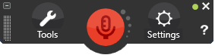

A **black** circle in the Dragon Bar indicates **basic text control** is available but the use of the Dictation Box is recommended.

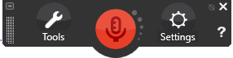

## The Dictation Box

The Dictation Box is a rich text editor which floats on the screen. It has full text control to enable editing of any composed text. Once composed, the text can be pasted into the text field. The voice command to paste the text is “click transfer”.

The size, appearance and behaviour of the Dictation box can be adjusted. The size is adjusted by moving the bottom right corner, and Dragon retains the size changes specific to the application where you were dictating when you re-sized it. For example, if you re-sized the Dictation Box when you last dictated with Microsoft Word, Dragon automatically opens the Dictation Box at that size the next time you use it with Microsoft Word.

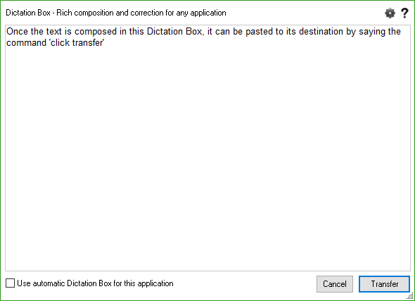

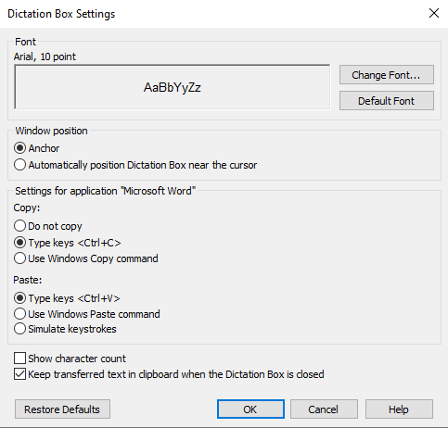

### How to open the Dictation Box.

1. Click ‘Tools’ on the Dragon Bar.
2. Click ‘Dictation Box’ or say the command “open dictation box”.

The dictation box can be resized and default font size and style can be configured by clicking the settings icon in the top right corner of the dictation box.

### PowerPoint example

Full text control is not available in PowerPoint (as indicated in the Dragon Bar). Click into the desired text box and start dictating. The dictation box will open automatically in PowerPoint.

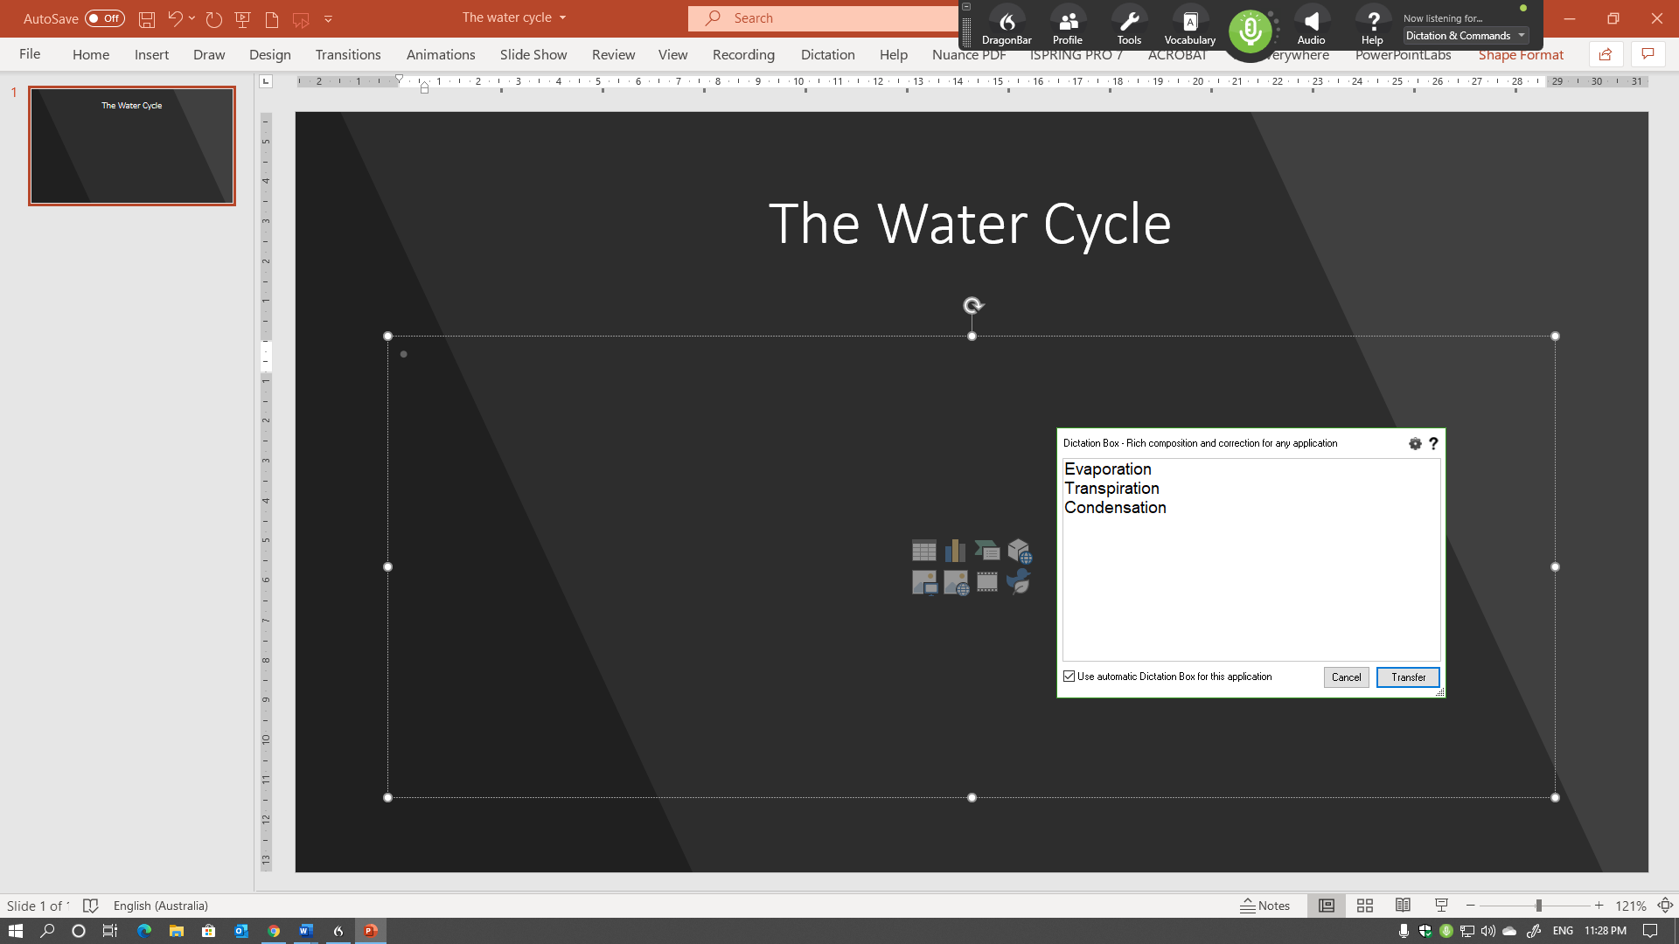

The dictation box is not intended for large amounts of text. If this is necessary, it is advised to **transfer a paragraph of text at a time**.

*More information is located on the Dragon Training and Support page* [www.westernsydney.edu.au/dragon-training](http://www.westernsydney.edu.au/dragon-training).