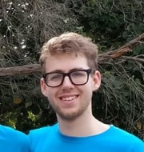
Hi my name is Frederick and I am hoping to be one of our new student editors on campus.
I strongly believe that a university newspaper is critical for uniting the student body and providing much needed information and reading material to everyone.
If elected I will start work on a unified calendar for student events, article, as well as opinion pieces, as I hope my insight would be able to provide an unbiased viewpoint and interesting voice on campus.

