Evaluating the Effectiveness of Three Organisational Bystander Anti-Racism Strategies

Oishee Alam

Introduction

Bystander anti-racism is action taken by 'ordinary' people in response to incidents of interpersonal or systemic racism. Research indicates that not only can bystander anti-racism have a positive impact on the target’s sense of belonging and community (Islamic Women’s Welfare Council of Victoria 2008), but a lack of action can also have a negative effect on the target, who may feel that bystanders feel the same way as the perpetrator who is responsible for the racist speech or behaviour (Dunn & Kamp 2009).

In their review of the literature on bystander anti-racism, Nelson et al. 2010 suggest that bystander anti-racism benefits not only targets of racism but also perpetrators, the bystander who intervene and other bystanders - as well as strengthening broader anti-racist social norms. This indicates that raising the confidence of members of an organisation to take bystander action when witnessing racism can have an overall beneficial impact on the organisation as a whole, leading to a more inclusive and cohesive organisation.

Research Question and Aims

The research question addressed by this study is: Does participation in organisational bystander anti-racism activities increase knowledge about responding to racism and confidence to undertake bystander anti-racism at the University of Western Sydney (UWS)?

This project aimed to develop an empirical understanding of the effectiveness of three organisational bystander anti-racism strategies delivered by Equity and Diversity at UWS as a means of increasing bystander anti-racism confidence.

The set of organisational bystander anti-racism activities evaluated are:

1. Bystander anti-racism training/workshop
2. Bystander anti-racism social marketing/communication campaign
3. Attendance at culturally and linguistically diverse community dinners

Project participants were invited to take part in all three of these events. The evaluation was carried out using a pre-test quantitative survey questionnaire (undertaken before participants were involved in any of the activities), a post-test questionnaire (undertaken once activities had been completed) and a follow-up questionnaire (6 months after involvement in the project activities was completed).

Research Methods

Evaluation of the bystander anti-racism strategies tested in this project was undertaken using survey questionnaires consisting of both closed and open-ended questions. The data was then coded and analysed using SPSS software.

Participants for this project were recruited amongst students, professional staff and academic staff at UWS. A hard copy of the pre-test questionnaire was administered and collected at the start of every bystander anti-racism training workshop, which took place across four UWS campuses throughout July and August 2014. A total of 116 participants completed the pre-test questionnaire and took part in the bystander anti-racism training. Each participant was then sent copies of the materials developed for the communications campaign, launched during Diversity Week in September 2014, by mail and email. Participants were also invited to attend one or more of the culturally and linguistically diverse community dinners held at UWS in the months of November and December 2014; however, these were not compulsory and not all participants attended. Each of these strategies were organised and delivered by Equity and Diversity staff, in conjunction with other UWS departments.

Following the last of the community dinners, a post-test survey questionnaire was distributed to participants by email. 54 participants completed the post-test questionnaire.

Results

Demographics of participants

116 members of UWS completed the pre-test questionnaire and participated in the bystander anti-racism training. Of these, 14 were students, 28 were academic staff and 73 were professional staff, with one missing response. 64.9% of respondents identified as female. Half of the respondents had a postgraduate university qualification, and over 80% had at least some university education. 60% of participants were born in Australia; of those born overseas, England and the Philippines were the most common countries of birth with four respondents from each. 38% of participants spoke a language other than English in their homes and/or communities. Only one participant identified as being Aboriginal or Torres Strait Islander.

Attitudes Towards Racism, Cultural Diversity and Anti-Racism

Participants were surveyed about their attitudes towards racism, cultural diversity and anti-racism, and these findings were then compared to the findings from the national level findings of the Challenging Racism project (2008). For this reason, the questions designed for the pre- and post-test surveys were similar to some of the ones used in the Challenging Racism project, though as can be seen in the tables below there were some slight differences in wording. The reasons for this comparison was to establish whether or not our sample group may already be more sympathetic to racial justice and anti-racism action than Australians more generally, given that the bystander anti-racism training was voluntary and they had to take time out of their work day to attend.

Table 1 shows the responses gathered from the current study pre and post-test and Table 2 those from the Challenging Racism project. It can be seen that while responses to statements 1 and 2 indicate that the sample group used for this project had similar attitudes towards cultural diversity and racism to the group used in the Challenging Racism project pre-test, responses to other statements suggest that the group for this project was more racially accepting and more committed to anti-racism.

Table 1: Attitudes to racism, cultural diversity and anti-racism from WSU bystander anti-racism survey, 2014 – pre and post test surveys

Survey Question | Agree (pre) | Agree (post) | Disagree (pre) | Disagree (post)
It is a good thing for society to be made up of different cultures. | 87% | 95.6% | 9.5% | 2.2%
There is racism in Australia. | 81.9% | 93.3% | 8.6% | 2.2%
I am prejudiced against other cultures. | 8.8% | 8.9% | 68.1% | 66.7%
Australia is weakened by people of different ethnic origins maintaining their cultural traditions | 3.5% | 2.2% | 81.9% | 88.9%
All races of people ARE equal. | 93.1% | 93.4% | 4.3% | 4.4%
Something should be done to fight or minimise racism in Australia. | 94.8% | 91.1% | 1.7% | 2.2%

Table 2: Attitudes to racism, cultural diversity and anti-racism from Challenging Racism survey, 2001-2008

Survey Question | Agree | Disagree
It is a good thing for society to be made up of people from different cultures. | 86.8% | 6.5%
There is racial prejudice in Australia. | 84.4% | 8%
You are prejudiced against other cultures. | 12.4% | 80.1%
Australia is weakened by people of different ethnic origins sticking to their old ways. | 41.2% | 42.1%
All races of people ARE equal. | 84.4% | 10.7%
Something should be done to fight or minimise racism in Australia. | 85.6% | 5.2%

Of these findings, one of the most significant is the over 40% difference in the number of people who agreed with the statement “Australia is weakened by people of different ethnic origins sticking to their old ways/maintaining their cultural traditions,” although this could perhaps partly be explained by the alternative wording. Also significant was that our sample group was more ambivalent to the statement, “I am prejudiced against other cultures,” with 23% neither agreeing nor disagreeing compared to 7.5% in the nationwide survey. Rather than indicating that our group was more prejudiced, it is more likely given the other responses that this group is more self-reflexive about their own prejudice to other cultures.
These findings indicate that as presumed, our group was more sympathetic to anti-racism and had generally more racially tolerant and inclusive attitudes than broader Australia, even before they had undertaken the bystander anti-racism training. This should be taken into consideration when taking into account their responses to other questions.

With regards to their attitudes before and after the strategies tested, overall the findings indicate that a higher percentage of respondents exhibited anti-racist and racially inclusive attitudes.

Self-reporting of bystander anti-racism action and confidence

Participants were asked to reflect on how they would respond in situations where they witnessed racism at UWS by giving them two examples: one of a racial slur, “towelhead,” and one of a racial stereotype, “blackfella time.” They were also asked whether they thought such language was acceptable at UWS, and how confident they felt about being an active bystander.

The vast majority of respondents (85% and more) believed that it was never acceptable to use the term towelhead or blackfella time, except if the person using the term in the second example was Aboriginal in which case it was acceptable. This percentage increased to over 90% in the post-test questionnaires.

Respondents’ pre-test self-reporting of how they would respond if they witnessed racism indicates that many felt that they would say or do something, but they would be more likely to say or do something if they knew the person. 68.1% of people pre-test stated they would say or do something if they heard a racial slur from a person they knew, but only 44.8% said they would take the same action if it was a stranger, with a similar drop in response for racial stereotypes, from 64.3% to 45.6%.

However, both of these sets of figures increased significantly when we look at the post-test surveys. After completing the bystander anti-racism strategies, 83% of respondents stated that they would take action against a racial slur expressed by someone they knew, and 67.4% said they would take action even if they didn’t know the person. Similarly, 78.8% of respondents stated that they would take action against a racial stereotype expressed by someone they knew, and 64.4% said they would take action if it was a stranger who made the stereotype. There is a greater increase in participants’ perceptions of how they would respond to a stranger than to someone they knew, which indicates a higher level of confidence to take bystander action.

This is also demonstrated by responses to the question, “How confident are you that you would know how to respond to an incident of racism?” which goes to the issue of knowledge and skills with regards to bystander action. As figures 1 and 2 show, while the percentage of people who answered “very confident” remained the same, at 19.8% and 20% respectively, no participant responded with “not at all confident” or “I don’t know” in the post-test survey findings. The percentage of those responding “not very confident” dropped from 26.7% to 6.7%, and those who responded “somewhat confident” increased from 47.4% to 73.3%. This finding suggests that the bystander anti-racism strategies increased participants’ confidence, skills and knowledge in responding to racism.

Finally, participants were asked how important it was for them to intervene if they witnessed racism at UWS and why, targeting the issues of both the important of intervention but also how they saw themselves within the UWS community. The pre- and post-test results were similar, with only a 2% increase in the “very important” response from 75.7% to 77.8%.
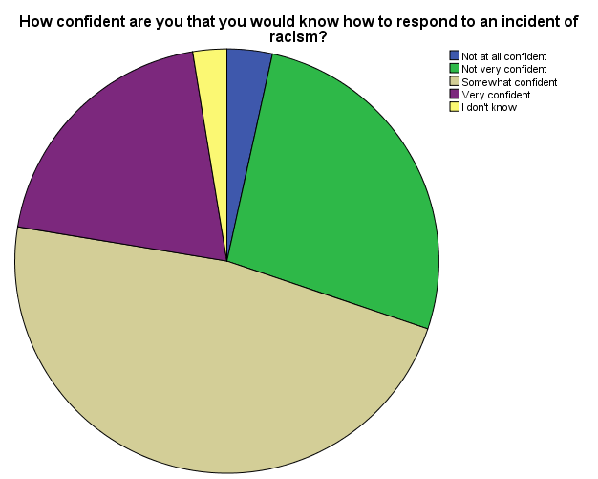

Figure 1: Pre-test survey question re confidence in responding to racism

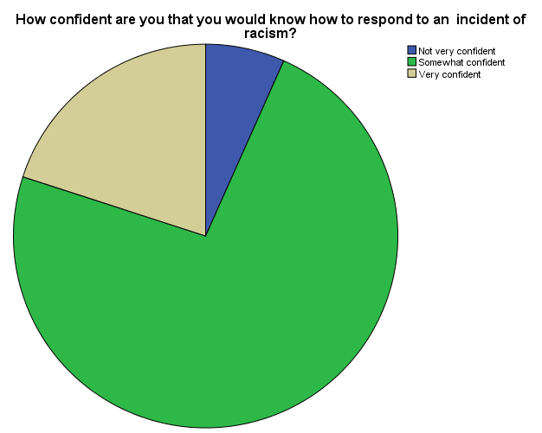

Figure 2: Post-test survey question re confidence in responding to racism
Participants’ reflections on effectiveness of individual strategies and project as a whole

Participants’ reflections on the individual strategies indicated that they felt the training workshops were the most effective in increasing knowledge, skills and confidence of bystander anti-racism action. Participants were asked to rate each strategy from 0-100, with workshops achieving a mean score of 77, the communications campaign a mean of 44 and the community dinners a mean of 47.

The majority of the participants who completed the post-test survey stated that they had gained knowledge, skills and confidence as a result of their participation in the project, as show in Table 3.

Table 3: Participant self-reflections on effectiveness of project overall

Survey Question | Agree | Disagree
I am more aware of racist talk and actions that takes place around me. | 86.7% | 4.4%
I am more willing to intervene when I witness racism. | 84.5% | 4.4%
I learnt new strategies/ways to help when I witness racism. | 84.5% | 8.9%
The project did not have any impact on my knowledge of or perspective on racism. | 11.1% | 71.1%

In response to the qualitative question, “Overall, what impact have the UWS bystander anti-racism strategies had on your confidence to racism that you witness at UWS?” the answers were largely positive and indicated that the strategies had had a high impact on the group. Some of the positive impacts identified included increased confidence, greater awareness of racist talk and actions and new skills in how to address racism and ideas on what to say/what phrasing to use. One respondent stated, “It has had a huge impact. I feel more empowered to stand up and do/say something about racism. I feel more confident in myself. I am also more aware that I may not be able to say anything to the aggressor [sic] sometimes. In these situations I have learnt that assisting [sic] the victim of racism by asking if they are ok can be just as powerful as standing up to the aggressor.”

Some respondents expressed that they felt the strategies had no impact, which was often put down to the fact that they felt they already had a strong understanding of racism and already felt confident to address racism. Only one respondent offered critical feedback about the strategies, responding: “None. Content of workshop was unsophisticated and preached to converted. Workshops failed to recognise complexity of racism [sic] and policies of multiculturalism.”

Conclusion

The findings of this project demonstrate that the UWS bystander anti-racism strategies had a largely positive impact on participants understanding and awareness of racism, their attitudes towards racism and their confidence to respond to racism. Based on the qualitative feedback as well as the rating of individual strategies, the bystander anti-racism training workshops were the most effective in meeting these aims, with the communications campaign and community dinners being perceived by participants as being less effective to this end. Participants felt that the workshops gave them the chance to explore the concepts of racism and anti-racism in more depth in a safe and open setting, and also gave them opportunities to practice their newly learned skills through the coaching exercises.

Bystander anti-racism is emerging as an evidence-based method of targeting interpersonal and individual racism in Australia, and the training being undertaken through UWS initiatives is at the forefront of this movement. The benefits of this training are hoped to affect the UWS community and broader Australian society at large.

