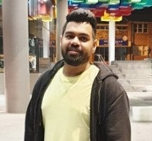
Hi,
I am Harsh Pania, current president of Desi Society and a student of Master’s in Electrical. I humbly advance my application to serve as the Vice President-Activities. During my Under Graduation I was the coordinator of the events like One India, Youthvibe and One World. They were basically associated with the inclusion of all kinds of communities together promoting their cultures. Keeping in mind that the position holds major values, if elected, I would want to bring forward more opportunities to the students and also try to add new concepts and make activities interesting which would include interactions of new students with the current one’s to make them feel like home. I will also assist and update the students to the events and also the services which is provided by the University. All the occasions that will be conducted will be fairly documented and underneath the rules and policies of the university.

