WORK HEALTH AND SAFETY:
eRGONOMIC Self-ASSESSMENT Checklist

CHECKLIST:
Chair
- Are your arms at 90 degrees or greater? If not, then increase chair height.  - If your feet are off the floor, then you need a foot stool please contact WHS&W |  | ☐ Yes | ☐ No | ☐ N/A
- Are your hips and knees at 90 degrees and feet planted firmly on floor or on a footstool? |  | ☐ Yes | ☐ No | ☐ N/A
- Is the curve of your lower back supported and complimented by the lumbar support of the chair?  - Adjust back rest height |  | ☐ Yes | ☐ No | ☐ N/A
Workstation
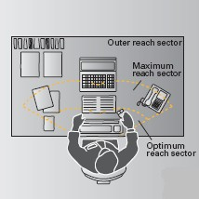  - Is your workstation arranged so that frequently used items (phone, materials etc) are easily reached? |  | ☐ Yes | ☐ No | ☐ N/A
- Is the telephone on non-dominant side? |  | ☐ Yes | ☐ No | ☐ N/A
- Do you refer to hard copy documents and transfer information to the screen for the majority of your work?  - You may need a document holder, please contact WHS&W |  | ☐ Yes | ☐ No | ☐ N/A
Mouse and Keyboard
- Are mouse and keyboard positioned so that they can be used while arms are tucked into body and at 90 degrees?  - Is your wrist position in neutral and in line with your forearm? |  | ☐ Yes | ☐ No | ☐ N/A
Monitor
- Is your eye line in line with the top of the monitor?  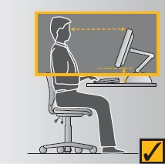 |  | ☐ Yes | ☐ No | ☐ N/A
- Is the monitor approximately an arm’s length away? |  | ☐ Yes | ☐ No | ☐ N/A
Movement breaks
- Are you getting up at least every half an hour for movement breaks?  - Are you making time to stretch every hour? |  | ☐ Yes | ☐ No | ☐ N/A
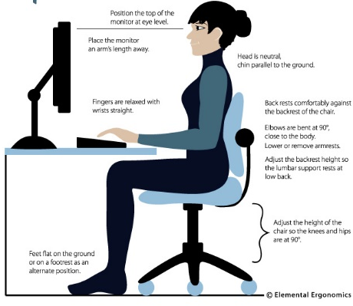
For further information:
Contact WH&S Unit on 9852 5154
Refer to Western Sydney University online training:
http://www.westernsydney.edu.au/whs/whs/workplace_ergonomics/workstation_ergonomics

