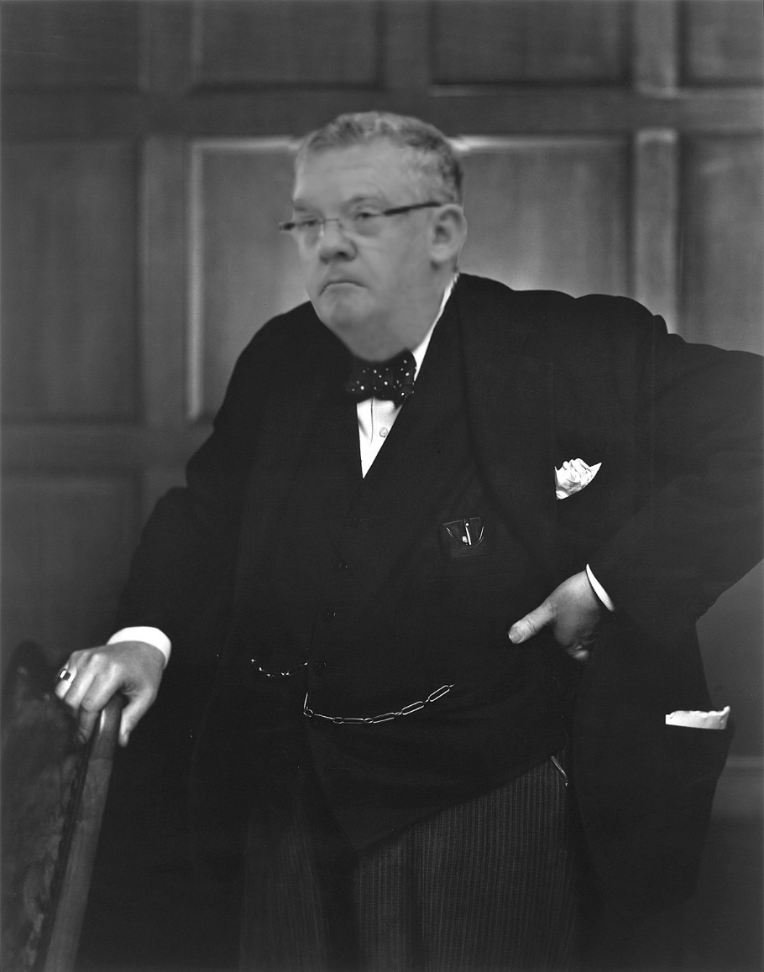

**9th (biennial) Western Sydney University & Inaugural Asian Symposium on NMR, MRI & Diffusion 2020**

Contents

Program 2

Bernhard Blümich 3

Advances and Adventures with Mobile NMR 3

Vivian Chen 4

pH Mapping of the Skeletal Muscle by Chemical Exchange Saturation Transfer (CEST) Imaging 4

Nirbhay Yadav 5

Magnetic resonance imaging of glycogen using its magnetic coupling with water 5

Johnny Chen 6

Development of Novel Chemical Exchange Saturation Transfer Techniques for MRI 6

Carolyn Mountford 7

Neurochemical Dysregulation Changes How We Feel and Function 7

Dennis Hwang 8

Development of new MRI methods for use in biomedical applications 8

Izuru Kawamura 9

Solid-state NMR of Seven-transmembrane Proteins 9

Graham Galloway 10

National Imaging Facility 10

Stuart Crozier 11

A flexible transcieve array for 7T musculoskeletal and prostate imaging 11

István Furó 12

Strong and weak ion binding to polymers and biopolymers as seen by electrophoretic NMR 12

Doctor of Philosophy Candidates & other Short Stories 13

# Program

| **9th (biennial) Western Sydney University & Inaugural Asian Symposium on NMR, MRI & Diffusion 2020** | | | |
| --- | --- | --- | --- |
| **2nd December 2020; 16:45 (EADT)** Session 1 - Chair: Professor William S. Price *Welcome to country and opening address* | | | |
| **17:00** | Bernhard Blümich | RWTH Aachen University, Germany | *Advances and Adventures with Mobile NMR* |
| **18:00 -**  **18:30** | Vivian Chen | Academia Sinica, Taiwan | *pH Mapping of the Skeletal Muscle by Chemical Exchange Saturation Transfer (CEST) Imaging* |
| **3rd December 2020; 09:00 (EADT)** Session 2 - Chair: Professor Eileen McLaughlin *Welcome to country and opening address* | | | |
| **09:15** | Nirbhay Yadav | John Hopkins University, USA | *Magnetic resonance imaging of glycogen using its magnetic coupling with water* |
| **10:05** |  |  | Poster competition and judging |
| **10:35** | Johnny Chen | Western Sydney University | *Development of Novel Chemical Exchange Saturation Transfer Techniques for MRI* |
| **11:00** | Noriko Kanai | Yokohama National University, Japan | *Spent coffee grounds as a new source of cellulose nanofibers* |
| **11:05 - 12:00** | ANZMAG Annual General Meeting | | |
| **3rd December 2020; 12:00 (EADT)** Session 3 - Chair: Abhishek Gupta | | | |
| **12:00** | Virtual Tour of the Biomedical Magnetic Resonance Facility & Questions | | |
| **12:15** | Carolyn Mountford | University of Technology, Queensland | *Neurochemical Dysregulation Changes How We Feel and Function* |
| **13:05** | Dennis Hwang | Academia Sinica, Taiwan |  |
| **13:40** | Izuru Kawamura | Yokohama National University, Japan | *Solid-state NMR of Seven-transmembrane Proteins* |
| **13:45 -**  **14:00** | Graham Galloway | National Imaging Facility |  |
| **3rd December 2020; 14:30 (EADT)** Session 4 - Chair: Professor Dennis Hwang | | | |
| **14:30** | Stuart Crozier | University of Queensland | *A flexible transcieve array for 7T musculoskeletal and prostate* |
| **15:10** |  |  |  |
| **15:15** | István Furó | KTH, Stockholm | *Strong and weak ion binding to polymers and biopolymers as seen by electrophoretic NMR* |
| **16:00** | Dr Dennis Hwang *Closing Address* | | |

# Bernhard Blümich

## Advances and Adventures with Mobile NMR

|  |  |
| --- | --- |
|  | Bernhard Blümich,  Institut für Technische und Makromolekulare Chemie,  RWTH Aachen University |

**Abstract**

Mobile NMR enables a variety of studies which are out of range when relying on conventional NMR instruments. For the most part, mobile NMR instruments are stray-field sensors, that characterize material properties by investigating relaxation and diffusion of nuclear magnetization. This contribution reviews the principles of portable stray-field NMR and selected recent applications to non-destructive materials testing and to tangible cultural heritage in- and outside the laboratory.

**Biography**

Bernhard Blümich gained his Ph.D. in physical chemistry from the Technical University of Berlin, Germany, in 1981. He spent a year as a NATO postdoctoral fellow at the University of New Brunswick, Canada, before joining the University of Bayreuth, Germany, as a staff scientist working on macromolecular chemistry. From 1984–1992, Blümich was a staff scientist at the Max Planck Institute for Polymer Research, Mainz, Germany, during which time he completed his Habilitation in physical chemistry. He took up his current position at the RWTH Aachen in 1993.

Blümich’s research focuses on the use of solid-state NMR spectroscopy for determining the structure of, and molecular interactions with, materials such as naphtha reforming catalysts, nylon carpet tiles, block copolymers, ionic liquids, and nanocomposites. He also develops portable NMR equipment for bench-top analysis, including the NMR-MOUSE which has been used to analyze paintings, rubber tires, and archeological specimens.

# Vivian Chen

## pH Mapping of the Skeletal Muscle by Chemical Exchange Saturation Transfer (CEST) Imaging

|  |  |
| --- | --- |
|  | Dr Vivian Chen  Academia Sinica, Taiwan |

**Abstract**

Yu-Wen Chen1, Hong-Qing Liu2, Qixuan Wu2,3, Yu-Han Huang2,4, Yu-Ying Tung1, Ming-Huang Lin1, Chia-Huei Lin1, Tsai-Chen Chen2,5, Eugene C. Lin3, and Dennis W. Hwang1,2*

1. Biomedical Translation Research Center, Academia Sinica, Taipei, Taiwan
2. Institute of Biomedical Sciences, Academia Sinica, Taipei, Taiwan
3. Department of Chemistry and Biochemistry, National Chung Cheng University, Chiayi, Taiwan
4. The Department of Biotechnology, Ming Chuan University, Taoyuan, Taiwan
5. The Institute of Biochemistry and Molecular Biology, National Yang-Ming University, Taipei, Taiwan

Magnetic resonance imaging (MRI) is extensively used in clinical and basic biomedical research. However, MRI detection of pH changes still poses a technical challenge. Chemical exchange saturation transfer (CEST) imaging is a possible solution to this problem. Using saturation transfer, alterations in the exchange rates between the solute and water protons because of small pH changes can be detected with greater sensitivity. In this study, we examined a fatigued skeletal muscle model in electrically stimulated mice. The measured CEST signal ratio was between 1.96 ppm and 2.6 ppm in the z-spectrum, and this was associated with pH values based on the ratio between the creatine (Cr) and the phosphocreatine (PCr). The CEST results demonstrated a significant contrast change at the electrical stimulation site. Moreover, the pH value was observed to decrease from 7.23 to 7.15 within 20 hours after electrical stimulation. This pH decrease was verified by 31P magnetic resonance spectroscopy and behavioral tests, which showed a consistent variation over time**.**

# Nirbhay Yadav

## Magnetic resonance imaging of glycogen using its magnetic coupling with water

|  |  |
| --- | --- |
| cid:577B6A50-F7FD-4FBF-AA2F-DD9AB1CAD97B | Dr Nirbhay Yadav  Assistant Professor of Radiology and  Radiological Science  The Johns Hopkins School of Medicine and  The Kennedy Krieger Institute |

**Abstract**

Glycogen is the primary form of glucose storage in mammals and plays a vital role in cellular energy homeostasis. Mapping glycogen in vivo is useful in the diagnosis and assessment of diseases where glucose metabolism is altered, such as diabetes, tumors, and liver diseases. Currently, imaging glycogen in the clinic is not feasible due to the lack of a practical approach. This talk will describe how the magnetic coupling between glycogen and water can be used for the high resolution imaging of glycogen in vivo. This approach can be implemented on standard human MRI scanners and has the potential to assess disease where glycogen metabolism is altered.

**Biography**

Nirbhay N. Yadav, PhD is an Assistant Professor of Radiology at The Johns Hopkins University School of Medicine and The Kennedy Krieger Institute, USA. Dr Yadav completed his PhD at the University of Western Sydney, Australia working on NMR studies of molecular diffusion under the supervision of Prof. William S. Price. In 2010, he moved to Johns Hopkins to take up a Post-Doctoral Fellowship under the supervision of Prof. Peter van Zijl. Dr Yadav has published over 50 reviewed articles and serves as the principle investigator for an ongoing National Institutes of Health (NIH)-funded study. His current research interests include the development of MRI-based molecular imaging methods and the application of these methods in animal models and human patients with cancer, stroke, and neurodegenerative diseases

# Johnny Chen

## Development of Novel Chemical Exchange Saturation Transfer Techniques for MRI

|  |  |
| --- | --- |
|  | Dr Johnny Chen  Western Sydney University |

**Abstract**

Chemical exchange saturation transfer (CEST) is an exciting contrast enhancement mechanism which improves the molecular imaging capability of magnetic resonance imaging (MRI). CEST typically involves labelling (i.e., saturating with radiofrequency pulses) the protons of biologically-relevant functional groups (i.e., hydroxyls, amides, or amines), which undergo proton exchange with the detectable free water to induce specific MRI contrast. My PhD study investigates the feasibility of another biologically-relevant functional group, the thiol group, to induce CEST contrast and explores some potential applications. In this talk, I will not only show that thiol-based CEST MRI is indeed feasible but how it can also be used for in vivo MRI detection of a common pharmaceutical drug, N-acetylcysteine, possibly leading to theragnostic applications.

**Biography**

Johnny Chen completed his PhD studies in 2020 at Western Sydney University (WSU), where he also received a Bachelor of Medical Science (Honours) in 2016. His PhD research primarily focussed on exploring the feasibility and potential applications of thiol-water proton exchange from metabolites and pharmaceutical drugs as a contrast mechanism in magnetic resonance imaging. His PhD was completed under the supervision of Dr Gang Zheng (primary), Dr Timothy Stait-Gardner, and Prof. William Price from the Nanoscale Organisation and Dynamics Group at WSU, and Dr Nirbhay Yadav from The Johns Hopkins University and The Kennedy Krieger Institute in the USA. Johnny has published five peer-reviewed papers during his candidature.

# Carolyn Mountford

## Neurochemical Dysregulation Changes How We Feel and Function

|  |  |
| --- | --- |
| ASMI 2021 – National Meeting of the Australian Society of Molecular Imaging | Professor Carolyn Mountford DPhil(Oxon)  Professor of Radiology, Queensland University of Technology  Professor of Radiology and Neuroglycobiology,  Griffith University  Neuroscientist, Athinoula A. Martinos Center for Biomedical Imaging, Harvard Medical School |

**Abstract**

Modern data mining of in vivo one-dimensional neuro MR spectroscopy of the human brain identifies markers that determine the presence or risk of developing diseases/disorders not previously assessable. Two-dimensional in vivo neuro MR spectroscopy provides unambiguous assignment of those biochemical pathways that are dysregulated due to anxiety, pain or exposure to traumatic events or blast. MR technology is now able to shed light by predicting early stage disease or by monitoring progression or response therapy. It also provides insight as to why people feel and function differently with conditions such as pain and PTSD.

**Biography**

Professor Mountford and her team are currently working to improve MR spectroscopy technology and broaden its medical application. This work has already resulted in techniques used by research centres and hospitals for patients with cancer, brain tumours, and neurologic and psychological disorders.

The USA and Australian military have contracted her team to further develop the new MR in vivo approach that diagnoses changes to brain chemistry associated with brain injury and post-traumatic stress disorder. These in turn promise new therapeutic approaches.

One of Prof Mountford’s programs has developed a way to monitor women at high risk for breast cancer identifying metabolic deregulations in their breast tissue that precede tumor growth.

Professor Mountford comes to TRI from the University of Newcastle where she was the Professor of Radiology and Director of the Centre for MR in Health since 2011. Other roles include full Professor of Radiology at Harvard Medical School since 2007, and Director of the Centre for Clinical Spectroscopy at the Brigham and Women’s Hospital in Boston since 2006.

# Dennis Hwang

## Development of new MRI methods for use in biomedical applications

|  |  |
| --- | --- |
| Dennis HWANG | Doctor of Philosophy | Academia Sinica, Taipei | Institute  of Biomedical Sciences | Dr Dennis Hwang  Assistant Research Fellow  Academia Sinica  Institute of Biomedical Sciences,  Taiwan |

**Biography**

Our research focuses on the development of new MRI methods for use in biomedical applications. A newly developed active feedback frequency lock-in imaging method in combination with conventional MRI techniques was used to enhance MRI contrast. The biomedical applications include liver fibrosis, neurodegenerative diseases involving iron accumulation, and tumor detection. To detect neurodegenerative diseases, we will combine optogenetics with functional MRI to label specific brain regions and investigate brain activity. Also, diffusion tensor MRI will be employed to inspect the neuron distribution in the brain. In hepatic fibrosis, the fibrotic stages can be distinguished by dynamics contrast-enhanced MRI (DCE-MRI) and then combined with feedback frequency lock-in imaging to quantify the liver iron content. This new MRI method can be also used for early detection of hepatic cancer.

# Izuru Kawamura

## Solid-state NMR of Seven-transmembrane Proteins

|  |  |
| --- | --- |
| Details of a Researcher - KAWAMURA Izuru | Associate Professor  Graduate School of Engineering Science, Yokohama National University,  Japan |

**Abstract**

Microbial rhodopsins are photoreceptive proteins and vital for cell function. While a microbial rhodopsin basically consists of seven transmembrane helices with all-trans retinal chromophore, the function of the proteins is highly divergent. Solid-state NMR spectroscopy is a powerful tool to probe the structure and dynamics of proteins in biological membranes of increasing complexity. Here, we present our approach using solid-state magic angle spinning NMR to investigate the structure and dynamics of microbial rhodopsins embedded in a membrane environment. 15N NMR assessments of protonated Schiff base of retinal chromophore among several microbial rhodopsins revealed the strength of the interaction between retinal and counter-ion. Site-specific detection of H/D exchange investigated light-induced conformational changes for new-type rhodopsin, heliorhodopsin. Chemical shift perturbation (changes in the chemical shifts) of light-driven sodium ion pumping rhodopsin when an alkali metal ion is added, revealed the affinity to Na+ and Li+.

Izuru Kawamura

Graduate School of Engineering Science, Yokohama National University, Yokohama, Japan,

**E-mail:** kawamura-izuru-wx@ynu.ac.jp

# Graham Galloway

## National Imaging Facility

|  |  |
| --- | --- |
| Professor Graham Galloway - UQ Researchers | Professor Graham Galloway  Chief Executive Officer,  National Imaging Facility |

**Biography**

Professor Graham Galloway is the Chief Executive Officer of the National Imaging Facility (NIF). He has been instrumental in establishing Imaging collaborative research infrastructure in Australia. In 2006, he led the collaborative team that developed the Investment plan for Imaging, within NCRIS (National Collaborative Research Infrastructure Strategy). This plan was accepted by Department of Industry, Innovation and Science, with $7M Commonwealth funding, plus $10M state and institutional funding and Galloway was nominated by the Imaging Community as the Inaugural Chief Executive Officer of the National Imaging Facility. In this role, he provides leadership to the NIF as it develops a strategic vision for imaging in Australia. Under his leadership, NIF has expanded through the Education Investment Fund and further capital investment through NCRIS. With state and institutional funding, this is a $130M project. He is passionate about providing open access to the imaging resources and enabling effective use of those resources.

Graham’s research interests include the use of in vivo Magnetic Resonance to test the efficacy of pharmaceutical agents, novel applications for the use of Magnetic Resonance in physiological studies and material sciences, and in pushing the boundaries of the technology into new applications. His role in all projects is characterised by his multidisciplinary background, which ensures that he is able to draw together these apparently disparate threads.

National Imaging Facility <https://anif.org.au/>

|  |  |
| --- | --- |
|  |  |

# Stuart Crozier

## A flexible transcieve array for 7T musculoskeletal and prostate imaging

|  |  |
| --- | --- |
|  | Associate Dean (Research) for the Faculty of Engineering, Architecture and Information Technology  University of Queensland |

**Abstract**

One of the main challenges in ultra-high field, whole body MRI relates to the uniformity and efficiency of the radiofrequency (RF) fields generated in tissue. Although recent advances in the design of RF coils have demonstrated that dipole antennas have a current distribution ideally suited to 7T MRI, they are limited by low isolation and poor robustness to loading changes. Multi-layered and self-decoupled loop coils have demonstrated improved RF performance in these areas at lower field MRI but have not been adapted to dipole designs. In this work, we introduce a novel type of RF antenna consisting of integrated multi-modal antenna with coupled radiating structures (I-MARS), which use layered conductors and dielectric substrates to allow dipole and transmission line modes to co-exist on the same compact dipole-shaped structure. A prototype parallel transmit coil array was built and tested on healthy volunteers at 7T. The articulated, modular construction of the I-MARS coil array allowed it to be readily conformed across multiple body regions (hip, knee, shoulder, lumbar spine and prostate), without requiring modification of the tuning and matching of the antennas.

**Biography**

Professor Stuart Crozier is the Associate Dean (Research) for the Faculty of Engineering, Architecture and Information Technology. His expertise lies in imaging technology and applications, instrumentation for physiological measurement and semi-automated diagnostics. The commercial and academic impact of the work in Magnetic Resonance Imaging has been significant, with about two thirds of all high-end, clinical MRI systems installed worldwide after 1997 containing patented technology co-invented and fully developed by him. In 2012 Professor Crozier received the Australian Academy of Technological Sciences (ATSE) Clunies Ross Award for his contributions to the field of Magnetic Resonance Imaging. The award recognises outstanding achievement in the application of science and technology for the benefit of the wider community.

# István Furó

## Strong and weak ion binding to polymers and biopolymers as seen by electrophoretic NMR

|  |  |
| --- | --- |
|  | Professor István Furó  KTH Royal Institute of Technology |

**Biography**

My current basic research interests can be divided into two broad groups. One concerns developing new NMR methods and instrumentation such as that for electrophoretic NMR. To the second group belong applications of NMR experiments to association phenomena, porous materials, cellulose, chromatographic media and more. I am also interested in NMR microimaging (MRI) and its applications to, for example, swelling of various materials such as tablets and clays and the behavior of molecular components in energy devices like batteries and fuel cells. Through the Industrial NMR Centre, I have numerous industrial contacts and due immersion in applied projects.

# Doctor of Philosophy Candidates & other Short Stories

|  |  |
| --- | --- |
| Noriko Kanai | *“Spent coffee grounds as a new source of cellulose nanofibers”*  Noriko is a PhD student at Graduate school of Yokohama National University under the supervision of Dr. Izuru Kawamura. She completed masters at same university in the field of chemistry in September 2020. She was staying at NANO group at WSU led by Prof. Price as a Visiting Fellow for 7 months in 2019. Currently, Noriko was involved in research on the characterization of lipids and cellulose in coffee beans using solid-state NMR and PGSE NMR, and the production of cellulose nanofibers from “spent” coffee grounds.  **Abstract:**  Research on spent coffee grounds (SCGs) aimed at waste revalorization as well as upcycling has significantly increased over the last decade. Almost half of the dry weight of SCGs consists of polysaccharides in cell walls, mainly cellulose and hemicellulose. We focus on cellulose containing around 10 wt% in SCGs and successfully isolated nano-sized cellulose fibers (i.e., cellulose nanofibers, CNF). Thus, we reported SCGs as a completely new non-wood source of CNF [1].  Catalytic oxidation using 2,2,6,6-tetramethylpiperidine-1-oxyl (TEMPO) was conducted to produce CNF from SCGs (CNF-SCGs) in accordance with the procedure detailed by A. Isogai [2]. We will present the detailed characterization of CNF-SCGs using solid-state NMR, field emission scanning electron microscopy, X-ray diffraction and thermogravimetric analysis in the symposium.  [1] Kanai, N. et al, Cellulose, 27, 5017–5028 (2020)  [2] Isogai, A. Proc. Jpn. Acad. B., 94, 161–179 (2018). |
| Poster 1 |  |
| Poster 2 |  |