Voice Control

Voice Commands.

Material compiled from  
macOS Big Sur.

Contents

How to enable Mac Voice Control and select language 3

Control the microphone 3

The essentials 4

To click a button or other interface item 5

Working with applications 5

Overlays and mouse 7

Position the mouse 7

Making selections 7

Drag the mouse 7

Cursor commands 8

Click the mouse 8

Basic dictation 8

Add lines and spaces 8

Dictating punctuation 8

Fixing mistakes 9

Others 9

Text selection 10

General selection 10

Character selection 10

Word selection 11

Sentence selection 11

Paragraph selection 11

Line selection 12

Text navigation with cursor 12

Basic commands 12

Characters 13

Words 13

Sentences 13

Paragraph 13

Line 14

Selection 14

Phrase 14

Text editing and formatting 14

Text deletion 15

General deletion 15

Character 15

Word 16

Sentence 16

Paragraph 16

Line 16

Creating your own commands 17

# How to enable Mac Voice Control and select language

Follow these steps to turn on Voice Control and select your preferred language to start speaking to your computer. Languages include English, Arabic and Spanish.

1. Go to the Apple Menu
2. Select System Preferences
3. Select Voice Control
4. Click “Enable Voice Control” checkbox.
5. Select “Language” and click “Customise”. Select your preferred language.
6. Click “Microphone” and select your preferred microphone.

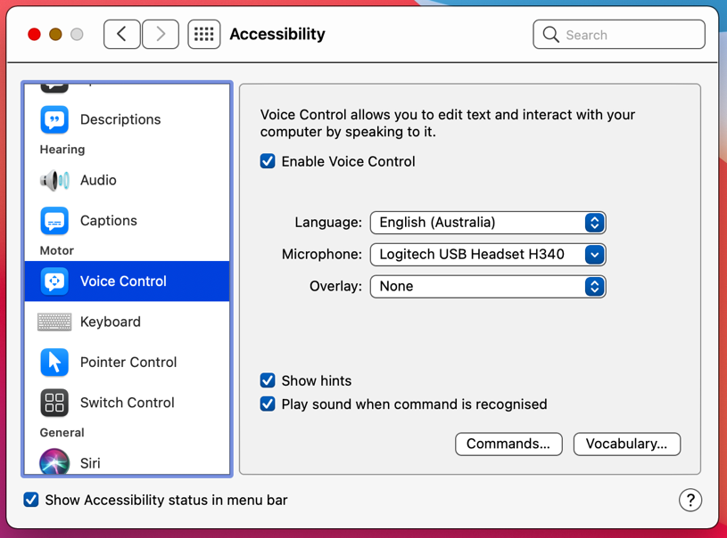

# Control the microphone

The word ‘Sleep’ will appear beneath the microphone when the microphone is actively listening for your commands. When the microphone is in sleep mode, the words ‘Wake Up’ will appear beneath it. Click on the word to change to that mode or speak the commands below.

* Go to sleep
* Wake up

# The essentials

* Go to sleep
* Wake up
* Show commands
* Open <application name>
* Quit <application name>
* Hide <application name>
* Minimise window
* New item
* Click <menu name>/<item name>
* Search
* Open Spotlight
* Show numbers/grid
* Choose <number>
* Zoom in/out
* Close window/tab/menu
* Copy that/selection
* Move to/Go to …
* Paste that/here
* Bold/underline/italicise that/selection
* Delete that
* Correct that
* Add to vocabulary
* Save document

# To click a button or other interface item

Say the word ‘click’ or ‘press’ followed closely by the name of the button or menu item. The name of the button can often be revealed by hovering your curser over it until a small pop-up box appears near the button. The text within should be the name you need to speak.

* Click/Press <item name>
* Click/Press <menu name> menu
* Click/Press <menu item name>

# Working with applications

* Open Siri
* Open <application name>
* Quit <application name>
* Hide <application name>
* Quit application
* Hide application
* New item
* Open document
* Save document
* Close window
* Minimise window
* Click <item name>
* Click <menu name> menu
* Click <menu item name>
* Close menu
* Go to previous field
* Go to next field
* Find next
* Show commands
* Hide commands
* Open Voice Control preferences
* Show keyboard
* Hide keyboard
* Search Spotlight for <phrase>
* Search for <phrase>
* Make this speakable **or** Create command
* Send that
* Open result
* Close Spotlight
* Previous result
* Next result
* Scroll preview down
* Scroll preview up
* Search now
* Go back
* Go forward
* New tab
* Close tab
* Zoom in
* Zoom out
* Close Siri

# Overlays and mouse

## Position the mouse

* Show numbers
* Show numbers continuously
* Hide numbers
* Show grid
* Show grid continuously
* Show window grid
* Hide grid

## Making selections

* Choose <number>
* <number>
* Click <number>
* Double click <number>
* Triple click <number>
* Long press <number>

## Drag the mouse

* Drag <number> to <number> **or** Drag from <number> to <number>
* Start drag <number> **or** Start drag at <number>
* Drop <number> or Drop at <number> **or** End drag at <number>
* Click and hold <number>
* <modifier keys> click and hold <number>
* Zoom in <number> **or** Zoom in at <number>
* Zoom out <number> **or** Zoom out at <number>

## Cursor commands

* Move cursor left <count> pixels
* Move cursor right <count> pixels
* Move cursor up <count> pixels
* Move cursor down <count> pixels

## Click the mouse

* Single click
* Double click
* Triple click
* Long press
* Click and hold mouse
* <modifier keys> click and hold mouse
* Release mouse

# Basic dictation

Click into the document or text field where you would like to type and speak the phrase you want to type into it.

## Add lines and spaces

* New line
* New paragraph

## Dictating punctuation

Speak the name of the punctuation you are after, for example:

* Full stop .
* Comma ,
* Question mark ?
* Exclamation mark !
* Hyphen -
* Underscore _
* Slash /
* Backslash \
* Open/Close parenthesis ( )
* Open/Close square bracket [ ]
* Open/Close brace { }
* Ellipsis …
* Quote “
* End quote ”
* Colon :
* Semi-colon ;
* Percent sign %
* Copyright sign ©
* At sign @

## Fixing mistakes

* Undo
* Delete
* Delete <word>
* Delete line

## Others

* Insert <name> emoji 😊
* Insert date
* Numeral <number> (inserts number rather than word)
* No space on (turns off spaces in the next sequence of words – great for URLs and passwords!)
* No space off (resumes normal spacing between words)
* Add to vocabulary **or** Add selection to vocabulary
* Press <key name> key. E.g. “Press caps lock key”.
* Press the <modifier keys> <key name> key <count> times. E.g. “Press the shift tab key 3 times”.
* Dictation mode
* Command mode (stops dictation and only listens for commands)

# Text selection

## General selection

* Select that
* Select all
* Select <phrase>
* Select <phrase> emoji
* Select previous
* Select next
* Deselect that **or** Unselect that

## Character selection

* Select <character>
* Select previous character
* Select next character
* Select previous <count> characters
* Select next <count> characters
* Extend selection <count> character/s
* Extend selection back <count> character/s

## Word selection

* Select <word>
* Select previous word
* Select next word
* Select previous <count> words
* Select next <count> words
* Extend selection <count> word/s
* Extend selection back <count> word/s

## Sentence selection

* Select sentence
* Select previous sentence
* Select next sentence
* Select previous <count> sentences
* Select next <count> sentences
* Extend selection <count> sentence/s
* Extend selection back <count> sentence/s

## Paragraph selection

* Select paragraph
* Select previous paragraph
* Select next paragraph
* Select previous <count> paragraphs
* Select next <count> paragraphs
* Extend selection <count> paragraph/s
* Extend selection back <count> paragraph/s

## Line selection

* Select line
* Select previous line
* Select next line
* Select previous <count> lines
* Select next <count> lines
* Extend selection <count> line/s
* Extend selection back <count> line/s

# Text navigation with cursor

## Basic commands

* Move down
* Move up
* Move left
* Move right
* Scroll up
* Scroll down
* Scroll to top
* Scroll to bottom
* Scroll left
* Scroll to left edge
* Scroll right
* Scroll to right edge
* Move to beginning **or** Go to top
* Move to end **or** Go to bottom

## Characters

* Move forward <count> character/s
* Move back <count> character/s
* Move right <count> character/s
* Move left <count> character/s

## Words

* Move to beginning of word **or** Go to beginning of word
* Move to end of word **or** Go to end of word
* Move forward <count> word/s
* Move back <count> word/s
* Move right <count> word/s
* Move left <count> word/s

## Sentences

* Move to beginning of sentence **or** Go to beginning of sentence
* Move to end of sentence **or** Go to end of sentence
* Move forward <count> sentence/s
* Move back <count> sentence/s
* Move right <count> sentence/s
* Move left <count> sentence/s

## Paragraph

* Move to beginning of paragraph **or** Go to beginning of paragraph
* Move to end of paragraph **or** Go to end of paragraph
* Move forward <count> paragraph/s
* Move back <count> paragraph/s
* Move down <count> paragraph/s
* Move up <count> paragraph/s

## Line

* Move to beginning of line **or** Go to beginning of line
* Move to end of line **or** Go to end of line
* Move forward <count> line/s
* Move back <count> line/s
* Move down <count> line/s
* Move up <count> line/s

## Selection

* Move to beginning of selection **or** Go to beginning of selection
* Move to end of selection **or** Go to end of selection

## Phrase

* Move after <phrase> **or** Insert after <phrase>
* Move before <phrase> **or** Insert before <phrase>

# Text editing and formatting

* Replace <phrase> with <phrase> **or** Change <phrase> to <phrase>
* Insert <phrase> after <phrase>
* Insert <phrase> before <phrase>
* Correct that
* Correct selection
* Correct <phrase> **or** Correct the word <phrase>
* Undo that **or** Scratch that
* Redo that
* Cut that **or** Cut selection
* Copy that **or** Copy selection
* Paste that **or** Paste here
* Capitalise that **or** Capitalise selection
* Capitalise <phrase>
* Lowercase that **or** Lowercase selection
* Lowercase <phrase>
* Uppercase that **or** Uppercase selection
* Uppercase <phrase>
* Bold that **or** Bold selection
* Bold <phrase>
* Italicise that **or** Italicise selection
* Italicise <phrase>
* Underline that **or** Underline selection
* Underline <phrase>

# Text deletion

## General deletion

* Delete that **or** Delete Selection
* Delete all
* Delete <phrase>

## Character

* Delete character
* Delete previous character
* Delete next character
* Delete previous <count> characters
* Delete next <count> characters

## Word

* Delete word
* Delete previous word
* Delete next word
* Delete previous <count> words
* Delete next <count> words

## Sentence

* Delete sentence
* Delete previous sentence
* Delete next sentence
* Delete previous <count> sentences
* Delete next <count> sentences

## Paragraph

* Delete paragraph
* Delete previous paragraph
* Delete next paragraph
* Delete previous <count> paragraphs
* Delete next <count> paragraphs

## Line

* Delete line
* Delete previous line
* Delete next line
* Delete previous <count> lines
* Delete next <count> lines

# Creating your own commands

You can create your own commands to personalise your experience even further. If you prefer to have a shortcut for specific phrases or actions follow the steps below.

1. Go to the Apple Menu
2. Select System Preferences
3. Select Voice Control
4. Click Commands
5. Click the “+”

And follow the prompts.  
  
