Dragon Professional.

  - Creating and setting up your
Dragon user profile.
  - Support manual.

Contents
Contents 1
Creating and Setting up your Dragon user profile 2
About Dragon user profiles 2
Create a user profile 2
Three ways to control your microphone 4
Configuring your user profile options 5
Correction tab 5
Commands tab 6
Hot keys 8
Playback/Text-to-speech 9
Miscellaneous 10
Data 11
Final Note 11

Creating and Setting up your
Dragon user profile

About Dragon user profiles
Dragon is a speaker-dependent voice recognition technology and each user must have their own profile. Dragon uses machine learning to continually collect voice sampling information specific to you and stores it in your user profile. The information that is stored in your user profile is therefore highly personalised to ensure greater dictation accuracy is developed.

Create a user profile
- PRIOR to starting Dragon, ensure that a Dragon approved microphone headset is plugged in to your computer.
- Start Dragon.
- From the DragonBar, click ‘Settings’ > ‘Profile’ > ‘New User Profile’.
- Click ‘New’ > ‘Next’.
- Enter a profile name.
- Click ‘Nex’t and select your speech accent option.
- Select the ‘Dragon approved microphone’ from the list of audio devices shown. (Dragon will also list system microphones. The use of system microphones should be avoided).
- Position your microphone as directed on the screen.
- Click ‘Start’ and read the text displayed on the screen.

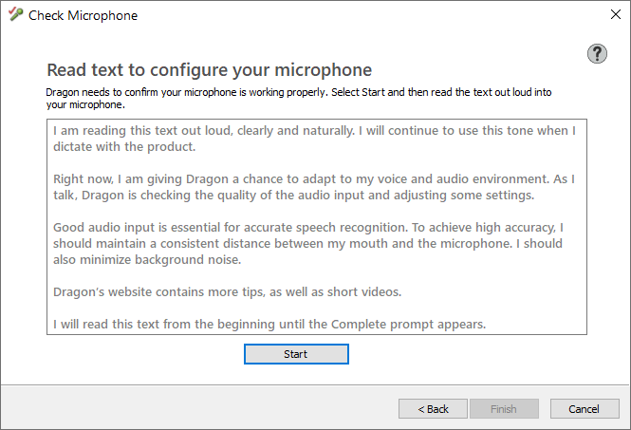
An array of green bars should appear on screen to measure and adjust volume levels.
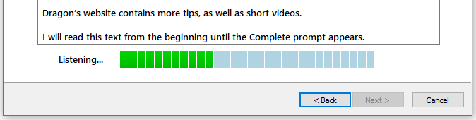
- Once complete, click ‘Finish’.
- The DragonBar will now appear on the screen.
By default, the Interactive Tutorial appears for newly created user profiles. You can choose to undertake this tutorial to become familiar with Dragon now or later. The tutorial can be accessed from the Help section of the DragonBar.
Dragon does not collect information about your voice during the user enrolment process. The text that was read into the microphone is used by Dragon to adjust a range of audio settings and calibrate them to the hardware.
Important: This ‘Check Microphone’ process should be repeated on a weekly basis to ensure that your microphone is correctly calibrated for accuracy. Click ‘Audio’ > Click ‘Check Microphone’.

Three ways to control your microphone
The DragonBar displays menus, indicators and a microphone button to operate Dragon’s microphone source. The DragonBar is below.
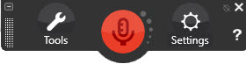
If you are using an older version of Dragon or have an individual user license the DragonBar may look like either the +A Modern or Classic looks below.
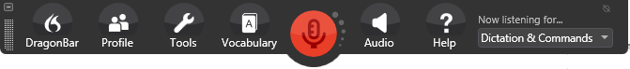
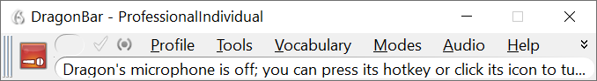

The microphone can be controlled in three ways.
- Mouse (left button) click will toggle the microphone on and off.
- Keyboard shortcut will toggle microphone on and off. The default hotkey on a full-size keyboard is the + sign on the numeric pad. If you’re using a computer that does not have a numeric keypad, you can allocate a different key in the Dragon options. The key F10 is recommended. Please refer to configuring keyboard shortcuts in the next section.
- Control your microphone by voice commands. You will still need to manually switch on your microphone. Once switched on, you can mute it by saying “go to sleep” and unmute it by saying “wake up”.

Configuring your user profile options
The default settings can be tweaked to provide more fluent user experience of Dragon. These settings can be configured by clicking on ‘Settings’ > Click ‘Options’. Please configure your settings according to the screenshots in each section below. Remember to click the ‘Apply’ button before clicking ‘OK’ to close the Options window.

Correction tab
The following settings are recommended to streamline the correction process. It includes a visually intuitive Correction menu that utilises the Spelling Window. Enabling the ‘Automatic playback on correction’ option will assist you to recall your utterances and self-check your articulation. The number of choices displayed can be set to 9 words.
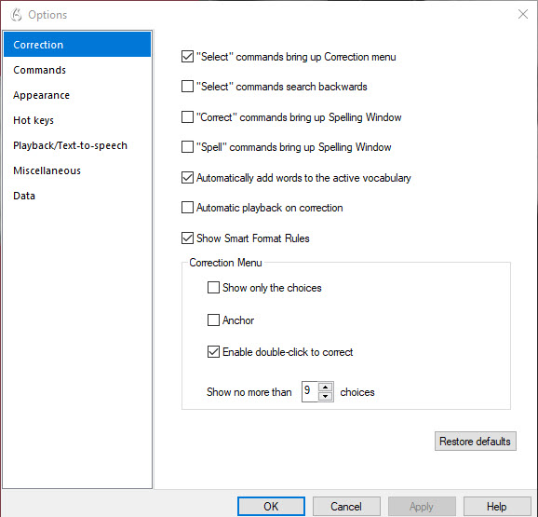

Commands tab
To increase its responsiveness, deselect the number of commands that Dragon will listen for. Click the ‘More Commands’ button to deselect the additional options.
Please note that all these options must be left enabled for a user needing to go completely hands-free due to physical accessibility challenges.
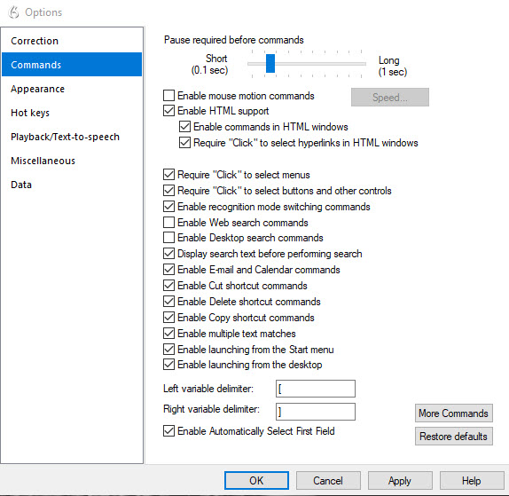
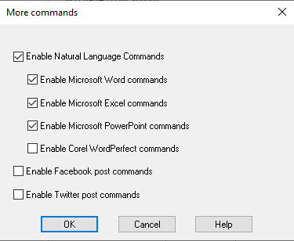

Hot keys
The keyboard shortcuts should not be modified unless necessary. To modify a key combination, select the desired Hotkey and click Edit. Press a new key combination. Click Ok. Click Apply and OK.
For computers without a numeric keyboard, modifying the key combination to F10 is recommended for toggling the microphone On/Off.
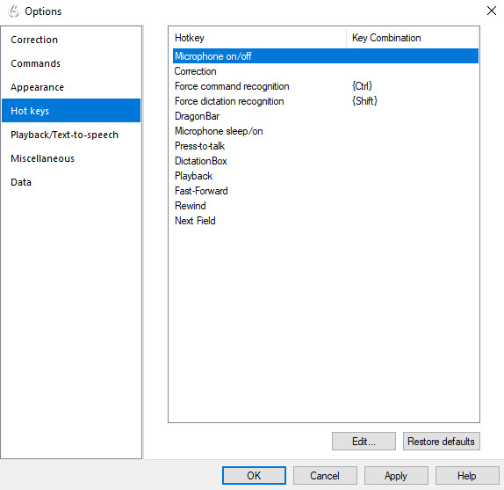
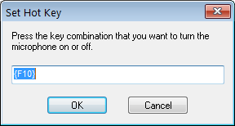

Playback/Text-to-speech
Dragon utilises the voices installed on your computer to read aloud selected text on the screen. Preview the voices available and adjust the playback speed to your preferences.
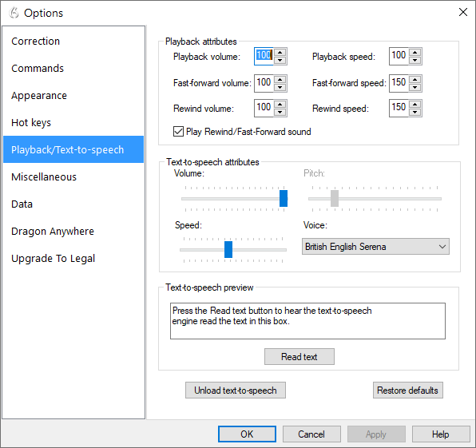

Miscellaneous
To achieve optimal performance on your computer, the default setting for ‘Speed vs. Accuracy’ may need to be adjusted. Dragon will present a message if it determines that your PC will not allow optimal performance.
It is recommended that the ‘Speed vs Accuracy’ sliding bar be slightly adjusted away from ‘Fastest Response’.
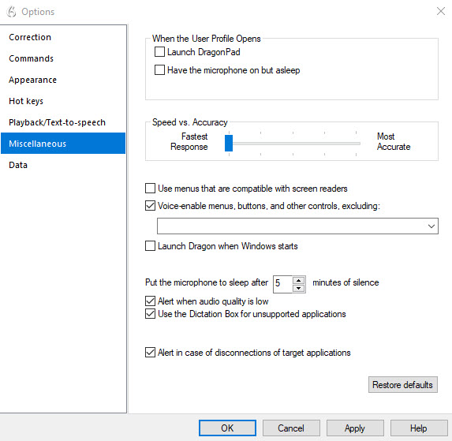

Data
By default, Dragon saves a recording of the dictated document. This non-essential feature can cause computer freezing. Click the drop-down list and change the setting to ‘Never’.
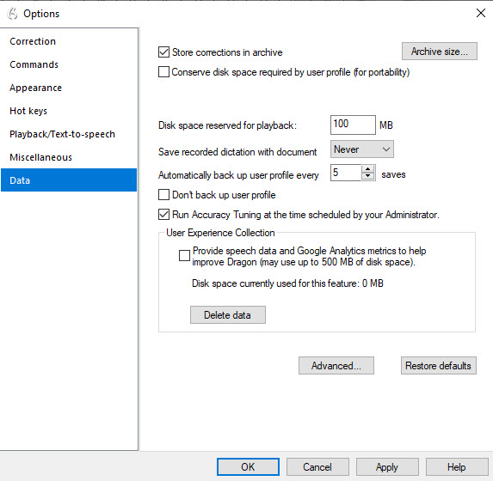

Final Note
Now that you have created and configured your user profile, please check out the series of tutorial videos to help you get underway with using Dragon. Please contact the Assistive Technology Team for more details at atspecialist@westernsydney.edu.au

