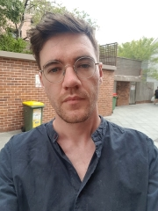
Candidate Statement

I’ve worked as a student editor for W’SUP from August 2018 to presently. The reason why I am running again is because I want to continue the work we’ve been doing and expand it. I want to publish work that is relevant to WSU students across all campuses. Part of this, I believe, is expanding our online content into podcasts and video pieces. I believe we need to expand our base of contributors. We’ve got a range of talented students studying here and W’SUP should be a platform for them to build a portfolio for future work. Giving students real world experience such as through pitching, editing and producing work to deadline is an example of how W’SUP can help students tell the stories that matter to them. Working on W’SUP has given me professional experience and confidence and I’m eager to continue on publishing high-quality work.

