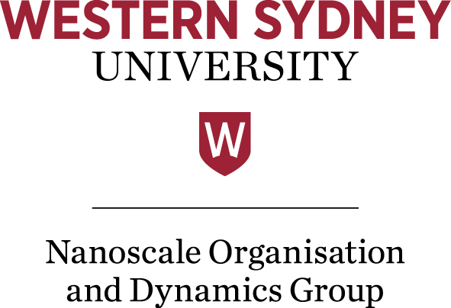

Application of Open MRI Systems with permanent magnets to plant imaging

Associate Professor Yasuhiko Terada

Institute of Applied Physics, University of Tsukuba

Abstract
There are two types of magnets used for MRI, superconducting and permanent magnets. The former has been used in medical imaging applications, with ever-increasing field strengths and signal-to-noise ratios (SNRs). Yet permanent magnets offer many attractive advantages such as reduced magnetic size and maintenance cost, high portability, and high sample accessibility. This talk presents recent applications of open compact MRI systems with permanent magnets to plant imaging in the outdoors. We have developed different types of MRI systems that are capable of imaging trees for different purposes. The presentation focuses on the development of an outdoor MRI system for long-term measurements of sap flow in a living tree in its natural environment.

Profile
Dr Terada is an associate professor at the University of Tsukuba, and is visiting the Nanoscale Group at WSU at Prof. William Price’s invitation. He received his PhD in engineering from the University of Tokyo in 2001. He then worked in the Advanced Research Laboratory, Hitachi Co. Ltd. before taking up a postdoctoral position at the University of Tsukuba in 2005. He began working with Professor Katsumi Kose in the NMR imaging laboratory in 2010. His current research interests are the development of novel NMR imaging systems and new applications in NMR imaging. More specifically, he enjoys developing open, compact MRI systems for specific uses, such as skeletal age assessment in children and microscopic imaging of sap flow in plants. For his academic career, he has authored and co-authored over 70 refereed publications, including journals and conference papers relating to this research field. More information on his research is available at http://www.bk.tsukuba.ac.jp/~mrlab/publications1-e.html.

Staff and students at all levels are welcome to attend.

Venue and Time:

This talk will be held on Thursday June 30 at 2:00 pm, at the Campbelltown Campus in Building 21, Lecture Theatre 5 (CA.21.G.03).

Enquiries:

Prof. William S. Price
Ext. 3336
e-mail: w.price@uws.edu.au

